

**PHYSICAL DATA DESIGN**

**FOR**

**COMBINED SYSTEM DEVELOPMENT SERVICES**

**FOR**

**LICENSING SELF-CERTIFICATION PORTAL**

**OF THE**

**BUILDINGS DEPARTMENT**

**Version 0.1**

**Jan 2025**

© The Government of the Hong Kong Special Administrative Region

The contents of this document remain the property of and may not be reproduced in whole or in part without the express permission of the Government of the HKSAR.

| **Distribution** | |
| --- | --- |
| Copy No. | Holder |
| 1 | Buildings Department (BD) |
| 2 | Master Concept (Hong Kong) Limited (MC) |

| **Amendment History** | | | | |
| --- | --- | --- | --- | --- |
| Change Number | Revision Description | Pages Affected on Respective Version | Revision / Version Number | Date |
| 1 | 1st draft | All | 0.1 | 16/01/2025 |
|  |  |  |  |  |
|  |  |  |  |  |
|  |  |  |  |  |

**TABLE OF CONTENTS**

1. Introduction 4

2. Objectives 5

3. Physical Data Structure Specification 6

3.1. Physical Data Structure 6

3.1.1. (GCIS) Frontend - Application Forms Submission 7

3.1.2. (GCIS) Frontend - OTP login control 8

3.1.3. (BD) Backend - TBC 9

4. Data Entity Description 10

# Introduction

This Physical Data Design Document provides a comprehensive description of the physical data structure and process design for the Licensing Self-Certification Portal (LSCP) Project. This document serves as a blueprint for the implementation of the LSCP database, ensuring a robust and efficient data management system.

The document delves into the detailed relationships between key business entities within the LSCP. A clear and concise diagrammatic representation is provided to visually illustrate the connections between these entities. This section also includes a comprehensive description of each entity, its attributes, and the data types used to represent them. The data relationships are further explained, highlighting the primary keys, foreign keys, and any constraints imposed on the data.

By providing a detailed understanding of the physical data structure, this document serves as a valuable resource for developers, database administrators, and other stakeholders involved in the implementation and maintenance of the LSCP.

# 

# Objectives

The objectives of the proposed Licensing Self-Certification Portal (LSCP) should:

1. Provide user-friendly and meaningful messages to users.
2. Store all electronic and paper submissions from applicant and authorized person (AP)/registered structural engineer (RSE) applications of the requisite safety certificates for registration of non-purpose built schools and child care centres, and applications in related to non-purpose non-local higher and professional education courses.
3. BD departmental portal login for internal users (BD), and provide User ID and password as an alternative.
4. Support the latest web browsers.
5. Comply with the standards of the Government System Architecture and government IT security policy.

## Physical Data Structure Specification

This section documents the data model and its associated descriptions of the required system.

## Physical Data Structure

An entity-relationship diagram consists of three basic elements such as entity, relationship, and attribute. Along with these are more components based on their main elements like weak entity, multi-valued attribute, and many more. Notations used to make ERD diagram examples include cardinality and ordinality to define relationships in numbers.   
  
There are 7 categories of entities in the data model design.

* (CGIS) Frontend - Application Forms submission
* (CGIS) Frontend - OTP login control
* Backend - Users
* Backend - Workflow of Application Forms submission

### (GCIS) Frontend - Application Forms Submission

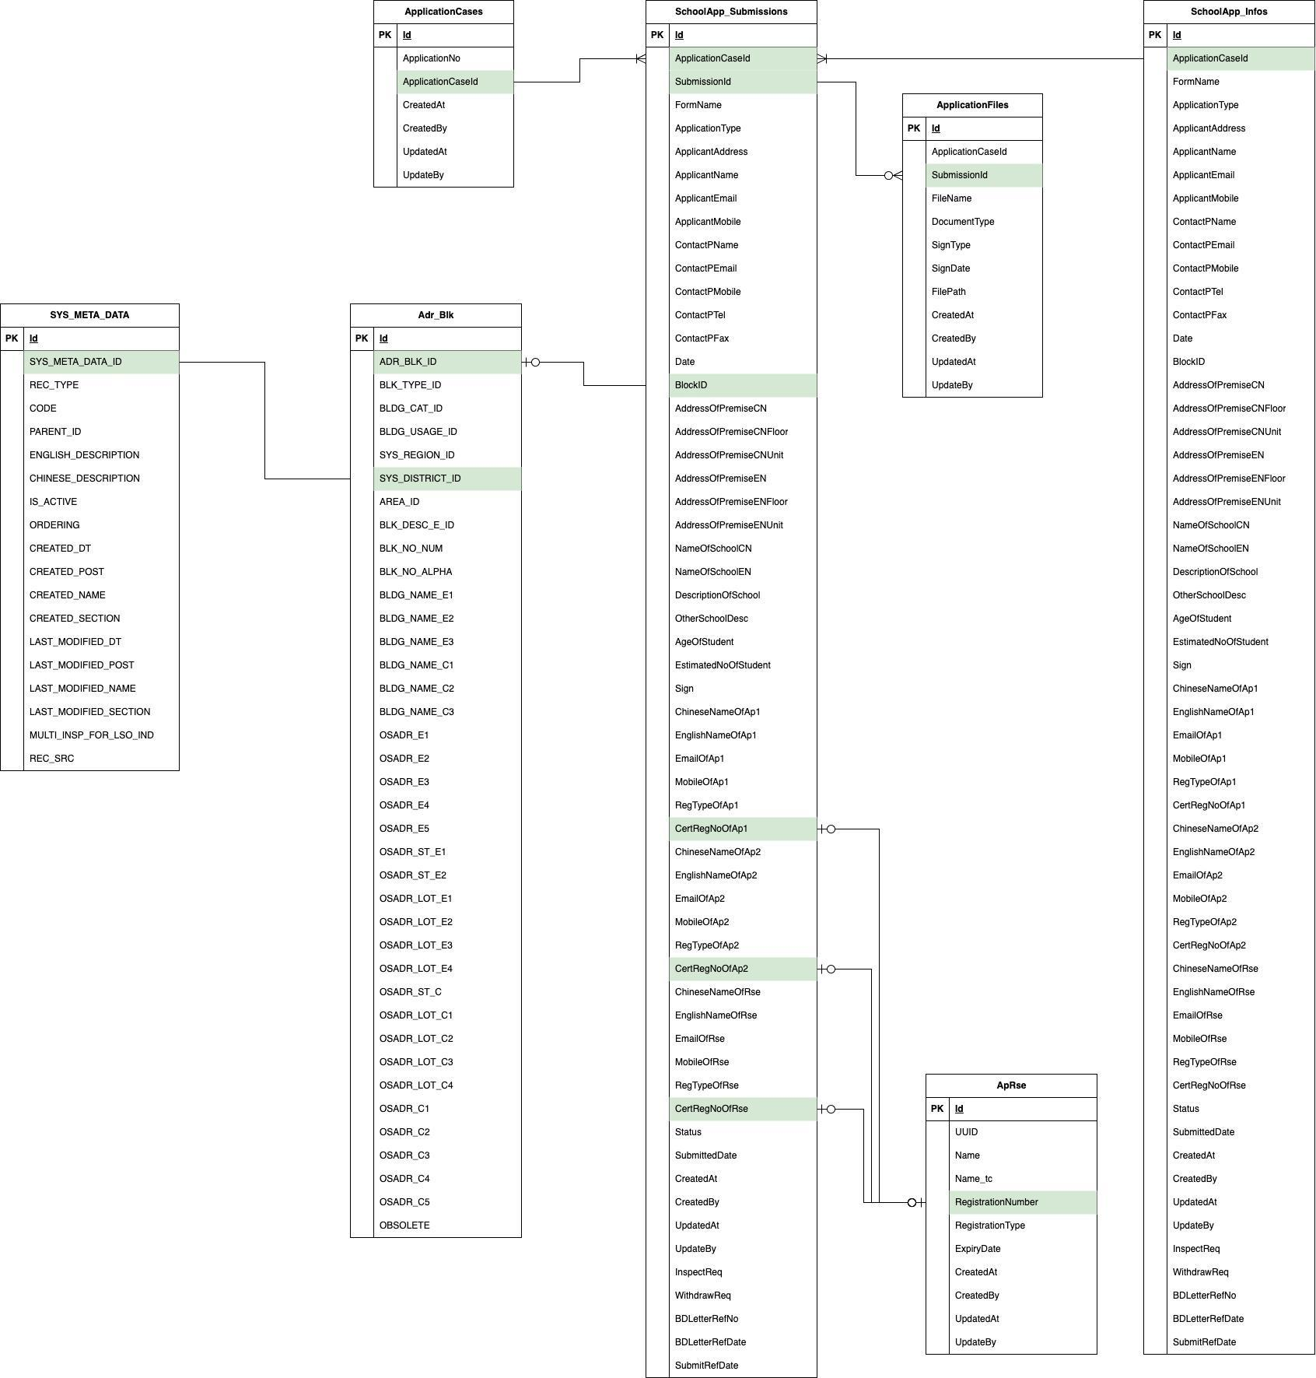

Diagram 3.1-1

### (GCIS) Frontend - OTP login control

Diagram 3.1-2

Pending

### (BD) Backend - TBC

Diagram 3.1-3

Pending

# Data Entity Description

This section states the conversion rules, the assumptions applied for the physical data design, the names of the physical data tables, the corresponding required system entities and key details to be stored into the database.

The database is a physical store of contract related information and textual data inside a database management system (DBMS). For LSCP, Microsoft SQL Server 2019 is selected for the database management system. All the spatial and textual entity will be stored into Microsoft SQL Server 2019.

The following tables document how the Logical Data Model (LDM) can be mapped onto the physical data design.

(RY Note: following table needs to review its correctness)

LSCP Frontend

| Table ID | LSCP Name | LSCP Entity Description | Key Nature | Key Data Item |
| --- | --- | --- | --- | --- |
| T-S-01 | ApplicationCases | Table to store all the application number | PK | Id |
|  | ApplicationNo |
| T-S-02 | SchoolApp_Infos | Table to store the latest update of the submitted application data as 1 row | PK | Id |
|  | ApplicationNo |
| T-S-03 | SchoolApp_Submissions | Table to store the submission of each application | PK | Id |
|  | ApplicationNo |
|  | SubmissionId |
| T-S-04 | ApplicationFiles | Table to store all the path of applicant upload files | PK | Id |
|  | ApplicationNo |
|  | SubmissionId |
| T-S-05 | LSCPMasterTable | Table to store meta-data or parameter data for frontend | PK | Id |
|  | Code |
|  | Type + Code |
| T-S-06 | GenOtp | Table to store generated OTP code and the usage status | PK | Id |
|  | ApplicationNo + userId + Otp |
| T-S-07 | AdrBlk | Table to store addresses that import from BCIS | PK | ADR_BLK_ID |
| T-S-08 | SYS_META_DATA | Table to store meta data that import from BCIS | PK | SYS_META_DATA_ID |
|  | REC_TYPE |
|  | CODE |
| T-S-09 | Aprse | Table to store AP / RSE information that import from MWMS 2.0 | PK | Id |
|  | Name + RegistrationNumber |

LSCP Backend

| Table ID | LSCP Name | LSCP Entity Description | Key Nature | Key Data Item |
| --- | --- | --- | --- | --- |
| T-S-01 | ApplicationCases | Table to store all the application number | PK | Id |
|  | ApplicationNo |
| T-S-02 | SchoolApp_Infos | Table to store the latest update of the submitted application data as 1 row | PK | Id |
|  | ApplicationNo |
| T-S-03 | SchoolApp_Submissions | Table to store the submission of each application | PK | Id |
|  | ApplicationNo |
|  | SubmissionId |
| T-S-04 | ApplicationFiles | Table to store all the path of applicant upload files | PK | Id |
|  | ApplicationNo |
|  | SubmissionId |
| T-S-05 | LSCPMasterTable | Table to store meta-data or parameter data for frontend | PK | Id |
|  | Code |
|  | Type + Code |
| T-S-06 | SYS_META_DATA | Table to store meta data that import from BCIS | PK | SYS_META_DATA_ID |
|  | REC_TYPE |
|  | CODE |
| T-S-07 | SYS_META_DATA | Table to store meta data that import from BCIS | PK | SYS_META_DATA_ID |
|  | REC_TYPE |
|  | CODE |

*** End of document***