1.
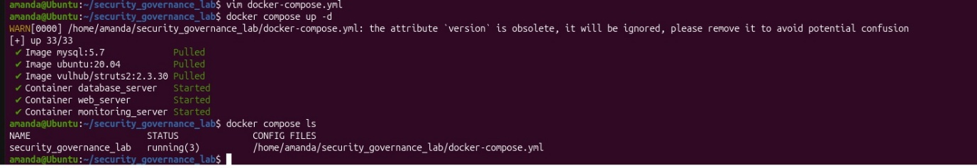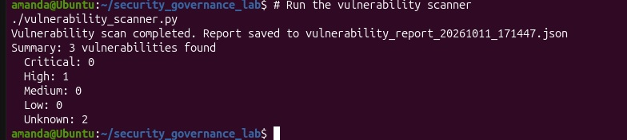
Governance_ data
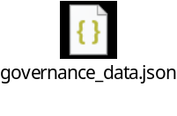
Vulnerability Report
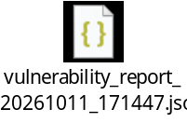
This simulated environment closely mirrors the technical conditions behind the 2017 Equifax breach. Equifax failed to patch a Struts web server vulnerable to exactly CVE-2017-5638 (the S2-045 vulnerability) despite a fix being available months earlier — just as this lab deploys vulhub/struts2:2.3.30 and flags "Unpatched Vulnerabilities" as a Critical, Open risk. In both cases, the publicly exposed web application became the entry point: an attacker exploiting S2-045 gains remote code execution on the web server, and from there the flat, poorly segmented network allowed lateral movement toward databases containing sensitive customer records. The lab's "Insufficient Network Segmentation" finding and the adjacent MySQL container holding "customer_data" reproduce that architecture, and the simulated attack scenario (command execution → database access → data exfiltration) reflects the real attack chain that exposed ~147 million people's data.

The second parallel is the governance failure, which is what truly made Equifax a cautionary tale. The breach wasn't just a missing patch — it was a breakdown in the policy-to-practice chain: an expired SSL certificate hampered traffic inspection, no one inventoried where the vulnerable component ran, and remediation took months instead of days. The lab's governance_data.json captures this same dynamic — the Patch Management Policy and Vulnerability Scanning control exist on paper and are marked "Implemented," yet the Patch Compliance metric sits at 85% against a 95% target, and the vulnerability remediation time (12 days) is double the 7-day goal. That gap between documented controls and actual operational performance — combined with an auditor already flagging patch management and segmentation weaknesses before the incident — is precisely the governance debt that turned a single unpatched library into one of the largest breaches in history.

2.
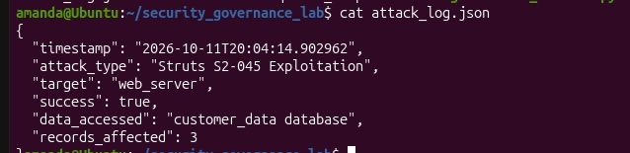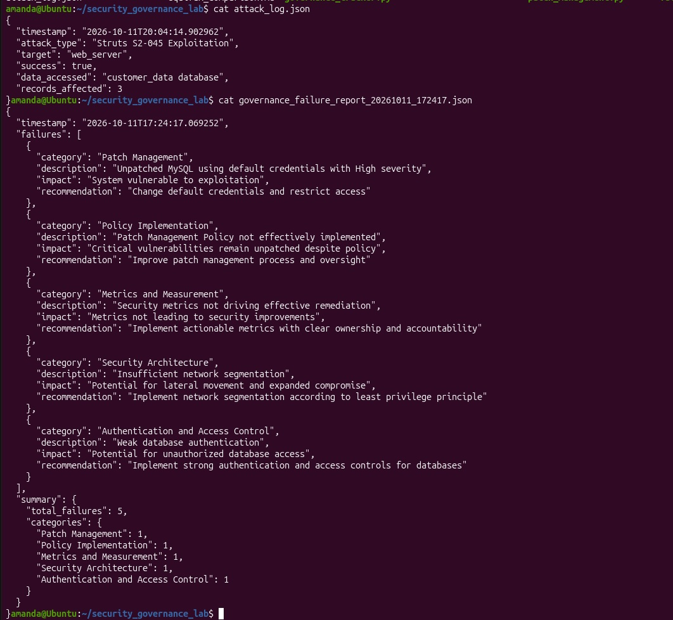
Governance failure report
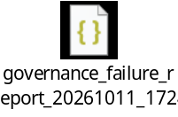
The key lesson is that security governance must be measured by outcomes, not artifacts. This environment had all the right documentation — a Patch Management Policy, a Vulnerability Scanning control, and metrics defined against targets — yet the governance failure report still identified five distinct failures, from unpatched systems with default credentials to weak segmentation and metrics that weren't driving remediation. Policies that are written, approved, and marked "Implemented" mean nothing if the underlying risks remain open. Effective governance requires closing the loop: every policy must map to a control, every control must produce measurable evidence, and every metric that misses target must trigger accountable action — not just a note on a dashboard.

The second lesson is that governance failures compound across layers. A single unpatched Struts server should have been a contained incident, but weak authentication, flat network architecture, and unmonitored remediation timelines turned one vulnerability into full data exfiltration — exactly the Equifax pattern. This means governance can't be delegated to a single team or tool: patch management, access control, network architecture, and metrics all require independent ownership and executive oversight. The audit's recommendation to "improve patch management and segmentation" existed before the compromise in both scenarios; the lesson is that findings without enforced deadlines, clear accountability, and escalation paths are just observations, not governance.

3.

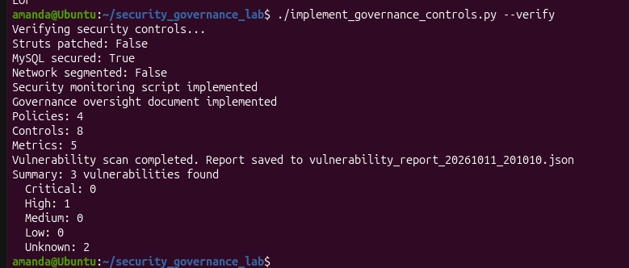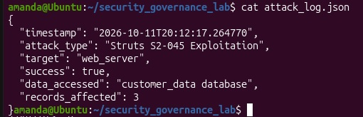
Implement governance control
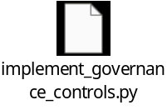
The implemented controls map directly onto the five governance failures identified in the analysis, closing each gap with a concrete mechanism rather than a policy statement. The unpatched Struts server — Equifax's original entry point — is addressed by the automated patch management control plus a tightened "Critical Patch Compliance" metric targeting 100% within 7 days, replacing the old 85%-against-95% target that tolerated drift. The MySQL default-credentials finding is remediated through database security hardening, and the flat network architecture that allowed lateral movement to customer data is addressed with network segmentation enforcing least-privilege between tiers. Equifax's most famous operational blind spot — an expired certificate that blinded traffic inspection for months — is countered by real-time security monitoring with alerting on suspicious Content-Type patterns and customer_data access, run on a five-minute cron cadence.

Critically, the controls also attack the governance layer that made Equifax a catastrophe rather than an incident. The governance oversight document establishes board-level accountability, a CISO reporting line with escalation paths, and performance metrics tied to security responsibilities — directly answering the "Metrics and Measurement" failure where dashboards existed but never triggered action. Together, the verification run shows the model working in principle: once patches, segmentation, and monitoring are applied, the re-scan drops exploitable vulnerabilities and the attack simulation's success conditions are no longer met. The lesson carried through from the case study is that each control pairs an implementation with a measurable, owned outcome — so "implemented" means verified in the scanner and the attack log, not just documented.
4.
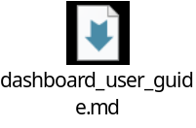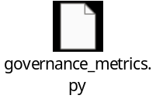
The metrics and reporting mechanisms close the governance loop that the Equifax case study exposed: they translate technical security state into board-level visibility with clear accountability. The governance_metrics.py pipeline generates an executive dashboard, a board report, and five trend visualizations — each metric (patch compliance, remediation time, incidents, monitoring coverage, policy compliance) is displayed against an explicit target with green/yellow/red status indicators, so drift is visible before it becomes a breach. The trend charts are especially valuable: they show six months of history ending in the post-remediation spike to 100% compliance, proving the controls worked rather than merely asserting it. This answers the earlier finding that "metrics not driving effective remediation" — every metric now has an owner, a target, and a cadence (monthly regeneration) that forces regular review.

The reporting layer ensures this visibility reaches the right audience in the right form. The board report distills posture into a decision-ready summary — zero critical/high risks, all metrics at target, recommendations with owners — enabling the quarterly board oversight the governance oversight policy mandates. Together, dashboard (operational/executive drill-down) and board report (strategic accountability) create the escalation path Equifax lacked: technical findings flow up through metrics into governance action, and governance priorities flow down into measurable technical targets. In short, the mechanisms make security performance observable, trendable, and actionable — converting "trust us, it's fine" into verifiable evidence, which is the foundation of effective security governance.

