Course | GRC102 – Information Security Governance
Module | Module 4 – Monitoring and Auditing Security Controls
Name | Amanda Obaje
REG NO: | C11/26/CGRCE/17597

Module 1 System Auditing with auditd
1.1
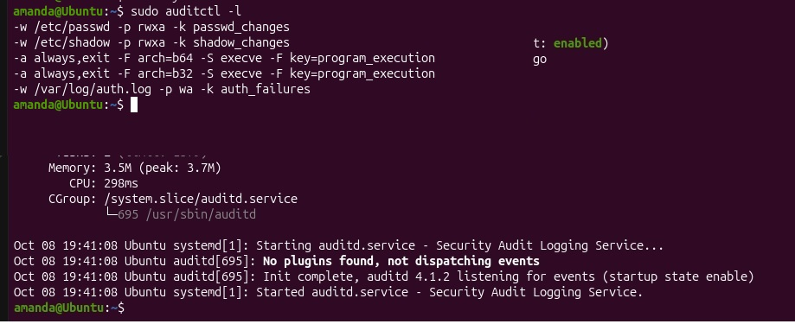

1.2
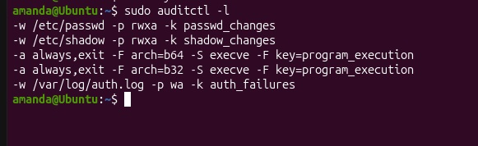

1.3
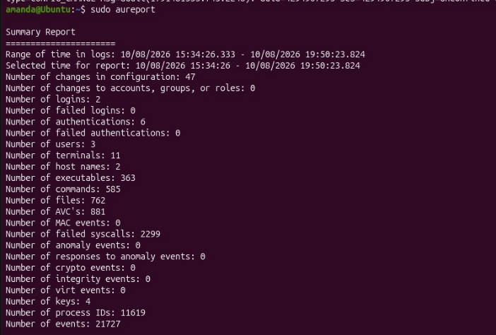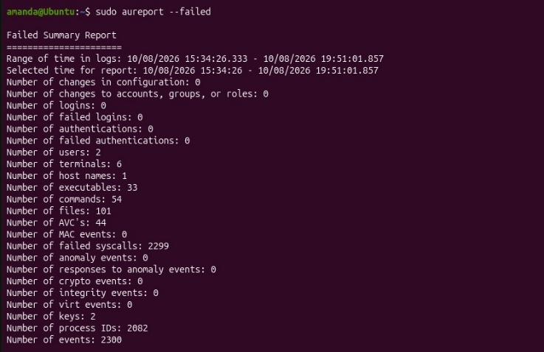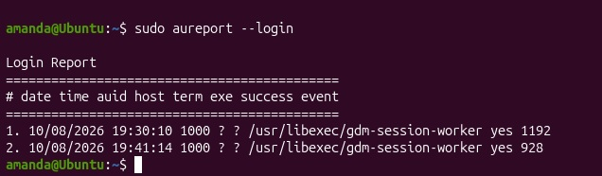
On 8 October 2026 at 19:41:14, the VM recorded a successful login for audit user ID 1000 through gdm-session-worker. Another successful login for the same ID appears at 19:30:10. The screenshots do not show the VM’s time zone or confirm which named account owns ID 1000. These records matter because management can compare access to authorised users and investigate unexpected login times. The summary shows zero failed logins and zero failed authentications in the recorded period; the 2,299 failed syscalls in the separate report should not be described as failed login attempts.

2.1
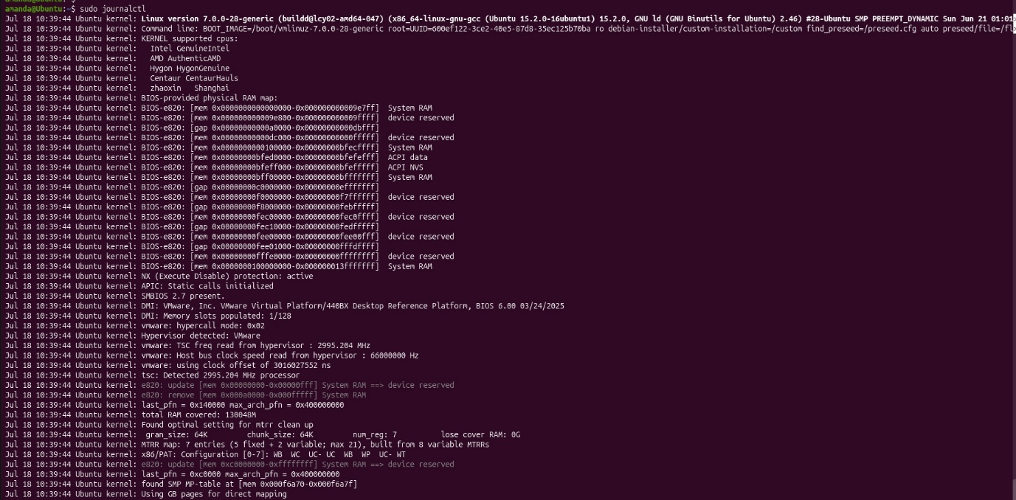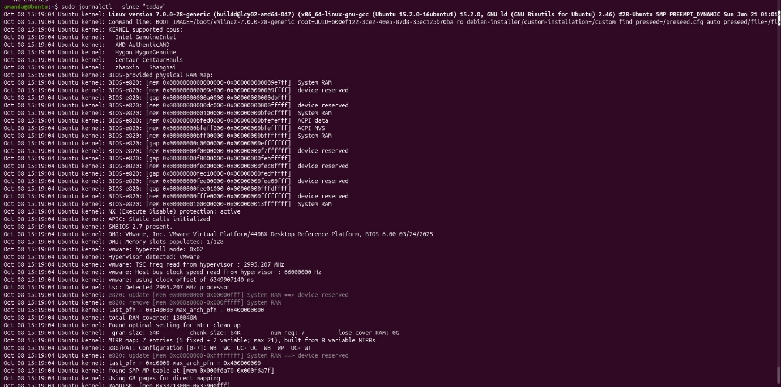
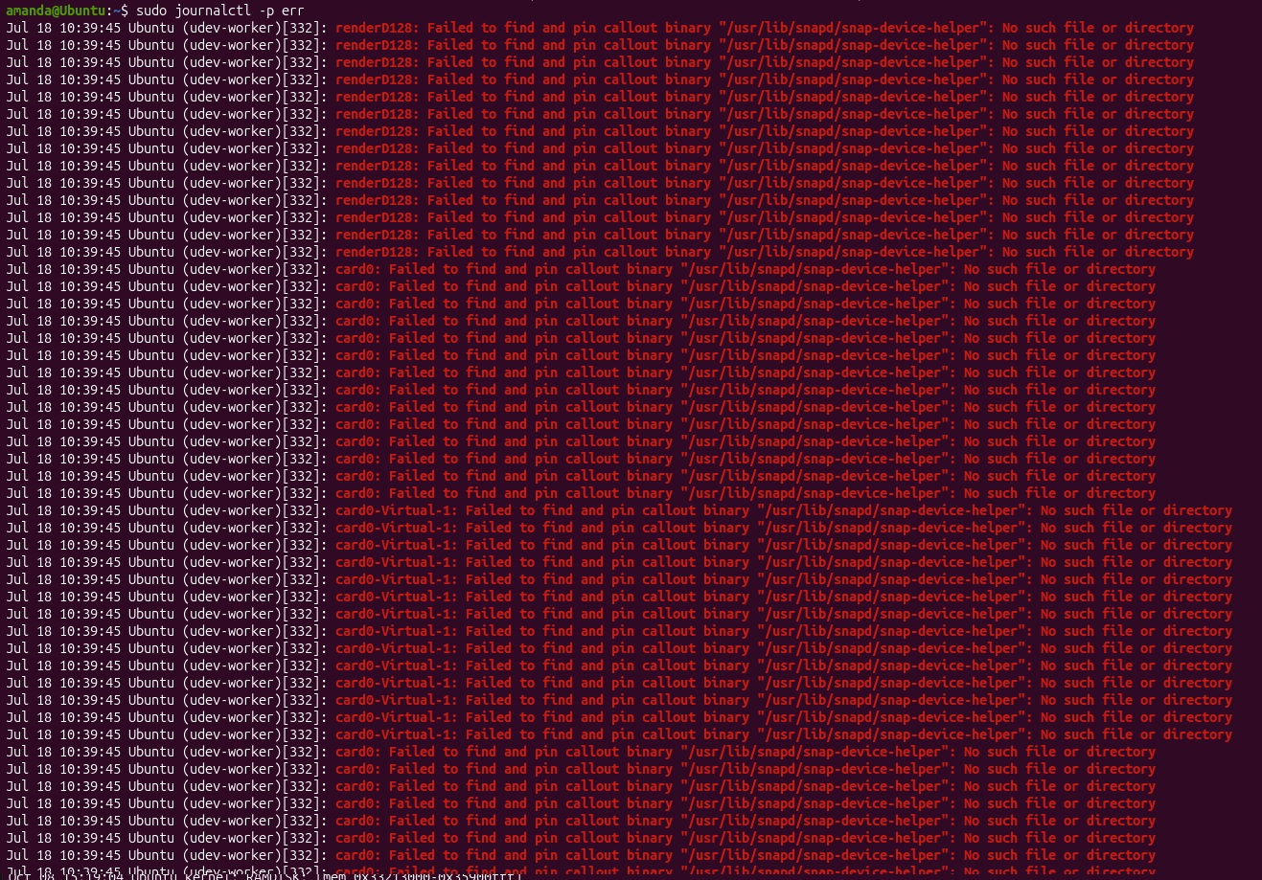

2.3

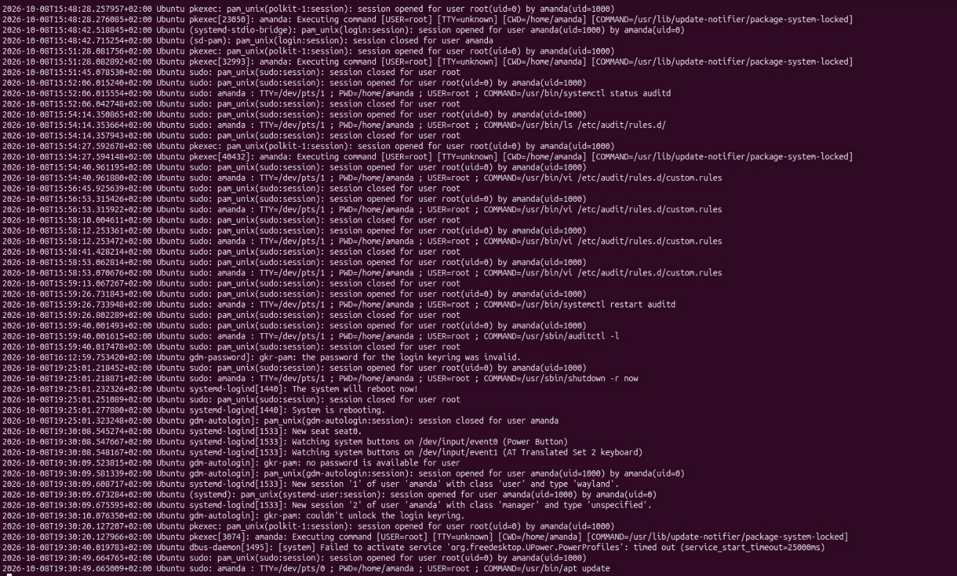

Event/Condition | Evidence Source | Time | User/Service | Security Significance | Recommended Action
Audit rules were edited and auditd was restarted | Authentication log | 8 Oct 2026, about 15:54–15:59 +02:00 | amanda, using sudo | This matches the lab work. Audit changes matter because incorrect rules could leave activity unrecorded. | Keep the change record and confirm the rules loaded with auditctl -l.
An automatic graphical login opened; the login keyring could not unlock | Authentication log | 8 Oct, about 19:30:09–10 +02:00 | amanda; gdm-autologin and gkr-pam | The keyring message is not evidence of a failed system login. Automatic login should be checked against the VM’s access policy. | Confirm whether automatic login is approved for this VM. Investigate the keyring issue separately if needed.
A desktop service activation timed out | Authentication/system log | 8 Oct, 19:30:40 +02:00 | dbus-daemon; org.freedesktop.UPower.PowerProfiles | A service error is visible, but this screenshot does not establish a security incident. | Check whether it recurs or affects a required service.
Repeated device-helper errors appear in older journal entries | Error journal | 18 July, 10:39:45; year and zone not shown | udev-worker | The snap-device-helper file was not found. The screenshot does not show that this is still occurring on 8 October. | Run sudo journalctl -p err --since today before treating it as a current finding.
No actual failed-password message appears in the displayed search | Failed-password search | 8 Oct, 20:02 and 20:13 +02:00 | amanda running sudo grep | The two matches are log entries recording the grep command itself, not failed login attempts. | Report “no failed-password entry observed in this search,” limited to the log and period checked.

The 02-2.-journalctl-today.jpg also shows routine startup messages from 8 October at 15:19:04; the visible lines do not establish a security issue.

3.1
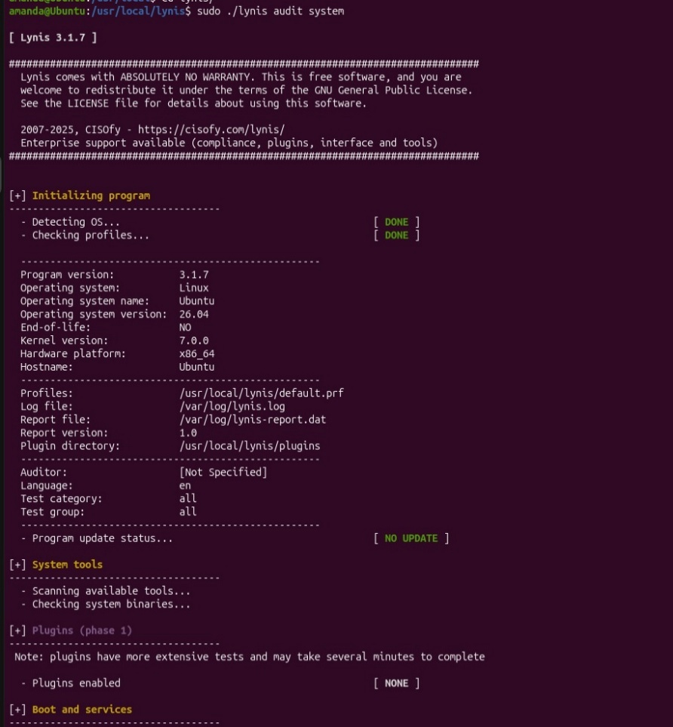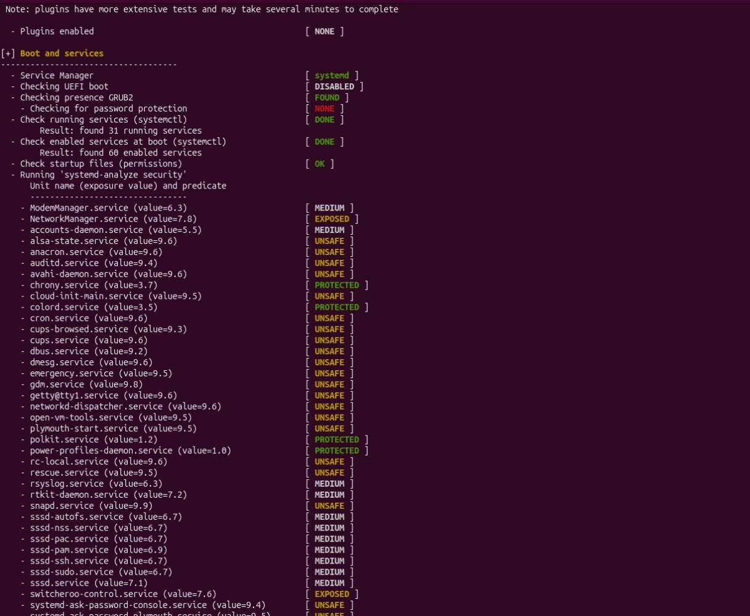
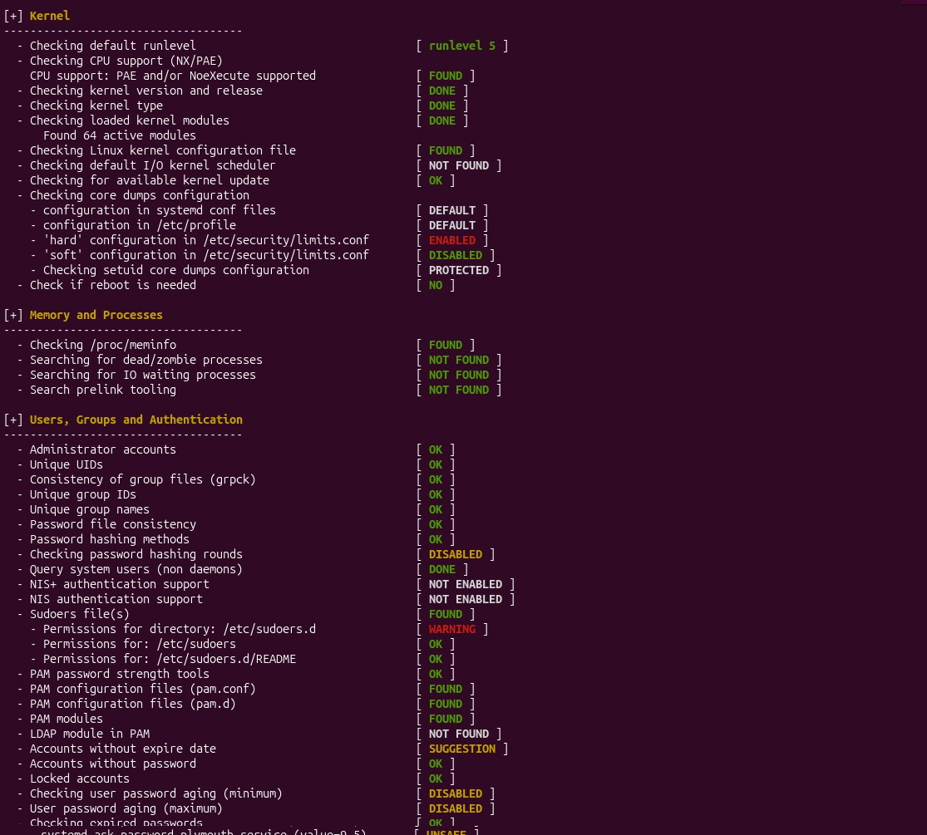

3.3
Item | Details
Lynis recommendation | Accounts without expire date
Risk level | Low
Current state | The selected user account had no expiry date (never).
Improvement implemented | Set an expiry date for the non-service user account using chage.
Command used | sudo chage -E 2027-01-06 student
Verification | sudo chage -l student
Re-test | sudo lynis audit system
Expected result | The account-expiration recommendation should reduced.

