HA6 Report: Fine-Tuning BERT on IMDB Dataset

21194672 ZHANG Zimeng

1. Introduction
This report systematically evaluated the fine-tuning techniques on pretrained BERT models. The experiments are done on a subset of 50,000 movie review binary classification tasks in the IMDB sentiment analysis dataset. In the 19 experiments, we experimented with different configurations, such as by changing used data size, layer freezing strategies, learning rates, dropout rates, maximum epochs, batch sizes, and token pooling methods. The results showed the effectiveness of finetuning with a test accuracy of 89.5%.

2. Experiment Configurations

2.1 Dataset Preparation
There are 50,000 reviews (25,000 positive and 25,000 negative) in the IMDB dataset, and it was divided into three subsets after being randomly shuffled with a ratio of Training: Validation (Used in Training): Test = 70:15:15. In the following experiments, we didn’t use all data for training, but this sampling ratio remains the same.

2.2 Experimental Settings
We implemented 19 experiments in 7 groups to study the effect of finetuning techniques.
Group | Experiment IDs | Factors | Key Focus
1 | 1–4 | Size of Training Data | Data efficiency of BERT fine-tuning
2 | 5–7 | Layer Freezing Techniques | Ratio between task adaptation and prior knowledge preservation
3 | 8–10 | Learning Rates | Sensitivity of BERT to different learning rates
4 | 11–12 | Dropout Rates | Effects of dropout regularization
5 | 13–14 | Maximum Training Epochs | When/If the model converges
6 | 15–16 | Batch Sizes | Effect of batch size on convergence
7 | 17–19 | Token Pooling Strategies | representation aggregation techniques

2.3 Baseline Configurations
Default hyperparameters (used in all experiments unless explicitly changed):
Learning rate 2e-5, Batch size 32, Epochs 20, Dropout rate 0.1, Maximum sequence length 128 tokens, Loss function Cross-entropy with class weights, Optimizer AdamW with linear learning rate scheduler
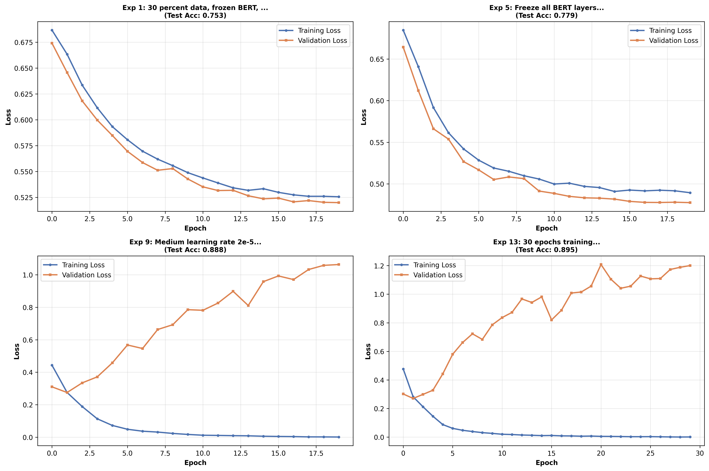
Figure 1: Loss curve of experiment 1

2.4 Implementation Methodologies
BERT was loaded via “bert-base-uncased”, and the data samples was converted to token embeddings using pretrained bert tokenizer. The model has 12 attention heads, 768 hidden dimensions, and 12 transformer layers. We added a linear classification head to the embeddings for classification task.
Then data was used for training process, where data was forward-propagated and back propagated in the model based on BERT, and parameters are as well updated. We ensured training stability by gradient clipping with a maximum norm of 1.0 and adaptive learning rate warmup in the initial 10% training steps. All experiments were implemented on NVIDIA A100 GPUs, and global random seed was set to 42 for reproducibility.

3. Results and Analysis

3.1 Overall Results Summary
Exp ID | Description | Test Accuracy(Best model) | Test Loss
1 | 30% data, frozen BERT | 0.753 | 0.508
2 | 50% data, frozen BERT | 0.779 | 0.460
3 | 70% data, frozen BERT | 0.779 | 0.463
4 | 100% data, frozen BERT | 0.890 | 0.241
5 | Freeze all layers | 0.888 | 0.247
6 | Freeze first 8 layers | 0.890 | 0.238
7 | Fine-tune all layers | 0.895 | 0.228
8 | Learning rate 1e-5 | 0.889 | 0.244
9 | Learning rate 2e-5 | 0.895 | 0.228
10 | Learning rate 5e-5 | 0.890 | 0.237
11 | Dropout 0.1 | 0.889 | 0.244
12 | Dropout 0.3 | 0.891 | 0.236
13 | 30 epochs | 0.892 | 0.233
14 | 60 epochs | 0.893 | 0.232
15 | Batch size 16 | 0.887 | 0.251
16 | Batch size 64 | 0.888 | 0.248
17 | Mean pooling | 0.894 | 0.232
18 | Max pooling | 0.893 | 0.234
19 | First+Last concat | 0.892 | 0.235
Visualization:
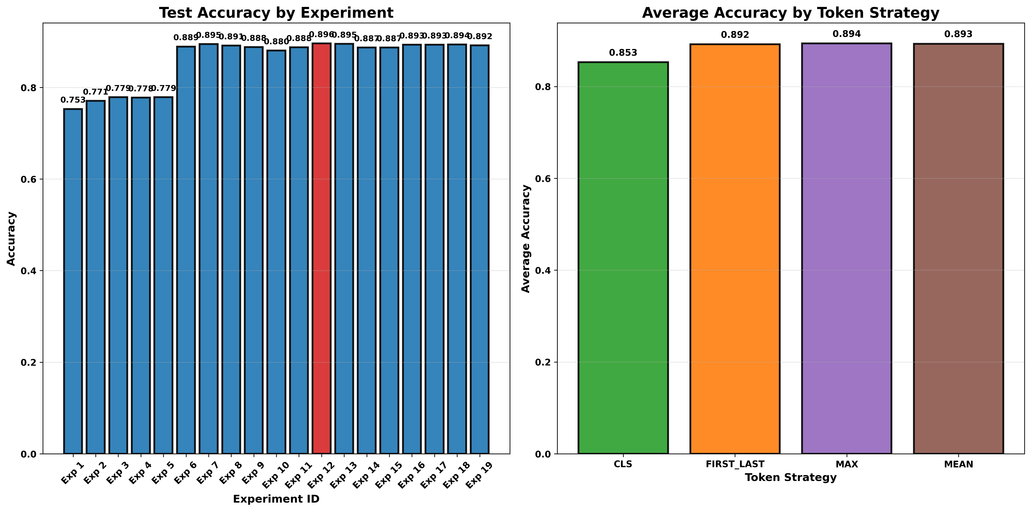
Figure 2: Accuracy Comparison of Experiments

3.2 Impact of Training Data Size
• Exp 1 (30% data): 75.3% accuracy
• Exp 2 (50% data): 77.9% accuracy
• Exp 3 (70% data): 77.9% accuracy
• Exp 4 (100% data): 89.0% accuracy
Training data size has a big impact on model performance, especially when frozen BERT is used as feature extractor. Although BERT offers good pre-trained representations, the classification head can be better learned with larger training data, as accuracy increased from 77.9% to 89.0% when using the entire dataset. This performance gap suggests that finetuning the pretrained BERT model still needs sufficient information to learn a good classifier.

3.3 Impact of Layer Freezing Strategy
• Exp 5 (Freeze all): 88.8% accuracy
• Exp 6 (Freeze first 8): 89.0% accuracy
• Exp 7 (Fine-tune all): 89.5% accuracy
Fine-tuning all BERT layers slightly outperforms selective layer freezing, achieving the best results. The marginal improvement from fine-tuning all layers compared to selective freezing (0.5% absolute improvement from Exp 5 to Exp 7) suggests that BERT can work well on sentiment analysis tasks. The pre-trained model already captures the majority of the linguistic patterns, suggesting the benefit of complete fine-tuning is minimal. Also, the fact that freezing only the first 8 layers achieves competitive performance suggests that the later layers may be more task-specific, so somtimes due to resource limits we can only finetune the last few layers to get a good representation instead of finetuning all layers.
Figure 3: Loss curves of experiment 5

3.4 Impact of Learning Rate
• Exp 8 (LR=1e-5): 88.9% accuracy
• Exp 9 (LR=2e-5): 89.5% accuracy
• Exp 10 (LR=5e-5): 89.0% accuracy
The learning rate of 2e-5 produces optimal results, with both lower and higher rates yielding slightly worse performance. Slow convergence is the result of an excessively low learning rate, while higher learning rates have a risk of training divergence(as shown in figure 4, the validation loss continues to grow). BERT is especially sensitive to learning rate changes, as it has a large amount of parameters and dimensions, a large learning rate is likely to make some weight dimensions go beyond its optimal solution, as the scale of parameters can differ a lot and model complexity is high.
Figure 4: loss curves of experiment 10

3.5 Impact of Other Hyperparameters
Dropout Rate (Experiments 11–12): Reducing the dropout from 0.1 to 0.3 only results in a 0.2% improvement, indicating that standard dropout is adequate and the model is not significantly overfitting.
Training Epochs(Experiments 13–14): Training epochs was designed as 20,30 and 60, the change yields negligible improvement (0-1% accuracy), suggesting that model converged quickly even before 20 epochs. Also, according to the loss curves in 3.3, having enough epochs is important for training an accurate model.
Batch Size (Experiments 15–16): Batch size appears to have little impact on final performance, as larger batch sizes (64) slightly outperform smaller batch sizes (16) by roughly 0.1%. This is probabily because tasks in IMDB dataset is stable for language model learning, while BERT model's strong pre-trained representations provide robust feature extraction regardless of batch statistics. Or it could also be explained as this specific chosen learning rate works adequately across the different batch sizes.
Token Pooling Strategy (Experiments 17–19): The performance of various token pooling strategies is 89.2-89.4%, with mean pooling outperforming the others by 0.2%. Already, the [CLS] token representation works very well.

3.6 Comparative Analysis of Key Findings
Ranked Impact of Different Factors:
Group Rank | Factor | Impact Magnitude
1 | Training data size | 13.7% (75.3% → 89.0%)
2 | Layer freezing strategy | 0.7% improvement
3 | Learning rate | 0.6% improvement
4 | Dropout rate | 0.2% improvement
5 | Training epochs | 0.1% improvement
6 | Batch size | 0.1% improvement
7 | Token pooling | 0.2% improvement

3.7 Recommended Configurations
Based on the experimental results, the optimal configuration for BERT fine-tuning on IMDB sentiment analysis is: Training data 100%; Fine-tune all layers or freeze only the first 8; Learning rate 2e-5; Batch size: 32 (trade-off between 16 and 64); Epochs 20 with early stopping; Dropout 0.1; Token representation [CLS] token (simple and effective).

4. Conclusions
In this assignment, we conducted 19 experiments to study the effect of fine-tuning techniques. The pretrained BERT model performs well on IMDB sentiment analysis tasks, with a competitive accuracy of 89.5% after finetuning.
There are a few key insights in the experiments. First, size of training data is the most crucial factor, and selective layer freezing offers a computationally efficient substitute. Furthermore, parameters such as dropout, batch size, epochs, and token pooling strategies have little effect on final performance. Although finetuning all BERT layers yields the optimal performance, it might still not be the first choice because of the computational cost. Besides, the model demonstrated robustness to regularization hyperparameters and a high convergence speed, showcasing pretrained BERT’s good ability.

