Ha4 Report: Image Classification Using Pre-trained CNNs

21194672 ZHANG Zimeng

1 Introduction

Six pre-trained models for image classification tasks, including AlexNet, VGG16, ResNet50, Inception V3, DenseNet121, and MobileNetV2, are evaluated on ten test images from the ImageNet dataset. By observing the results, we get a clearer look into how model architectures and image constructions might probably influence the prediction performances.

2 Methodology

2.1 Experimental Setup

PyTorch was used to deploy the pre-trained models from torchvision to implement the evaluation framework. To ensure the consistency of reasoning behavior, all models were loaded with ImageNet pre-trained weights and set to evaluation mode, as the "pretrained=True" parameter has been deprecated. The implementation included image preprocessing pipelines suitable for the initial model training configurations, including cropping, resizing, and normalization techniques. The model loading codes are (these two don’t result in difference in classfication resutls, but the results are produced by a more proper way as shown in comments):
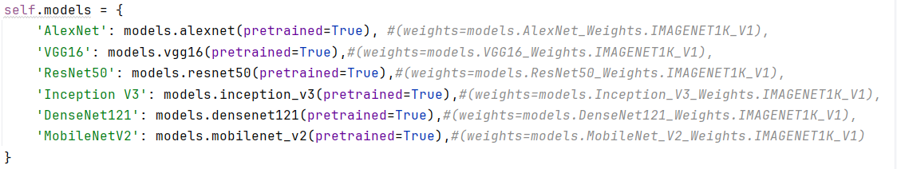

2.2 Data Processing

Ten different test images from a variety of categories was subjected to standardized preprocessing, which included normalization using ImageNet statistics and resizing to the proper dimensions (Inception 299/299 and others 256/224). The results are turned into human-readble contents by a json file, and compared on all 6 models, 60 results in total.

2.3 Metrics of Evaluation

Model performances were assessed by a variety of metrics, including classification accuracy and model agreement rates, with each images’s class prediction probabilities and predicted class saved respectivelt to get a clearer view of the results. Analysis encompassed both qualitative observations and quantitative measurements of error patterns across different model architectures.

3 Results and Analysis

3.1 Comparison of Overall Performance

There were notable variations in models' performances. There were notable variations in models' performances.With the highest accuracy of 0.9, DenseNet121, Inception V3, MobileNetV2, and VGG16 were able to correctly classify nine out of ten images. AlexNet performed the worst with an accuracy of 0.7, while ResNet50 came in second with an accuracy of 0.8.
Table 1: Summary of Model Performances
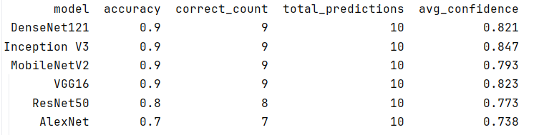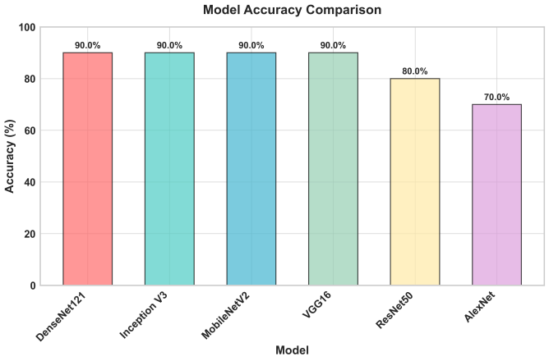
The performance variations can be attributed to the following architectural variations:
1. DenseNet121's and InceptionV3's superior performance is likely due to their efficient feature reuse and multi-scale processing capabilities, respectively. The remarkable performance of MobileNetV2 demonstrates that effective architectures can compete with computationally intensive models while maintaining parameter efficiency, whereas VGG16 was able to maintain strong performance due to its deep, uniform architecture.
2. Despite introducing revolutionary residual connections, ResNet50's performance in this evaluation was surprisingly poorer than that of more recent architectures. This could be because of its relative age and later architectural advancements.
3. With three incorrect classifications for water bottle, golf cart, and desktop computer, respectively, AlexNet had the worst performance. It is evident that AlexNet's capacity to learn intricate hierarchical representations is limited by its comparatively shallow 8-layer architecture and smaller receptive fields in comparison to contemporary networks.

3.2 Confidence Analysis

The analysis of the confidence distribution showed some intriguing trends in the behavior of the model. With an average confidence score of 0.847, Inception V3 outperformed DenseNet121 and VGG16. Interestingly, although confidence did not always perfectly correlate with accuracy, models with higher accuracy tended to maintain higher confidence levels. In difficult situations like the classification of water bottles, some models showed an excessive amount of confidence in inaccurate predictions.
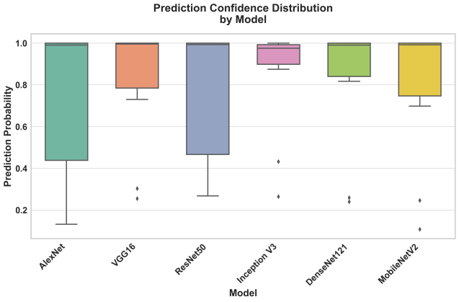
3.3 Image-wise Performance Variability

The performance across different images showed substantial variation, which are shown in the following graph:
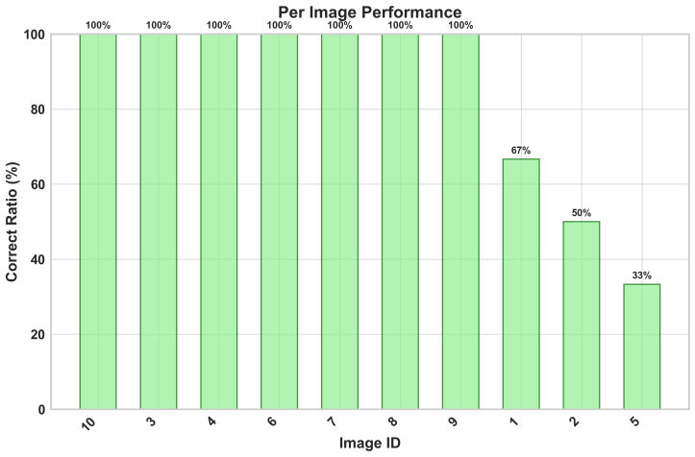
From the results, we can see that 7 images such as carousel, zebra, school bus, pillow, and fireboat achieved perfect classification across all models, indicating these categories are well-learned and easy to distinguish. While golf cart (Image 1), water bottle (Image 2), and desktop computer (Image 5) had classification challenges, with an correct calssification accuracy of 2/3, 1/2, and 1/3 respectively, revealing limitations in some of the models, which we will analyse later.

Figure: Misclassified images with their predicted probabilities
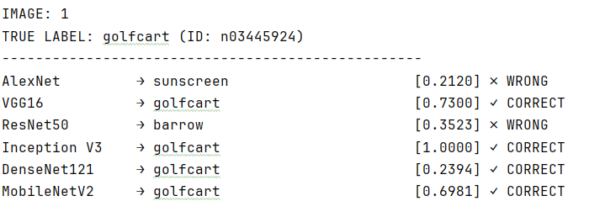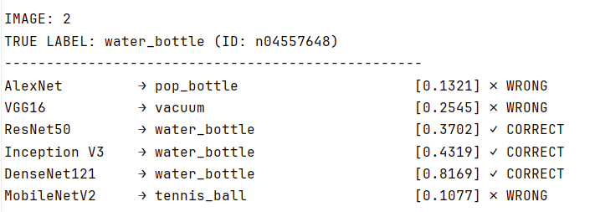
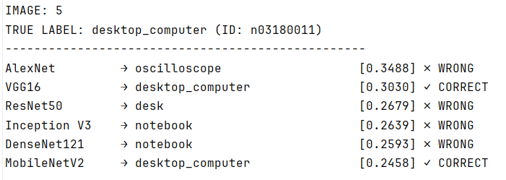

The details for misclassification are as follows:
Image 1 (golfcart): This image was misclassfied by AlexNet and ResNet50 as "sunscreen" and "barrow" respectively, indicating that these models’ weakess in recognizing vehicles under particular situations.
Image 2 (water_bottle): This image has a classification accuracy of 50%, with 3 models’ predictions wrong, showcasing its difficulty. AlexNet mistook it for "pop_bottle," VGG16 for "vacuum," and MobileNetV2 for "tennis_ball," demonstrating sensitivity to contextual features and shape similarities.
Image 5(desktop_computer): This image is the most challenging case, with only VGG16 and MobileNetV2 able to classify it into the true “desktop_computer” class. Other models mistakenly identified it as an "oscilloscope," "desk," or "notebook." This is likely due to the background selection, with a notebook nearby and a desk beneath the computer. Despite the age of this desktop computer, it could still be mistaken for an oscilloscope.
A closer look at the image reveals reasonable results, consistent with the potential failure scenarios highlighted in the image pattern. However, the error pattern suggests that the model struggles to make subtle distinctions between similar object categories, objects with different contextual appearances, and categories with significant intra-class variation. By observing the correctly classifed images, we can find that in most of those images, all 6 models performed well with a pretty high confidence(probability score), only for image 3 “library”, models like AlexNet and ResNet50 are not giving a high confidence, showing their weaknesses in image classification.

Figure: Correctly classified images and their predicted probabilities
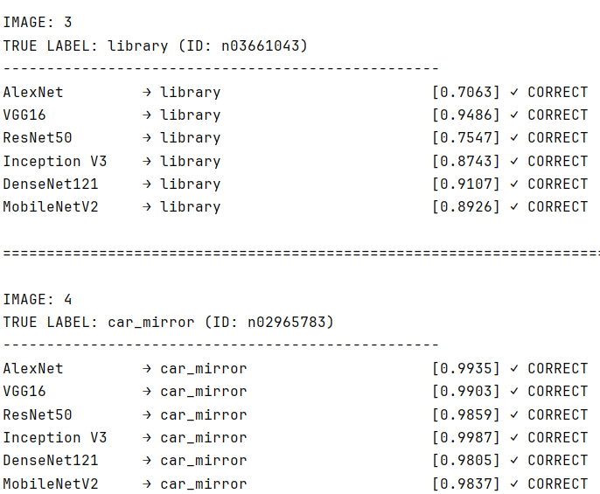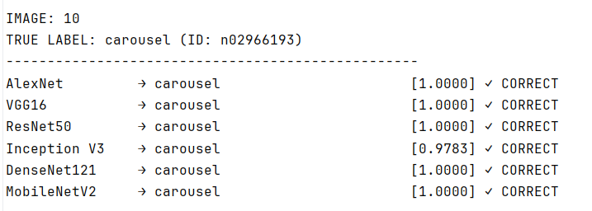
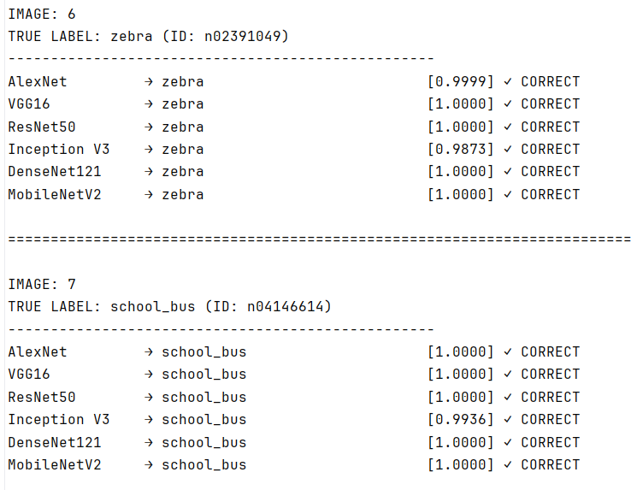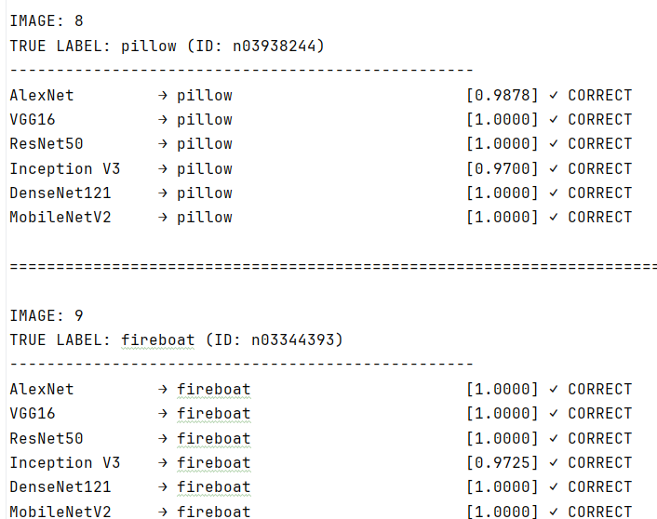
3.5 Between Model Analysis
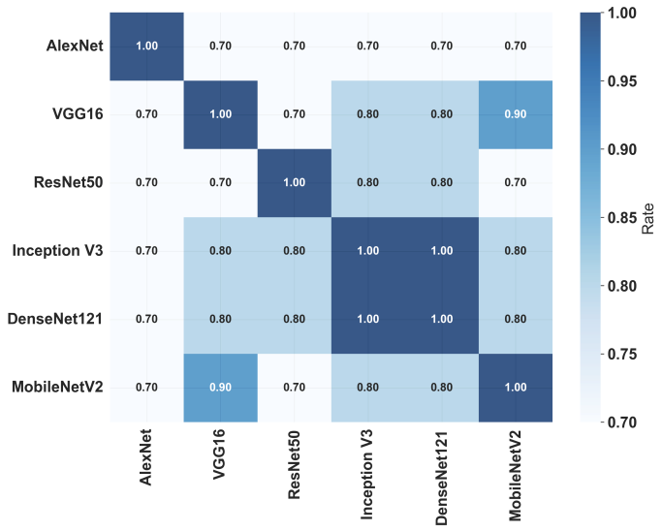
From this figure, we can see that the consistency between DenseNet121 and InceptionV3 is 1.0, indicating that they make exactly the same class predictions on the provided test set. VGG and MobileNetV2 achieve the second-highest consistency score of 0.9.

4 Conclusions and Future Work

In this assignment, we evaluated 10 test images labeled with name strings from another folder, which served as ground truth. By evaluating six different models on a test image set, we explored the importance of model choice and discussed possible reasons behind the results related to model architecture. The results show that architectural improvements to DenseNet121 and InceptionV3 significantly outperform previous model designs; however, some object categories remain difficult to recognize across various architectures, suggesting the need for further development. We also visualized the results to provide a clearer understanding of performance. Future work could expand testing to larger datasets or use fine-tuning to improve model performance. It could also test recent models such as ViT to see if they provide better results.

