CYB333 Final Project Report — Password Strength Analyzer
Student: Emmanuel Sanchez Salazar
Course: CYB333 Security Automation
National University
Filename: CYB_333_Project_SanchezSalazar.docx
GitHub repository (public): https://github.com/Mane48/cyb333-password-strength-analyzer

Introduction
The main goal of this project was to automate checking password quality instead of just guessing if something looks strong. Weak passwords still get people into trouble with guessing, spraying, and credential stuffing, so I wanted a small Python tool that scores them the same way every time. I picked Password Strength Analyzer off the course project list because it felt doable in the time we had and still connected to security automation.
What the tool does is take a password and score it based on length, character types (lower, upper, digits, symbols), a rough entropy estimate, whether it shows up in a common password list, and weak patterns like repeats, sequences, keyboard walks, and years like 2024. Then it gives you a score out of 100, a rating from Very Weak to Very Strong, a checklist, the issues it found, and suggestions. You can run it interactive with --prompt, pass one password, batch a file, or export JSON. Thats basically the project in a sentence: make password review repeatable and documented on GitHub so someone else can actually run it.

Development Process
For planning I kept the scope pretty tight on purpose. I didnt want a giant UI that I wouldnt finish. Proposal first, then a working MVP, then the mid week update, then demos and this final report. That order helped because if I got stuck I still had something submitted along the way.
Design wise I split the code up instead of dumping everything in one file. analyzer.py does the scoring and has an AnalysisResult dataclass so printing and JSON use the same shape. patterns.py is where the weak pattern checks live. cli.py is argparse, getpass, and formatting. The common password list is just a text file under wordlists/. I stuck to the standard library for runtime so setup isnt annoying for grading.
Implementation was mostly iterative. Score goes up for length, classes, entropy, and passphrase style structure, then gets dinged for common list hits and patterns, then clamped 0–100 into rating bands. I used git, pytest, and tried to keep naming readable / PEP 8-ish. Samples under samples/ are fake demo passwords so Im not putting real secrets in the repo. Nothing fancy for methodology, just small modules, clear checks, and a README that tells you how to run it without me explaining it live.

Use of AI Tools
I used Cursor a lot for scaffolding and docs, and I already had VS Code with Copilot style stuff from the week one environment setup. AI helped with module layouts, argparse wiring, README chunks, pytest ideas, and the Word draft files for Navigate. It didnt replace me actually running the tool or checking if the scoring made sense.
Prompts I used were like:
- Create a Python CLI password strength analyzer with batch mode, JSON export, a common-password list, and unit tests.
- Add heuristics for keyboard walks, repeated characters, sequences, and year-like suffixes; return issues and suggestions.
- Draft a CYB333 final project report outline matching the Navigate sections and filename CYB_333_Project_LastName.docx.
- Generate pytest cases for very weak common passwords, year suffixes, and a strong random-looking password.
Value wise it saved time and stopped me from forgetting dumb checklist stuff like README sections and filename format. Limits though: AI can sound generic, invent thresholds that dont match the code, or write reflections your not supposed to let it write. I didnt just copy the output. I tested localy, ran pytest, and rewrote the personal parts in my own words. Demo screenshots of the tool running are under Demonstration Evidence below.

Project Challenges
One challenge was making the scoring meaningful without overbuilding. If I only checked length it would feel too thin for this project, but a full cracking pipeline was way to much for the timeline. So I mixed simple heuristics, a common list, and suggestions that explain why something is weak instead of only printing a number.
Another one was safe demos. Putting passwords on the command line can leak through shell history if your not careful. I documented --prompt as the better option, kept sample passwords synthetic, and added a masked preview that only shows first and last character.
Also just time. Between labs, midterm stuff, and work, its easy to leave docs for last. Breaking it into proposal / update / final helped. Getting the repo public earlier was good too so I wasnt scrambling on GitHub access at the end.
Honestly the scoring challenge taught me the most. I kept wanting to add more features then realized a clean CLI with honest checks and tests is more useful for this class then a half finished UI. That kinda matches what CYB333 is about, packaging judgment into something repeatable.

Reflection on Learning
This project changed how I think about security automation a bit. Before I mostly pictured big SOAR playbooks or enterprise tools. This was smaller, but it still forced the same habits: define checks clearly, return structured output, document how somebody else runs it, and prove it with tests. Thats closer to real defensive scripting then I expected.
On the Python side I got more comfortable splitting code into modules instead of one long script. The dataclass for AnalysisResult made JSON export pretty easy, and pytest caught dumb mistakes early like rating bands that didnt match the score clamp. I also practiced safer CLI habits with getpass and keeping secrets out of git.
It also connected to credential attacks we talked about in class. When the analyzer flags qwerty walks, years, or common list hits, its pointing at the same shortcuts attackers try first. Seeing weak samples score near zero and a longer random password land in Very Strong made that more concrete. Week one env setup and the week three Jupyter stuff helped too, by the end VS Code / GitHub felt less like homework and more like just the workbench.
If Im being real the biggest improvement wasnt some fancy algorithm. It was finishing a public repo another person can clone and run from the README without me sitting next to them. That feels like the actual bar for this class. If I did this again I would capture screenshots the same day a feature works instead of waiting till submission week.

Time Management
Total time was around 28–32 hours across the term. Rough breakdown: planning/proposal about 4 hours, coding and cleanup about 12–14, testing and demos about 5, README/update/final report about 7–8.
What worked was front loading the MVP so the mid week update wasnt empty, then doing shorter night sessions for docs instead of waiting for one long free day that never shows up when I have work. What didnt work as well was leaving screenshot and report polish too close to other deadlines. Next time Im grabbing demo evidence earlier.

Demonstration Evidence
Repo is public at the GitHub link on the title page. Screenshots below are from successful local runs on Windows after making a venv and installing requirements. Commands I used:
- python main.py --file samples/passwords.txt --reveal-preview
- python main.py --file samples/passwords.txt --json -o samples/demo_report.json
- pytest -q
Figure 1. Batch analysis with masked previews (synthetic sample passwords).
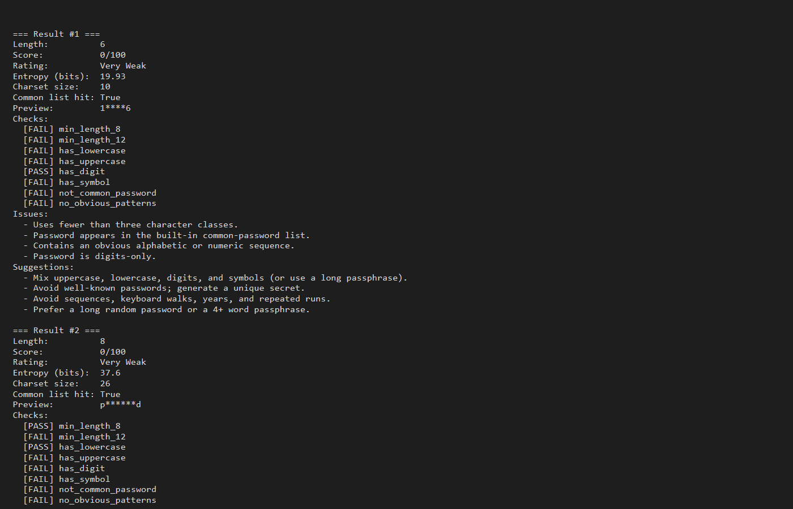
Figure 2. pytest suite result (6 passed).
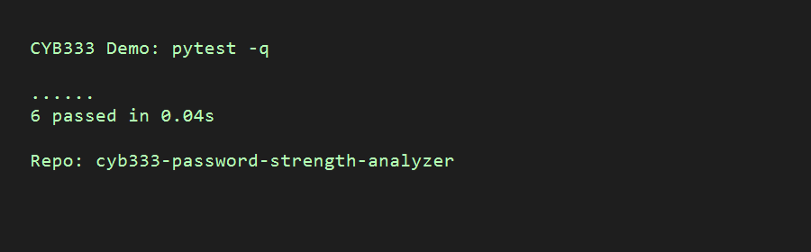
Figure 3. Excerpt of the JSON report output.
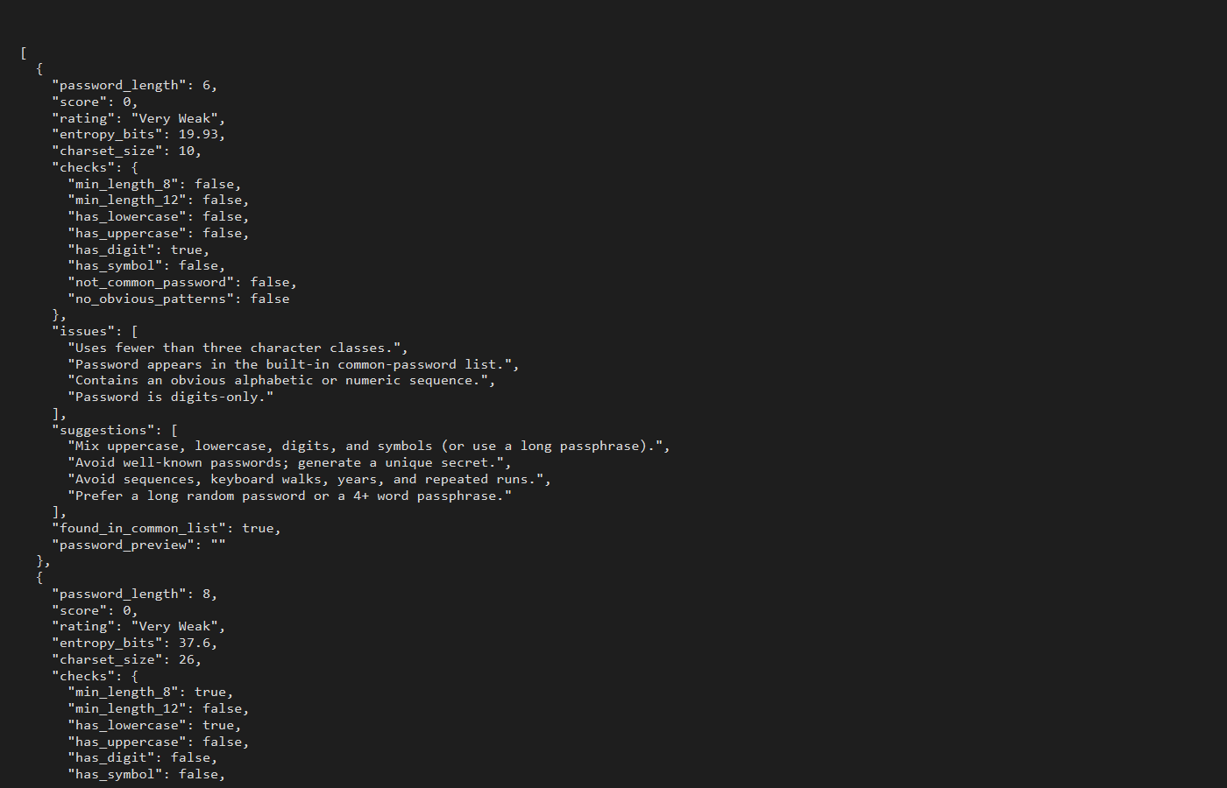
Behavior matched what I expected. Common/weak samples come out Very Weak, year style mixed passwords score lower then stronger random ones, and the better samples hit Strong / Very Strong with suggestions when theres still something off.

Team Collaboration
Not applicable, I did this project individually.

Conclusion
Overall the Password Strength Analyzer is a documented, testable automation utility that scores passwords, explains weaknesses, and exports results. I have a public GitHub repo, README setup steps, unit tests, sample inputs, and this report lined up with the course rubric areas.
If I kept going later I might add Have I Been Pwned range checks, a simple HTML summary, or a CI check that fails on weak demo credentials. I left that out on purpose so what I turned in stays reliable and easy to grade. For now it matches what I said in the proposal: a practical security automation script that makes password quality measurable instead of just vibes.

Appendix — Submission Checklist
- GitHub URL public: https://github.com/Mane48/cyb333-password-strength-analyzer
- README covers objectives, setup, usage, layout, tests, security notes, AI disclosure
- Code split into modules with comments / meaningful names; pytest present
- Report filename CYB_333_Project_SanchezSalazar.docx
- Demo screenshots included (batch run, pytest, JSON)
- AI usage described with example prompts; personal reflection in my own wording
[Approximate word count including captions/lists: 1436]

