The relationship between athletic participation and long-term health outcomes has remained a subject of enduring scientific interest. While physical activity is widely recognized as a key contributor to improved cardiovascular function, psychological well-being, and reduced mortality risk, recent research suggests that not all sports confer these benefits to the same degree. Emerging evidence indicates that the physiological demands, injury profiles, and structural characteristics of different sports may influence how athletic engagement interacts with aging and longevity.
A growing number of comparative studies have revealed substantial disparities in lifespan across sporting disciplines, particularly between sports involving frequent physical contact and those characterized by minimal bodily impact. High-contact sports—such as football, martial arts, and combat-oriented disciplines—are increasingly associated with elevated risks of chronic traumatic encephalopathy (CTE), cardiovascular complications, and metabolic disorders. Conversely, non-contact sports including swimming, running, and racket sports appear to yield more favorable long-term health outcomes, likely due to lower injury burdens and sustained aerobic conditioning. Despite these trends, existing evidence remains fragmented, with no large-scale, data-driven investigation directly comparing lifespan between contact and non-contact athletes across a broad range of disciplines.
This gap in the literature underscores the need for a systematic and empirical assessment of whether physical contact level within a sport serves as a meaningful determinant of athlete longevity. To address this, the present study employs a structured exploratory data analysis (EDA) using lifespan records of 27,333 professional athletes sourced from Wikidata. By categorizing sports into contact and non-contact groups and analyzing differences in average lifespan, distributional patterns, and statistical significance, this research aims to evaluate whether participation in high-contact sports is associated with reduced longevity relative to low- or non-contact sports. The study further explores sport-specific patterns and examines whether career duration moderates the relationship between sport type and lifespan.
Through this comprehensive analytical framework, the study seeks to advance understanding of how the intrinsic characteristics of sports shape long-term health outcomes, offering new insights for athletes, policymakers, and health practitioners concerned with risk management and lifespan optimization in athletic populations.

A Data-Driven Approach to Understanding Longevity Across Different Types of Sports

I. Introduction
The relationship between sports participation and human longevity has long attracted scientific and societal attention. Regular physical activity is widely recognized for its ability to reduce mortality risk, enhance cardiovascular health, and improve overall quality of life. Athletes, in particular, represent a unique population for examining the long-term effects of intensive training and competitive performance on lifespan.
However, not all sports influence the human body in the same way. Variations in physical contact, energy expenditure, and injury exposure can lead to different long-term health outcomes across disciplines. Understanding how these diverse forms of athletic engagement affect longevity is essential for evaluating both the benefits and potential costs of high-level sports participation.

II. Literature review
Understanding the relationship between athletic participation and longevity has attracted increasing academic attention. The multifactorial nature of this relationship demands an integrative approach that examines various types of sports, physiological metrics, and sociodemographic variables. Across several empirical and meta-analytic studies, diverse patterns emerge concerning how sport engagement, athletic intensity, and career characteristics shape life expectancy.
One key domain of inquiry centers on comparative lifespan analyses across sports disciplines. Altulea et al. (2025) conducted a comprehensive observational study involving over 95,000 athletes from 183 countries, finding that male athletes lived on average 3.1 years longer than the general population, with pole vaulting and gymnastics offering particularly pronounced benefits. In contrast, participation in sports such as sumo and martial arts was associated with significantly lower longevity. Interestingly, female athletes generally showed shorter lifespans, except in low-impact sports like golf and racket games, where gains of 2–3 years were observed (Altulea et al., 2025). Complementing these findings, Lystad and Vedantam’s study of Australian athletes indicated that Olympians enjoyed a 3.4-year longevity advantage, while rugby players had reduced life expectancy, underscoring how contact intensity likely mediates health risks (Lystad and Vedantam, 2025).
The influence of sport modality - especially the contrast between endurance, strength, and skill-based sports - emerges as another pivotal factor. A systematic meta-analysis encompassing 2.6 million adults found that running, cycling, and swimming significantly reduced mortality risk, particularly from cardiovascular diseases. Running, for instance, lowered all-cause mortality by 23%, whereas strength-centric sports like handball had more limited impacts (Oja et al., 2024). These conclusions are reinforced by a large-scale National Health and Nutrition Examination Survey (NHANES) investigation showing that jogging or running at least 75 minutes per week was associated with telomere lengths indicating biological youthfulness equivalent to 12 years younger than non-runners (Blackmon et al., 2023). Collectively, these results highlight that endurance sports provide more pronounced anti-aging benefits compared to power-based disciplines.
Psychological and environmental variables are increasingly recognized in longevity research. Noseworthy et al.'s systematic review comparing indoor and outdoor exercise concluded that all statistically significant outcomes favored outdoor activities, which promoted better mood, motivation, and physical functioning (Noseworthy et al., 2023). Similarly, Bielec et al. reported that regular long-term swim training among Master swimmers prevented age-related muscular degradation, with no significant decline in body composition even across the disruptive COVID-19 pandemic (Bielec et al., 2023). These studies illustrate the sustaining effects of regular physical activity and the amplifying role of natural environments.
A more nuanced approach to longevity prediction considers not just sport type but also individual career trajectories. Newman’s analysis of elite baseball and basketball athletes found that those who reached peak performance later and experienced slower declines in ability lived longer, even when controlling for confounders like body mass index (BMI) and birth season. This suggests that intrinsic physiological and performance profiles can act as biomarkers of biological resilience and slower aging (Newman, 2023).Reinforcing this personalized view, Warren and Rumore’s analysis of American football players found that linemen had shorter lifespans compared to non-playing peers, with head trauma and cardiovascular complications posited as contributing factors (Warren and Rumore, 2023).
Beyond athletic engagement itself, broader lifestyle contexts play a crucial role. A meta-analysis of over five million participants distinguished between leisure-time physical activity (LTPA) and occupational physical activity (OPA), revealing that only LTPA significantly reduced cardiovascular disease risk. The optimal effect was found with 3.5–5 hours of moderate weekly activity, whereas OPA showed negligible or even adverse effects on atrial fibrillation risk (Kazemi et al., 2024). This reinforces the importance of intentional, recreational sport over physically demanding labor in supporting long-term health.
Finally, the relationship between athletic achievement and longevity adds another layer of complexity. A large-scale analysis of Olympic athletes revealed that medalists tended to live shorter lives than non-medalists, with the effect most pronounced in individual and power-based sports. Skill-oriented disciplines like shooting and equestrian sports were associated with the highest longevity, likely due to lower physical stress and injury risks. These findings imply that extreme performance pressure and intense competition might incur post-career health costs, possibly through psychosocial stress or maladaptive coping mechanisms (Kovbasiuk et al., 2025).
Taken together, the existing body of research points toward a noteworthy trend: sports that involve frequent physical impact, bodily collisions, or high mechanical strain are often associated with lower average lifespans or increased long-term health risks. Conversely, disciplines that emphasize endurance, technical skill, or minimal contact appear to offer more favorable longevity outcomes.
This emerging pattern raises an important question that has yet to be systematically explored - does the physical contact level inherent to a sport play a determinative role in shaping athlete longevity? Motivated by this observation, the present study seeks to empirically examine whether athletes in high-contact sports indeed experience shorter lifespans compared to those in low- or non-contact sports, using large-scale data and structured analytical methods. This inquiry not only builds upon prior findings but also offers a novel framework for evaluating health disparities in athletic populations.

III. Main discussion
To examine the divergence mentioned above more rigorously, a structured exploratory data analysis (EDA) was conducted using lifespan data sourced from Wikidata After processing, the dataset consisted of 27,333 professional athletes, each with verified birth and death information, spanning a wide range of sports disciplines and competitive levels. This rich dataset enabled a comparative investigation between those who participated in contact sports and those involved in non-contact sports, thereby providing a robust empirical foundation for evaluating the long-term health consequences associated with each category.
In this study, “contact sports” are operationally defined as sports involving frequent physical collisions, bodily contact, or sustained physical engagement. This category includes both team-based and combat-oriented sports such as:
“soccer (football)”, “ice hockey”, “Australian rules football”, “judo”, “karate”, “Muay Thai”, “wrestling”, and “mixed martial arts”.
By contrast, “non-contact sports” are those that minimize direct physical confrontation and include disciplines such as:
“swimming”, “cycling”, “athletics”, “golf”, “badminton”, “table tennis”, “gymnastics”, and “tennis”.

1. Overall Longevity Comparison
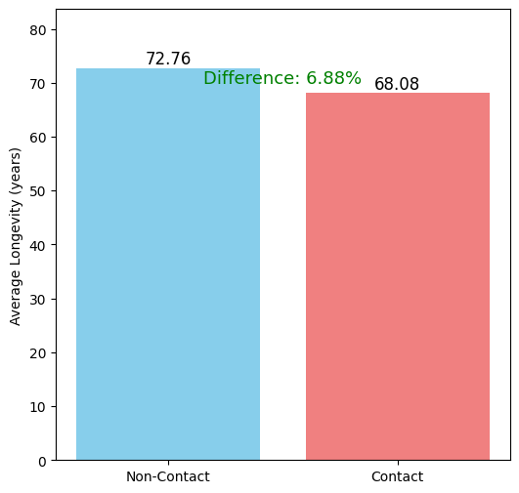
The results of the EDA revealed a statistically significant disparity in life expectancy between the two groups. On average, athletes who engaged in non-contact sports outlived their contact-sport counterparts by 6.88%. Specifically, the data showed that athletes in non-contact disciplines had an average lifespan of 72.76 years, compared to 68.08 years among athletes in contact sports. While this difference might seem modest in relative terms, it becomes profoundly meaningful when extrapolated across national or global athlete populations and further contextualized within other health-related variables, such as career duration, injury history, and post-retirement lifestyle.
Figure 1: Average Lifespan Comparison between Contact and Non-contact Sports

Figure 1.1 visually captures the average lifespan difference between the two groups, emphasizing the measurable impact of sport type on longevity. This 6.88% gap is more than a statistical analyst reflects the systematic health advantages of non-contact sports.
To gain deeper insight into the distributional characteristics of longevity in each group, a density analysis was conducted. The resulting plot is shown in Chart 2.
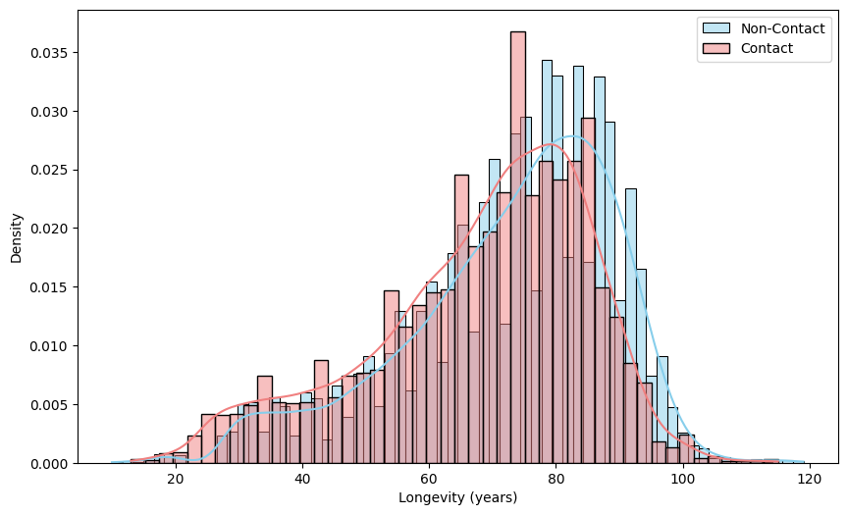
Figure 2: Comparison of Longevity Distribution: Non-Contact vs Contact

An examination of the two density curves in the figure 2 reveals that the red line (Contact) and the blue line (Non-contact) intersect at around 80 years of age.
For individuals whose lifespan falls below 80, the Contact curve displays a higher density, implying that participants in contact sports are more prevalent within the group with shorter life expectancy.
Conversely, for those living beyond 80 years, the Non-contact curve rises above, indicating that engagement in non-contact sports is associated with a higher likelihood of extended longevity.

2. Longevity by Sport
To build upon the previous findings, a more detailed exploration of lifespan distribution by sport was conducted using a boxplot visualization that excluded outliers to better capture the central tendencies of each discipline (Figure 3).
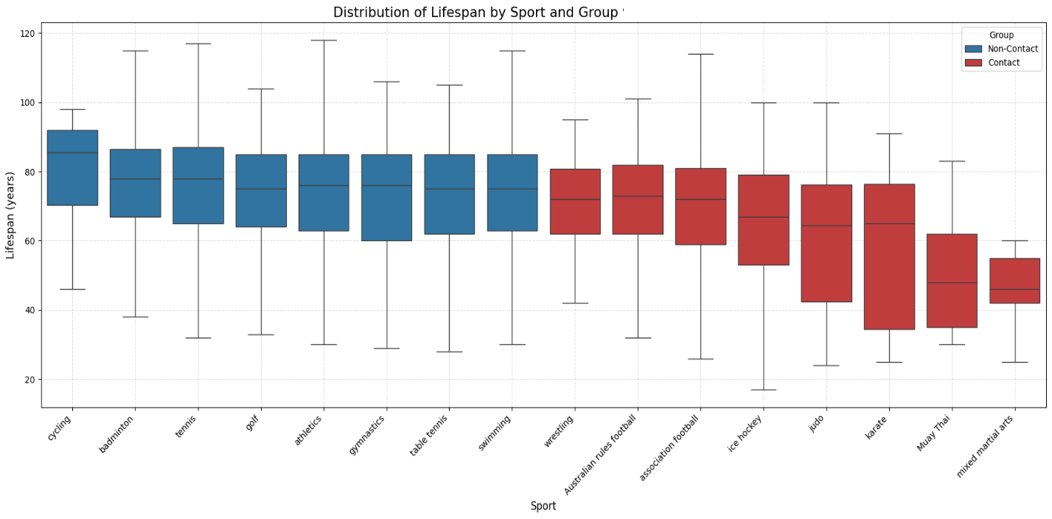
Figure 3: Distribution of Lifespan by Sport and Group

The results reveal a striking and highly consistent directional trend. Across all disciplines analyzed, athletes participating in non-contact sports - cycling, badminton, tennis, golf, athletics, gymnastics, table tennis, and swimming - demonstrated superior longevity outcomes compared with those in contact sports. Median lifespans in several of these disciplines, particularly cycling and tennis, extended well into the eighth decade of life, accompanied by narrow interquartile ranges, suggesting both durability and predictability in lifespan distribution. Conversely, contact sports such as Muay Thai, mixed martial arts, karate, and judo exhibited markedly lower median lifespans - some below 60 years - and substantially wider interquartile ranges, indicating not only shorter average lifespans but also greater heterogeneity in survival outcomes.
This discipline-specific pattern provides compelling evidence that physical contact intensity constitutes a meaningful determinant of life expectancy in athletes. Notably, no contact sport in the dataset outperformed any non-contact discipline in terms of lifespan distribution - a degree of consistency unlikely to arise from stochastic variation alone. Although caution is warranted for sports with limited sample sizes (e.g., Muay Thai, n = 9; karate, n = 19; cycling, n = 18), the overarching pattern is strongly validated in high-volume datasets such as athletics (n = 10,644), football/soccer (n = 6,759), and swimming (n = 2,669). Collectively, these findings substantiate the inference that reduced exposure to physical impact is associated with both extended and more stable lifespan trajectories, underscoring the potential long-term biological costs of sustained contact in competitive sports.

3. Statistical Significance
To further strengthen the observed disparity in lifespan between the two groups of sports, an independent-samples t-test was conducted using scipy.stats library. The goal was to determine whether the difference in average lifespan between non-contact and contact sport athletes is statistically significant. The test was performed at a significant level of α = 0.05.
The results of this analysis are presented in Table 1 below:
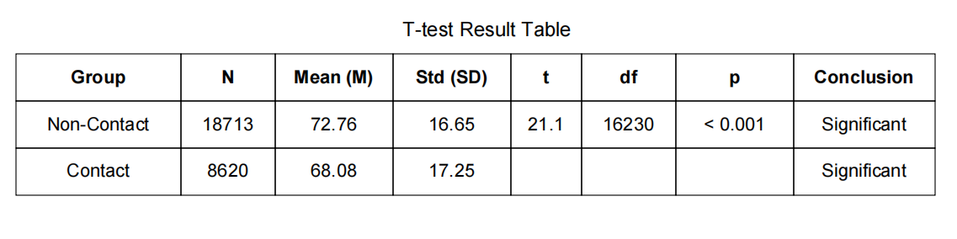
As shown in the table, non-contact athletes had an average lifespan of 72.76 years, significantly higher than the 68.08 years observed among contact-sport athletes. With a t-statistic of 21.1 and a p-value less than 0.001 (approximately 1.46 × 10⁻⁹⁷), the results strongly reject the null hypothesis and confirm that the difference is statistically significant.
Therefore, the variation in average lifespan cannot be attributed to random sampling errors. Rather, it provides compelling empirical evidence that physical contact in sport is more than a descriptive feature - it is a meaningful biological risk factor that may contribute to long-term health disadvantages for contact-sport athletes.

4. The Impact of Career Duration
In addition to these differences, it is evident that non-contact sports are generally easier to play and suitable for a wider range of age groups, allowing athletes to maintain participation over a longer period of time. Consequently, the study also investigates whether the longer lifespan observed among non-contact athletes may be attributed to their extended playing careers. Using data from approximately 600 athletes whose career durations could be accurately estimated, a scatter plot with a linear regression line was constructed employing two distinct loss functions - Mean Squared Error (MSE) and Mean Absolute Error (MAE) (Figures 4, 5) - to separately examine the trends for contact and non-contact sports.

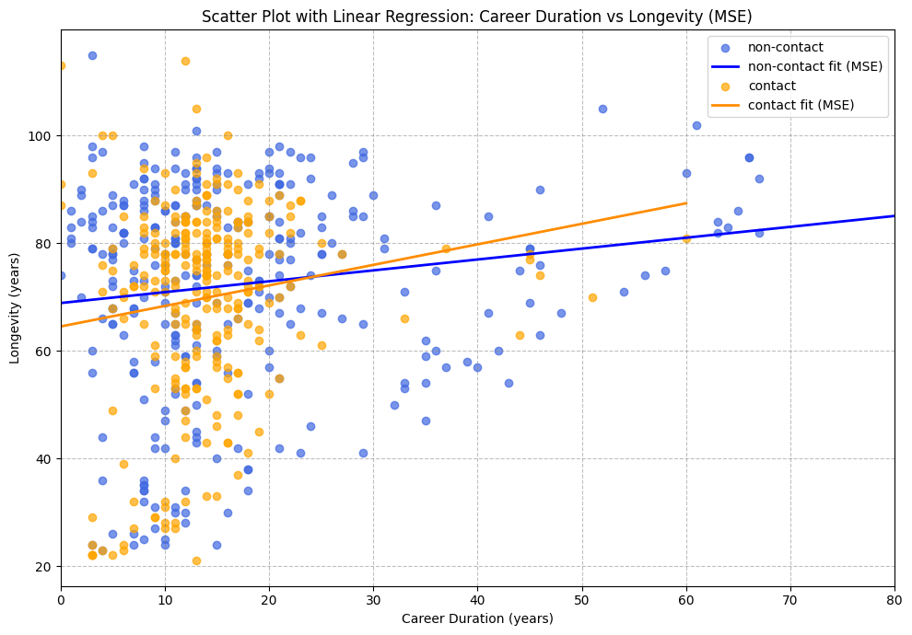
Figure 4: Scatter Plot with Linear Regression – Career Duration vs Longevity (MSE)

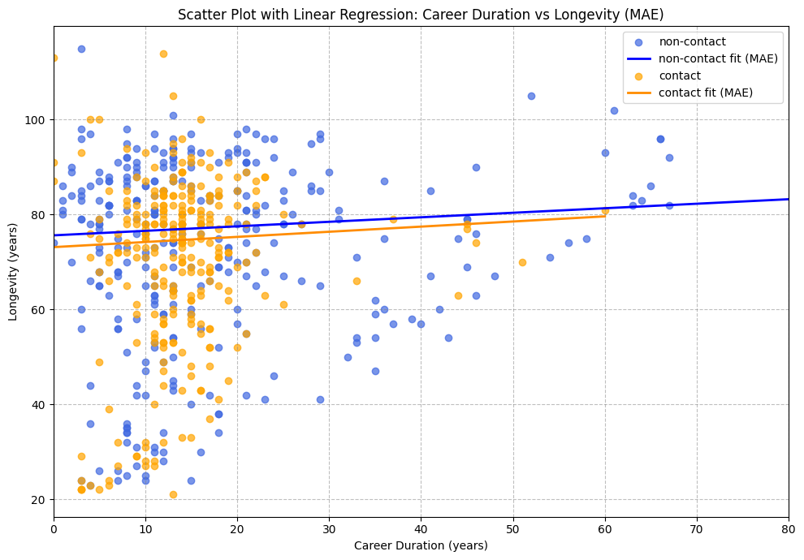
Figure 5: Scatter Plot with Linear Regression – Career Duration vs Longevity (MAE)

In both figures, the differences in distribution and correlation between the two groups of sports appear negligible. The slight upward trend observed in the plots is attributable to age dependence, as an athlete’s career length cannot exceed their lifespan. Therefore, the claim that "athletes in non-contact sports live longer due to a longer career duration" is not supported by the data.

5. Geographic and Socioeconomic Factors
A possible explanation for the lower lifespan observed among contact-sport athletes is that they may predominantly come from countries with lower average life expectancy. To examine this, two world maps were generated using geographic data from Wikidata and visualized through the geopy library in Python.
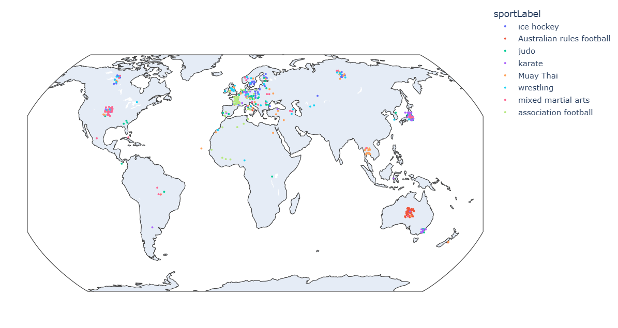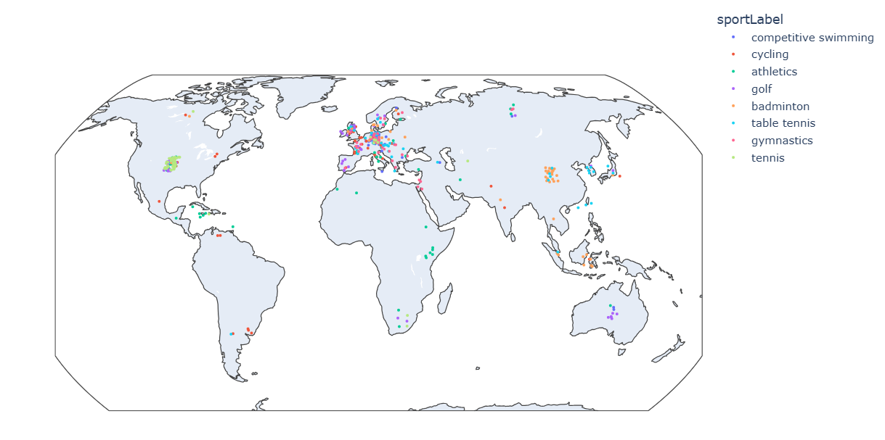
As shown in the maps below, athletes from both groups are distributed across all continents, with no substantial geographical differences in their representation.
To further clarify, the average life expectancy of the general population in each athlete’s country of origin (sourced from Wikidata) was used to estimate the expected lifespan if these individuals were ordinary citizens not engaged in sports.
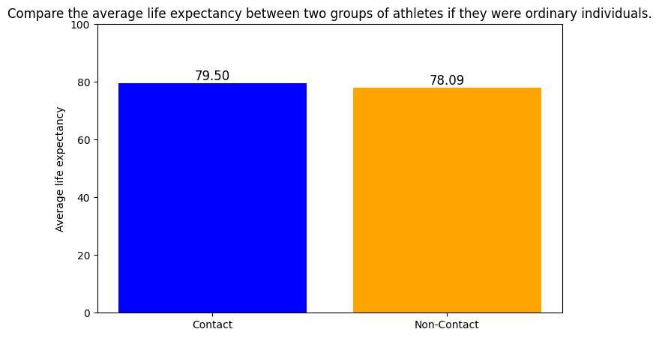
The resulting comparison shows that, under this assumption, contact-sport athletes would actually have a 1.41-year higher average lifespan than non-contact athletes. Therefore, the hypothesis that “the shorter lifespan of contact-sport athletes is due to their coming from countries with lower life expectancy” is not supported.

IV. Conclusion
This study provides clear evidence that the level of physical contact in sports is closely associated with athlete longevity. Non-contact disciplines consistently show longer average lifespans and more stable survival patterns than contact sports. Additional analyses confirm that this disparity cannot be explained by factors such as career duration or national life expectancy. Instead, the findings highlight the long-term biological and health costs of sustained physical impact. Overall, the study underscores the importance of sport-specific physical demands in shaping long-term health outcomes and contributes to a broader understanding of how athletic participation influences human longevity.

V. References
Altulea, A., Rutten, M.G.S., Verdijk, L.B., Demaria, M., 2025. Sport and longevity: an observational study of international athletes. GeroScience 47, 1397–1409. https://doi.org/10.1007/s11357-024-01307-9
Bielec, G., Goździejewska, A., Langhammer, B., Borysławski, K., 2023. Body Composition of Master Swimmers before and after the COVID-19 Pandemic: A Longitudinal Study. Journal of Clinical Medicine 12, 6992. https://doi.org/10.3390/jcm12226992
Blackmon, C.M., Tucker, L.A., Bailey, B.W., Davidson, L.E., 2023. Time Spent Jogging/Running and Biological Aging in 4458 U.S. Adults: An NHANES Investigation. International Journal of Environmental Research and Public Health 20, 6872. https://doi.org/10.3390/ijerph20196872
Kazemi, A., Soltani, S., Aune, D., Hosseini, E., Mokhtari, Z., Hassanzadeh, Z., Jayedi, A., Pitanga, F., Akhlaghi, M., 2024. Leisure-time and occupational physical activity and risk of cardiovascular disease incidence: a systematic-review and dose-response meta-analysis of prospective cohort studies. International Journal of Behavioral Nutrition and Physical Activity 21, 45. https://doi.org/10.1186/s12966-024-01593-8
Kovbasiuk, A., Ciechanowski, L., Jemielniak, D., 2025. A taste of ambrosia: Do Olympic medalists live longer than Olympic losers? Scand J Public Health 53, 8–14. https://doi.org/10.1177/14034948231219833
Lystad, R.P., Vedantam, S., n.d. Survival and longevity among male Australian elite athletes: A retrospective cohort study.
Newman, S.J., 2023. Early-life physical performance predicts the aging and death of elite athletes. Science Advances 9, eadf1294. https://doi.org/10.1126/sciadv.adf1294
Noseworthy, M., Peddie, L., Buckler, E.J., Park, F., Pham, M., Pratt, S., Singh, A., Puterman, E., Liu-Ambrose, T., 2023. The Effects of Outdoor versus Indoor Exercise on Psychological Health, Physical Health, and Physical Activity Behaviour: A Systematic Review of Longitudinal Trials. International Journal of Environmental Research and Public Health 20, 1669. https://doi.org/10.3390/ijerph20031669
Oja, P., Memon, A.R., Titze, S., Jurakic, D., Chen, S.-T., Shrestha, N., Em, S., Matolic, T., Vasankari, T., Heinonen, A., Grgic, J., Koski, P., Kokko, S., Kelly, P., Foster, C., Podnar, H., Pedisic, Z., 2024. Health Benefits of Different Sports: a Systematic Review and Meta-Analysis of Longitudinal and Intervention Studies Including 2.6 Million Adult Participants. Sports Medicine - Open 10, 1–17. https://doi.org/10.1186/s40798-024-00692-x
Warren, J.R., Rumore, G., 2023. The association between playing professional American football and longevity. Proceedings of the National Academy of Sciences 120, e2308867120. https://doi.org/10.1073/pnas.2308867120

