Nume: Manea

Prenume: Emil

E-mail: [Manea.Em.Emil@student.utcluj.ro](mailto:Manea.Em.Emil@student.utcluj.ro)

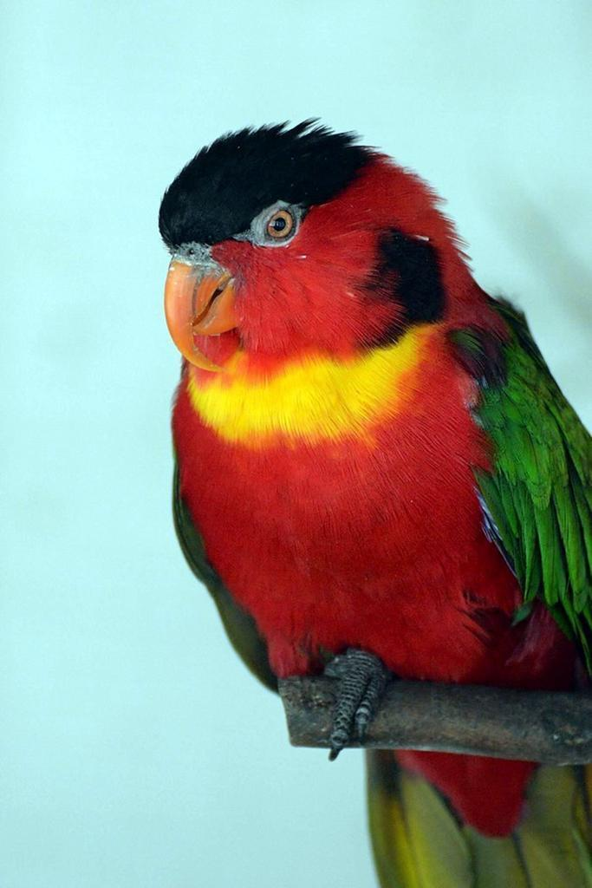

Sa obtin informatii despre diverse limbaje de programare

Discipline:

* Optoelectronica (Anul III) <https://el.el.obs.utcluj.ro/site/2021_2022/tst/PDF/TST32.00.pdf>
* Surse de alimentare (Anul III) <https://el.el.obs.utcluj.ro/site/2021_2022/tst/PDF/TST101.00.pdf>
* Grafica asistata de calculator (Anul II) <https://el.el.obs.utcluj.ro/site/2021_2022/tst/PDF/TST15.00.pdf>

<https://etti.utcluj.ro/files/Acasa/Site/planuri-invatamant/PI_TST.pdf>

Hobby-uri:

* Programare
* Muzica
* Jocurile video