**Methods-**

It is block of statements are used to perform the task called as methods.

**Why?**

Writing methods avoid the rewriting same code again and again. Suppose you have block of statements in your program that will calculate sum of two numbers and perform some operation on it. But at later, you want to calculate the sum and average in another program at that time, you need to write the same code again.

So it will increase your efforts and time also. If you define one method and write the sum of number logic into it, if you want to calculate same in another program, you can do it by just calling the method. So it will help you to avoid the same code again and again. That’s why methods comes into picture.

**Note**- Writing all codes into one method that is not good programmer practice.

**Syntax**- [Specifiers] return_type method_name (arg 1,arg 2)

{

Statement 1

Statement 2

--------------

Statement n

}

**Note**- Method arguments is an optional thing.

**Example-**

There are two types of methods as

* **Static method**
* **Non-Static method**

1. Static methods-

* When you define method in class with using static keyword called as static method.
* We can call this method by 3 ways.

First way is by using class name.

Example.test ();

Second way is by creating object of class.

Example example= new Example ();

example.test ();

In same program, we can call it test();

**Example**

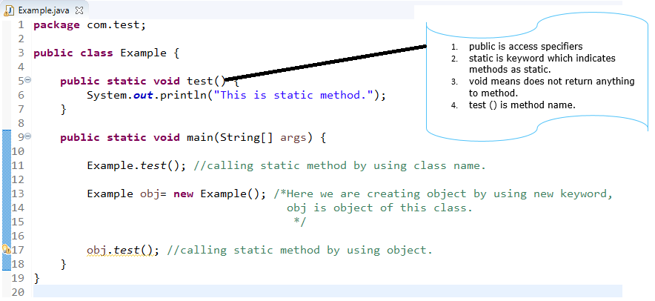

**Output**

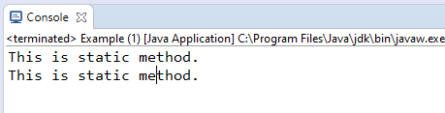

2. Non-Static methods-

* When you define method in class without using static keyword called as non-static method.
* We can call this method by creating object of class only.

Example example= new Example ();

example.test ();

**Example-**

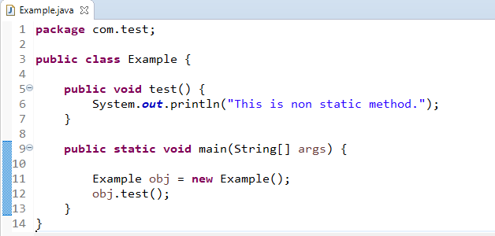

**Output**

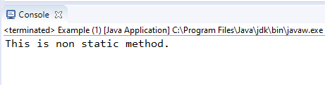

**Rules-**

* Method name in camel case only.
* E.g. if you method name is addemployee() then as per java coding standards, it should be like addEmployee(). It means always starts with lower case letter.
* Method name should be some meaningful name, so developer can easily identify it what are the operation are performed in that methods.
* Method is always enclosed within curly brackets {  }.

Program for design method as getStudentName() which return the student name.

**public** **class** Test {

// Design method which return student name

String getStudentName(String name) { // ram is store into name

**return** name; //return name to method

}

**public** **static** **void** main(String[] args) {

Test test = **new** Test();

String s = test.getStudentName("ram"); // calling of method

System.***out***.println("student name>>" + s);

}

}

Output

student name>>ram