User introduction for AFEIO pipeline

1. Main
   1. Installation

Open the file *Main.m* in folder *AFEIO* with MATLAB and run it. In order to open the images usually acquired as bio formats, please download the *bioformats_package[1]* from  [https://downloads.openmicroscopy.org/bio-formats/6.2.1/artifacts/bioformats_package.jar](%20https://downloads.openmicroscopy.org/bio-formats/6.2.1/artifacts/bioformats_package.jar), and copy the *.jar* file into the *bfopen* folder.

* 1. System requirements

Software requirement: MATLAB2014a or higher version.

Memory: 4GB

CPU type: 1 gigahertz (GHz) or faster 64-bit (x64) processor.

* 1. Main GUI (Graphical User Interface)

Fig1 Main GUI

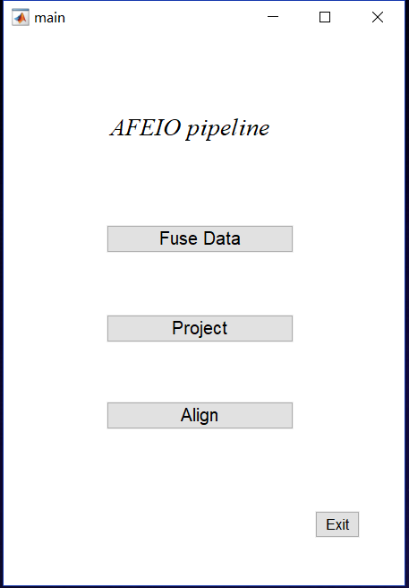

The main pipeline includes three main parts: data fusion, projection, and registration. Those three parts will run independently. Click a button to jump into the corresponding part.

1. Data fusion
   1. Description and data arranging

This step is to fuse the stacks acquired from two opposing views, and the raw data should be arranged as follows,

Name: “time point _G group index”, for example, “233_G1” means the time point 233, and group one.

Image stacks sequence: In one group, the sequence should be, channel1left-channel2left (if had)-channel1right-channel2right (if had). Channel1 is the channel used for main analysis and channel2 is the co-localization channel.

Image stacks group: We assumed that during the image acquisition, there is only one camera and it is fixed, and the sample should rotate by 180 degrees to acquire group2. In other words, the group 2 will rotate by 180 degrees during the processing pipeline.

* 1. Data fusion GUI

The main GUI of data fusion part is shown in Fig2.

Fig 2 Data Fusion GUI

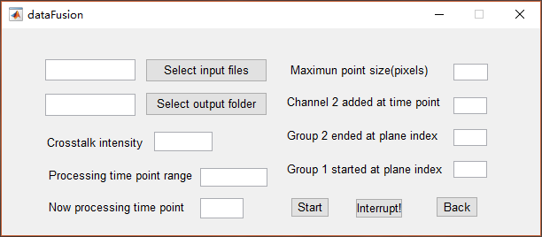

1. Select input files

Click “Select input files” button and a window will be shown on screen, user may turn to the folder where the files were saved, then select one of the files to be processed. After selection, the path will be shown in the box before the button, and the selected time point will be shown in the “Processing time point range” box.

1. Select output folder

Click “Select output folder” button to select where the user wants to save the processed data, and the will be shown in the box before the button. Please make sure the disk has enough space.

1. Crosstalk intensity

If there is crosstalk from channel 1 to channel 2, user may estimate the crosstalk intensity as figure3: select two regions as following, one is background region(a,b), and calculate the average of those two region as b1,b2 for channel 1 and channel 2. The other is where there should only be the signal from channel (c,d) and calculate the average of those two region as s1,s2, then the crosstalk intensity c should be

Fig 3 Crosstalk intensity estimation

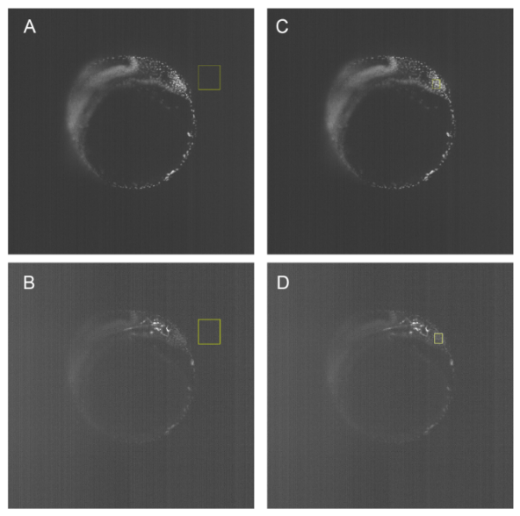

If there is no need for crosstalk correction, the c should be 0.

1. Maximum cell size

Estimation of the maximum cell size, note that the unit is pixel. This parameter is used to estimate the image background.

1. Channel 2 added at

A second marker may be used for co-localization during imaging, and if the marker does not express from the beginning, the second channel may be added at some later time point, in other word, channel 2 added at this time point. For example, “233” means that before time point 233, there is only one channel in each stacks, and after time point 233(included), there are two channels.

1. Group 2 started and Group 1 started

To make sure the whole sample is covered, there may be some extra blank plane at the end of the stacks. This parameter determines the useful range among all planes. For example, 100 means the plane whose indexes are before 100(excluded) will be ignored during the processing. If those blank planes have been removed, “1” means all planes are useful and do not ignore any plane.

1. Processing time point range

Determine the processing time point range. In the previous “Select input files” step, a single time point is selected. If there are multiple time points, those time point should be connected by “,” and “-”, comma means “and” and hyphen means “from to”. For example, “1,4,7-10” includes 6 time points, they are 1, 4, 7, 8, 9 and10.

1. Now processing time point

This box is a reminder shows which time point is being process.

1. Start, Interrupt and Back

Click “Start” when all setups have completed, and the processing will start.

During the processing, if the button “Interrupt!” is pressed, the process will cease after finishing processing the current time point.

Click “Back” if the data fusion step has finished to quit and jump to the home.

* 1. Test case

A test case for data fusing part can be found in the folder *example/data fusion,* 1_G1.tif and 1_G2.tif, and the data is a cropped part of a zebrafish embryo. And you may set the settings as following:

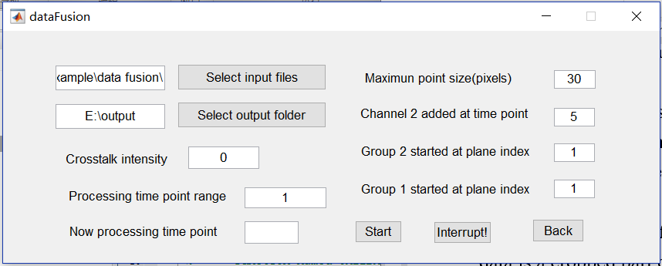

Fig4 Setting example for data fusing

The expected output can be found in the folder *example/data fusion/Expected output,* and the expected run time is about 10 seconds for the test case.

1. Projection
   1. Description

This process is to preview or to save the projection of stacks both of main view and side view.

* 1. Projection GUI

The main GUI of projection part is shown in Fig5.

Fig5 Projection GUI

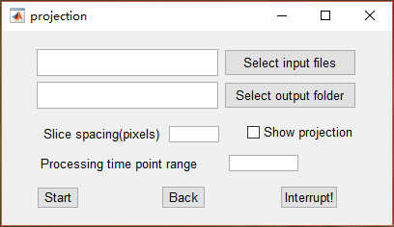

1. Select input files

Click “Select input files” button and a window will be shown on screen, user may turn to the folder where the processed data is saved, then select one of the files to be projected. After selection, the path will be shown in the box before the button, and the selected time point will be shown in the “Processing time point range” box.

1. Select output folder

Click “Select output folder” button to select where the user wants to save the processed data, and the will be shown in the box before the button. Please make sure the disk has enough space.

1. Slice spacing

The ratio of distance between two slices and the size of a single pixel. For example, if the slice step is 3μm, and a single pixel represents 0.5um, the slice spacing should be 3/0.5 = 6 pixels.

1. Show projection

Whether show the result on screen or not.

1. Processing time point range

Determine the processing time point range. In the previous “Select input files” step, a single time point is selected. If there are multiple time points, those time point should be connected by “,” and “-”, comma means “and” and hyphen means “from to”. For example, “1,4,7-10” includes 6 time points, they are 1, 4, 7, 8, 9 and10.

1. Start, Interrupt and Back

Click “Start” when all setups have completed, and the processing will start.

During the processing, if the button “Interrupt!” is pressed, the process will cease after finishing processing the current time point.

Click “Back” if the data fusion step has finished to quit and jump to the home.

1. Alignment
   1. Description

This process is to correct the shift between different time points based on the projection acquired from the projection step.

* 1. Alignment GUI

Fig6 Alignment GUI

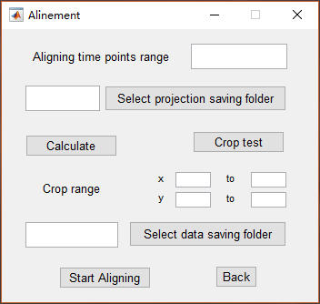

1. Aligning time points range

This parameter means where there are shifts. For example, if the sample was moved during the acquiring between time points 155 and 154, 342 and 341, the input should be 155,342. Also, those time points should be connected by “,” and “-”, comma means “and” and hyphen means “from to”.

1. Select projection saving folder

Click “Select projection saving folder” button and a window will be shown on screen, user may turn to the folder where the projections are saved to select the folder.

1. Calculate, Crop range and Crop test

If previous setups have completed, click “Calculate” button to align the projections. After this step, a folder *new* will be in the projection saving folder, and two image stacks *Front.tif* and *Side.tif* are in the folder for preview. Also the Crop range suggestion will be in the box below, users can also manually change the crop range. After setting the crop range, click “Crop test” to generate a file *Crop.tif* in the previous mentioned *new* folder to see whether the parameters are suitable.

1. Select data saving folder and Start aligning

Select where the fused data are saved. Make sure all the parameters have been set properly because this step will OVERWRITE the old files. Click “Start” when all setups have completed, and the processing will start.

1. Back

Click “Back” if the data fusion step has finished to quit and jump to the home.

* 1. Test Case

A test case for both projecting and aligning part can be found in the folder *example/projection&alignment*, 1.tif and 2.tif, and the data is two virtual balls that have displacement. And you may set the settings as following:

Fig8 Setting example for aligning

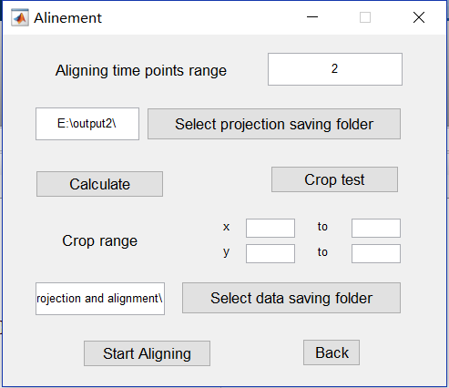

Fig7 Setting example for projecting

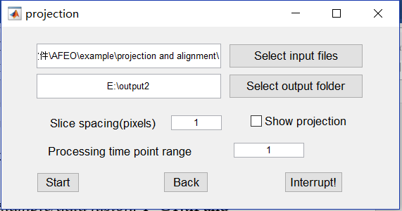

The expected output can be found in the folder *example/ projection and alignment/Expected output,* and the expected run time is about 5 seconds for the test case.

Citation:

[1] Linkert M , Rueden C T , Allan C , et al. Metadata matters: access to image data in the real world[J]. The Journal of Cell Biology, 2010, 189(5):777-782.