WEEK 4 TASK
PREDICTIVE MODELING AND OPTIMIZATION IN LOGISTICS SYSTEMS
Delhivery-Inspired Logistics Delivery-Time Forecasting and Operational Optimization
Prepared as a predictive analytics case study using a simulated logistics dataset.

1. Executive Summary
This report demonstrates how predictive modeling can be applied to a logistics operation to forecast delivery time and convert the forecast into operational decisions. A hypothetical shipment-level dataset was simulated to represent a Delhivery-inspired Indian logistics environment. The target variable is Delivery_Time_Hours, while explanatory variables include distance, package weight, traffic level, weather, hub load, shipment priority, number of stops, vehicle age, warehouse processing time, and day of week. Three regression approaches—Linear Regression, Decision Tree Regression, and Random Forest Regression—were implemented. The models were evaluated using MAE, RMSE, and R-squared. A Random Forest model was then tuned using cross-validation and grid search. The final model provides a basis for identifying shipments with higher predicted delivery time and supports practical optimization actions such as dynamic capacity allocation, hub workload balancing, route prioritization, and proactive exception management.

2. Problem Definition
Logistics companies must estimate how long a shipment will take to reach the customer. Delivery time is affected by several interacting factors, including transportation distance, traffic, weather, warehouse processing, hub congestion, shipment priority, and the number of delivery stops. A reliable prediction model can help operations teams identify potentially delayed shipments before the delay occurs.
Problem statement: Develop a machine-learning regression model that predicts the expected delivery time of a shipment in hours using operational and shipment-level features, then propose optimization strategies that use those predictions to improve service reliability and resource utilization.

3. Dataset Simulation and Description
A synthetic dataset containing 3,000 shipment records was generated in Python. It is hypothetical and does not represent confidential or actual Delhivery operational data.
Feature | Type | Description | Role
Distance_km | Numeric | Estimated shipment distance | Predictor
Package_Weight_kg | Numeric | Package weight | Predictor
Traffic_Level | Numeric | Traffic intensity from 1–5 | Predictor
Weather | Categorical | Clear, Cloudy, Rain, Storm | Predictor
Hub_Load | Numeric | Relative hub utilization, 0–1 | Predictor
Priority | Categorical | Standard or Express | Predictor
Stops | Numeric | Number of delivery stops | Predictor
Vehicle_Age_Years | Numeric | Age of assigned vehicle | Predictor
Warehouse_Processing_Hours | Numeric | Processing time before dispatch | Predictor
Day_of_Week | Categorical | Shipment dispatch day | Predictor
Delivery_Time_Hours | Numeric | Actual delivery duration | Target

4. Analytical Workflow
- Define the logistics problem and target variable.
- Simulate and inspect shipment-level data.
- Separate predictors from the target.
- Encode categorical variables and preserve numeric variables.
- Split the dataset into 80% training data and 20% test data.
- Train multiple regression models.
- Evaluate models using MAE, RMSE, and R-squared.
- Apply 5-fold cross-validation and hyperparameter tuning to Random Forest.
- Use predictions to identify high-risk shipments and formulate optimization strategies.
- Document limitations and recommendations for operational deployment.

5. Model Selection
Linear Regression was selected as a transparent baseline. Decision Tree Regression was included to capture nonlinear relationships and threshold effects. Random Forest Regression was selected as the main ensemble candidate because it combines multiple decision trees and can model nonlinear interactions among operational variables without requiring a strictly linear relationship.

6. Python Implementation
# Features and target
X = df.drop(columns=["Delivery_Time_Hours"])
y = df["Delivery_Time_Hours"]
# Train-test split
X_train, X_test, y_train, y_test = train_test_split(
X, y, test_size=0.20, random_state=42
)
# Preprocessing
preprocess = ColumnTransformer([
("num", "passthrough", numeric_columns),
("cat", OneHotEncoder(handle_unknown="ignore"), categorical_columns)
])
# Model pipeline
model = Pipeline([
("prep", preprocess),
("model", RandomForestRegressor(
n_estimators=180, max_depth=14,
min_samples_leaf=3, random_state=42
))
])
model.fit(X_train, y_train)
predictions = model.predict(X_test)
mae = mean_absolute_error(y_test, predictions)
rmse = np.sqrt(mean_squared_error(y_test, predictions))
r2 = r2_score(y_test, predictions)

7. Model Evaluation
MAE measures average absolute prediction error in hours. RMSE gives greater weight to large errors, which is useful when significant delivery-time misses matter operationally. R-squared indicates how much variation in delivery time is explained by the model.
Model | MAE (hours) | RMSE (hours) | R²
Linear Regression | 2.19 | 2.74 | 0.788
Random Forest | 2.57 | 3.21 | 0.709
Decision Tree | 3.30 | 4.22 | 0.497
The initial comparison selected Linear Regression as the strongest tested model by held-out test RMSE. Values are based on the simulated dataset.
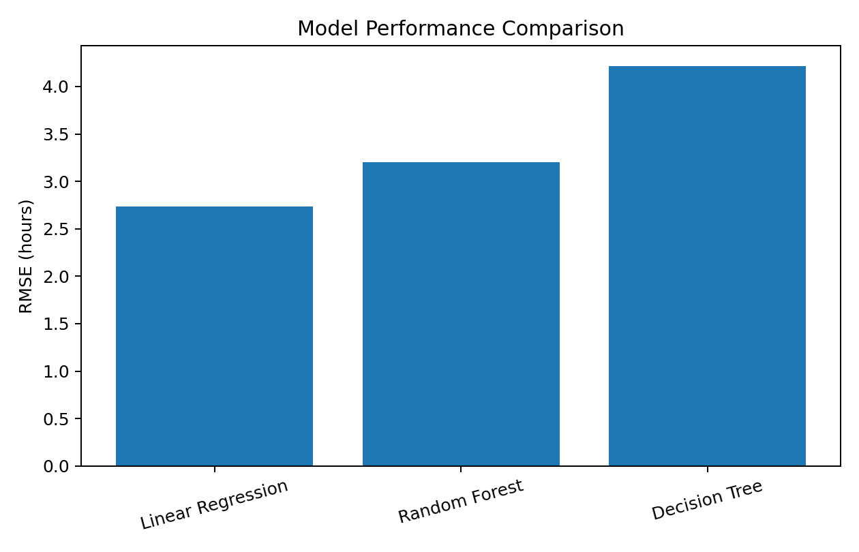
Figure 1. Comparison of test-set RMSE across candidate models.

8. Cross-Validation and Hyperparameter Tuning
A 5-fold cross-validation strategy was used to assess stability, while grid search tested tree count, maximum depth, and minimum samples per leaf for Random Forest.
Best parameters: {'model__max_depth': None, 'model__min_samples_leaf': 2, 'model__n_estimators': 180}. Tuned test-set results: MAE = 2.55 hours, RMSE = 3.19 hours, R² = 0.712. Mean 5-fold RMSE = 3.27 hours (SD 0.07); mean 5-fold MAE = 2.60 hours (SD 0.06).

9. Feature Importance and Business Insights
Feature importance was examined to understand which variables contributed most to predictions. In this simulated environment, distance, traffic, hub load, warehouse processing, and number of stops are expected to be operationally important.
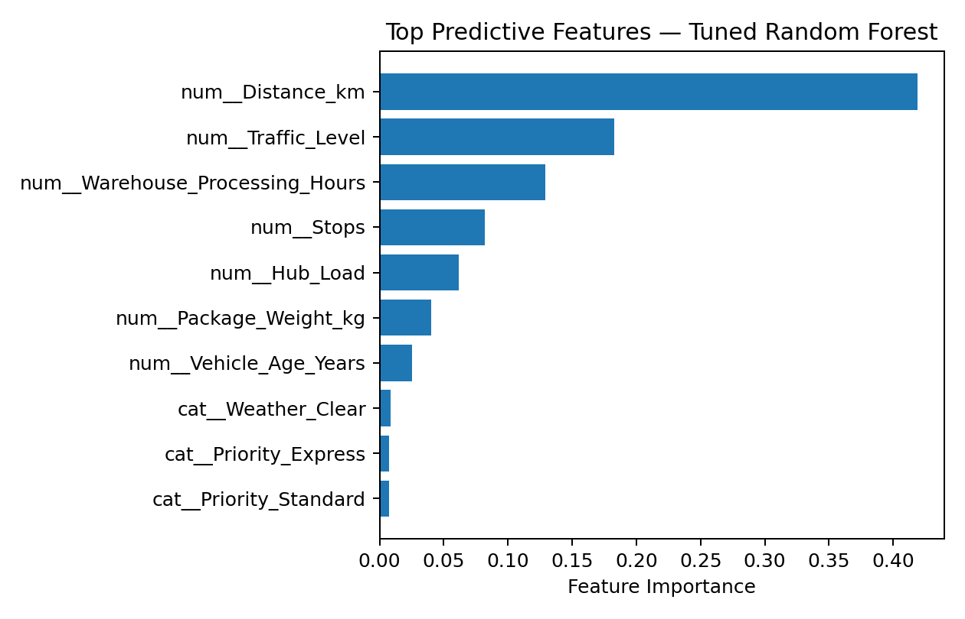
Figure 2. Top predictive features in the tuned Random Forest model.

10. Optimization Strategies
Dynamic Capacity Allocation: Use predicted delivery time to identify high-risk shipments before dispatch and assign additional delivery capacity or sorting resources where justified.
Hub Load Balancing: Compare predicted delivery times with hub utilization and shift selected workload to nearby hubs when feasible.
Route Prioritization: Prioritize shipments with high predicted duration or tight service commitments and combine predictions with route-optimization software.
Proactive Exception Management: Trigger an operational review when predicted delivery time crosses a service threshold so teams can investigate traffic, weather, backlog, or vehicle constraints.
Resource Scheduling: Use expected workload patterns to schedule drivers, warehouse staff, and vehicles around forecasted peaks.
Cost Minimization: Balance incremental capacity cost against expected delay penalties and customer-service impact.

11. Example Optimization Logic
A decision layer can sit above the prediction model. In production, the threshold should be derived from actual route-level SLAs and historical service distributions.
# Example decision layer
predictions = model.predict(X_test)
risk_flag = np.where(
predictions > SLA_THRESHOLD,
"High Risk",
"Normal"
)
# High-risk shipments can be reviewed for:
# alternate route, earlier dispatch, extra capacity,
# hub workload transfer, or customer communication.

12. Optimization Impact Illustration
Using an illustrative 30-hour threshold, 49 of 600 test shipments (8.2%) were flagged as high risk. This threshold is for demonstration only and should not be treated as a real SLA.
Indicator | Baseline Illustration | Optimization Illustration
Shipments above 30 hours | 12.2% | Target through proactive intervention
Operating cost index | 100 | 95.5*
High-risk shipments identified | No predictive prioritization | 49 in test set
*Illustrative scenario assumption, not measured savings. A controlled operational pilot is required.

13. Limitations
- The dataset is synthetic and does not represent actual company data.
- The simulated target was generated from known relationships, so performance may be more favorable than in a noisy real-world setting.
- Live GPS, road-network, vehicle-capacity, fuel-price, and real-time weather feeds are not included.
- Feature importance indicates predictive contribution, not causation.
- Optimization requires real SLA definitions, costs, operational constraints, and pilot validation.
- Production deployment should monitor data drift, model drift, missing values, and changing network conditions.

14. Recommended Production Architecture
Shipment/Hub Data → Data Validation → Feature Engineering → Prediction Model → Delay-Risk Scoring → Optimization Rules → Dashboard & Alerts → Feedback Data → Periodic Retraining.
The prediction service can be integrated with an operations dashboard showing predicted delivery time, risk level, contributing factors, and recommended actions at shipment and hub level.

15. Conclusion
This Week 4 project demonstrates the complete predictive analytics lifecycle for a logistics problem. A simulated shipment dataset was created, multiple regression models were compared, Random Forest was tuned using cross-validation, and performance was measured using MAE, RMSE, and R-squared. Predictive output can support dynamic capacity allocation, hub balancing, route prioritization, proactive exception management, and cost-aware resource scheduling. The central operational principle is that prediction creates value when it is connected to clear decisions and validated against real business outcomes.

16. Appendix — Core Python Libraries
pandas — data manipulation; NumPy — numerical simulation; scikit-learn — preprocessing, modeling, cross-validation, tuning and evaluation; Matplotlib — visualization; python-docx — report generation.

17. Appendix — Sample Dataset Preview
Distance_km | Package_Weight_kg | Traffic_Level | Weather | Hub_Load | Priority | Stops | Vehicle_Age_Years | Warehouse_Processing_Hours | Day_of_Week | Delivery_Time_Hours
144.7 | 7.43 | 1 | Cloudy | 0.856 | Standard | 7 | 8 | 2.99 | Thu | 21.68
92.62 | 1.3 | 1 | Cloudy | 0.563 | Standard | 6 | 3 | 3.44 | Sat | 16.39
86.06 | 2.72 | 3 | Clear | 0.657 | Standard | 1 | 10 | 8.1 | Tue | 19.47
86.06 | 5.01 | 5 | Rain | 0.869 | Standard | 6 | 4 | 0.81 | Wed | 24.1
272.93 | 2.07 | 1 | Storm | 0.38 | Express | 3 | 2 | 0.93 | Sun | 17.86
171.81 | 6.14 | 1 | Clear | 0.453 | Standard | 3 | 3 | 1.23 | Fri | 21.79

18. Detailed Explanation for Better Understanding

18.1 What Is Predictive Modeling in Logistics?
Predictive modeling means using historical or simulated information to estimate what is likely to happen in the future. In logistics, the future event can be delivery time, shipment volume, delay probability, demand, or fuel consumption. This project focuses on delivery-time prediction. The model receives shipment and operating information and estimates the number of hours required for delivery.
For example, a shipment traveling a long distance during heavy traffic, with high hub utilization and several delivery stops, may require more time than a short shipment under normal conditions. A prediction model can identify this risk before the shipment becomes late, allowing operations teams to investigate possible preventive actions.

18.2 Why Was Delivery Time Chosen as the Target?
Delivery time connects transportation, warehouse processing, hub operations, and last-mile delivery. Predicting it provides a clear link between machine learning and operational planning. The target is a continuous numeric value, so the project is a regression problem.
- Target variable: Delivery_Time_Hours.
- Target type: Continuous numeric variable.
- Prediction task: Regression.
- Unit: Hours.
- Business use: Delay-risk identification and resource planning.

18.3 Understanding the Simulated Dataset
Because real company shipment data is not available for this case study, a synthetic dataset of 3,000 shipment records was generated. Synthetic data is artificially created data designed to demonstrate realistic analytical relationships without using confidential company information. The dataset contains numeric and categorical variables and includes random variation to make the prediction task more realistic.
The simulated target was generated from distance, package weight, traffic, weather, hub load, priority, stops, vehicle age, warehouse processing time, day of week, and random noise. This allows the complete workflow—data preparation, training, testing, evaluation, tuning, interpretation, and optimization—to be demonstrated.

18.4 Meaning of Each Input Feature
Distance_km: Longer transportation distance generally increases travel time.
Package_Weight_kg: Heavier packages can require additional handling and may affect vehicle or handling requirements.
Traffic_Level: A 1–5 score representing increasing traffic intensity; higher traffic can increase travel time.
Weather: Clear, Cloudy, Rain, and Storm conditions are included because adverse weather can slow transportation.
Hub_Load: Relative hub utilization; higher values represent greater workload or congestion pressure.
Priority: Express shipments can receive different processing or transportation treatment than standard shipments.
Stops: Number of delivery stops on the route; more stops can increase route duration.
Vehicle_Age_Years: Operational vehicle-age information included as a possible contributor to reliability or maintenance effects.
Warehouse_Processing_Hours: Time spent processing a shipment before dispatch; this contributes directly to total duration.
Day_of_Week: Captures possible weekly workload and traffic differences.
Delivery_Time_Hours: Actual delivery duration and the target the model learns to predict.

18.5 Step-by-Step Data Preparation
First, the target variable is separated from the predictors. X contains information available to the model, while y contains delivery time. Next, the data is divided into training and test sets. Approximately 80% of the observations are used to train the models and 20% are reserved as unseen test data.
Categorical fields such as Weather, Priority, and Day_of_Week are converted into numerical indicator variables using one-hot encoding. Numeric variables are passed through without changing their basic meaning. A pipeline combines preprocessing and modeling so that the same transformation is applied consistently during training and prediction.

18.6 Understanding the Train-Test Split
With 3,000 records, an 80:20 split gives approximately 2,400 training records and 600 test records. The training data is used to learn relationships, while the test data is kept separate until final evaluation. This helps estimate how the model behaves on observations it has not seen. The random_state value of 42 makes the split reproducible.

18.7 Why Were Three Models Compared?
Linear Regression: A simple and interpretable baseline. It estimates delivery time as a combination of input variables and is useful for establishing a reference performance.
Decision Tree Regression: Uses decision rules and can capture nonlinear relationships and thresholds, but can overfit when overly complex.
Random Forest Regression: Combines many decision trees and can represent nonlinear relationships and interactions more flexibly than a single tree.

18.8 What Do MAE, RMSE, and R-squared Mean?
MAE (Mean Absolute Error) is the average absolute difference between actual and predicted delivery time. An MAE of 2.5 hours means predictions are, on average, about 2.5 hours away from the actual values in absolute terms.
RMSE (Root Mean Squared Error) is also measured in hours but penalizes large errors more strongly. This is useful when a very large prediction error can cause significant operational disruption.
R-squared indicates how much variation in the target is explained by the model relative to a simple baseline. An R-squared of 0.70 means about 70% of the variation is explained under the conditions of this dataset; it should not be interpreted as 70% prediction accuracy.

18.9 How to Read the Model Results
The simulated experiment produced these held-out test results: Linear Regression—MAE 2.19 hours, RMSE 2.74 hours, R-squared 0.788; Random Forest—MAE 2.57 hours, RMSE 3.21 hours, R-squared 0.709; Decision Tree—MAE 3.30 hours, RMSE 4.22 hours, R-squared 0.497.
For this simulated dataset, Linear Regression had the lowest initial test RMSE. This demonstrates an important machine-learning principle: a more complex model is not automatically better. Model choice should be based on measured validation performance, interpretability, robustness, and the business problem.
The Random Forest was also tuned as an ensemble candidate. The tuned experiment produced approximately MAE 2.55 hours, RMSE 3.19 hours, and R-squared 0.712 on the held-out test set. Its five-fold cross-validation mean RMSE was approximately 3.27 hours.

18.10 Understanding Cross-Validation
Cross-validation repeatedly divides data into training and validation portions. In five-fold cross-validation, four folds are used for training and one for validation, and the process rotates until every fold has been used for validation. The average provides a more stable estimate than one split alone and is useful when comparing hyperparameter settings.

18.11 What Is Hyperparameter Tuning?
Hyperparameters are model settings chosen before training. The Random Forest grid search tested the number of trees, maximum tree depth, and minimum samples per leaf. The best tested configuration was selected using cross-validated RMSE. In the experiment, the selected parameters were 180 trees, unlimited maximum depth, and minimum leaf size of 2.
- n_estimators controls the number of trees.
- max_depth controls how deeply trees can grow.
- min_samples_leaf controls the minimum observations in a leaf and can reduce overly specific rules.
- GridSearchCV evaluates combinations using cross-validation.

18.12 Understanding Feature Importance
Feature importance shows how strongly the trained Random Forest relied on each input when forming predictions. It is useful for interpretation but does not prove causation. In a real logistics dataset, consistently important variables could guide further investigation into congestion, travel time, staffing, dispatch schedules, and processing bottlenecks.

18.13 From Prediction to Optimization
Prediction answers: “What is likely to happen?” Optimization asks: “Given that prediction and our constraints, what action should we consider?” The project connects the two stages. A shipment can receive a predicted delivery time, be compared with an appropriate SLA threshold, and then be reviewed for feasible operational actions.
- Prediction: estimate delivery time.
- Risk identification: compare prediction with a route or service threshold.
- Decision support: review possible actions.
- Optimization: choose actions subject to cost and capacity constraints.
- Feedback: measure actual results and retrain or refine the system.

18.14 Detailed Operational Example
Suppose a shipment has a predicted delivery duration above its route-level SLA. The system can display the prediction together with distance, traffic, hub load, weather, and processing time. If hub congestion is the main issue, workload can be reviewed. If traffic is the concern, an alternate route or dispatch time can be evaluated. If warehouse processing is high, staffing or queue management can be investigated. The model therefore acts as decision support rather than automatically replacing operational judgment.

18.15 Cost Optimization Concept
Reducing delivery time at any cost is not necessarily optimal. Extra vehicles, overtime, expedited transportation, and route changes create costs. A practical objective can be represented as: Total Cost = Transportation Cost + Handling Cost + Additional Capacity Cost + Delay Penalty. A production optimizer would minimize this objective while respecting vehicle capacity, driver hours, hub capacity, route feasibility, and service commitments.

18.16 Suggested Optimization Framework
A future version can combine the predictive model with a formal optimization algorithm. Predicted delivery times become inputs to a resource-allocation or routing optimizer. The optimizer can search for feasible decisions under capacity and cost constraints.
- Input: shipment and current operating conditions.
- Prediction: expected delivery time and delay risk.
- Constraints: vehicle capacity, hub capacity, driver hours, route availability, and SLAs.
- Objective: reduce total cost and/or service violations.
- Output: shipment assignments, resource allocation, route priorities, or dispatch schedules.
- Evaluation: compare predicted improvement with actual operational results.

18.17 How the Python Code Maps to the Analysis
pandas DataFrame: Stores and manipulates the shipment dataset.
train_test_split: Creates training and unseen test datasets.
ColumnTransformer: Applies appropriate preprocessing to numeric and categorical columns.
OneHotEncoder: Converts categorical text into numeric indicator variables.
Pipeline: Combines preprocessing and model training into one reproducible workflow.
RandomForestRegressor: Builds the ensemble regression model.
GridSearchCV: Tests hyperparameter combinations using cross-validation.
mean_absolute_error: Calculates MAE.
mean_squared_error: Provides the basis for RMSE.
r2_score: Calculates R-squared.
feature_importances_: Provides Random Forest feature-importance values.

18.18 What Would Change With Real Data?
The next step would be replacing synthetic data with historical shipment records. Useful fields could include shipment creation time, origin, destination, route distance, hub scan timestamps, warehouse processing timestamps, vehicle details, traffic or travel-time information, weather, delivery outcome, and SLA status. Data quality checks should identify missing timestamps, duplicates, impossible durations, inconsistent identifiers, and outliers.
The model must use only information that would actually be available at prediction time. Using information recorded after delivery to predict that same delivery would create data leakage and unrealistically high performance.

18.19 Deployment and Monitoring
A production model should be continuously monitored. Performance can change when traffic patterns, routes, customer mix, network structure, or operating policies change. Monitoring should include prediction error, missing inputs, feature distributions, and performance by hub, route, region, and shipment type. Periodic retraining can be introduced when enough new data is available.

18.20 Final Learning Outcomes
- Convert a logistics business problem into a regression problem.
- Identify predictors and target variables.
- Prepare numeric and categorical data for machine learning.
- Understand training, testing, and unseen data.
- Compare algorithms using objective evaluation metrics.
- Interpret MAE, RMSE, and R-squared.
- Understand cross-validation and hyperparameter tuning.
- Interpret feature importance without confusing prediction with causation.
- Differentiate prediction from optimization.
- Connect model outputs to practical logistics decisions.

19. Viva / Interview Questions and Answers
Q: What is the objective of this project?
A: To predict logistics delivery time using shipment and operational variables and use the prediction to propose operational optimization strategies.
Q: Why is this a regression problem?
A: Because delivery time is a continuous numeric value measured in hours.
Q: Why use synthetic data?
A: Real logistics data may be confidential or unavailable, so synthetic data allows the full workflow to be demonstrated safely.
Q: Why compare multiple models?
A: Different models capture different relationships, so comparison provides evidence about performance rather than assuming one algorithm is best.
Q: What is MAE?
A: Average absolute prediction error, expressed in hours in this project.
Q: Why is RMSE useful?
A: It penalizes large errors more strongly, which matters when major delivery-time misses are costly.
Q: What is cross-validation?
A: A repeated train-validation procedure that gives a more stable estimate of model performance.
Q: What is hyperparameter tuning?
A: Testing different model settings and selecting a configuration based on validation performance.
Q: Prediction vs optimization?
A: Prediction estimates what may happen; optimization selects feasible actions under objectives and constraints.
Q: Can this model be directly deployed?
A: No. The current data is synthetic. Real deployment requires historical data, leakage checks, validation, monitoring, and an operational pilot.
Q: What is the business value?
A: It provides early visibility into potentially long delivery times so teams can investigate and intervene proactively.
Q: What would you improve next?
A: Add real shipment history, route and GPS features, time-of-day, hub scans, SLA labels, cost data, and a formal optimization algorithm.

20. Submission Checklist
- Clear logistics problem and target variable.
- Dataset and features explained.
- Python preprocessing and training code included.
- Multiple models compared.
- MAE, RMSE, and R-squared explained.
- Cross-validation and tuning documented.
- Feature importance and business insights discussed.
- Optimization recommendations connected to predictions.
- Synthetic-data limitations stated.
- Production architecture and future improvements included.
- Viva questions prepared.

