WEEK 3 PROJECT REPORT
Advanced Data Analysis and Visualization in Logistics
A Detailed Python-Based Logistics Analytics Study
Hypothetical Logistics Dataset | EDA | Visualization | Insights | Recommendations
Academic / Internship Week 3 Submission

1. Introduction
Logistics operations generate large amounts of data every day. Shipment records can contain information about distance, shipment volume, delivery time, transportation cost, fuel cost, delays, transport modes, and customer experience. Analyzing this information helps organizations understand what is happening in their delivery network and where operational improvements may be possible.
This project demonstrates a complete logistics data-analysis workflow using Python. A hypothetical dataset of 500 shipments is analyzed using Pandas, NumPy, and Matplotlib. The project begins with data simulation and inspection, continues through exploratory data analysis (EDA), and then uses visualizations to identify patterns and relationships. Finally, the findings are translated into logistics-focused insights and recommendations.
Important note: all shipment data in this report is simulated for educational purposes. The results should not be treated as actual performance figures of any logistics company.

2. Project Objective
The main objective is to understand how data analysis and visualization can support logistics decision-making.
- Create a structured hypothetical logistics dataset.
- Understand the characteristics of logistics data before analysis.
- Check data quality and identify missing values.
- Calculate descriptive statistics such as mean, median, standard deviation, minimum, and maximum.
- Study the distribution of delivery times, shipment volumes, costs, and delays.
- Analyze relationships between distance, delivery time, transportation cost, delays, and customer ratings.
- Compare transportation modes such as Road, Rail, and Air.
- Identify possible operational bottlenecks and cost drivers.
- Convert analytical findings into practical logistics recommendations.

3. Business Problem Statement
A logistics organization needs to understand why some shipments cost more, why some deliveries take longer, and which operational factors may be associated with delays. Looking only at individual shipment records makes it difficult to see broader patterns. Data analysis provides a structured way to summarize the network and identify relationships between important performance indicators.
The project therefore investigates questions such as:
- What is the typical delivery time?
- What is the typical transportation cost per shipment?
- How does distance relate to transportation cost?
- How does distance relate to delivery time?
- Which transport modes show different cost and delay patterns?
- How frequently are shipments delayed?
- Do higher delays coincide with lower customer ratings?
- Are shipment volumes changing over time?
- Which areas should logistics managers investigate further?

4. Dataset Design and Simulation
The dataset contains 500 simulated shipment records covering January to June 2026. The records represent movements between major Indian cities. The simulation intentionally includes relationships that are plausible in logistics—for example, longer distances tend to require more time and generally increase transportation cost.
The three transport modes used are:
- Road – the most frequently used mode in the simulated dataset.
- Rail – used for a portion of shipments and modeled with different time/cost characteristics.
- Air – used for a smaller portion of shipments and modeled as faster but more expensive.
The dataset is designed to be large enough for meaningful exploratory analysis while remaining easy to understand and reproduce using Python.

4.1 Dataset Variables
Variable | Meaning
Shipment_ID | Unique ID assigned to every shipment.
Date | Date on which the shipment was recorded.
Origin | City from which the shipment started.
Destination | Shipment destination city.
Transport_Mode | Road, Rail, or Air.
Distance_km | Approximate transportation distance in kilometres.
Shipment_Volume_kg | Shipment weight/volume represented in kilograms.
Delivery_Time_hr | Total delivery time in hours.
Transportation_Cost_INR | Estimated total transportation cost in Indian Rupees.
Fuel_Cost_INR | Estimated fuel-related cost in Indian Rupees.
Delay_Hours | Number of hours by which a shipment was delayed.
Delivery_Status | On Time or Delayed.
Customer_Rating | Customer rating on a 1–5 scale.

5. Tools and Technologies
Python: Main programming language used to perform the analysis.
Pandas: Used for creating, cleaning, filtering, grouping, and summarizing tabular data.
NumPy: Used for numerical calculations and generating simulated values.
Matplotlib: Used to create charts such as histograms, bar charts, scatter plots, and line charts.
python-docx: Used to generate the final Word report programmatically.

6. Analysis Methodology
- Data Simulation: Generate realistic-looking shipment records with controlled relationships between variables.
- Data Inspection: Check dataset size, columns, data types, sample records, and overall structure.
- Data Quality Check: Find missing values and check whether numerical values are within reasonable ranges.
- Descriptive Statistics: Calculate mean, median, standard deviation, minimum, and maximum.
- Univariate Analysis: Study one variable at a time, such as delivery-time or cost distributions.
- Bivariate Analysis: Study relationships between two variables, such as distance versus cost.
- Categorical Comparison: Compare metrics between Road, Rail, and Air.
- Time Analysis: Examine how shipment counts change month by month.
- Correlation Analysis: Measure linear relationships between numerical variables.
- Business Interpretation: Translate statistical patterns into logistics-related observations.
- Recommendations: Suggest areas for operational investigation and improvement.

7. Exploratory Data Analysis (EDA)

7.1 Dataset Structure
The final dataset contains 500 rows and 13 columns. Each row represents one shipment. Numerical fields are used for statistical calculations, while categorical fields are used for grouping and comparison.
A typical first inspection in Python is:
print(df.head())
print(df.shape)
print(df.info())
print(df.describe())
The purpose of these commands is straightforward: head() shows sample records, shape shows the number of rows and columns, info() shows data types and non-null counts, and describe() summarizes numerical variables.

7.2 Descriptive Statistics
The average shipment volume is 108.9 kg. Average delivery time is 41.3 hours, while the median is 38.0 hours. Average transportation cost is ₹1,631, with a median of ₹1,490. Average delay is 7.1 hours.
Metric | Mean | Median | Std. Dev. | Min | Max
Distance_km | 528.28 | 465.50 | 278.66 | 100.00 | 1500.00
Shipment_Volume_kg | 108.93 | 99.35 | 61.00 | 15.60 | 300.00
Delivery_Time_hr | 41.32 | 38.00 | 22.45 | 4.00 | 118.50
Transportation_Cost_INR | 1631.32 | 1489.55 | 815.62 | 314.74 | 6837.15
Fuel_Cost_INR | 444.01 | 390.61 | 244.82 | 83.18 | 1360.09
Delay_Hours | 7.10 | 6.60 | 6.26 | 0.00 | 25.30
Customer_Rating | 4.37 | 4.44 | 0.54 | 2.56 | 5.00

7.3 Mean vs Median – Why Both Matter
The mean is calculated by adding all values and dividing by the number of observations. The median is the middle value after sorting the observations. In logistics, both are useful because a small number of extremely long deliveries or unusually expensive shipments can pull the mean upward. Comparing mean and median therefore helps analysts understand whether the data may be influenced by extreme observations.

7.4 Missing-Value Analysis
- Fuel_Cost_INR: 5 missing values detected.
- Customer_Rating: 5 missing values detected.
Missing-value analysis is important because statistical calculations and visualizations can be affected when data is incomplete. In a real organization, the analyst should determine why a value is missing before choosing a treatment such as imputation, exclusion, or correction at the source.

8. Visualizations

8.1 Delivery Time Distribution
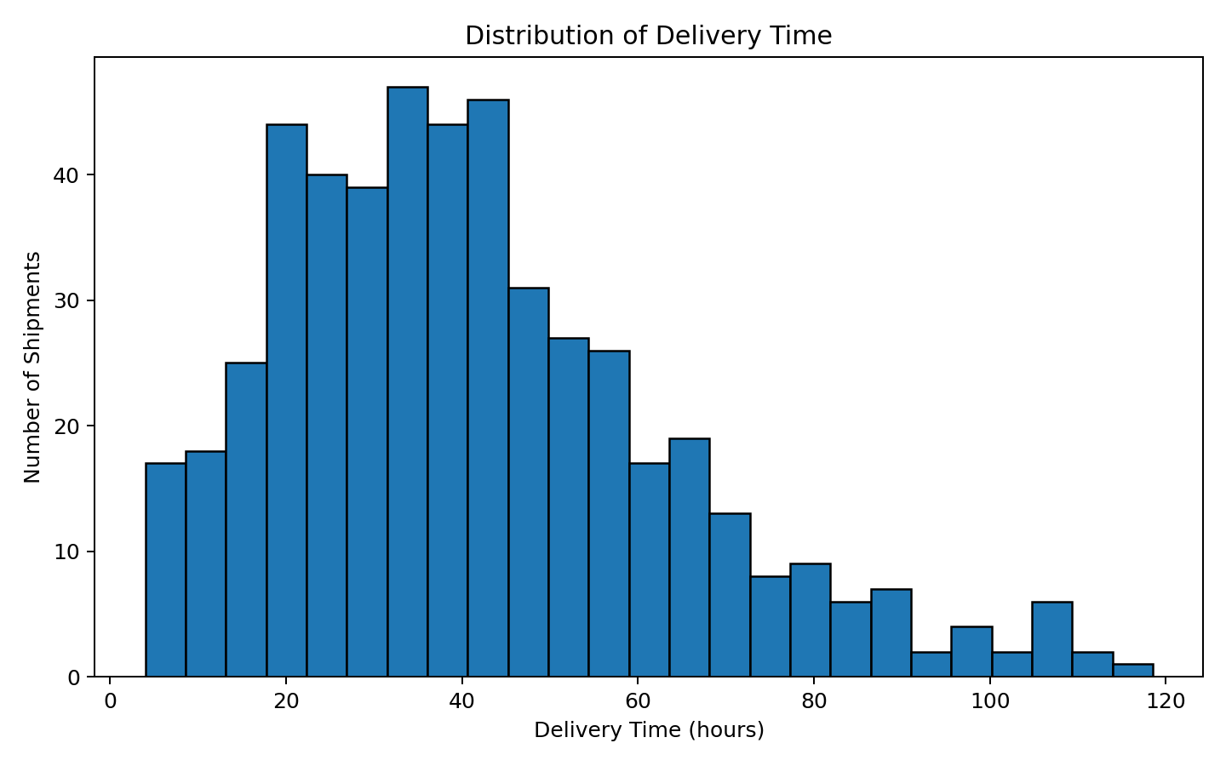
How to understand it: A histogram groups delivery times into ranges. It is useful for understanding the typical delivery-time range, the spread of observations, and whether unusually slow shipments form a long tail. In logistics, this can help operations teams understand consistency rather than relying only on the average.

8.2 Transportation Cost by Transport Mode
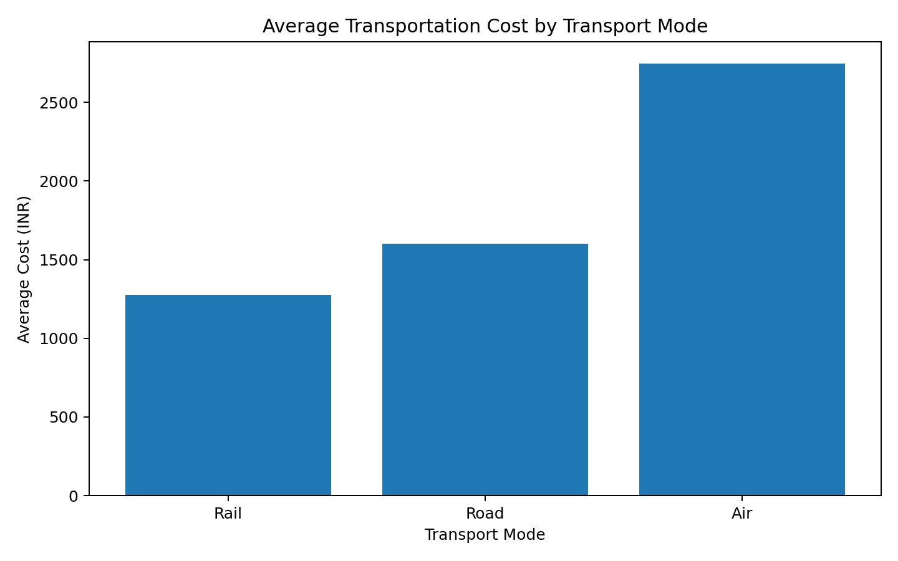
How to understand it: A bar chart is suitable because transport mode is categorical. Comparing the average cost of Road, Rail, and Air makes it easy to identify cost differences. The simulated data shows Air as the highest-cost mode. This does not mean Air should never be used; faster delivery requirements may justify higher cost.

8.3 Transportation Cost vs Distance
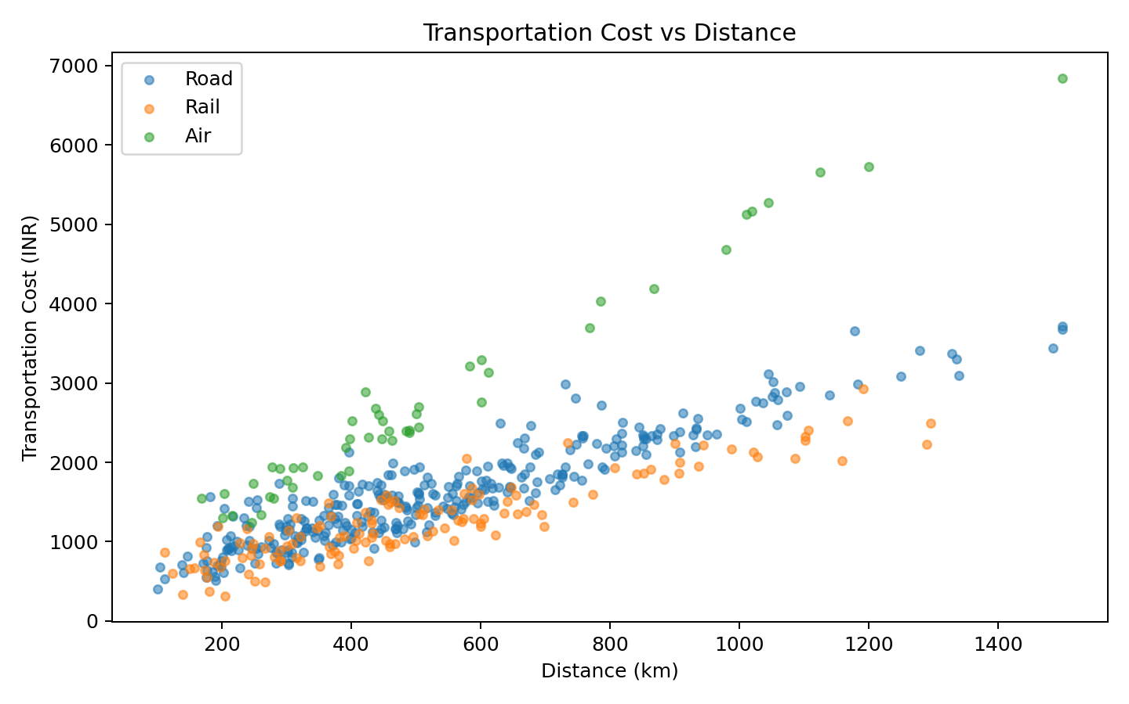
How to understand it: A scatter plot is used because both variables are numerical. Each point represents a shipment. The positive correlation of {cost_distance_corr:.2f} indicates that longer-distance shipments generally have higher costs in the simulated data. The spread around the trend shows that distance is not the only factor affecting cost.

8.4 Delivery Time vs Distance
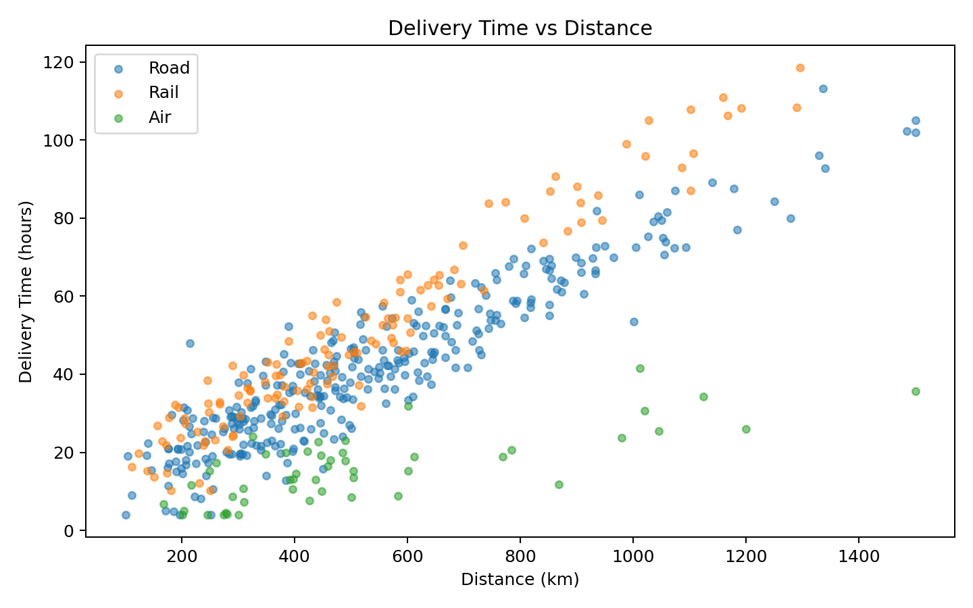
How to understand it: This scatter plot examines whether longer routes tend to require more time. The calculated correlation is 0.83. Different transport modes can create different patterns, showing why route distance should be analyzed together with transportation mode.

8.5 Monthly Shipment Trend
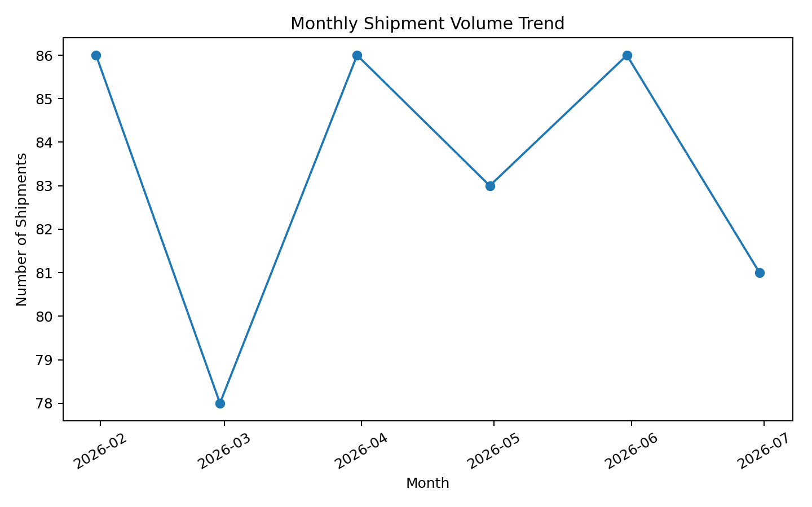
How to understand it: A line chart is appropriate for time-based observations. It helps identify increases or decreases in shipment activity. Such information can support workforce scheduling, vehicle allocation, warehouse planning, and capacity decisions.

8.6 Delivery Status Distribution
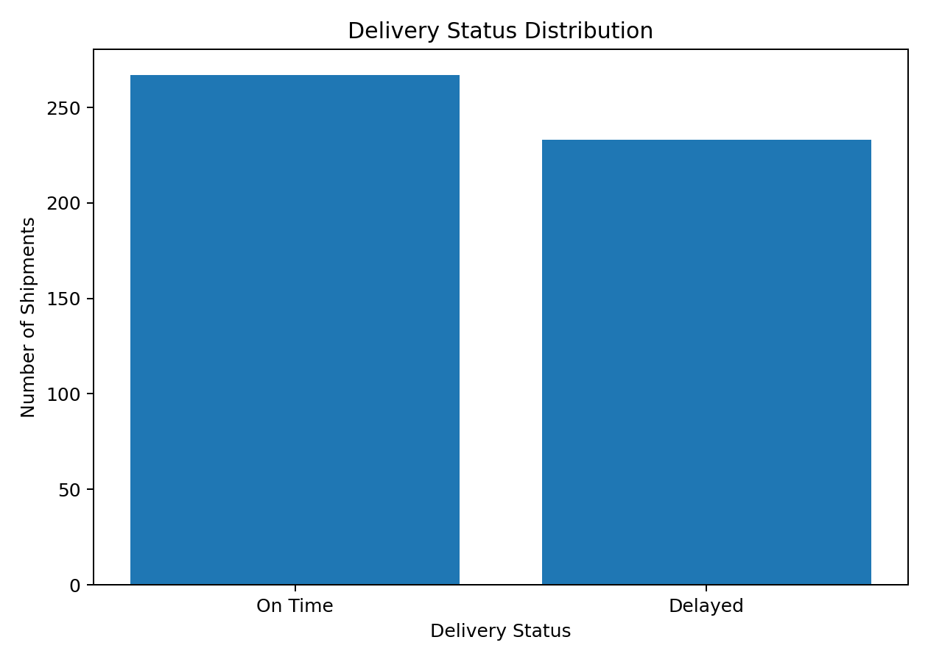
How to understand it: A bar chart compares on-time and delayed shipments. The simulated on-time percentage is 53.4%. This KPI can be monitored regularly because a change in on-time performance may signal operational problems.

8.7 Average Delay by Transport Mode
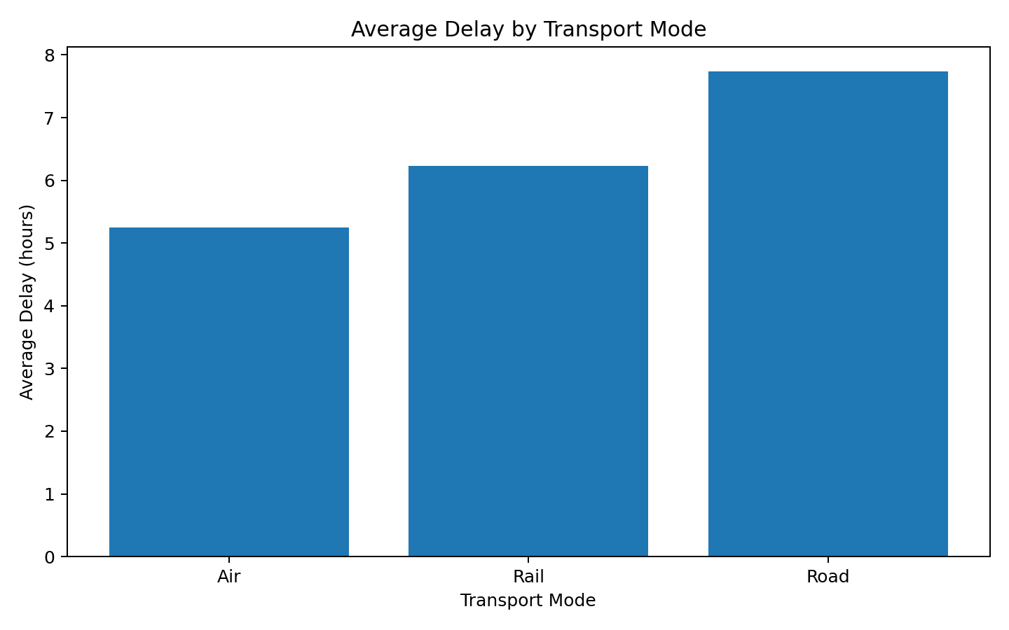
How to understand it: A mode comparison helps identify whether different transportation choices are associated with different delay patterns. The result should be combined with distance, cost, route conditions, and service requirements.

8.8 Correlation Matrix
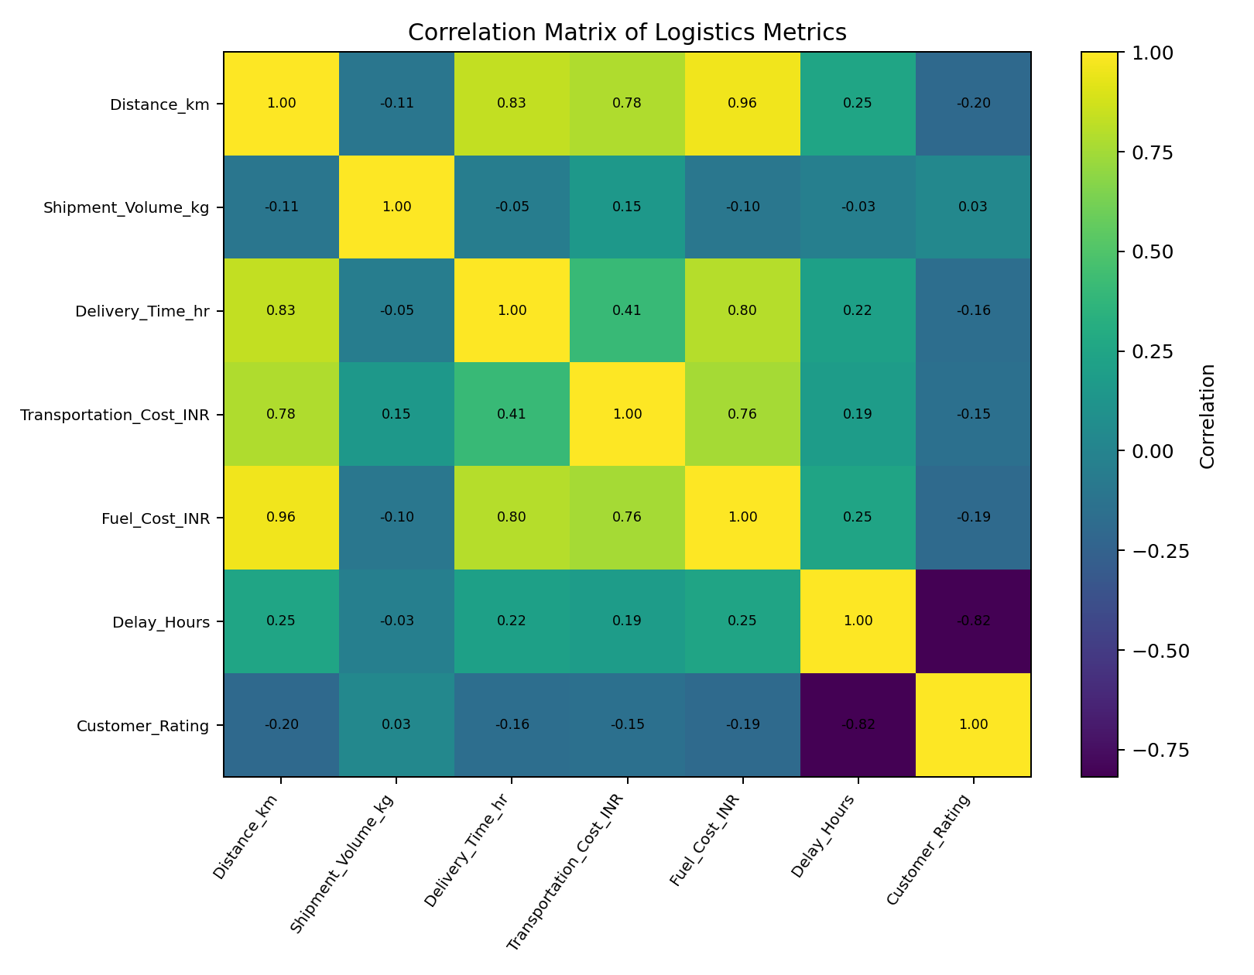
How to understand it: A correlation matrix summarizes the strength and direction of pairwise linear relationships between numerical variables. Values near +1 indicate strong positive linear association, values near -1 indicate strong negative association, and values near 0 indicate weak linear association. Correlation should not be interpreted as proof of causation.

9. Detailed Correlation Analysis
Correlation is a statistical measure that describes the direction and strength of a linear relationship between two numerical variables. It ranges from -1 to +1. A positive value means the variables tend to increase together; a negative value means one tends to increase while the other decreases.
Distance vs Transportation Cost: 0.78
Distance vs Delivery Time: 0.83
Delay Hours vs Customer Rating: -0.82
The negative delay-rating relationship in this simulation means that shipments with larger delays tend to have lower customer ratings. This is an analytical association in the simulated dataset, not proof that delay is the only cause of customer dissatisfaction.

10. Logistics Performance Metrics
KPI | Value | Why it matters
Average Delivery Time | 41.3 hours | Shows the typical time required to complete a shipment.
Median Delivery Time | 38.0 hours | Provides a central value that is less affected by extreme delivery times.
Average Transportation Cost | ₹1,631 | Shows typical transportation spending per shipment.
On-Time Delivery Rate | 53.4% | Measures the share of shipments classified as on time.
Average Delay | 7.1 hours | Indicates the typical amount of delay among all simulated records.
Average Shipment Volume | 108.9 kg | Provides a basic view of shipment size and capacity requirements.

11. Key Analytical Insights
- Distance is an important cost factor: the simulated correlation between distance and transportation cost is 0.78. Longer routes generally require more transportation resources.
- Distance also affects delivery time: the distance-delivery-time correlation is 0.83, indicating that longer routes generally take more time in this simulation.
- Transport modes have different cost profiles. Air has the highest simulated average transportation cost, while lower-cost modes may require more time depending on the route.
- Delivery reliability is measurable through the on-time rate. The simulated dataset has an on-time rate of 53.4%, making on-time delivery a useful operational KPI.
- Delays are associated with customer experience in the simulated data. The delay-rating correlation is -0.82.
- Shipment volume changes over time, which means logistics resources should be reviewed periodically instead of assuming demand is constant.
- Cost cannot be explained by distance alone. Shipment volume, transport mode, fuel-related expense, and other operational factors can also contribute.

12. Potential Bottlenecks
Based on the simulated patterns, the following areas deserve further operational investigation:
- Long-distance routes that consistently show high delivery time and high transportation cost.
- Routes with repeated delays even when distance is moderate.
- Transport modes with relatively high costs that are not matched by a corresponding service requirement.
- Periods of high shipment volume that may create pressure on fleet or warehouse capacity.
- Shipments with unusually high fuel cost compared with their distance.
- Delayed shipments associated with lower customer ratings or increased service complaints.

13. Recommendations
1. Route Performance Monitoring: Create route-level KPIs for distance, average delivery time, delay rate, and transportation cost. Routes that repeatedly underperform should be investigated.
2. Transport Mode Selection: Evaluate Road, Rail, and Air using a combined cost-time-service framework. A faster but more expensive mode may be appropriate for urgent shipments, while slower modes may be suitable for cost-sensitive shipments.
3. Delay Root-Cause Analysis: For delayed shipments, collect additional information such as traffic conditions, weather, loading time, warehouse processing time, vehicle availability, and route disruptions.
4. Cost Monitoring: Separate transportation cost into distance-related, fuel-related, and shipment-volume-related components wherever possible. This makes cost-control opportunities easier to identify.
5. Capacity Planning: Use shipment trends to anticipate periods of higher demand and adjust vehicle, workforce, and warehouse capacity.
6. Customer Experience Tracking: Monitor on-time delivery together with customer ratings to understand whether operational delays are associated with customer-service outcomes.
7. Dashboard Development: Build a Power BI or Tableau dashboard using the same KPIs so that managers can filter performance by date, origin, destination, and transport mode.
8. Future Predictive Analytics: Once real historical data is available, machine-learning models could be developed to predict delivery delays, demand, or transportation cost.

14. Python Implementation
The following examples show the main analysis techniques used in the project.

14.1 Import Libraries and Load Data
import pandas as pd
import numpy as np
import matplotlib.pyplot as plt
df = pd.read_csv("Week_3_Hypothetical_Logistics_Dataset.csv")
print(df.head())

14.2 Descriptive Statistics
numeric_cols = [
"Distance_km", "Shipment_Volume_kg", "Delivery_Time_hr",
"Transportation_Cost_INR", "Fuel_Cost_INR",
"Delay_Hours", "Customer_Rating"
]
print(df[numeric_cols].describe())

14.3 Missing-Value Check
missing_values = df.isnull().sum()
print(missing_values)

14.4 Grouping by Transport Mode
mode_summary = df.groupby("Transport_Mode").agg({
"Transportation_Cost_INR": "mean",
"Delivery_Time_hr": "mean",
"Delay_Hours": "mean"
})
print(mode_summary)

14.5 Correlation Analysis
correlation = df[numeric_cols].corr()
print(correlation)

14.6 Scatter Plot
plt.scatter(df["Distance_km"],
df["Transportation_Cost_INR"])
plt.xlabel("Distance (km)")
plt.ylabel("Transportation Cost (INR)")
plt.title("Transportation Cost vs Distance")
plt.show()

15. How Visualizations Support Logistics Decisions
Histogram: Helps understand the normal operating range and identify unusually slow or fast deliveries.
Bar Chart: Makes categorical comparisons such as transport-mode cost or delay easy to communicate.
Scatter Plot: Shows whether two numerical variables move together and highlights unusual shipments.
Line Chart: Shows changes over time and helps with capacity planning.
Correlation Matrix: Provides a compact overview of relationships between multiple numerical metrics.
The key benefit of visualization is that managers can identify patterns much faster than by reading hundreds of individual shipment rows. However, charts should be supported by numerical analysis and operational context.

16. Limitations and Assumptions
- The dataset is simulated and does not represent actual Delhivery or another company's operational data.
- The simulation uses simplified relationships and therefore cannot represent every real-world logistics factor.
- Traffic, weather, tolls, loading/unloading time, vehicle condition, warehouse congestion, and labor availability are not modeled in detail.
- Correlation does not prove causation.
- The conclusions are intended to demonstrate analytical thinking and should be validated using real operational data.

17. Future Scope
- Integrate real shipment and route data.
- Build an interactive Power BI/Tableau dashboard.
- Develop a delivery-delay prediction model.
- Develop demand forecasting for shipment volumes.
- Perform route-level profitability analysis.
- Analyze vehicle utilization and fuel efficiency.
- Add warehouse processing and last-mile delivery metrics.
- Use anomaly detection to identify unusual cost or delay events.

18. Conclusion
This project demonstrates how a logistics dataset can be transformed into useful business information through Python-based exploratory data analysis and visualization. The analysis covers descriptive statistics, missing values, distributions, categorical comparisons, time trends, scatter plots, and correlations.
The simulated results show that distance is positively associated with both transportation cost (0.78) and delivery time (0.83). The dataset also demonstrates differences between transport modes and an association between delivery delays and customer ratings (-0.82). These findings illustrate why logistics performance should be evaluated using multiple KPIs rather than a single metric.
Overall, the project provides a reusable analytical framework: collect data, validate it, summarize it, visualize important relationships, interpret the patterns, and convert the results into operational questions and recommendations.

19. Appendix A – Sample Dataset
Shipment_ID | Date | Origin | Destination | Transport_Mode | Distance_km | Shipment_Volume_kg | Delivery_Time_hr | Transportation_Cost_INR | Delay_Hours | Delivery_Status
SHP10001 | 2026-01-01 | Mumbai | Bengaluru | Road | 555.8 | 129.3 | 57.5 | 1609.07 | 2.6 | On Time
SHP10002 | 2026-01-01 | Pune | Kolkata | Road | 359.2 | 67.7 | 29.5 | 1011.58 | 0.0 | On Time
SHP10003 | 2026-01-01 | Chennai | Kolkata | Road | 503.7 | 103.4 | 46.9 | 1612.38 | 2.0 | Delayed
SHP10004 | 2026-01-02 | Pune | Delhi | Road | 464.1 | 237.2 | 48.2 | 1993.01 | 0.0 | On Time
SHP10005 | 2026-01-02 | Pune | Chennai | Road | 645.3 | 162.1 | 45.1 | 1944.1 | 2.0 | On Time
SHP10006 | 2026-01-02 | Bengaluru | Chennai | Road | 1339.5 | 19.0 | 92.7 | 3093.84 | 11.3 | Delayed
SHP10007 | 2026-01-03 | Chennai | Kolkata | Road | 520.3 | 57.1 | 49.0 | 1214.52 | 12.5 | Delayed
SHP10008 | 2026-01-03 | Chennai | Delhi | Rail | 1027.7 | 86.2 | 105.0 | 2069.14 | 8.2 | Delayed
SHP10009 | 2026-01-03 | Chennai | Pune | Road | 632.5 | 98.8 | 52.5 | 1986.93 | 8.7 | Delayed
SHP10010 | 2026-01-04 | Pune | Chennai | Road | 502.4 | 104.8 | 33.6 | 1456.46 | 0.5 | Delayed

20. Appendix B – Project File Structure
Week_3_Logistics_Project/
│
├── Week_3_Advanced_Logistics_Data_Analysis_Report.docx
├── Week_3_Hypothetical_Logistics_Dataset.csv
├── Week_3_Logistics_Analysis.py
│
└── Visualizations/
├── delivery_time_distribution.png
├── cost_by_mode.png
├── cost_vs_distance.png
├── delivery_time_vs_distance.png
├── monthly_shipments.png
├── delivery_status.png
├── delay_by_mode.png
└── correlation_heatmap.png

