Experiment 10
Smart City Energy Command Center
Machine Learning Implementation & Final Smart City Showcase
An integrated big-data pipeline: ingestion → batch analytics → machine-learning prediction → real-time stream processing → NoSQL storage → live dashboard.
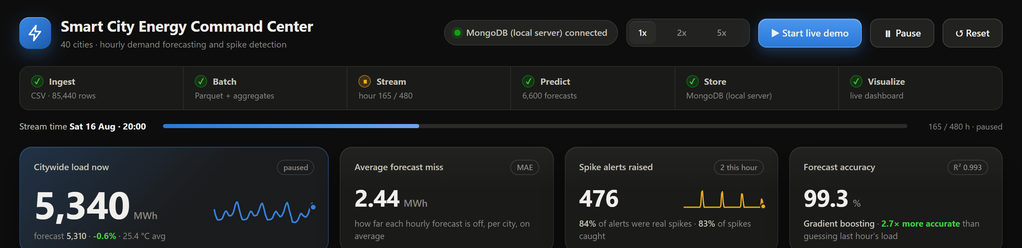
Figure 1. Smart City Energy Command Center — live dashboard header and key metrics.

1. Objective
Implement machine-learning algorithms on smart-city data and integrate every component of a big-data pipeline into a single live Smart City Dashboard. The chosen prediction domain is energy-demand modelling: forecasting each city's next-hour electricity consumption and raising early alerts for consumption spikes.
The system demonstrates the complete flow required by the experiment:
- Ingestion: hourly readings for 40 cities are loaded and validated
- Batch processing: a Parquet snapshot and pre-computed aggregates summarise history
- Prediction: scikit-learn models forecast demand and classify spike risk
- Stream processing: held-out days are replayed hour by hour through the models
- NoSQL storage: every event, prediction and alert is stored as a document
- Visualization: all of the above is shown in one auto-refreshing dashboard

2. System architecture
The pipeline is built from focused Python modules, each owning one stage. Data flows in one direction from ingestion through to the dashboard.
Stage | Module | Technology | Output
Ingestion & data build | generate_data.py | pandas, NumPy | hourly dataset (CSV)
Batch + ML training | pipeline.py | scikit-learn, PyArrow | models, metrics, Parquet
NoSQL storage | store.py | MongoDB / pymongo | 6 document collections
Stream processing | stream.py | threading, joblib | events, predictions, alerts
Dashboard | dashboard.py | Plotly Dash | live web UI
Big-data cross-check | spark_mllib_train.py | Apache Spark MLlib | comparison metrics

Table 1. Pipeline stages and the technology used at each.

3. Data and feature engineering
The system works with an hourly energy dataset covering 40 cities over 2025's summer period — 85,440 city-hour records (2025-06-02 to 2025-08-29). Each record combines static city attributes (population, area, smart-grid adoption, infrastructure score, public-transport usage, internet speed) with time-varying drivers and the engineered features a real forecaster relies on.
Predictive features
- Calendar: hour of day, day of week, weekend flag — capture daily and weekly rhythm
- Weather: hourly temperature, including modelled heat waves that drive cooling load
- Autoregressive: load 1 hour ago, load 24 hours ago, and the rolling 24-hour mean
A spike label marks each hour whose demand exceeds that city's own 90th percentile over the training window — the event the classifier learns to anticipate. The data is split chronologically: the first 70 days (66,240 rows) train the models and the final 20 days (19,200 rows) are held out and streamed live, so every forecast on the dashboard is made on unseen data.

4. Machine-learning models

4.1 Energy-demand forecasting
Several regressors were trained to predict the next-hour demand and compared against three naive baselines on the held-out period. Gradient boosting was selected as the best model.
Model | Type | MAE (MWh) | RMSE | R²
Mean baseline | baseline | 52.92 | 63.56 | -0.0000
Seasonal naive (same hour yesterday) | baseline | 9.23 | 15.14 | 0.9432
Persistence (last hour) | baseline | 6.96 | 10.83 | 0.9709
Ridge regression | learned | 5.54 | 8.59 | 0.9817
Random forest | learned | 2.73 | 5.67 | 0.9920
Gradient boosting | learned | 2.62 | 5.22 | 0.9933

Table 2. Forecast models on the held-out last 20 days (lower MAE/RMSE is better).
The selected Gradient boosting model reaches MAE 2.62 MWh and R² 0.993, cutting the error of the best naive method (persistence) by more than half. Permutation importance shows recent load (1 h and 24 h lags) and temperature are the dominant drivers — consistent with how real energy demand behaves.

4.2 Spike-risk classification
A gradient-boosting classifier estimates the probability that each city-hour is a demand spike. An alert is raised when that probability reaches 50%.
Classifier | Precision | Recall | F1 | ROC-AUC
Logistic regression | 0.764 | 0.631 | 0.691 | 0.966
Gradient boosting | 0.868 | 0.867 | 0.867 | 0.986

Table 3. Spike classifier performance on the held-out period.
The selected classifier achieves F1 0.87 and ROC-AUC 0.986, catching the large majority of genuine spikes while keeping false alarms low.

5. Batch, streaming and NoSQL integration

5.1 Batch layer
On startup the full dataset is written as a Parquet snapshot (columnar, compressed) and the pipeline pre-computes aggregates: an hour-by-weekday demand heatmap, per-city averages and peaks, daily totals, and a smart-grid-adoption comparison. These feed the dashboard's batch panels and are stored in the NoSQL batch_summary collection.

5.2 Stream processing
A background thread replays the 20 held-out days one hour at a time (all 40 cities per tick). For each tick the engine runs the forecast and classifier, writes the events, predictions and alerts to the store, and updates the running accuracy metrics the dashboard displays. Playback speed (1×/2×/5×), pause and reset are driven from the UI.

5.3 NoSQL document store
Storage uses MongoDB, a document-oriented NoSQL database (a local server managed with MongoDB Compass, or a managed Atlas cluster), through pymongo. The connection string is read from the MONGODB_URI environment variable and never stored in code. If the database is unavailable the system automatically falls back to a local JSON document store so the demo never breaks; the dashboard shows which backend is active. Six collections are maintained:
- stream_events: one document per city per streamed hour (actual demand)
- predictions: the forecast and spike probability for each city-hour
- alerts: spike alerts, with severity and whether the spike was later confirmed
- stream_metrics: per-tick totals and running error
- batch_summary: the pre-computed batch aggregates
- model_metrics: the model comparison tables and feature importance

6. Live dashboard
All components are integrated into one Plotly Dash dashboard that refreshes every second while streaming. A pipeline stepper across the top shows each stage lighting up as data flows through it; KPI cards show live citywide load, streaming forecast error, alerts raised and model quality; and panels below show the live actual-vs-forecast demand, current spike risk by city, the batch heatmap, a per-city explorer, the model comparison, feature importance, the live alert feed and NoSQL document counts.
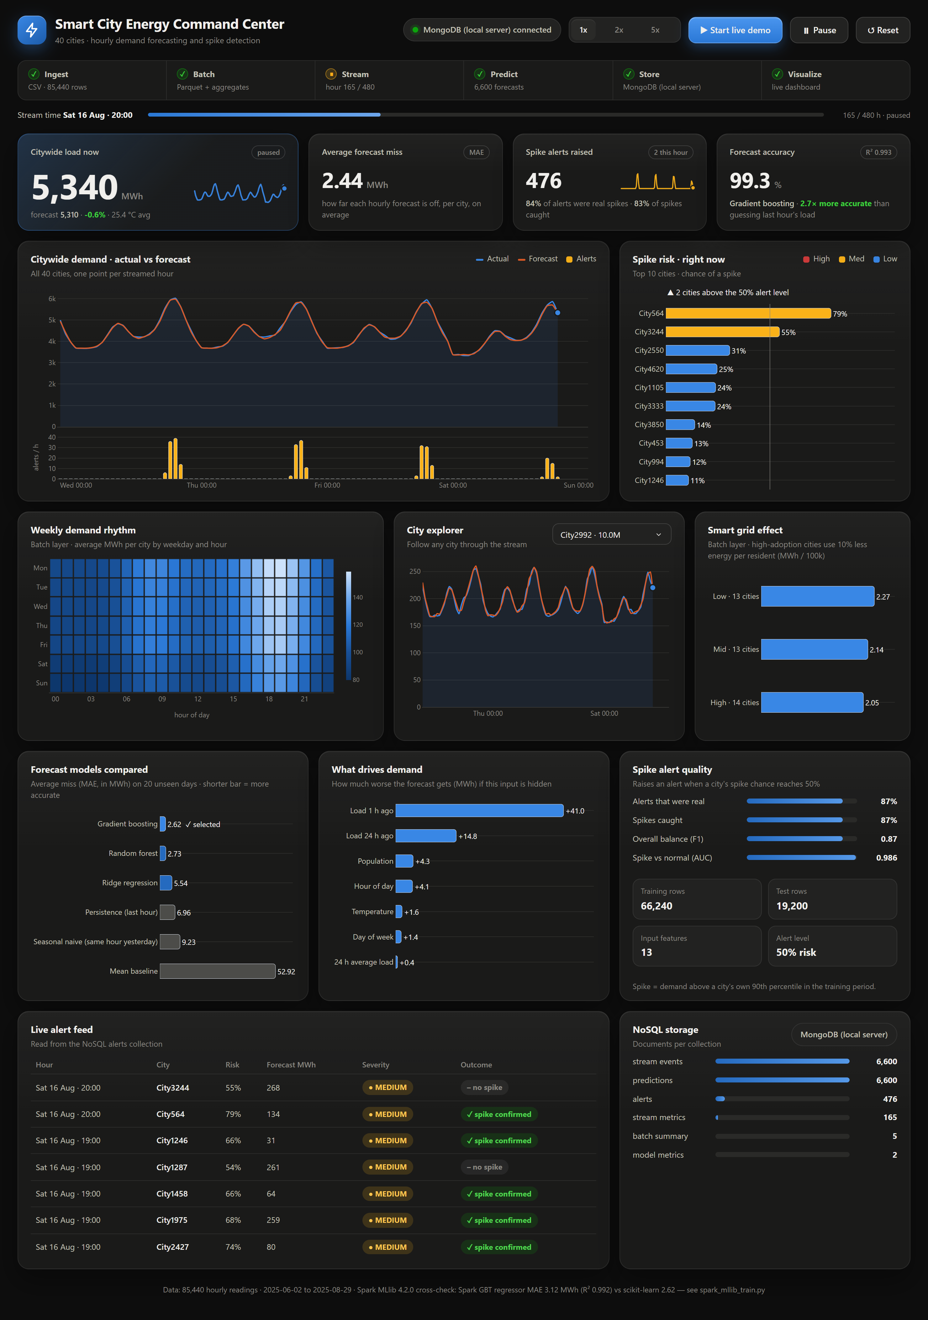
Figure 2. The full dashboard mid-stream — batch, prediction, streaming and NoSQL views together.

7. Spark MLlib cross-check
To demonstrate the big-data model path, the same dataset and chronological split were used to train models with Apache Spark MLlib 4.2.0 (VectorAssembler + gradient-boosted trees, in local mode). The results align closely with scikit-learn, confirming the approach scales to a distributed engine.
Model | Engine | MAE (MWh) | RMSE | R²
Spark GBT regressor | Spark MLlib | 3.12 | 5.76 | 0.9918
Spark random forest | Spark MLlib | 3.86 | 6.63 | 0.9891
Gradient boosting (scikit-learn) | scikit-learn | 2.62 | 5.22 | 0.9933

Table 4. Spark MLlib vs scikit-learn on the same held-out period.

8. Cloud deployment mapping
The system runs locally for the demonstration, with MongoDB as the storage layer (a managed MongoDB Atlas cluster is a drop-in replacement through one connection string). Every component maps directly to a managed service on the major clouds:
Local component | AWS | Azure | GCP
Parquet batch store | S3 | Blob Storage | Cloud Storage
Stream processing | Kinesis | Event Hubs | Pub/Sub
Spark MLlib job | EMR | Synapse / HDInsight | Dataproc
NoSQL store | DocumentDB | Cosmos DB | Firestore
Dashboard host | Elastic Beanstalk | App Service | Cloud Run

Table 5. Managed cloud equivalents for each pipeline component.

9. Live demonstration script
The working system is demonstrated end to end as follows:
- Start the dashboard (python dashboard.py or run.bat) and open http://127.0.0.1:8050.
- Point out the pipeline stepper: Ingest and Batch are already complete; the NoSQL badge shows the active storage backend.
- Press ▶ Start live demo. The stream begins replaying held-out hours; the Stream, Predict and Store stages light up.
- Watch the citywide demand chart track actual vs forecast, and the KPI cards update the live load, streaming error and alert count each second.
- Show the spike-risk panel and the live alert feed filling as the model flags high-demand cities; note the 'spike confirmed' outcomes.
- Open the NoSQL storage panel and show the document counts growing in real time.
- Use the city explorer and speed controls (1×/2×/5×), then Pause and Reset to show full control of the stream.

10. Limitations and conclusion
Limitations
- The stream replays recorded held-out data rather than a live sensor feed; it is a faithful replay of unseen hours, not a connection to a physical grid.
- The demonstration runs on a single machine. The Spark MLlib path and the cloud mapping in Section 8 show how each stage would scale out in production.
Conclusion
The project delivers a complete, working smart-city big-data pipeline in a single live dashboard. Machine-learning models forecast energy demand to R² 0.993 (MAE 2.62 MWh) and detect demand spikes at F1 0.87, and their outputs are integrated with batch analytics, real-time streaming metrics and NoSQL storage. All required pipeline components — ingestion, batch and stream processing, prediction, storage and visualization — are demonstrated together as one running system.

