## Energy saving using Automated Smart

## Street Lights

*Submitted in partial fulfillment of the requirements for the degree of*

**Bachelor of Technology**

in

**Electronics and Communication Engineering**

*by*

**Maneesh Busi**

**16BEC0710**

**Under the guidance of**

**Prof. / Dr. Elizabeth Rufus**

**SENSE**

**VIT, Vellore.**



May, 2020

## DECLARATION

I hereby declare that the thesis entitled “Energy saving using automated smart street lights” submitted by me, for the award of the degree of *Bachelor of Technology in* *Electronics and Communication Engineering* to VIT is a record of bonafide work carried out by me under thesupervision of **Prof. Elizabeth Rufus**.

I further declare that the work reported in this thesis has not been submitted and will not be submitted, either in part or in full, for the award of any other degree or diploma in this institute or any other institute or university.

Place : Vellore

Date :

**Signature of the Candidate**

## CERTIFICATE

This is to certify that the thesis entitled “Energy saving using automated smart street lights ” submitted by **Maneesh Busi, 16BEC0710, SENSE**, VIT University, for the award of thedegree of *Bachelor of Technology in Electronics and Communication Engineering*, is a record of bonafide work carried out by him under my supervision during the period, 01. 12. 2018 to 30.04.2019, as per the VIT code of academic and research ethics.

The contents of this report have not been submitted and will not be submitted either in part or in full, for the award of any other degree or diploma in this institute or any other institute or university. The thesis fulfills the requirements and regulations of the University and in my opinion meets the necessary standards for submission.

Place

Date

: Vellore

:

**Signature of the Guide**

**Internal Examiner** **External Examiner**

Head of the Department

SENSE

## ACKNOWLEDGEMENTS

I wish to express my sincere thanks to Dr.G.Viswanathan, Chancellor, Mr. Sankar Viswanathan, Vice President, Ms. Kadhambari S. Viswanathan, Assistant Vice President, Dr.Anand A. Samuel, Vice Chancellor and Dr. P. Gunasekaran, Pro-Vice Chancellor for providing me an excellent academic environment and facilities for pursuing B.Tech. programme. I am grateful to Dr. Vaidehi Vijayakumar, Dean of School of Com-puting Science and Engineering, VIT University, Vellore. I would like to express my gratitude to my internal guide Prof. Elizabeth Rufus and my external guide Mr. A.V Satish Kumar who inspite of their busy schedule guided me in the correct path. I am thankful to **Quantela Technologies Pvt. Ltd**., Hyderabad for giving me an opportunity to work on my project and helped me gain knowledge. I thank my family and friends who motivated me during the course of the project work.

**Maneesh Busi**

## Executive Summary

Currently, in the world, enormous electric energy is consumed by the street lights, which are automatically turned on when it becomes dark and automatically turned off when it becomes bright. This is a huge waste of energy. This paper discusses a smart street light system.

The main aim of smart street light systems is that lights turn on when needed with the minimum required intensity so as to not use too much power, and light turn off when not needed.

The smart street light system consists of LED lights, brightness sensors, motion sensors and short-distance communication networks. The lights turn on before pedestrians and vehicles come and turn off or reduce brightness when there is no one. It will be difficult for pedestrians and drivers of vehicles to distinguish our smart street lights and the conventional street lights because our street lights all turn on before they come.

|  |  |  |  |
| --- | --- | --- | --- |
|  |  | CONTENTS | **Page** |
|  |  |  | **No.** |
|  | **Acknowledgement** | | i |
|  | **Executive Summary** | | ii |
|  | **Table of Contents** | | iii |
|  |  | |  |
| 1 | **INTRODUCTION** | | 1 |
|  | 1.1 | Objective | 1 |
|  | 1.2 | Motivation | 1 |
|  | 1.3 | Background | 2 |
| 2 **PROJECT DESCRIPTION AND GOALS** | | | 2 |
| 3 | **TECHNICAL SPECIFICATION** | | 3 |
| 4 **DESIGN APPROACH AND DETAILS (as applicable)** | | | . |
|  | 4.1 | Design Approach / Materials & Methods | . |
|  | 4.2 | Codes and Standards | . |
|  | 4.3 | Constraints, Alternatives and Tradeoffs | . |
| 5 **SCHEDULE, TASKS AND MILESTONES** | | | . |
| 6 | **PROJECT DEMONSTRATION** | | . |
| 7 | **COST ANALYSIS / RESULT & DISCUSSION (as applicable)** | |  |
| 8 | **SUMMARY** | |  |
| 9 | **REFERENCES** | |  |

|  |  |  |
| --- | --- | --- |
|  | **List of Figures** |  |
| **Figure No.** | **Title** | **Page No.** |
| 2.1 | Figure caption | 13 |
| 2.2 | Figure caption | 15 |

(In the chapters, figure caption should come below the figure and table caption should come above the table. Figure and table captions should be of font size 10.)

**List of Tables**

**Table No.**

**Title**

**Page No.**

2.1 Table caption

28

|  |  |
| --- | --- |
|  | **List of Abbreviations** |
| 3GPP | Third Generation Partnership Project |
| 2G | Second Generation |
| 3G | Third Generation |
| 4G | Fourth Generation |
| AWGN | Additive White Gaussian Noise |

**Symbols and Notations**

f

CFO

NCFO

## 1. INTRODUCTION

### 1.1. OBJECTIVE

Automation’s main goal is to reduce manual labour or man power with the help of intelligent systems so that humans can be used for more creative and thought-based work instead of physical work. But usage of machines usually requires a lot of electrical power. So one of the main considerations when automating a particular system is cost effectiveness and power consumption.

The main aim of the project is Automatic street power saving system using Ambient Light resistor and Infra-red sensors. We can save power automatically using this system instead of someone manually doing it. So it’s also cost effective.

### 1.2. MOTIVATION

Nowadays, in the whole world, street lights consume enormous electric energy. The number of street lights is not known accurately, but it is said that one hundred million or one billion street lights exist in the whole world. If one hundred million street lights exist, each street light consumes 20W and a half of all street lights always turn on in the whole world, 8760GWh electric power, which is about 0.8% of annual consumption of electric power in Japan. In the future, many developing countries will install many street lights and consume much electric power. Thus, to save electric power that is consumed by street lights is important to reduce greenhouse gases.

Current street lights are controlled only by means of the embedded brightness sensors; they are automatically turn on when it becomes dark and automatically turn off when it becomes bright. This is the huge waste of energy in the whole world and should be changed. There are some attempts in which the energy wastes of the street lights are reduced. A sensor light, which is controlled by a brightness sensor and a motion sensor, is sometimes used to reduce wastes of energy. It only turns on for a while when the motion is detected in front of the light and it is dark. However, usually a sensor light is too late to turn on when pedestrians or vehicles come in front of it. The light should turn on before pedestrians or vehicles come. Ideally, it is desirable that smart street lights look like usual street lights; no one notices that smart street lights are usual street lights.

### 1.3. BACKGROUND

When you get up in the morning you may have noticed that street lights are still ON when it’s not necessary & when you travel to rural areas either there is no street lamp or there are not so many vehicles to fully utilize that facility. Simply it means the wastage of electricity. At the beginning, street lamps were controlled manually in which the control switch was set in each of the street lamps. That was called as the first generation of the original street light. Another method that has been used after that was based on the optical control method. In this method the high pressure sodium lamps were used. Even the new automated street lights usually require some kind of human intervention to run perfectly. The amount of resources in the above examples is a little too much for something as simple as a street light, something which even rural areas have. Most rural areas won’t be able to afford the cost required for these resources. This project suggests an automatic system which uses less power and provides more features as compared to other street light systems.

## 2. PROJECT DESCRIPTION AND GOALS

The automated light system controls the street light to give out the minimum intensity required to light up the surrounding area. It is a simple yet powerful concept using ambient light sensors and IR sensors.

The lights switch on and glow at a low intensity at a given time. This intensity depends on the light falling on the ambient light sensor placed near the chosen lane. The intensity is recorded and updated in our custom-made IoT UI Dashboard using a messaging protocol called MQTT.

If a vehicle happens to use the lane where the street lights are installed, the IR sensor which is placed a few metres before the street light senses the vehicle. It then sends that data to the microcontroller to turn up the intensity of the light to a 100% output.

Each IR sensor will control 3 street lights that come after it. The lights wont switch off/turn down their intensity as long as the car doesn’t hit the next IR sensor i.e. the lights are not programmes to switch off after a certain delay, instead they are made to turn off when the vehicle moves forward and passes the next “checkpost” which is the IR sensor. This little algorithm will be useful when the vehicle is not in a condition to move in the middle of the road.

The project also has a parking system which uses the same technology and code used above, but instead switches off the surrounding lights except the light placed near the parking spot.

## 3. TECHNICAL SPECIFICATIONS

### 3.1 Hardware Specifications

#### 3.1.1 Arduino Mega

Fig 3.1 is a pinout diagram of Arduino MEGA, the microcontroller being used for this project.

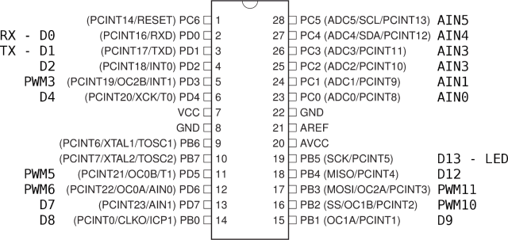

Fig. 3.1 : Pin diagram of Arduino MEGA

And Table 3.1 is the specification of the microcontroller.

Table 3.1 :- Specification of Arduino MEGA

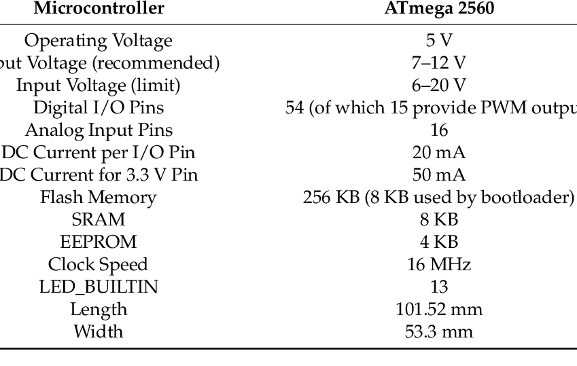

#### 3.1.2 NodeMCU

NodeMCU is also a microcontroller but doesn’t have enough power to control the whole system. So instead it is being used as a Wi-Fi Shield for the Arduino to connect to the internet.

Fig 3.2 contains the pinout diagram of the module. We will be using only 4 pins here. The Tx , Rx pins and 2 other pins which are set as a secondary input and output for serial communication.

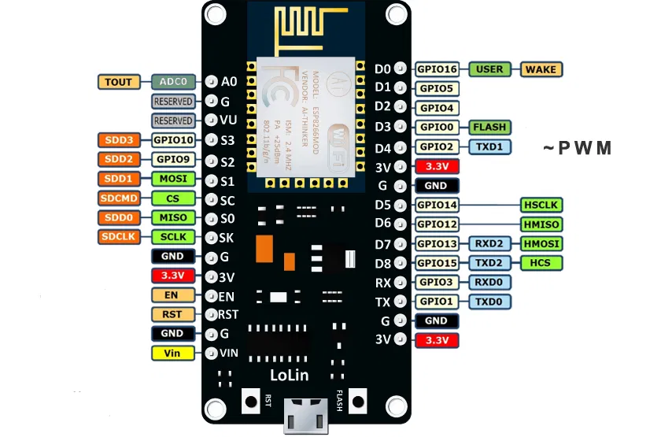

Fig 3.2 GPIO Pinout of NodeMCU

Table 3.2:- Specification of the NodeMCU

|  |  |
| --- | --- |
| **Microcontroller** | **ESP-8266 32-bit** |
| NodeMCU Size | 49mm x 26mm |
| Pin Spacing | 22.86mm |
| Clock Speed | 80MHz |
| USB to Serial | CP2102 |
| USB Connected | Micro USB |
| Operating Voltage | 3.3v |
| Input Voltage | 4.5V-10V |
| SRAM | 4MB/ 64KB |
| Digital I/O Pins | 11 |
| Analog Pins | 1 |
| ADC Range | 0-3.3V |
| UART/SPI/I2C | 1/1/1 |
| WiFi Built-in | 802.11 b/g/n |
| Temperature Range | -40C -125C |

#### 3.1.3 Light Dependent Resistor (LDR)

An LDR is a component that has a (variable) resistance that changes with the light intensity that falls upon it. This allows them to be used in light sensing circuits.

Fig 3.3 (a) is an LDR and (b) is the circuit symbol of an LDR.

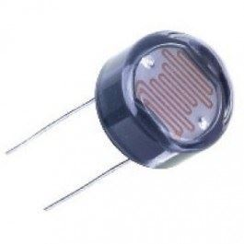 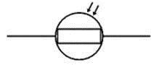

(a) (b)

Table 3.3 :- Specification for LDR

|  |  |
| --- | --- |
| **Product** | **GM5539 LDR** |
| Diameter | 5mm |
| Maximum voltage | 150V DC |
| Maximum wattage | 90mW |
| Spectral peak | 540nm |
| Light Resistance | 50-100Kohm |
| Operating temperature | -30 ~ + 70 degree Celsius |

#### 3.1.4 Infrared Sensors (IR Sensor)

An infrared sensor is a set of an electronic transmitter and receiver device that emits IR rays in order to sense some objects in the surroundings. The range of IR sensors is normally 8-10 meters.

Fig 3.4 (a) is the IR module being used for the project, (b) labels its components and Fig 3.4 (c) explains the working of the sensor. Both the IR LED and PhotoDiode are in the same IR Module here, which is why the range of this sensor is far less than other IR sensors.

Fig 3.4

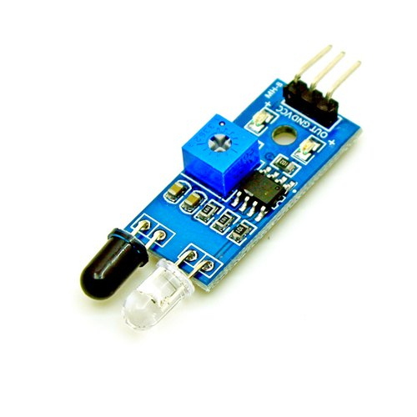 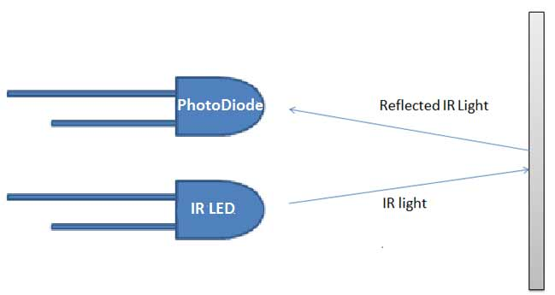

(a) (c)

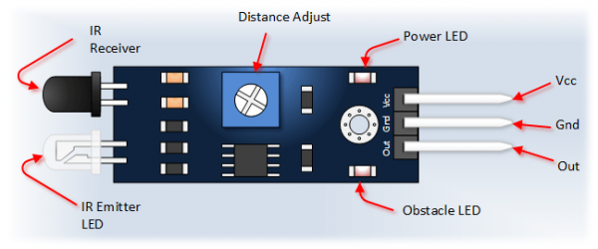

(b)

Table 3.4:- Specification of IR Module

|  |  |
| --- | --- |
| **Product** | **IR Obstacle Sensor** |
| Operating Voltage | 3.0V - 5.0V |
| Detection range | 2cm -30cm |
| Current Consumption | At 3.3V: ~23mA, at 5.0V: ~43mA |
| Active output level | Outputs Low logic level when obstacle is detected |

#### 3.1.5 Street Light (LED)

A light-emitting diode(LED) is a two lead semiconductor light source which is made up of InGaN material. It is a pn-junction diode, which emits light when activated.When a suitable voltage is applied to the leads of LED, electrons can recombine with electron holes within the device, and release energy in the form of photons.

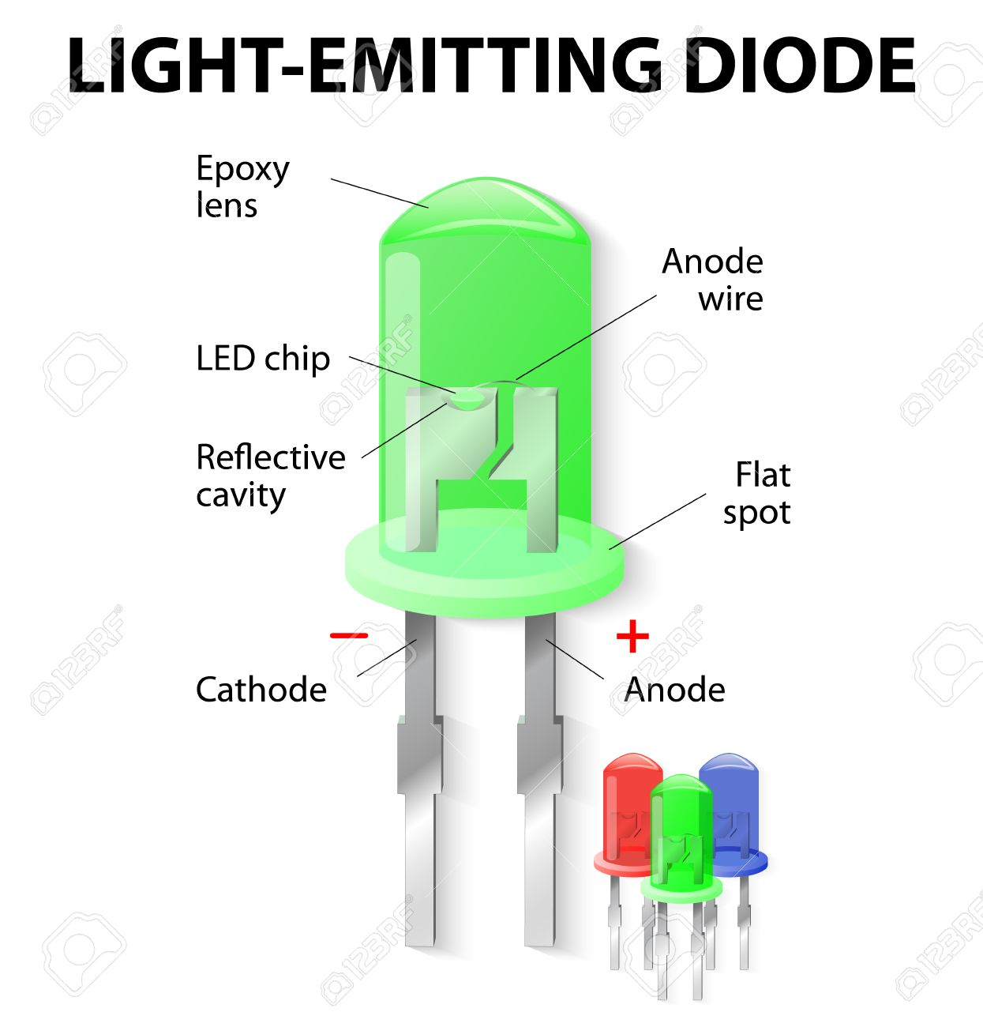

Fig 3.5 LED pinout

Table 3.5 Specifications of LED used

|  |  |
| --- | --- |
| **Product** | **Generic LEDs** |
| Diameter | 5mm |
| Voltage | 3.0V - 3.3V |

### 3.2 Software Specifications

3.2.1

## 4. DESIGN APPROACH AND DETAILS

### 4.1 Design Approach / Materials & Methods

#### 4.1.1 Hardware design

* The model consists of two lanes, the first being a parking space and the other a regular one-way highway. The parking space has two spaces available and there are ambient light sensors at the end of each lane.
* When switched on, the ambient light sensor detects the light falling on it, and calculates how much light intensity is required to light up the lane i.e., how much voltage is supplied to the street lights.
* The LDR detects the light and converts it into an analog value between 0 and 255. This value is then subtracted from 255 and stored.

**Y=255-ldr**

* This Y value is then used to vary the intensity of the street lights. This is done using PWM pins on the Arduino Board.
* As this is happening, the infrared sensors (IR Sensors) are looking for objects (vehicles) that pass in front of them.
* When they detect a vehicle, the IR sensor sends a boolean value to the Arduino and the arduino increases the intensity of **2** street lights, that come right after the sensor, to full intensity regardless of the Y value.
* One of the major drawbacks of an automatic light system is that it assumes that the vehicles are constantly moving without stopping in the middle of the road. But that is not always the case. It could be a medical emergency or maybe the vehicle broke down.
* If the car is stopped right next to the sensor i.e., blocking the sensor then the street light will be on. But if the vehicle stops between two sensors, then most street lights would switch off after a while.
* This drawback is rectified. Let’s assume the first sensor is X and the first street light is Y. Let us also assume that a sensor is placed after every street light. So the lane would somewhat like this:

|  |  |  |  |  |  |  |  |  |  |  |
| --- | --- | --- | --- | --- | --- | --- | --- | --- | --- | --- |
| X | Y | X+1 | Y+1 | X+2 | Y+2 | X+3 | Y+3 | X+4 | Y+4 | X+5 |

* Sensor X triggers lights Y and Y+1. And usually they switch off if nothing is blocking X. But in this system, the lights will only switch off if the vehicle hits the sensor that comes after the lights.
* Here X triggers Y and Y+1 to switch on. And they stay on indefinitely until the vehicle passes the X+1 sensor. Then Y is switched off and Y+2 and Y+3 are switched on. When the vehicle passes X+2 then Y+1 is switched off. This goes on until X+5 when all lights until Y+4 are switched off.
* The system also takes into account that multiple vehicles use the lane, so there is a loop that checks the IR status constantly.
* The parking lot also employs a similar working system except when it comes to the lights installed at the parking spot. In the parking lot, there are regular street lights put up along with a separate street light for each parking space.
* When a vehicle parks in the space, an IR sensor placed there detects the vehicle’s presence and informs it to the controller. Then all the surrounding street lights are switched off and only the parking space light is on.
* When the vehicle is leaving, the driver usually takes a reverse to come out of the parking spot. When going back, the vehicle will trigger an IR sensor placed in the regular lane, which will switch on the regular street light of the lane and switch off the parking space light.

#### 4.1.2 Software design

* Sf
* Sf

**References**

1. Sergiy Fefilatyev, “Algorithms for Visual Maritime Surveillance with Rapidly Moving Camera”, Doctoral dissertation, University of South Florida, 2012.
2. Domenico Bloisi, Luca Iocchi, Michele Fiorini, Giovanni Graziano, “Automatic Maritime Surveillance with Visual Target Detection”, International Defense and Homeland Security Simulation Workshop (DHSS), September 2011.
3. Domenico Bloisi, Luca Iocchi, Michele Fiorini, Giovanni Graziano, “Camera Based Target Recognition for Maritime Awareness”, Information Fusion (FUSION), 15th International Conference, July 2012.
4. Rodrigo Da Silva Moreira, Nelson Francisco Favilla Ebecken, Alexandre Soares Alves, Frédéric Livernet4, Aline Campillo-Navetti, “A Survey on Video Detection and Tracking of Maritime Vessels”, IJRRAS 20, July 2014.
5. Digi-key Corporation. http://www.digikey.com/

[6] Alldatasheet. http://www.alldatasheet.com/