**Construction of variable length hash function from fixed length hash function**

**Merkle Damgard Transform**

Theorem:

If (Gen, h) is a fixed length collision resistant hash function, then (Gen, H) is a collision resistant hash function

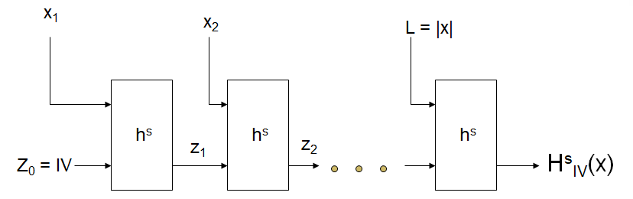

Let (Gen, h) be a fixed-length collision-resistant hash function for inputs of length $2l\left(n\right)$ and output length $l\left(n\right)$. Construct a variable-length hash function (Gen, H) as flows:

* Gen: remains unchanged
* H: on input a key s and a string $x ϵ {\left\{0.1\right\}}^{*}$ of length $L<2^{l\left(n\right)}, do the following (set l=l(n)$ in what follows:
  1. Set $B≔ \left\lceil \frac{L}{l}\right\rceil$ (i.e., the number of blocks in x). Pad x with zeroes so its length is a multiple of $l$. Parse the padded result as the sequence of $l$– bit blocks $x_{1},x_{2},…, x_{B}$. Set $x_{B+1}≔L,$ where L is encoded using exactly $l$ bits.
  2. Set $z_{0}≔0^{l}$.
  3. For $i=1,…, B+1$, compute $z_{i}≔h^{s}(z_{i-1}|\left|x_{i}\right).$
  4. Output $z_{B+1}$.

References

[1] J. K. a. Y. Lindell, Introduction to Modern Cryptography.

[2] B. Micali, "Hardcord bits," [Online]. Available: <https://crypto.stanford.edu/pbc/notes/crypto/hardcore.html>.

[3] Lecture Slides