**Collision Resistant Fixed Hash**

Assuming DL is hard to invert, we built fixed length collision resistant hash function.

**Lemma:** Fix a positive integer N, and say $q≤\sqrt{2N}$ elements $y_{1},…,y_{q}$ are chosen uniformly and independently at random from a set of size N. Then the probability that there exist distinct $i,j$ with $y_{i}=y_{j}$ is at least $\frac{q(q-1)}{4N}$. i.e., $coll\left(q,N\right)≥ \frac{q\left(q-1\right)}{4N}.$

“Smaller the value of q w.r.t N, higher is the collision resistance”

Proof:

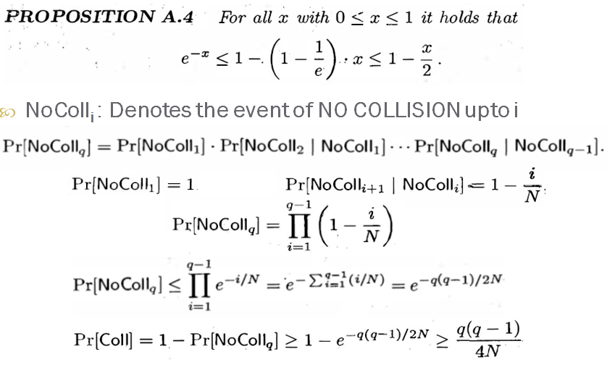

Construction of fixed length hash function

Assuming that DL is hard to invert (one-way function).

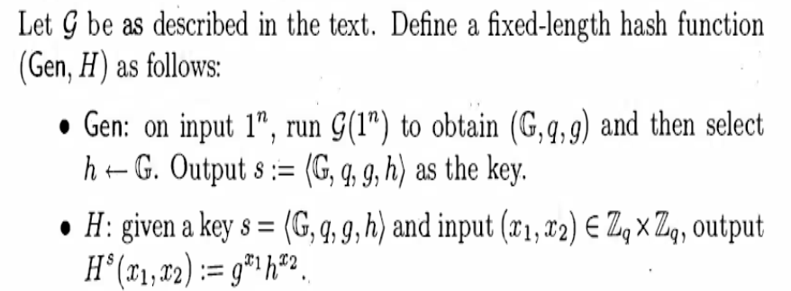

Proof by contradiction

If discrete logarithm problem is hard relative to G, then the following construction is a fixed-length collision-resistant hash function

$$H^{s}\left(x_{1},x_{2}\right)=H^{s}\left(x_{1}^{'},x_{2}^{'}\right)⇒g^{x_{1}}h^{x_{2}}=g^{x_{1}^{'}}h^{x_{2}^{'}}⇒g^{x_{1}-x_{1}^{'}}=h^{x_{2}^{'}-x_{2}}$$

$$let Δ=x_{2}^{'}-x_{2} \\ g^{{(x}_{1}-x_{1}^{'}).Δ^-1}={\left(h^{x_{2}^{'}-x_{2}}\right)}^{Δ^{-1}mod q}=h^{Δ.Δ^{-1}mod q}=h^{1}=h$$

For the given value of g, h we found an X, which contradicts the assumption of DL being a one-way function.

Hence, (Gen, H) is a collision resistant hash function.

References

[1] J. K. a. Y. Lindell, Introduction to Modern Cryptography.

[2] B. Micali, "Hardcord bits," [Online]. Available: <https://crypto.stanford.edu/pbc/notes/crypto/hardcore.html>.

[3] Lecture Slides