Network Traffic Analysis Report
MSVK Maneesh | msvkmaneesh95@gmail.com
Date: April 2026 | Tool: Wireshark 4.x | Interface: Wi-Fi

1. Objective
To capture and analyze live home network traffic using Wireshark, identify the protocols in use, detect anomalous or suspicious patterns, and document findings in a structured format aligned with SOC analyst workflows.

2. Tools & Environment
Field | Details
Tool Used | Wireshark 4.x (with Npcap 1.86 driver)
Operating System | Windows 11
Capture Interface | Wi-Fi (Home network)
Capture Duration | Approximately 10 minutes
Total Packets Captured | 1,262 packets
Total Data Captured | 181,987 bytes (~182 KB)
Capture File | capture1.pcap

3. Methodology
The following steps were performed during this analysis:
- Installed Wireshark and Npcap on a Windows 11 machine
- Initiated a live packet capture on the active Wi-Fi interface
- Generated traffic by visiting multiple websites and running ping commands
- Applied display filters (dns, http, tcp.flags.syn==1) to isolate specific traffic types
- Analyzed Statistics > Protocol Hierarchy to understand traffic composition
- Reviewed Statistics > Conversations (TCP tab) to identify top communication endpoints
- Documented all findings with screenshots for evidence

4. Findings

4.1 Protocol Distribution
The Protocol Hierarchy statistics revealed the following breakdown of captured traffic:
Protocol | Packets | % of Traffic
IPv6 / UDP / DNS | 1,248 | 98.9%
IPv4 / UDP / DNS | 14 | 1.1%

Observation: The overwhelming dominance of DNS traffic (98.9%) over IPv6 indicates the device was actively resolving domain names throughout the capture window, consistent with background services and browser activity.

4.2 DNS Analysis
Applying the dns display filter revealed 1,262 DNS query and response packets. Key domains queried included:
- filedownload.csw.lenovo.com — Lenovo background software making download requests (AAAA + CNAME records observed)
- pti.store.microsoft.com — Microsoft Store service performing routine lookups
- Google NTP servers — Time synchronization traffic (GET /time/1/current)
- DNS rate observed: 2,930 bits/sec sustained throughout the capture
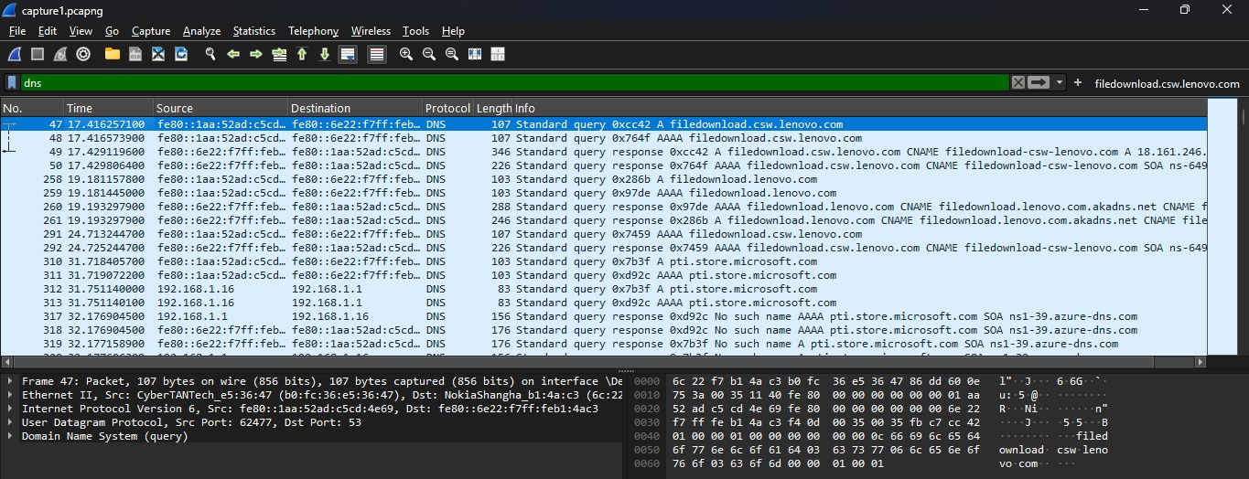

Protocol Hierarchy Statistics
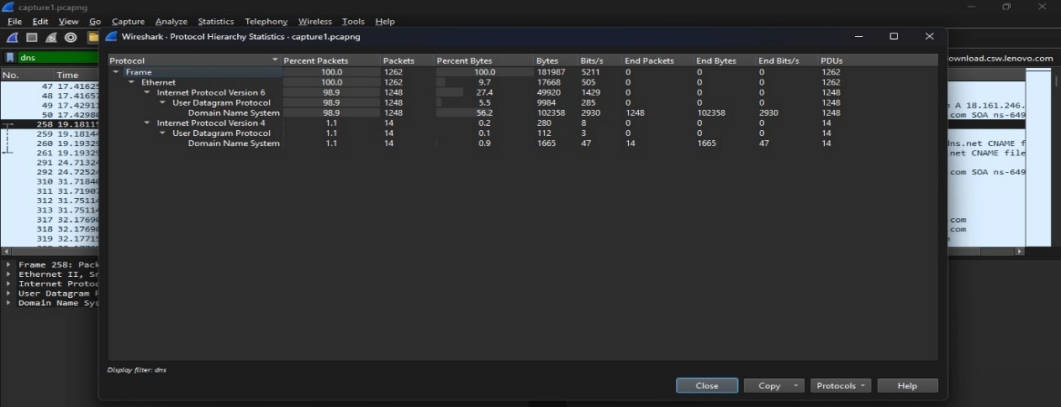

Security Finding: 3 DNS responses returned "No such name" (NXDOMAIN) for pti.store.microsoft.com — indicating a failed domain resolution. This is consistent with a misconfigured or deprecated Microsoft endpoint and does not indicate malicious activity but is worth flagging as a monitoring point.

4.3 TCP Conversations
The TCP Conversations tab (Statistics > Conversations) revealed 238 unique TCP streams. The top endpoints identified were:
- 18.161.246.122 — Akamai CDN: busiest endpoint with 481 packets and 381 KB transferred
- 4.153.129.168 — Microsoft Azure: multiple streams, up to 170 KB per stream
- 3.160.242.41 / 3.211.179.33 — Amazon AWS infrastructure
- 18.97.36.16 / 18.97.36.17 — Microsoft servers
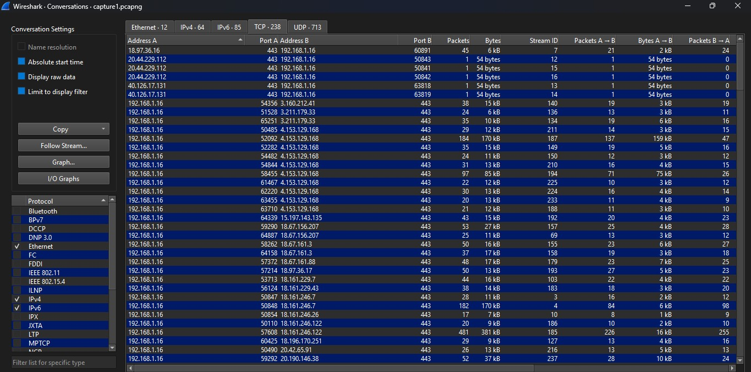

Security Finding: All 238 TCP conversations used Port 443 (HTTPS/TLS). No unencrypted TCP sessions were observed on sensitive ports. This indicates the device maintains good encryption hygiene for outbound connections.

4.4 HTTP Traffic
Applying the http filter revealed a small number of unencrypted HTTP packets, primarily consisting of:
- Microsoft Windows Update .cab file downloads from 151.101.38.172 (Fastly CDN)
- Google time synchronization request (GET /time/1/current) over HTTP/1.1
- TCP Out-of-Order and Previous Segment Not Captured events — normal behavior on a busy home network
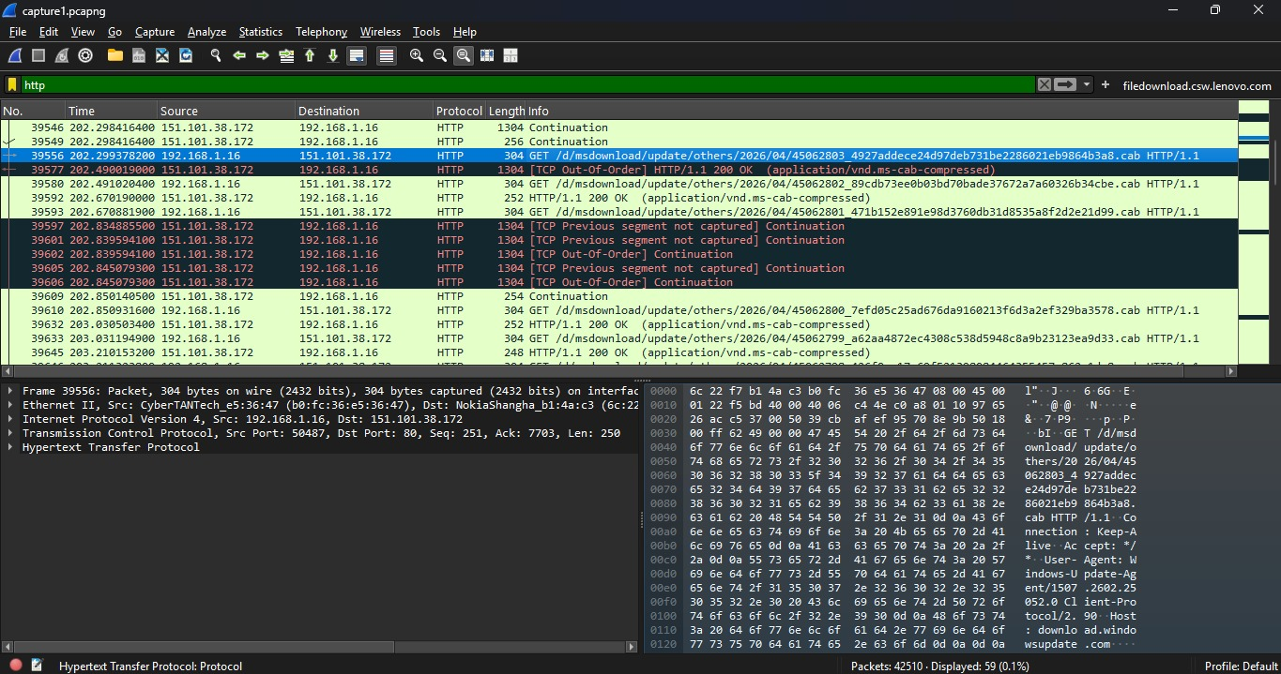

Observation: The presence of unencrypted HTTP for Windows Update delivery is a known Microsoft behavior for certain update metadata requests. No sensitive user data was observed in plaintext.

4.5 TCP SYN Analysis (New Connections)
Applying the filter tcp.flags.syn==1 revealed 15+ SYN packets representing new connection initiations. Key observations:
- All SYN packets received valid SYN-ACK responses — confirming successful three-way handshakes
- Destinations included Microsoft Azure (52.137.106.217) and Akamai CDN (18.161.246.26)
- No SYN flood pattern detected — no single destination received an abnormal volume of SYN packets
- No suspicious port scanning activity observed
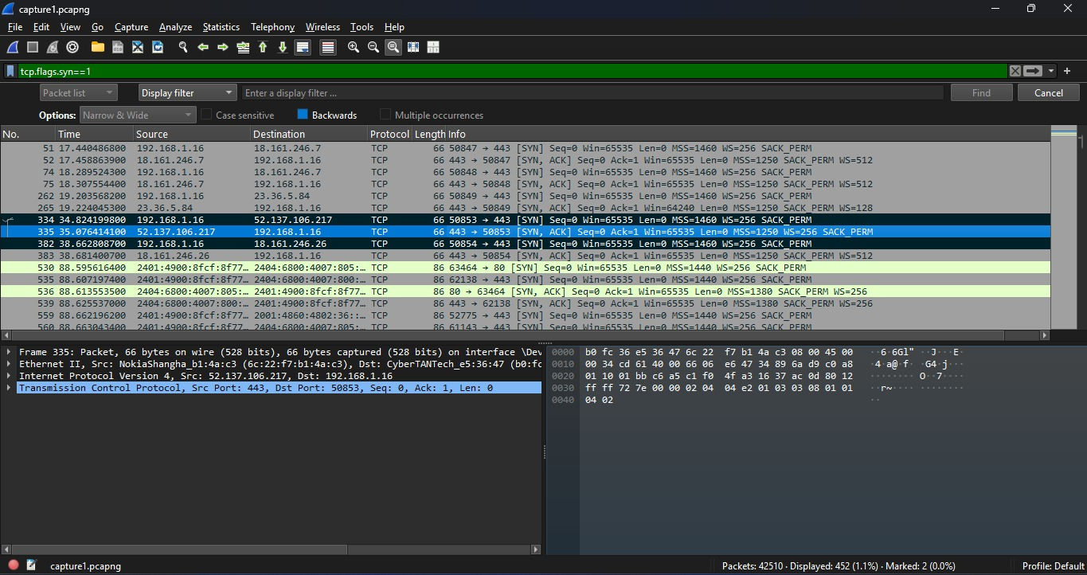

5. Summary of Findings
Finding | Severity | Notes
NXDOMAIN DNS responses | Low | Deprecated Microsoft endpoint, no user data exposed
Unencrypted HTTP (Windows Update) | Low | Known Microsoft behavior for update metadata
All TCP on Port 443 (HTTPS) | Info (Good) | All 238 TCP streams used TLS encryption
No port scanning or SYN flood | Info (Good) | Clean SYN/SYN-ACK handshakes observed

6. Conclusion
This network traffic analysis of a home Wi-Fi environment over approximately 10 minutes captured 1,262 packets totaling 182 KB of data. The traffic was predominantly DNS-based (98.9%), with all TCP connections using TLS encryption on port 443.

Two low-severity observations were noted: NXDOMAIN responses for a deprecated Microsoft endpoint, and unencrypted HTTP traffic for Windows Update metadata — both consistent with normal Windows operating system behavior. No indicators of compromise, port scanning, or suspicious outbound connections were detected.

This analysis demonstrates practical application of Wireshark for network traffic inspection, protocol analysis, and basic threat detection aligned with SOC analyst workflows.

MSVK Maneesh | msvkmaneesh95@gmail.com | linkedin.com/in/msvk-maneesh-64a936278 | github.com/ManeeshMSVK

