Task 1: Design Use Critique

(Examples shown in blue)

This design critique is performed on the website visitfaroeislands ([www.visitfaroeislands.com](http://www.visitfaroeislands.com)), a website for a getaway island called the faroeislands located halfway between Iceland and Scotland in the North Atlantic Ocean. The purpose of this website is to house all of the information about what to do there, how to plan your stay, what the currently popular events are, and much more. This is the homepage of the website which contains a navigation menu, logo, and a slideshow of pictures containing info. At first glance it looks aesthetically pleasing but after digging into each of the menu’s, some flaws seem to pop out.

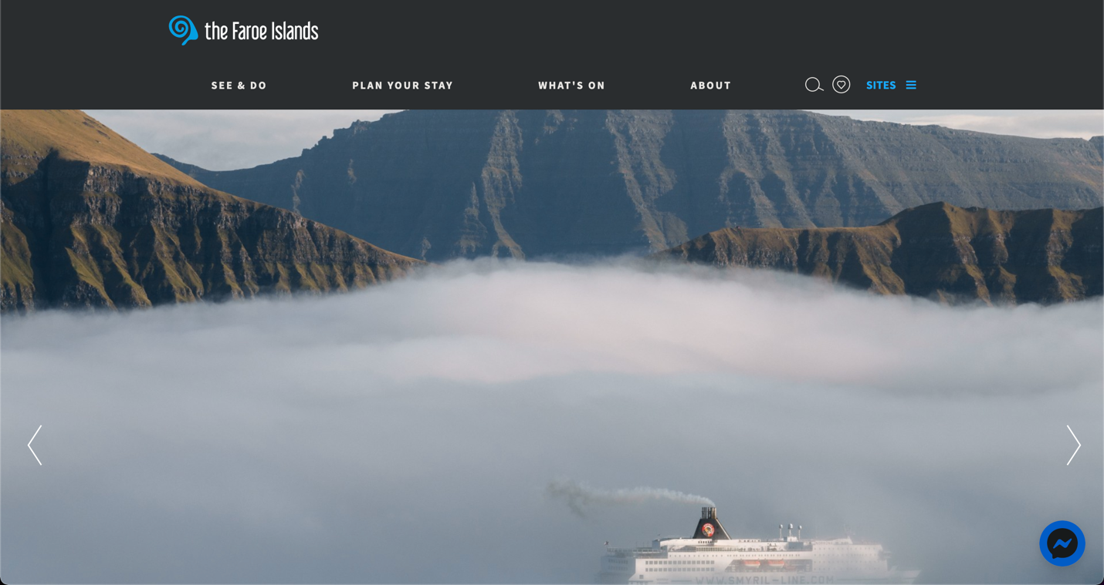

This website uses a colour scheme of dark grey/white/blue. The fonts being white, contrast well with the dark background and allows all of the buttons to be easily read. Having a clickable slideshow of what the current news is about the island is an efficient way for users to get more information without having to click around menus and pages. Things like COVID-19 plans, giveaways and other news is all within reach from the homepage. The pictures are used connect with the text and they are all high-quality images that really sell the islands to users. I especially like the blocky pictures when scrolling to the bottom. Here you will find everything about the website in a block style format with different types of grids. This type of style has recently come into play because of social media such as Pinterest and Instagram. I feel as though the drop shadow effect when hovering over any block really portrays a clean and minimal feel to the website. It also allows the user to know exactly where they are currently on the website which is key.

This website does the navigation bar a little different than others where the actual headings are the buttons that are clickable to see more pages. For example, when hovering over “Plan Your Stay”, there are subheadings such as “Transport”, “Accommodation”, and more, which contains other sub sub-headings. All of the information you would ever need are housed in this website and I could not find one option or search that was not already included. This ensures that every user, however specific their needs may be, they will undoubtably be able to find it in the menus or using the search function. Having all of this information about a getaway island allows for this website to be the one stop shop for it and everything to do about it. Do you want to learn about the history of it? Maybe some myths and legends about the islands? What about music and sports? Every little thing is documented on this website and so the lack of information is nowhere to be found.

A quick positive I have to mention is how compatible this website is with different size pages as well as mobile. I noticed when resizing the website, the navigation buttons disappear and a hamburger menu appears on the right side which houses them all. I think this is a smart touch and looks the exact same on mobile phones as well.

When going into a menu such as “Plan Your Stay”, I appreciate how the heading changes into a blue colour notifying the user what page they are currently on. This is also the same in the actual page they are in where some other options are displayed on the right-hand side. It does get confusing for the user however because the “Sites” option is also coloured in blue which would contradict the point of the function. Having the “Sites” option white instead of blue would get rid of that contradiction and confusion that some users might have. One thing that irked me while using the website was how hovering over any of the navigation buttons, a large window would appear containing all of the sub headings. This is a good idea in theory and I would have appreciated more if it were a click function but having it as a hover function does worse than good. It becomes more intrusive to the user and it does not go away until the cursor is positioned off of the big rectangle. I think the design is very nicely done but the execution could have been better by using a click function instead.

Looking at the website for the first time there is a lot of information crammed into these menu’s which can turn off the user into actually clicking around. For example, in the “Before You Arrive” sub-heading in the “Plan Your Stay” heading, there are so many different options which can overwhelm a user especially since it’s under that heading implying that there are so many things to do before arriving. This can be improved by removing all of the individuals sub sub-headings but keeping the regular sub-headings as when you click on the main heading. This will clean out the navigation bar with the useless information it contains and when a user clicks on what they want such as “Activities”, everything is layered in a block format very concisely.

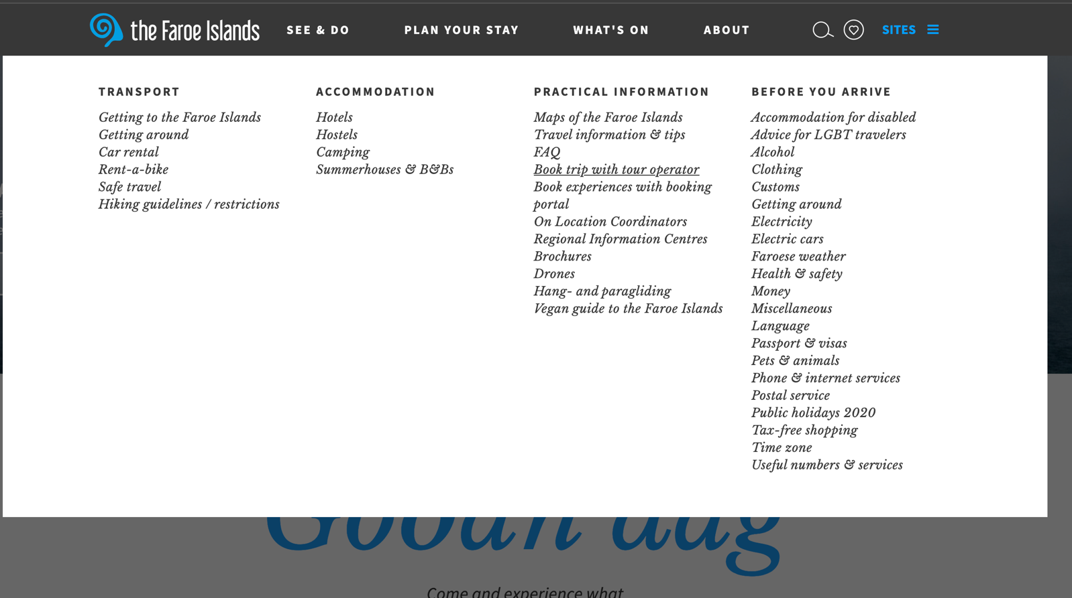

Task 2: Simple Example of a Usability Flaw

Consider the following menu page from visitfaroeislands ([www.visitfaroeislands.com](http://www.visitfaroeislands.com)),

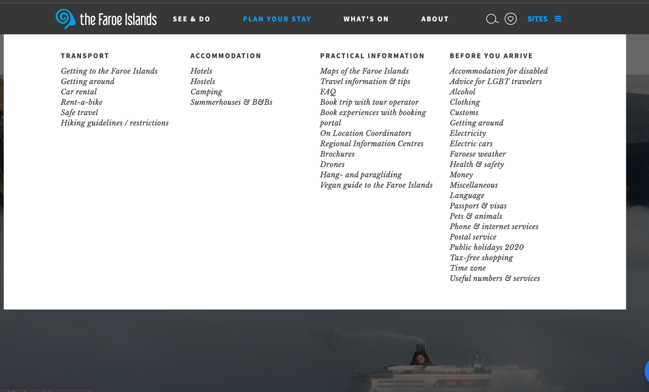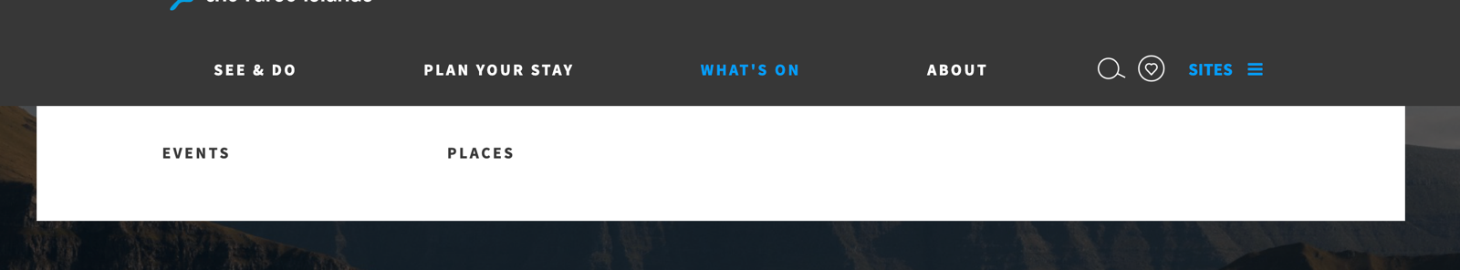

**Flaw 1:**

**Font Selection (major flaw)**

This flaw addresses the font choice for the sub-headings in the menu bar. This font is distracting to users and at some points, hard to read. It is also very inconsistent as when you hover over the “What’s on” tab, there are only 2 options and they both use the same font as the titles which begs the question as to why the other ones use a different one. Typically, an easier type of font to read would be a traditional one such as Arial. Having italicised script-like fonts are not prohibited by any means however with the amount of information provided with the site, it does become an eye sore. To fix this however, using the same font that was used in the buttons as well as the info blocks would have made everything flow better and match. Some typical fonts that could be used are Arial, Helvetica, Times New Roman, and many other web-safe fonts. Another suggestion would be to use uppercase lettering for the main headings and lower-case for the sub-headings which would allow for some differentiation if needed.

**Flaw 2: (could not properly screenshot this one but when you navigate to the site, you can see)**

**Home Page Button inconsistency (minor flaw)**

This flaw talks about the logo at the top of the page which is there at all times. I noticed that the actual button spans across most of the top page and not just the logo itself which does not make any sense. This shows me that whoever coded the button, did not properly check where the element resided in the code or did not properly resize it with the logo. Typically clicking the logo brings the user back to the homepage but it should not be the entire top part of the page being the button. It is very hidden and most users might not notice it however after simply navigating the website I noticed my cursor becoming a clickable button even when I was not hovering over the logo portion. To fix this simply make sure the button element in the HTML code is properly resized and matches with the logo in the CSS.

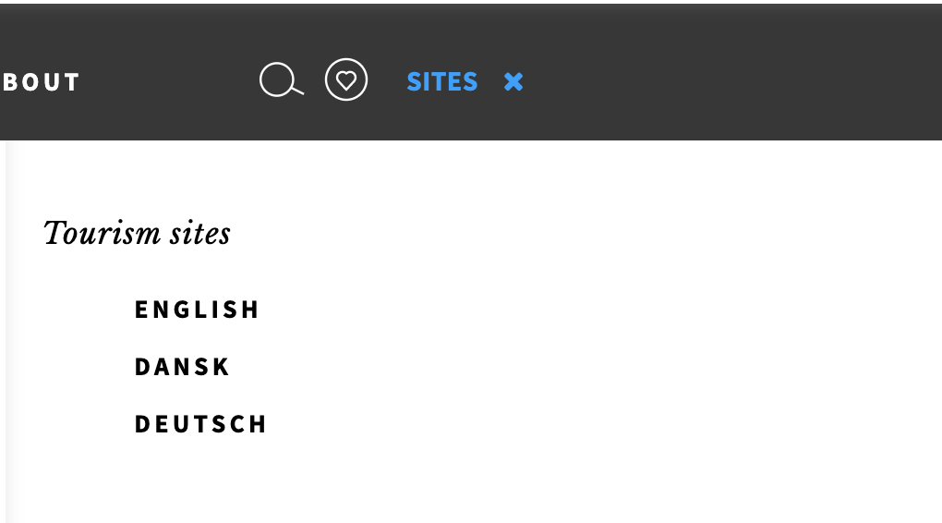

**Flaw 3:**

**Load Times for Translation Sites (major flaw)**

This flaw has to do when clicking on the sites section to change the language from English, Dansk, and Deutsch. I minor complaint I have is just to add more language options as I am sure there will be many people from different countries that do not speak any of the 3 languages and will have a hard time navigating the website. Apart from that, the load times within these 3 language options are very long. So long that I feel as though users will get discouraged and leave the site entirely. After clicking on one of the languages, it took almost a full 15 seconds to reach the site which in today’s modern web is unacceptable. Load times should be around 2-3 seconds at most and anything longer will push users away from actually using the site. I believe that this is caused by poor server use on the backend but also the fact that in these sites, the homepage has a moving image which in turn will make the load times slower. To fix this, I would change the opening image to a still one as well as maybe try using a smaller image instead. When it comes to the actual code, having the stylesheet (CSS) in the <head> element will allow the pages to feel like its loading faster because it renders the style progressively. Along with this, placing the script references in the bottom of the HTML before the closing <body> tag will allow the browser to load whatever is at the top first and deal with the scripts after. Since I do not have the code with me, I’m not sure if these fixes have been made already but they are suggestions to make pages load faster.