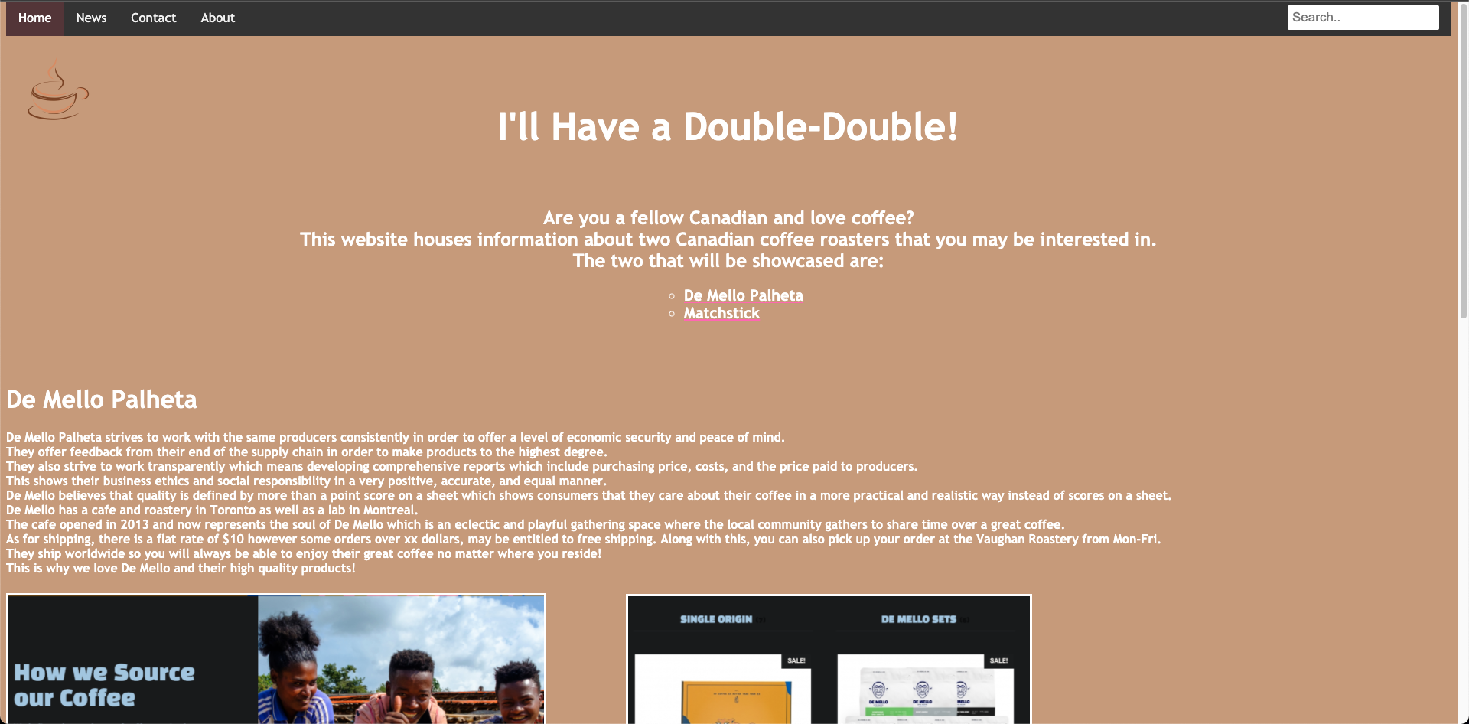

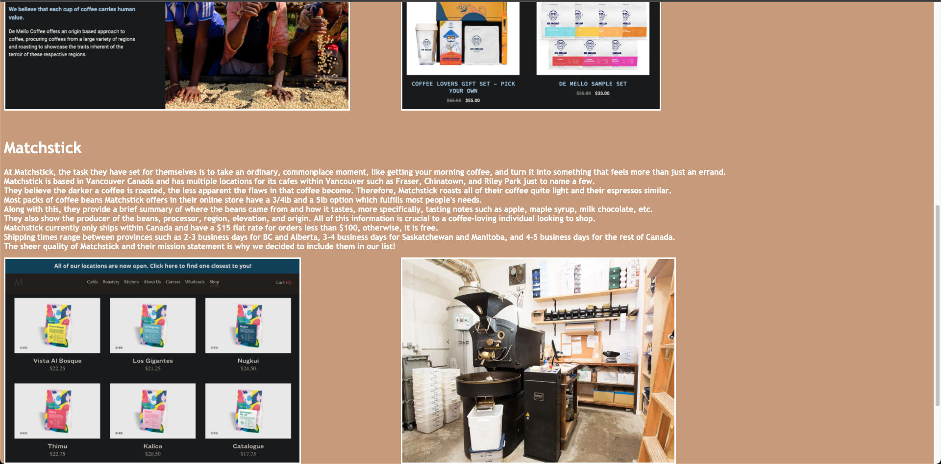



Works Cited

“COFFEE Archives.” *De Mello Coffee Roastery - Award Winning Coffee Roastery and Cafe in Toronto*, hellodemello.com/product-category/coffee/.

“Coffee Logo Design Creative Idea Logo Elements #7502 - Free Transparent PNG Logos.” *Freepnglogos.com*, www.freepnglogos.com/images/coffee-logo-png-7502.html.

“Coffee.” *Matchstick*, matchstickyvr.com/collections/coffee.

“PURCHASING PHILOSOPHY.” *De Mello Coffee Roastery - Award Winning Coffee Roastery and Cafe in Toronto*, hellodemello.com/purchasingphilosophy/.

“Roasting - The Process.” *Matchstick*, matchstickyvr.com/pages/roast-profiling.