**PACKAGING AND DEPLOYMENT OF SPFX WEBPART**

* **Steps( Commands) for Packaging and Deploying**
* Run the below commands in the terminal .

1) gulp clean

2) gulp build

3) gulp bundle –ship

4) gulp package-solution –ship

* **Steps for creation of App Catalog.**
* Sharepoint admin center->show all->sharepoint->More features
* Navigate to SharePoint admin center (https:// manuchebrolu -admin.sharepoint.com/_layouts/15/online/AdminHome.aspx#/classicFeatures)

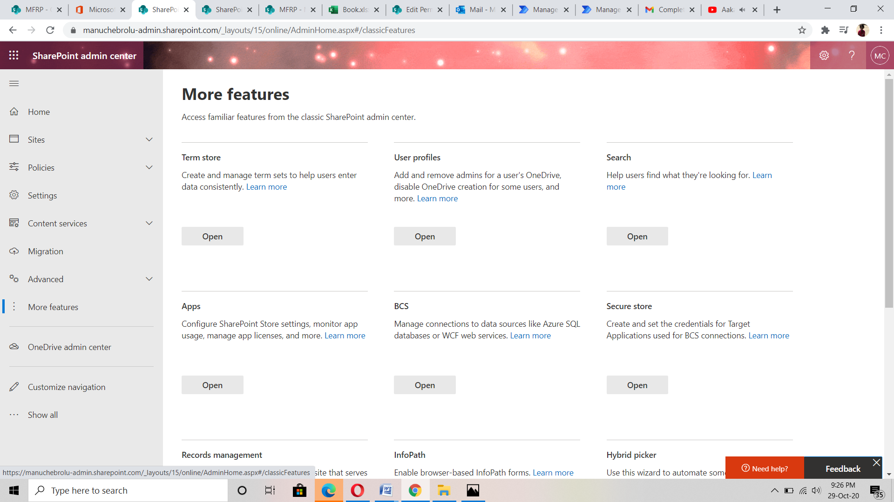

* Click on "apps" and then on the App Catalog link.

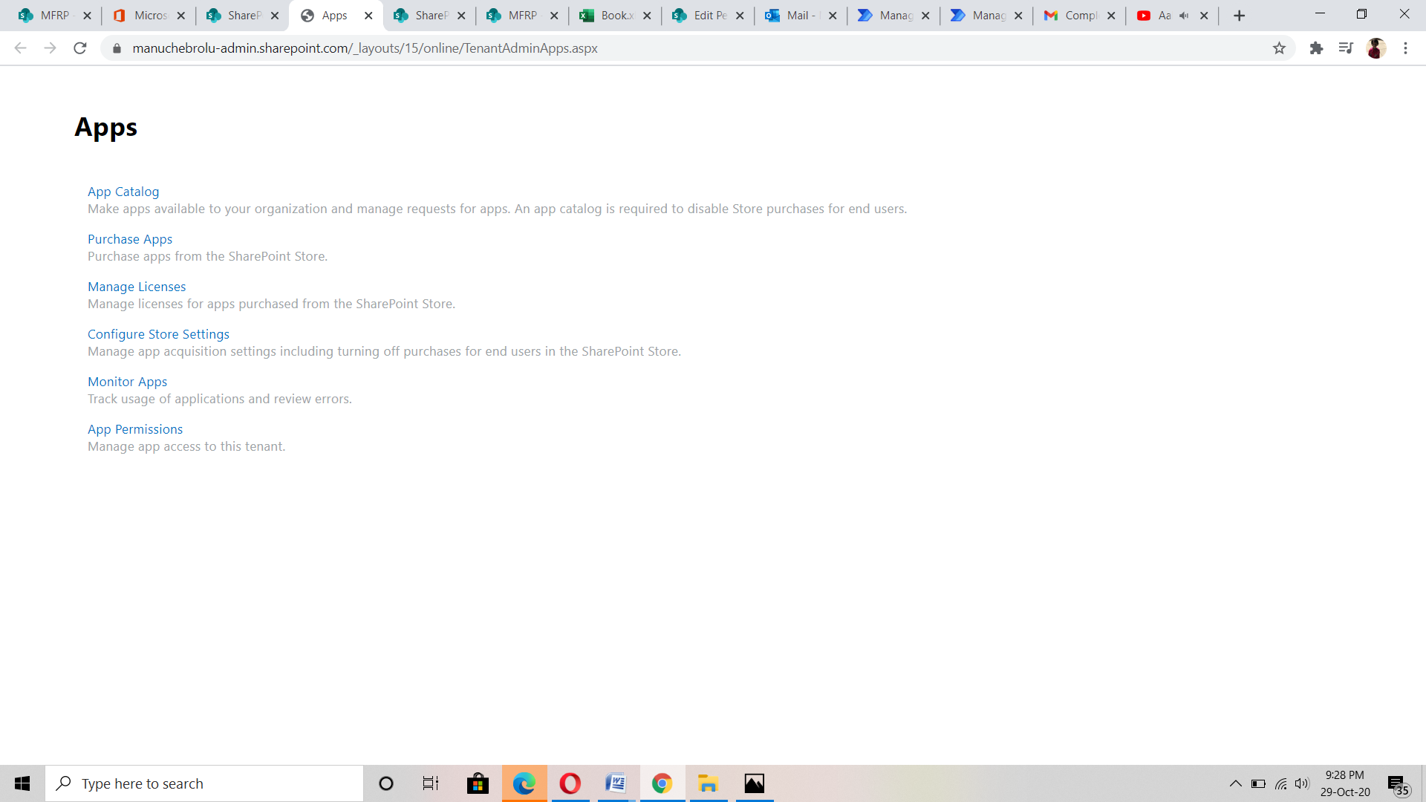

* Keep the radio button selected for "Create a new app catalog site" and click OK
* Fill out the entries in the form and click OK.
* An app catalog site collection will be created named MFRPCatalog.

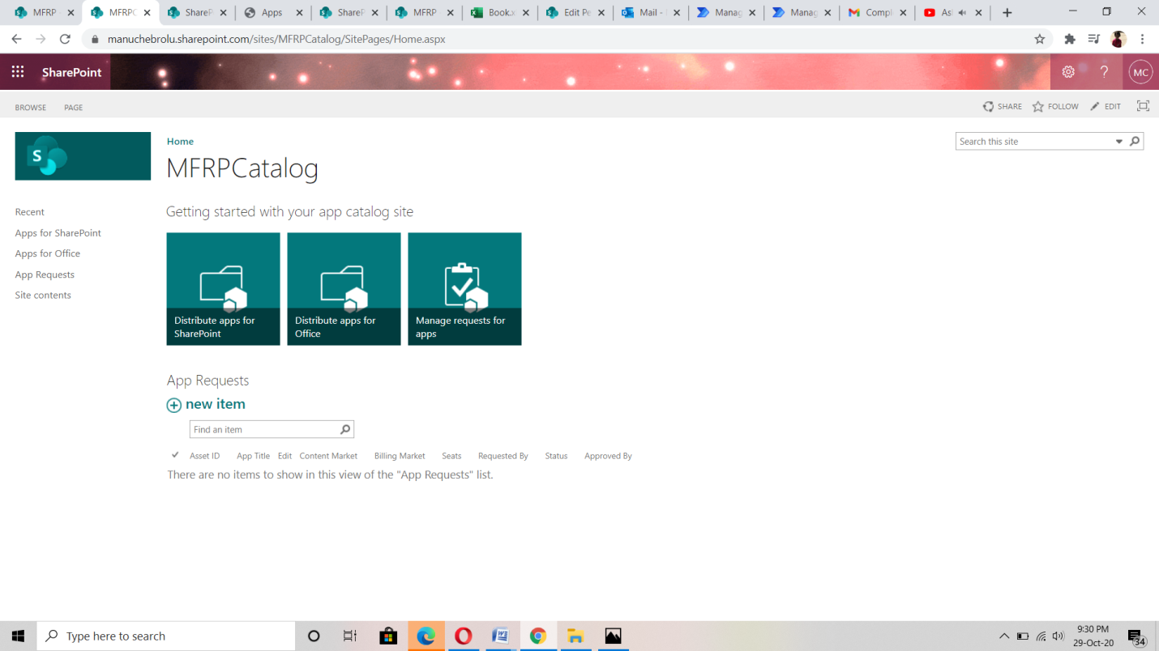

* Select "Apps for SharePoint".
* Click on "New" and browse to the APP or SPPKG file you want to upload which is orders.sppkg.

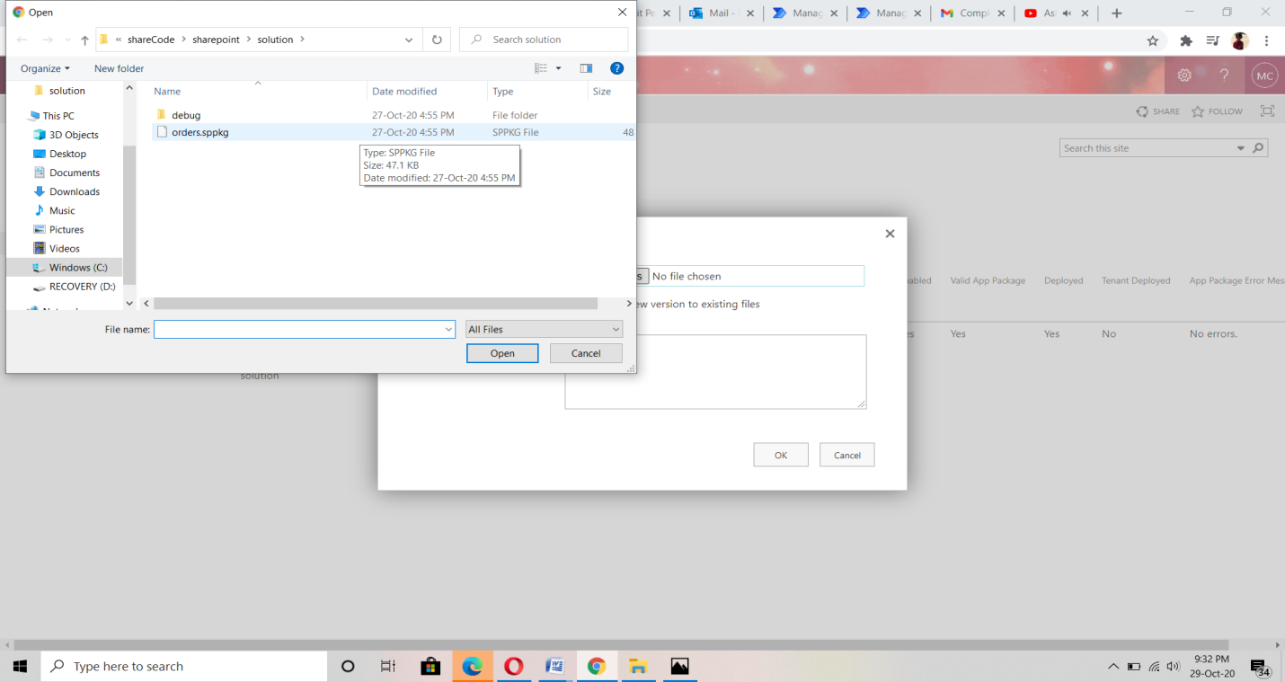

* Next need to select deploy option to deploy our solution in sharepoint.
* The file has been added.

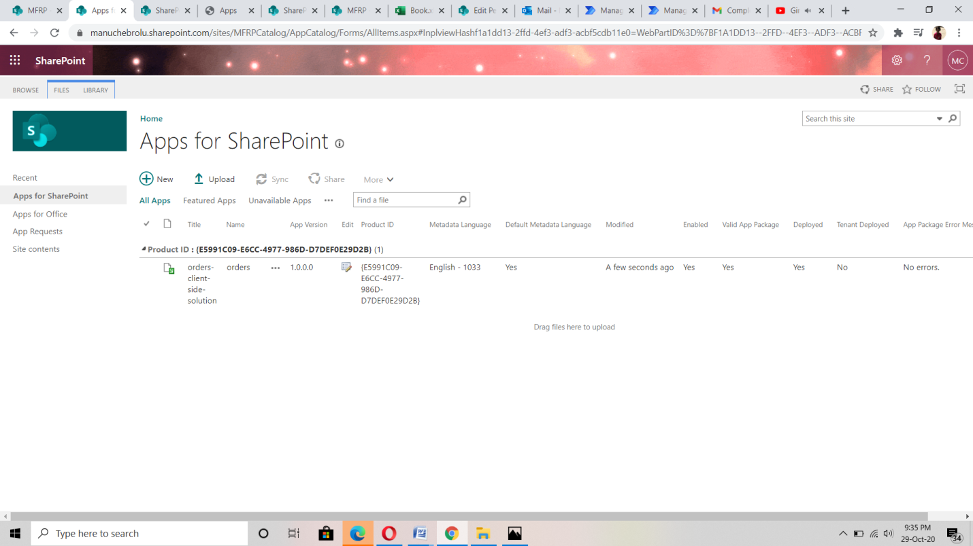

* Open the site collection in our MFRP Site where you want to add an app from the catalog.
* Click on "Site Contents" in the Quick Launch and then click on "add an app".

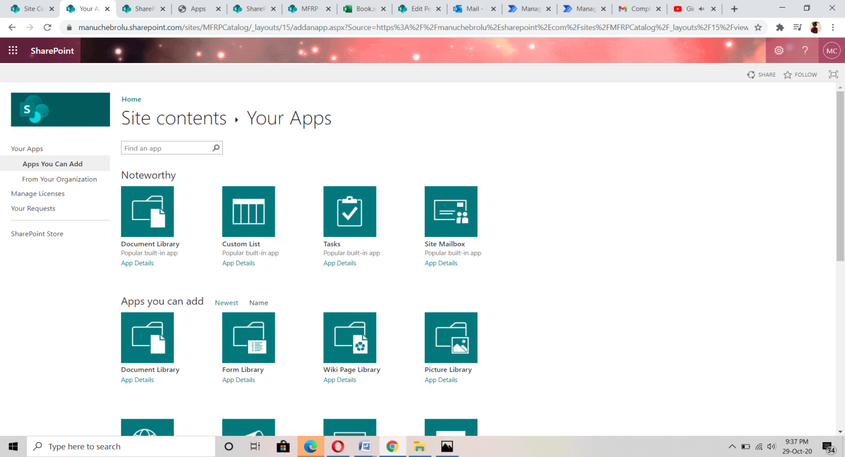

App will be uploaded in our site contents naming orders-client-side-solution

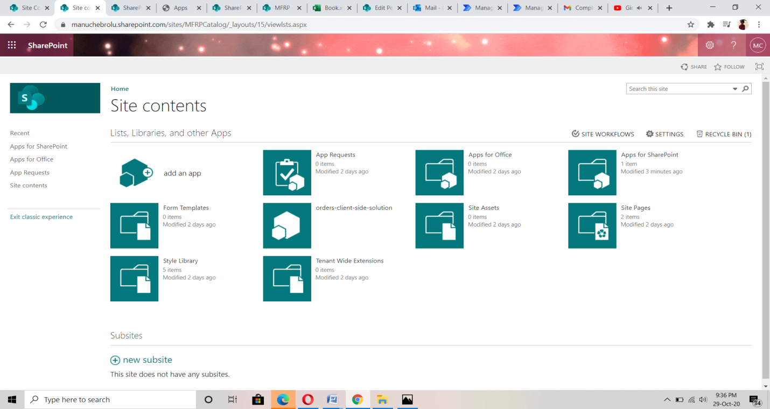

* Navigate to the site contents then go to site pages, in site pages click on new and add an Webpart page.

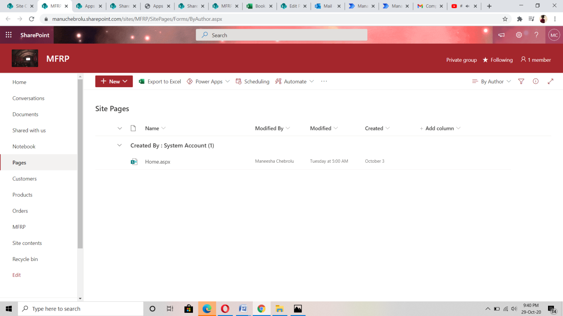

* Then publish our webpart.

