**FUNCTIONAL REQUIREMENT**

* **Customers List**

Displays the list of Customer ID, Customer Name, Customer Email Address.

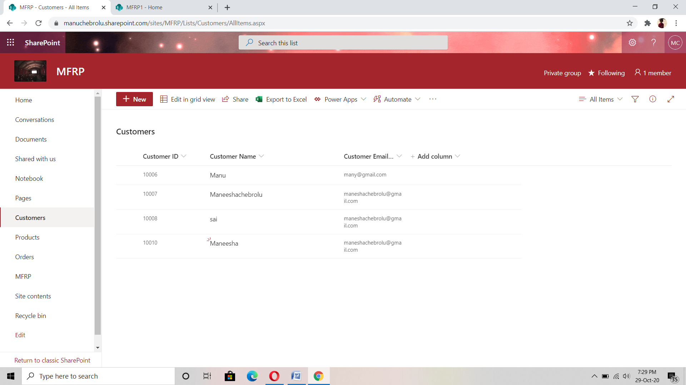

|  |  |  |
| --- | --- | --- |
| **Field Name** | **Field Type** | **Description** |
| Customer ID | Number | Displays the ID of the Customer |
| Customer Name | Single Line of Text | Displays Customer Name |
| Customer Email Address | Single Line of Text | Displays Customer Email Address |

* **Products List**

Displays the list of Product ID, Product Name, Product Type, Product Unit Price, Product Expiry Date.

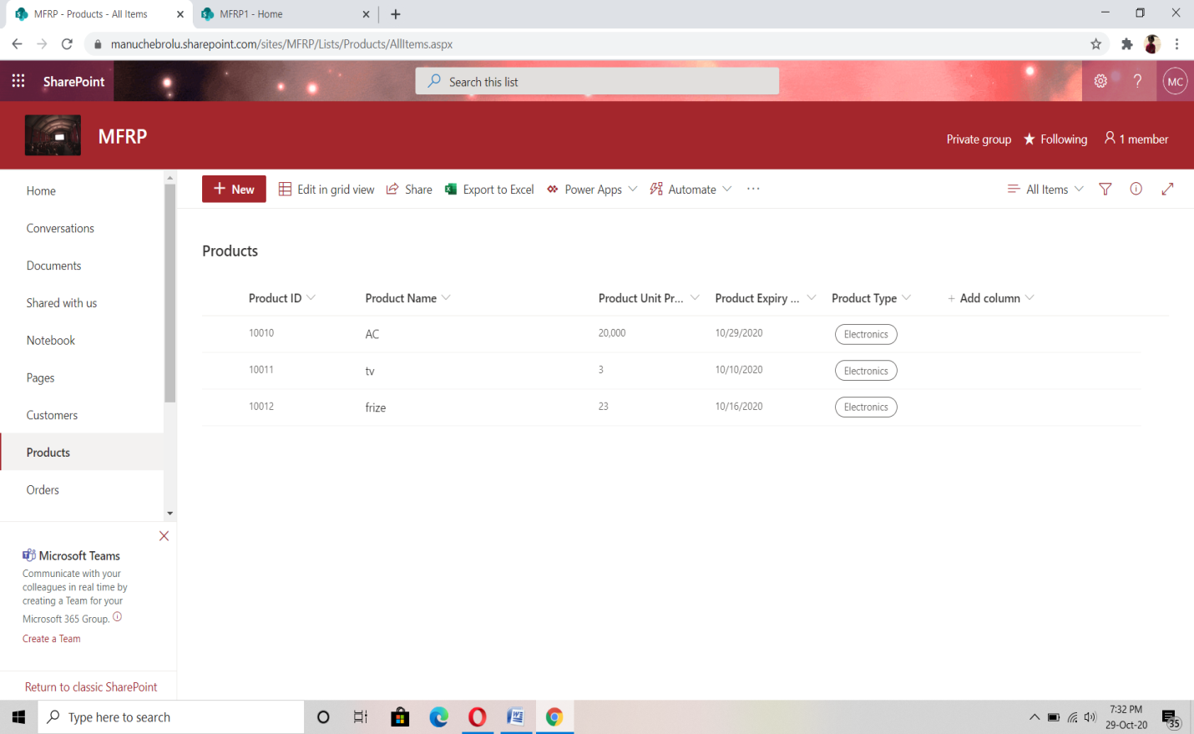

|  |  |  |
| --- | --- | --- |
| **Field Name** | **Field Type** | **Description** |
| Product ID | Number | Displays the ID of the product |
| Product Name | Single Line Of Text | Displays the product Name |
| Product Unit Price | Currency | Displays the Unit Price of the product in currency format |
| Product Expiry Date | Date | Displays expiry date of product in MM/DD/YYYY format . |
| Product Type | Single Line of Text | Displays the type of product. |

* **Orders List**

Displays the list of Order ID, Customer ID, Product ID, Units Sold, Unit Price, Sale Value, Order Status.

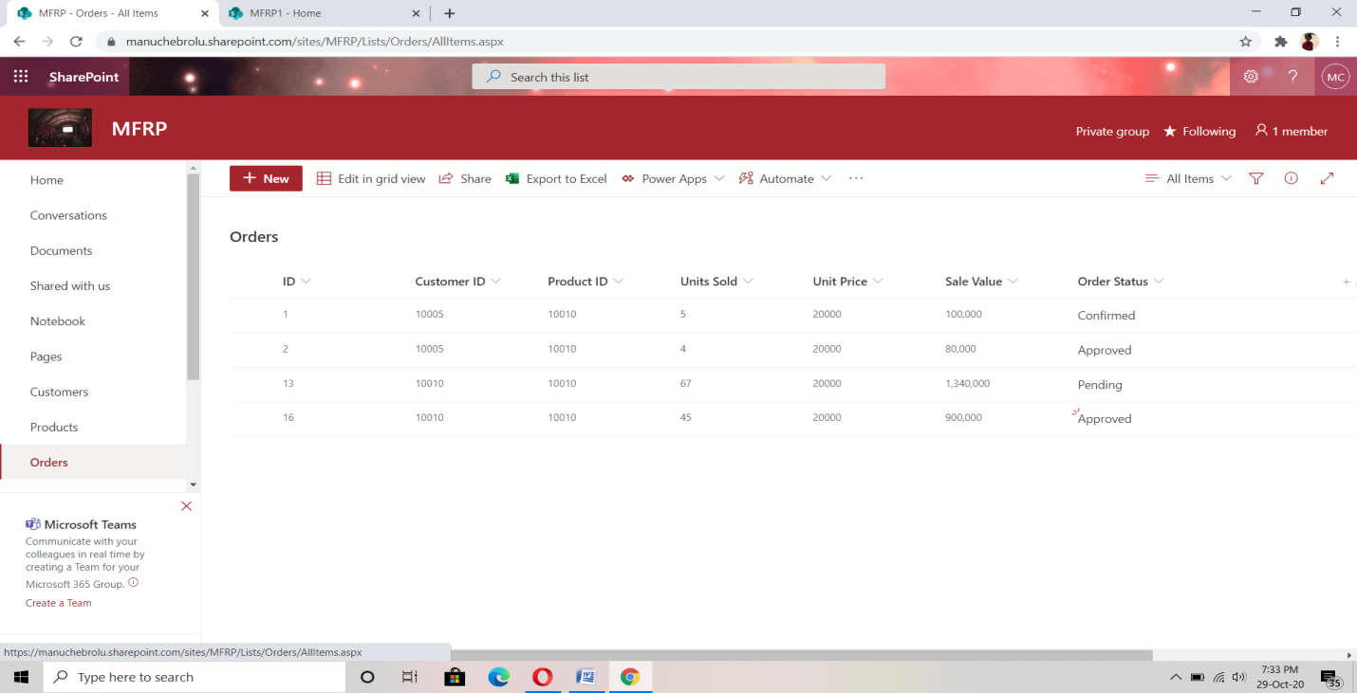

|  |  |  |
| --- | --- | --- |
| **Field Name** | **Field Type** | **Description** |
| Order ID | Number | Displays the order ID of sale order placed. |
| Customer ID | Number | Displays the ID of the Customer who placed the sale order. |
| Product ID | Number | Displays the product ID of the product ordered |
| Units Sold | Single Line of Text | Displays the number of units sold of the particular product. |
| Unit Price | Single Line of Text | Displays the Unit Price of particular product |
| Sale Value | Number | Displays the total price(Sale Value) of Unit Price and Units Sold |
| Order Status | Choice | Displays status of the ordered item whether Approved, Rejected , Completed. |