|  |  |  |  |  |  |  |  |  |  |
| --- | --- | --- | --- | --- | --- | --- | --- | --- | --- |
| **SCHOOL OF COMPUTER SCIENCE AND ARTIFICIAL INTELLIGENCE** | | | | | **DEPARTMENT OF COMPUTER SCIENCE ENGINEERING** | | | | |
| **ProgramName:**B. Tech | | | | **Assignment Type: Lab** | | | **AcademicYear:**2025-2026 | | |
| **CourseCoordinatorName** | | | | Venkataramana Veeramsetty | | | | | |
| **Instructor(s)Name** | | | | 1. Dr. Mohammed Ali Shaik  2. Dr. T Sampath Kumar  3. Mr. S Naresh Kumar  4. Dr. V. Rajesh  5. Dr. Brij Kishore  6. Dr Pramoda Patro  7. Dr. Venkataramana  8. Dr. Ravi Chander  9. Dr. Jagjeeth Singh | | | | | |
| **CourseCode** | | | 24CS002PC215 | **CourseTitle** | | AI Assisted Coding | | | |
| **Year/Sem** | | | II/I | **Regulation** | | R24 | | | |
| **Date and Day**  **of Assignment** | | |  | **Time(s)** | |  | | | |
| **Duration** | | | 2 Hours | **Applicableto**  **Batches** | |  | | | |
| **AssignmentNumber:3.3**(Present assignment number)/**24**(Total number of assignments) | | | | | | | | | |
|  | | | | | | | | | |
|  | **Q.No.** | **Question** | | | | | | ***ExpectedTime***  ***to complete*** |  |
|  | 1 | Lab 3: Prompt Engineering – Improving Prompts and Context Management  **Lab Objectives:**   * To understand how prompt structure and wording influence AI-generated code. * To explore how context (like comments and function names) helps AI generate relevant output. * To evaluate the quality and accuracy of code based on prompt clarity. * To develop effective prompting strategies for AI-assisted programming.   **Lab Outcomes (LOs):**  After completing this lab, students will be able to:   * Generate Python code using Google Gemini in Google Colab. * Analyze the effectiveness of code explanations and suggestions by Gemini. * Set up and use Cursor AI for AI-powered coding assistance. * Evaluate and refactor code using Cursor AI features. * Compare AI tool behavior and code quality across different platforms.   **Task Description#1**   * Try 3 different prompts to generate a factorial function.   **Expected Output#1**   * Comparison of AI-generated code styles   **Task Description#2**   * Provide a clear example input-output prompt to generate a sorting function.   **Expected Output#2**   * Functional sorting code from AI   **Task Description#3**   * Start with the vague prompt “Generate python code to calculate power bill” and improve it step-by-step   **Expected Output#3**   * Enhanced AI output with clearer prompts   **Task Description#4**   * Write structured comments to help AI generate two linked functions (e.g., login_user() and register_user()).   **Expected Output#4**   * Consistent functions with shared logic   **Task Description#5**   * Analyzing Prompt Specificity: Improving Temperature Conversion Function with Clear Instructions   **Expected Output#5**   * Code quality difference analysis for various prompts   **Note: Report should be submitted a word document for all tasks in a single document with prompts, comments & code explanation, and output and if required, screenshots**  **Evaluation Criteria:**   | **Criteria** | **Max Marks** | | --- | --- | | Factorial Function (Task#1) | 0.5 | | Sorting Function (Task#2) | 0.5 | | Vogue Vs. Specific Prompting (Task #3) | 0.5 | | Linked Functions (Task #4) | 0.5 | | Temperature Conversion Function (Task #5) | 0.5 | | **Total** | **2.5 Marks** | | | | | | | 03.08.2025 EOD |  |

**Task Description#1**Comparison of AI-generated code styles

**Expected Output#1:Try in 3 different ways**

the factorial of a given number using recursive functions

Prompt 1 : Write a python program to find

**Expected Output#1**

the factorial of a given number using recursive functions

Prompt 2: Write a python function to find the factorial of a given number using iterative function

Prompt 3:Write a python function to find the factorial of a given number using builtin function

**Task Description#2**

* Provide a clear example input-output prompt to generate a sorting function.

**Expected Output#2**

* Functional sorting code from AI

Prompt:Write a Python function to take input as different numbers and sort those numbers in ascending or descending order that should be decided by the user and print the output

**Task Description#3**

* Start with the vague prompt “Generate python code to calculate power bill” and improve it step-by-step

**Expected Output#3**

* Enhanced AI output with clearer prompts

Prompt: Write a python function to calculate the power bill to calculate the present month and previous month power hose number and it should calculate the power consumed by different domestic , industries in different units and print the output

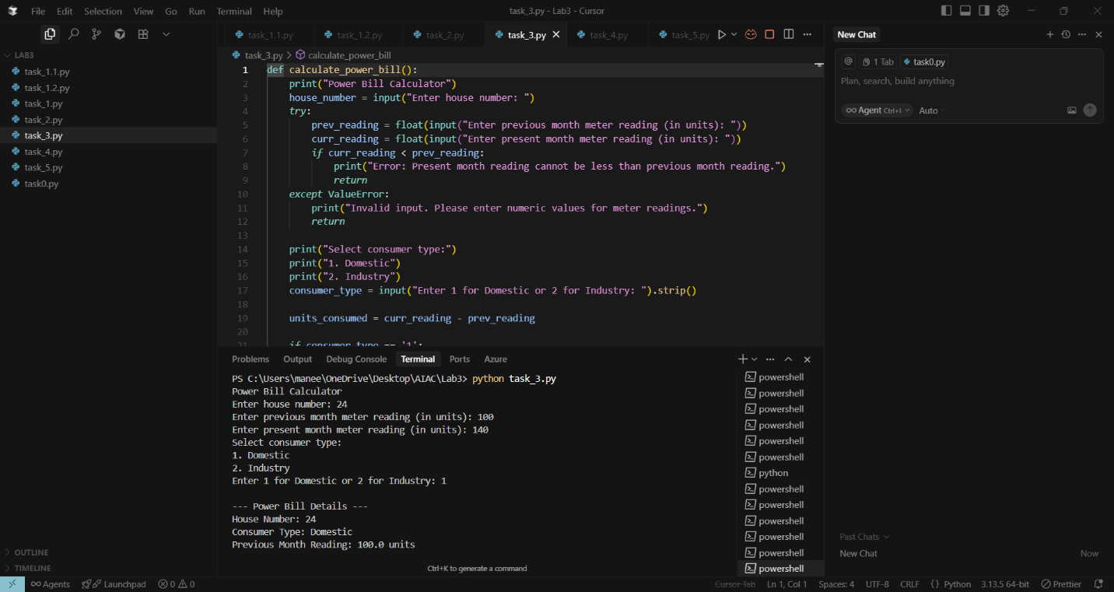

**Task Description#4**

* Write structured comments to help AI generate two linked functions (e.g., login_user() and register_user()).

**Expected Output#4**

* Consistent functions with shared logic

Prompt : Write a python function where you need to take the structured comments with the help of two linked fumctions login user() and register user() . It should ask the user to register or login and enter to their page

**Task Description#5**

* Analyzing Prompt Specificity: Improving Temperature Conversion Function with Clear Instructions

**Expected Output#5**

* Code quality difference analysis for various prompts

Prompt : Write a python function to analyise the temperature and give the clear instructions about the temperature outside and print the output

