Project Design Phase-II
Technology Stack (Architecture & Stack)
Date | 31 January 3035
Team ID
Project Name | Metro Ticket Generating System
Maximum Marks | 4 Marks

Technical Architecture
The Metro Ticket Generating System is implemented using the ServiceNow cloud platform. Passengers interact with the system through the Service Portal and Service Catalog. The booking form uses Catalog Client Scripts and UI Policies for dynamic behaviour and validation. Fare calculation and ticket processing are handled using ServiceNow automation and server-side logic. Ticket/request information is stored in ServiceNow tables, and a QR-code URL is generated for the booked ticket. The QR code is displayed through a Service Portal widget and can be used as digital proof for intended station verification.
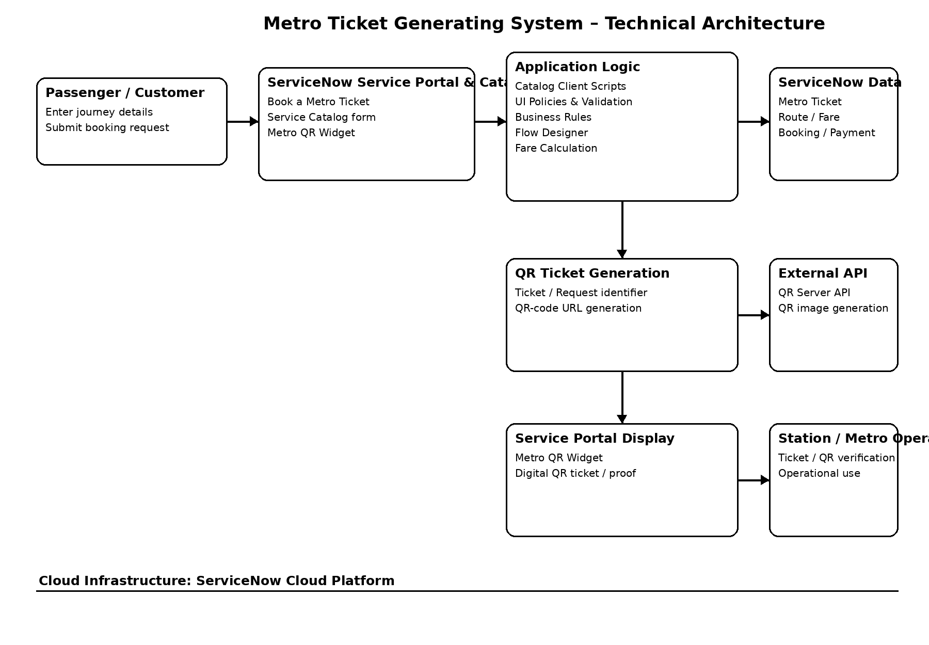
Table-1: Components & Technologies
S.No. | Component | Description | Technology
1 | User Interface | Interface through which passengers enter journey and booking details and view their generated QR ticket. | ServiceNow Service Portal, Service Catalog, HTML, CSS, JavaScript
2 | Application Logic-1 | Handles form behaviour, field validation, conditional fields and dynamic form interactions. | ServiceNow Catalog Client Scripts, UI Policies, JavaScript
3 | Application Logic-2 | Handles ticket processing, fare calculation, field mapping and automated record processing. | ServiceNow Business Rules, Flow Designer
4 | Application Logic-3 | Generates the QR-code URL using the created ticket/request identifier and makes the QR information available for display. | ServiceNow scripting, Service Portal Widget
5 | Database | Stores metro ticket, route/fare, booking and payment-related information in ServiceNow application tables. | ServiceNow Platform Database / ServiceNow Tables
6 | Cloud Database | Provides managed cloud-based data storage for application records. | ServiceNow Cloud Platform
7 | File Storage | No separate file-storage service is required for the core ticket-booking process. | Not Applicable
8 | External API-1 | Generates the QR-code image from the ticket/request identifier. | QR Server API
9 | External API-2 | No additional external API is required for the implemented system. | Not Applicable
10 | Machine Learning Model | Machine learning is not used in the current implementation. | Not Applicable
11 | Infrastructure (Server / Cloud) | Hosts the application, database, Service Portal, Service Catalog, automation and application services. | ServiceNow Cloud Platform

Table-2: Application Characteristics
S.No. | Characteristics | Description | Technology
1 | Open-Source Frameworks | The project does not depend on a separate open-source application framework. ServiceNow provides the development platform, Service Portal, Service Catalog and scripting environment. | ServiceNow Platform, JavaScript
2 | Security Implementations | Role-based access control and Access Control Rules (ACLs) restrict access to application records and sensitive data. Users use the booking functionality without requiring direct access to backend database tables. | ServiceNow ACLs, Roles, Authentication and Authorization
3 | Scalable Architecture | The application is deployed on the ServiceNow cloud platform. Application logic is separated between user-interface logic, server-side logic and data storage, supporting growth in users and booking requests. | ServiceNow Cloud Platform, Service Catalog, Flow Designer
4 | Availability | The application is hosted on the ServiceNow cloud platform instead of relying on a locally hosted server. Users can access the booking application through the Service Portal when the instance is available. | ServiceNow Cloud Platform
5 | Performance | Client-side validation and dynamic form behaviour reduce unnecessary processing. Automated fare calculation and workflow processing are handled within ServiceNow, while the QR code is generated from the ticket/request identifier. | JavaScript, Catalog Client Scripts, UI Policies, Business Rules, Flow Designer

Technology Stack Summary
Layer | Technology Used
Presentation Layer | ServiceNow Service Portal, Service Catalog, HTML, CSS, JavaScript
Client-side Logic | Catalog Client Scripts, UI Policies
Application / Business Logic | Business Rules, Flow Designer, JavaScript
Data Layer | ServiceNow Tables / Platform Database
QR Generation | QR Server API
Security | ServiceNow Roles and ACLs
Cloud Infrastructure | ServiceNow Cloud Platform
Machine Learning | Not Used
File Storage | Not Required
Implementation Note
The current implementation uses payment mode selection (UPI, Card or Others) rather than a live payment gateway. The QR code is treated as a digital ticket/proof for intended station verification. Machine learning, separate file storage and additional external APIs are not part of the implemented core system.
References
ServiceNow – Service Portal documentation: https://www.servicenow.com/docs/r/platform-user-interface/service-portal/
ServiceNow – Flow Designer documentation: https://www.servicenow.com/docs/r/washingtondc/build-workflows/flow-designer.html
ServiceNow – Access Management documentation: https://www.servicenow.com/docs/r/platform-security/access-management-landing.html
C4 Model: https://c4model.com/
IBM Cloud Architecture: https://www.ibm.com/cloud/architecture
AWS Architecture: https://aws.amazon.com/architecture
Faculty-provided references from the Technology Stack template.

