LAB Logbook

Lab 1
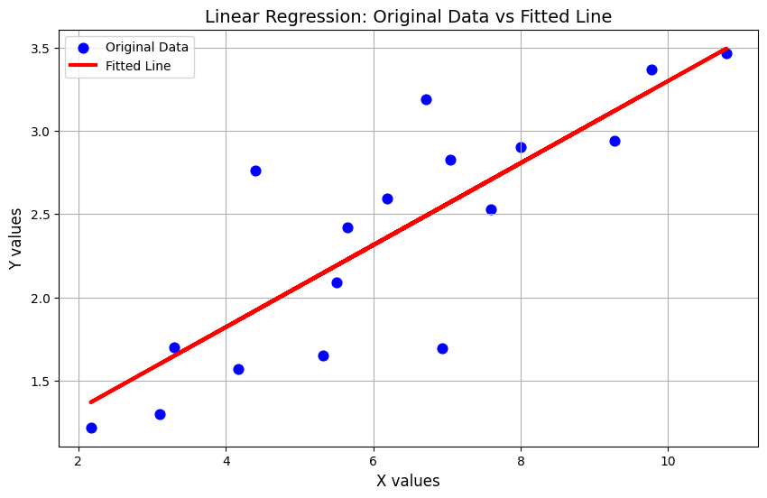

Lab 2
Test Accuracy = 0.94
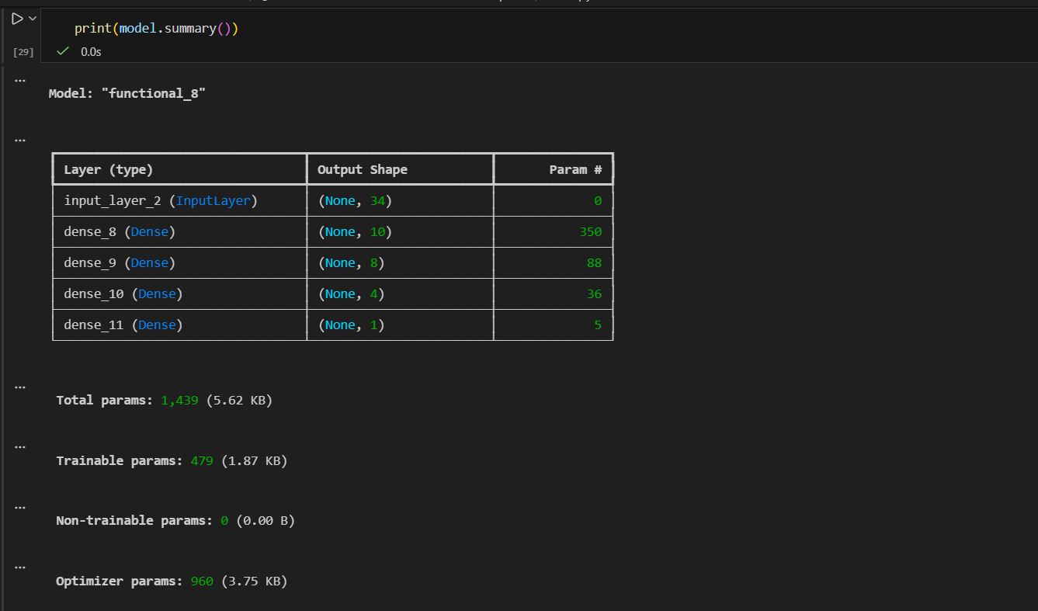
Lab 3
Test accuracy: 0.8873000144958496
Lab 4
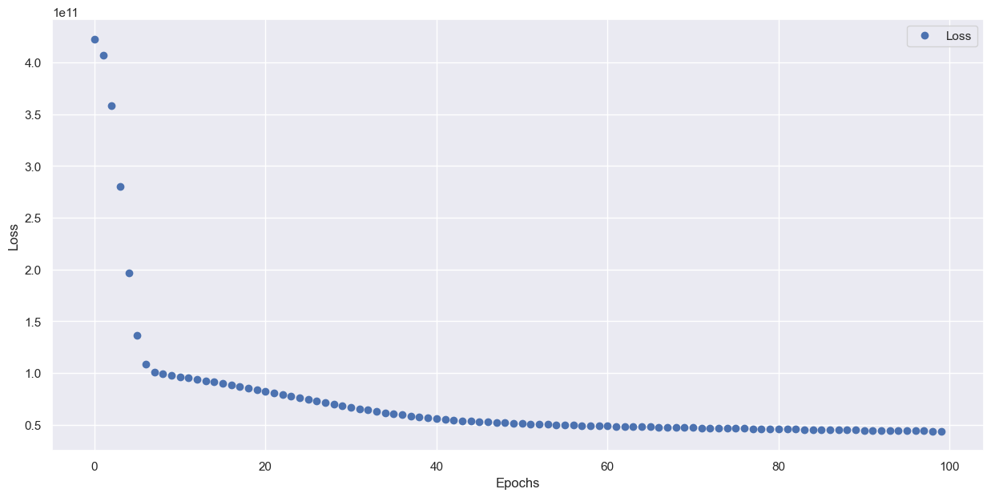
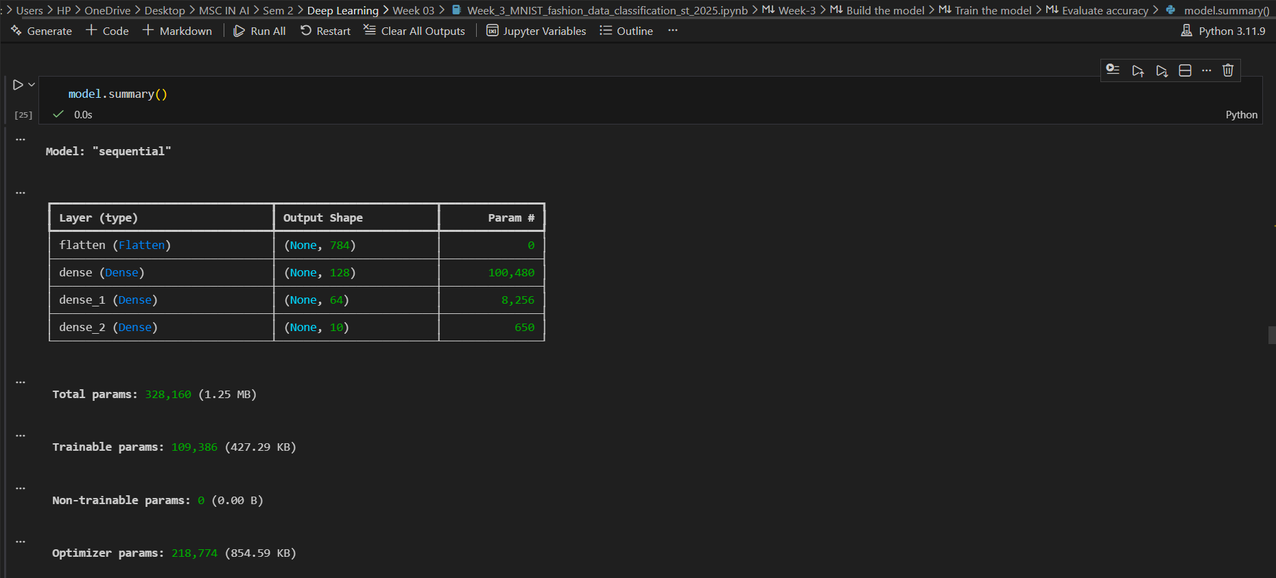
Lab 5

Lab 6

Lab 7

Lab 8

Lab 9

Lab 10

Lab 11

Lab 12

