1. Check if Git is installed on our computer.
2. Initialize a new Git repository in the current folder "C:\Git-GitHub\GTEC-Training".
3. Check the current state of our working directory and staging area.
4. Stage changes in our working directory for the next commit.
5. Create a new commit with message describing the changes we have staged.
6. List all local branches in this Git repository.
7. Create a new branch, switch to it and list all branches in the Git repository.
8. Return to branch master and display the history of commits in this branch.
9. Merge a new text file into branch master:
10. Add a new text file "Git-Commands" in the current folder "C:\Git-GitHub\GTEC-Training".
11. Stage changes in our working directory for the next commit.
12. Create a new commit with a message describing the changes we have staged and display the history of commits.
13. Create a new remote repository "Git-GitHub" and link it to our local Git repository at "C:\Git-GitHub\GTEC-Training".
14. Check the current state of the remote repository "Git-GitHub":
15. Show remote names.
16. List all remotes connected to our local Git repository at "C:\Git-GitHub\GTEC-Training" along with their URLs.
17. Download updates from the remote repository "Git-GitHub".
18. Display the URL of the origin remote to which our local project is connected.
19. Create another remote repository "SeleniumJavaAutomation":
20. Update the origin remote to point to the "SeleniumJavaAutomation" repository.
21. Switch back to the first remote repository "Git-GitHub" and display its URL.
22. Manage project versions by switching between branches using the Git repository at "C:\Git-GitHub\GTEC-Training":
23. Highlight the branch currently working on it.
24. Switch to branch "feature25_05_2025", copy/paste the text file, stage it in our working directory and commit it with clear message.
25. Push & update the remote "feature25_05_2025" branch:
26. Check that the origin remote is pointing to the "Git-GitHub" repository.
27. Push our local commits from "feature25_05_2025" branch to the remote repository (origin).
28. Check that the remote "feature25_05_2025" branch is updated.
29. Push & update the remote "master":
30. Switch to "master" branch.
31. Push our local commits from "master" branch to the remote repository (origin).
32. Check that the remote "master" branch is updated.
33. Create a copy of the remote repository into our local machine.

**Solution:**

1. git version

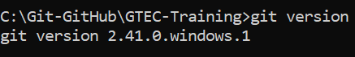

1. git init

Notes: When we run the command git init, Git creates a .git/ folder in the current directory:

This hidden folder contains the metadata and internal files Git needs to track versions (like commits, branches, configuration, etc).

1. git status

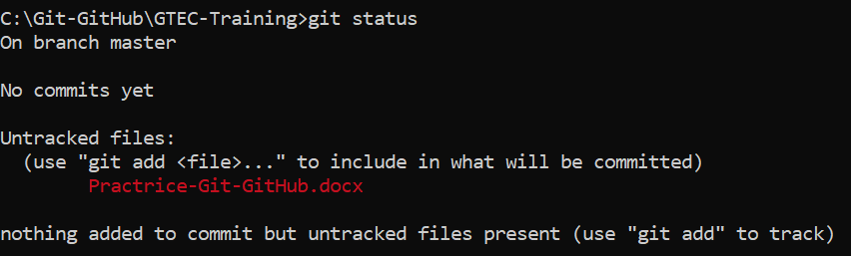

|  |  |
| --- | --- |
| **Area** | **What it tells us** |
| Current branch | Which branch you're working on |
| Changes to be committed | Files staged for the next commit |
| Changes not staged | Modified files not yet staged ('git add' needed) |
| Untracked files | New files not tracked by Git yet |
| Files ignored | Files ignored via '.gitignore' |

1. git add Practrice-Git-GitHub.docx

This command is used to stage a specific file.

It moves changes from the working Directory 🡪 to the Staging Area.

1. git commit -m "add the new file: Practrice-Git-GitHub.docx"

git status

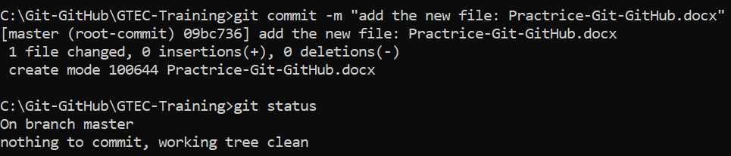

1. git branch

🡪 The only available branch is master, and we are currently checked out on it.

1. git branch feature25_05_2025: Create a new branch named feature25_05_2025

git branch: Presence of two branches master and feature25_05_2025 but still checked out on master branch.

git checkout feature25_05_2025: Switch to branch feature25_05_2025

git branch: Presence of two branches master and feature25_05_2025, and we are currently checked out on branch feature25_05_2025.

git status

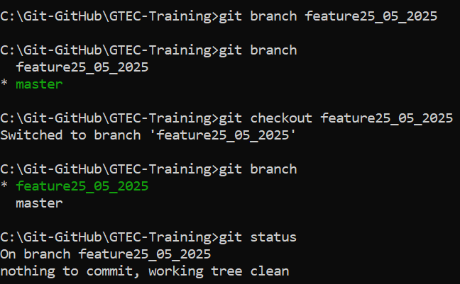

1. git checkout master

git log

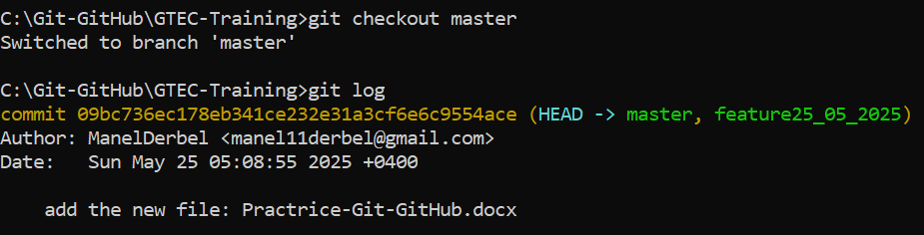

Notes: Displays the history of commits in our current Git branch master, from most recent (HEAD) to oldest. Each commit shows:

* The commit hash (ID)
* The author
* The date
* The commit message

1. Create a new text file "Git-Commands" in the local directory "C:\Git-GitHub\GTEC-Training".

git status

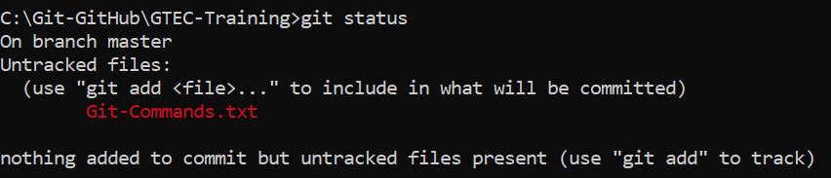

🡪 The file "Git-Commands" exists in the working directory but is not yet tracked by Git.

1. git add .



🡪 Stage all changes (new, modified, deleted files) in the current directory and below.

git status

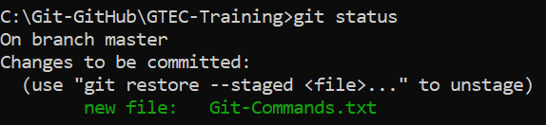

🡪 The file "Git-Commands" exists in the working directory, tracked and staged by Git for the next commit.

1. git commit -m "add the new file: Git-Commands.txt"

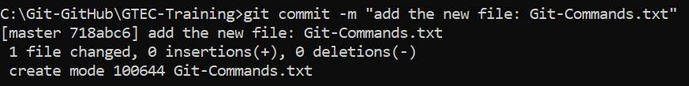

git log

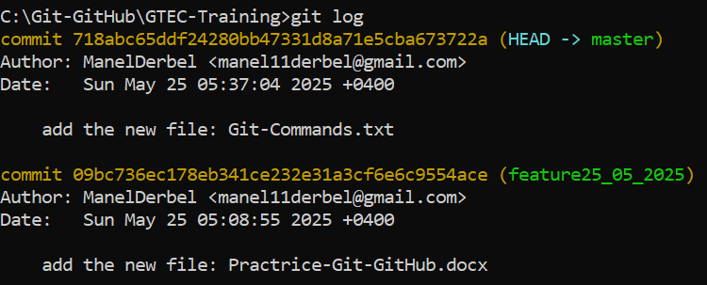

🡪 The most recent commit involving "Git-Commands.txt" is displayed as the HEAD commit on the master branch.

1. Sign up to GitHub and refer to this link: <https://github.com/new>

git remote add origin <https://github.com/ManelDerbel/Git-GitHub>



1. git remote
2. git remote -v
3. git fetch: Downloads updates from the remote repository "Git-GitHub" without merge them into our local copy of the remote at "C:\Git-GitHub\GTEC-Training".
4. git remote get-url origin

1. Refer to the link: <https://github.com/new>

1. git remote set-url origin <https://github.com/ManelDerbel/SeleniumJavaAutomation>

git remote get-url origin

1. git remote set-url <https://github.com/ManelDerbel/Git-GitHub>

git remote get-url origin

1. git branch

🡪 By referring to the local repository while working on the master branch, we detected that all files (word and text) are present on the repertoire.

1. git checkout feature25_05_2025

git branch

git status: Check that there is nothing to be committed in the branch feature25_05_2025

🡪 While working on the feature25_05_2025 branch, we found that only the Word file exists in the local repository. The missing files should be merged into this branch.

1. git add .

git commit -m "Add the new file: Git-Commands"

1. git remote get-url origin

1. git push origin feature25_05_2025

1. Using GitHub:

Go to: <https://github.com/ManelDerbel/Git-GitHub/tree/feature25_05_2025> and confirm that feature25_05_2025 branch contains our latest commits.

* 1. git checkout master

git status: Check if there are any staged files that not yet committed.

* 1. git push -u origin master

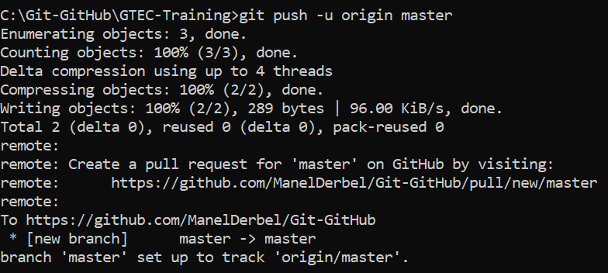

* 1. By using GitHub:

Go to: <https://github.com/ManelDerbel/Git-GitHub/tree/master> and confirm that master branch contains our latest commits.

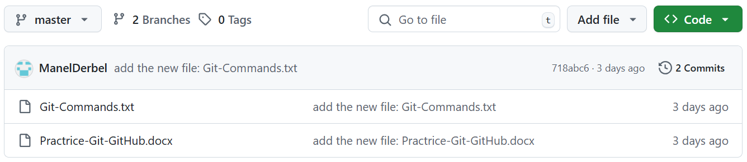

1. Create a new folder "recupGit-GitHub" and type cmd

git init

git clone <https://github.com/ManelDerbel/Git-GitHub>



