- Check if Git is installed on our computer.
- Initialize a new Git repository in the current folder "C:\Git-GitHub\GTEC-Training".
- Check the current state of our working directory and staging area.
- Stage changes in our working directory for the next commit.
- Create a new commit with message describing the changes we have staged.
- List all local branches in this Git repository.
- Create a new branch, switch to it and list all branches in the Git repository.
- Return to branch master and display the history of commits in this branch.
- Merge a new text file into branch master:
- Add a new text file "Git-Commands" in the current folder "C:\Git-GitHub\GTEC-Training".
- Stage changes in our working directory for the next commit.
- Create a new commit with a message describing the changes we have staged and display the history of commits.
- Create a new remote repository "Git-GitHub" and link it to our local Git repository at "C:\Git-GitHub\GTEC-Training".
- Check the current state of the remote repository "Git-GitHub":
- Show remote names.
- List all remotes connected to our local Git repository at "C:\Git-GitHub\GTEC-Training" along with their URLs.
- Download updates from the remote repository "Git-GitHub".
- Display the URL of the origin remote to which our local project is connected.
- Create another remote repository "SeleniumJavaAutomation":
- Update the origin remote to point to the "SeleniumJavaAutomation" repository.
- Switch back to the first remote repository "Git-GitHub" and display its URL.
- Manage project versions by switching between branches using the Git repository at "C:\Git-GitHub\GTEC-Training":
- Highlight the branch currently working on it.
- Switch to branch "feature25_05_2025", copy/paste the text file, stage it in our working directory and commit it with clear message.
- Push & update the remote "feature25_05_2025" branch:
- Check that the origin remote is pointing to the "Git-GitHub" repository.
- Push our local commits from "feature25_05_2025" branch to the remote repository (origin).
- Check that the remote "feature25_05_2025" branch is updated.
- Push & update the remote "master":
- Switch to "master" branch.
- Push our local commits from "master" branch to the remote repository (origin).
- Check that the remote "master" branch is updated.
- Create a copy of the remote repository into our local machine.

Solution:
- git version
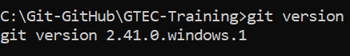
- git init
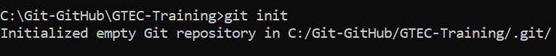
Notes: When we run the command git init, Git creates a .git/ folder in the current directory:
This hidden folder contains the metadata and internal files Git needs to track versions (like commits, branches, configuration, etc).
- git status
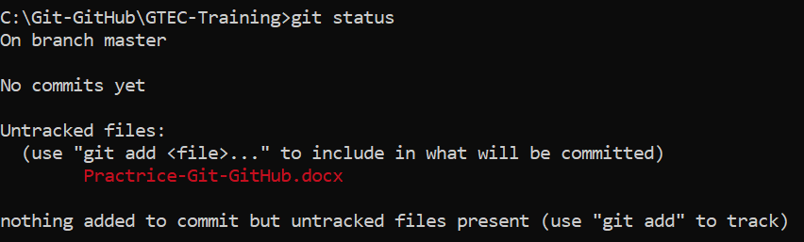

Area | What it tells us
Current branch | Which branch you're working on
Changes to be committed | Files staged for the next commit
Changes not staged | Modified files not yet staged ('git add' needed)
Untracked files | New files not tracked by Git yet
Files ignored | Files ignored via '.gitignore'

- git add Practrice-Git-GitHub.docx
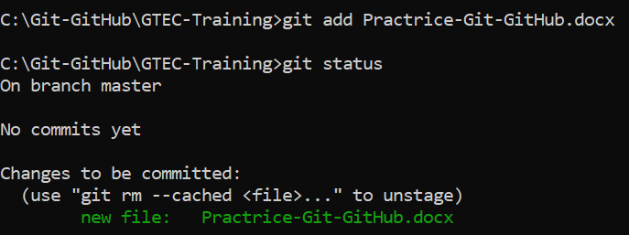
This command is used to stage a specific file.
It moves changes from the working Directory to the Staging Area.
- git commit -m "add the new file: Practrice-Git-GitHub.docx"
git status
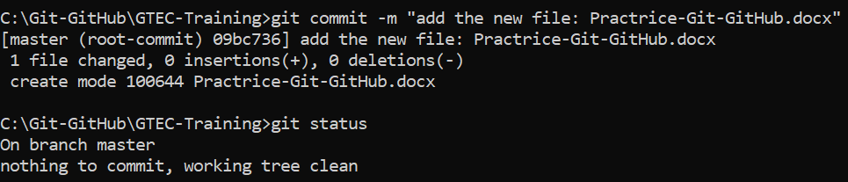
- git branch
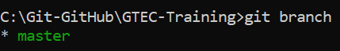
The only available branch is master, and we are currently checked out on it.
- git branch feature25_05_2025: Create a new branch named feature25_05_2025
git branch: Presence of two branches master and feature25_05_2025 but still checked out on master branch.
git checkout feature25_05_2025: Switch to branch feature25_05_2025
git branch: Presence of two branches master and feature25_05_2025, and we are currently checked out on branch feature25_05_2025.
git status
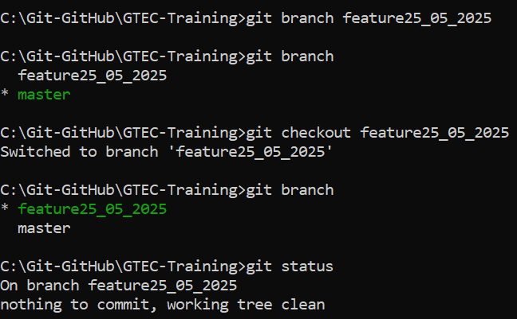
- git checkout master
git log
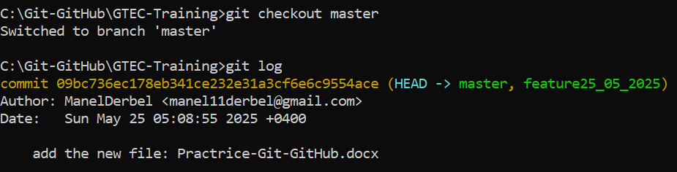
Notes: Displays the history of commits in our current Git branch master, from most recent (HEAD) to oldest. Each commit shows:
- The commit hash (ID)
- The author
- The date
- The commit message

- Create a new text file "Git-Commands" in the local directory "C:\Git-GitHub\GTEC-Training".
git status
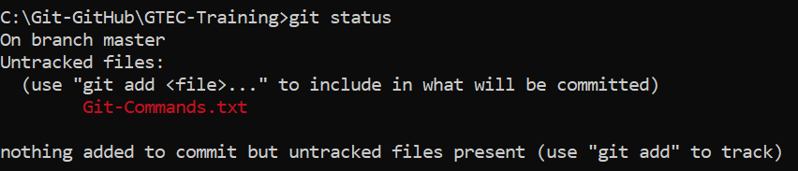
The file "Git-Commands" exists in the working directory but is not yet tracked by Git.
- git add .
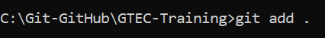
Stage all changes (new, modified, deleted files) in the current directory and below.
git status
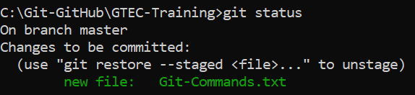
The file "Git-Commands" exists in the working directory, tracked and staged by Git for the next commit.
- git commit -m "add the new file: Git-Commands.txt"
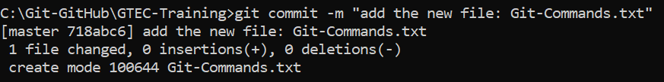
git log
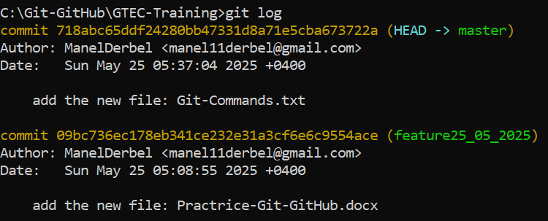
The most recent commit involving "Git-Commands.txt" is displayed as the HEAD commit on the master branch.
- Sign up to GitHub and refer to this link: https://github.com/new
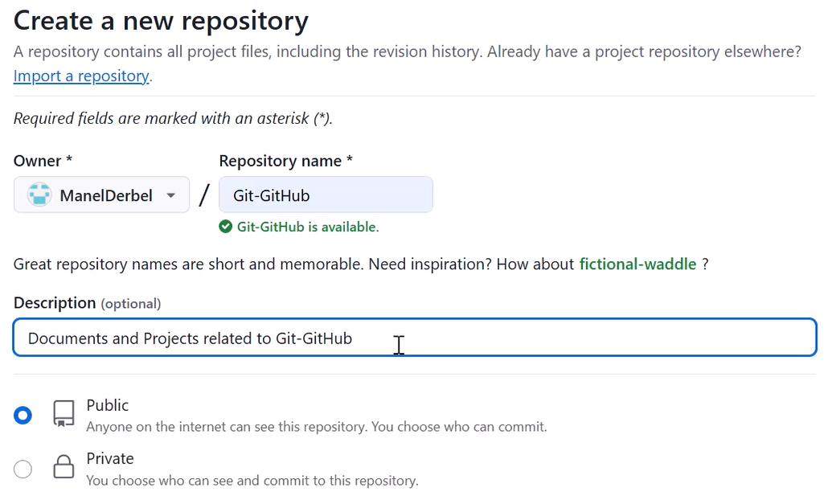
git remote add origin https://github.com/ManelDerbel/Git-GitHub

- git remote
- git remote -v
- git fetch: Downloads updates from the remote repository "Git-GitHub" without merge them into our local copy of the remote at "C:\Git-GitHub\GTEC-Training".
- git remote get-url origin
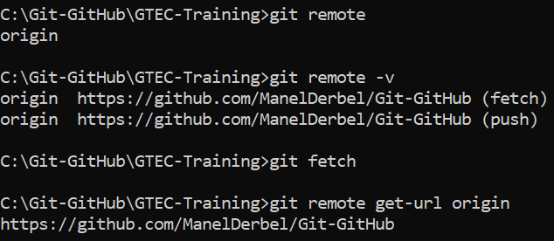
- Refer to the link: https://github.com/new
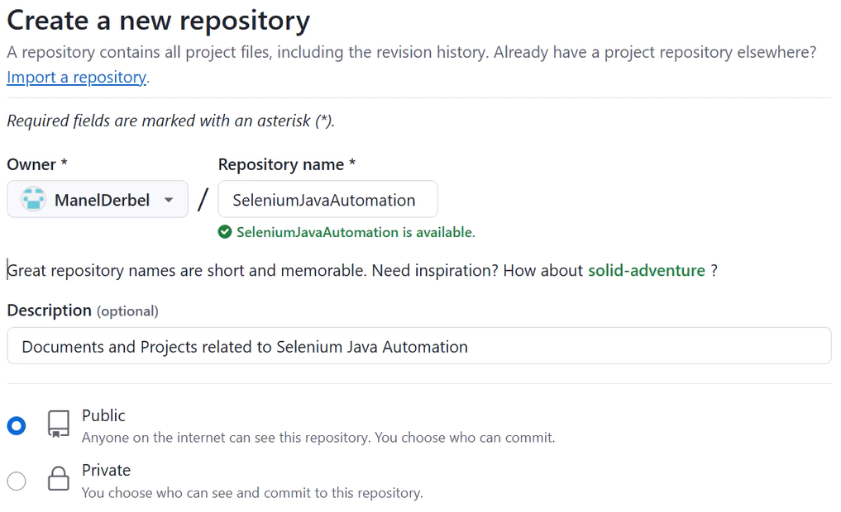
- git remote set-url origin https://github.com/ManelDerbel/SeleniumJavaAutomation
git remote get-url origin
- git remote set-url https://github.com/ManelDerbel/Git-GitHub
git remote get-url origin
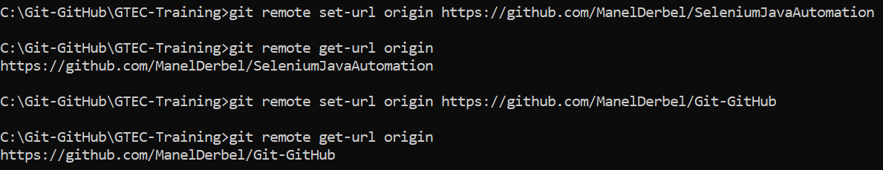

- git branch
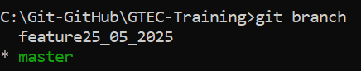
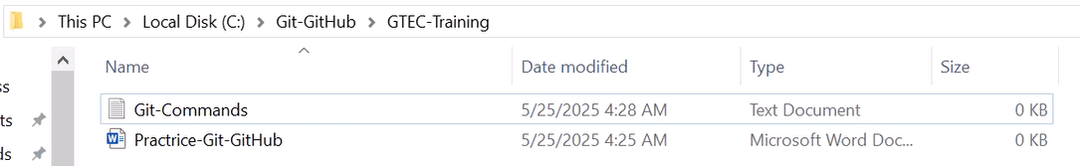
By referring to the local repository while working on the master branch, we detected that all files (word and text) are present on the repertoire.
- git checkout feature25_05_2025
git branch
git status: Check that there is nothing to be committed in the branch feature25_05_2025
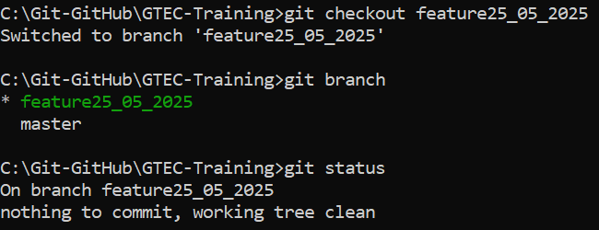
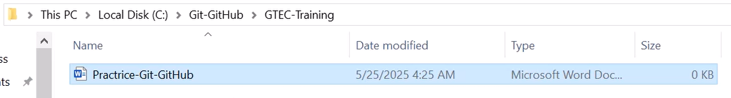
While working on the feature25_05_2025 branch, we found that only the Word file exists in the local repository. The missing files should be merged into this branch.
- git add .
git commit -m "Add the new file: Git-Commands"
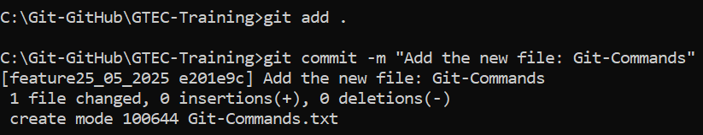

- git remote get-url origin
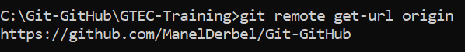
- git push origin feature25_05_2025
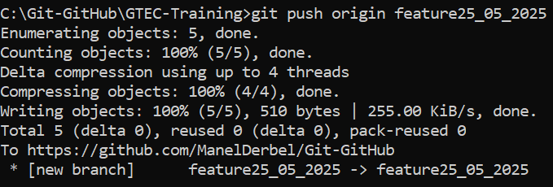
- Using GitHub:
Go to: https://github.com/ManelDerbel/Git-GitHub/tree/feature25_05_2025 and confirm that feature25_05_2025 branch contains our latest commits.
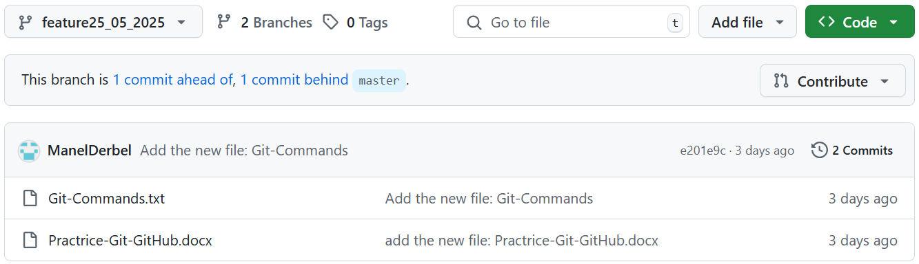

  - git checkout master
git status: Check if there are any staged files that not yet committed.
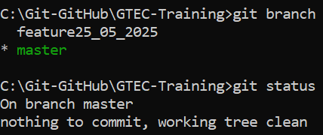
  - git push -u origin master
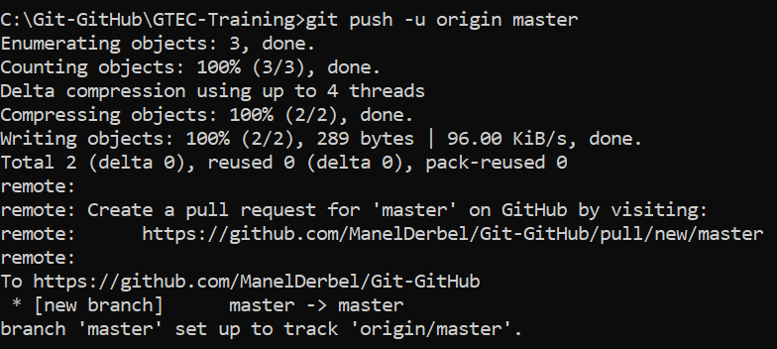
  - By using GitHub:
Go to: https://github.com/ManelDerbel/Git-GitHub/tree/master and confirm that master branch contains our latest commits.
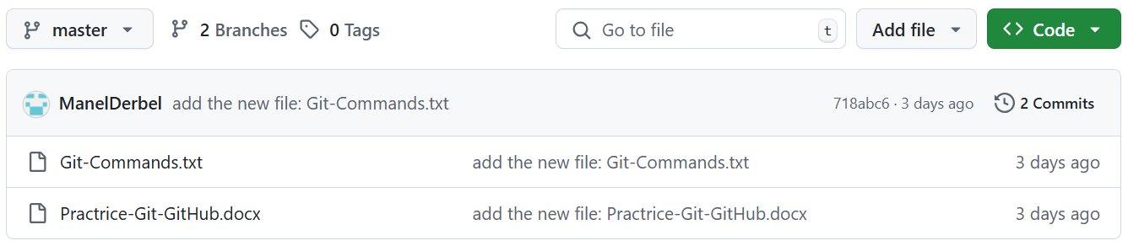

- Create a new folder "recupGit-GitHub" and type cmd
git init
git clone https://github.com/ManelDerbel/Git-GitHub
