Install and SetUp MongoDB in your computer

First : after installing mongodb compass on your pc you have to setup it by following these steps

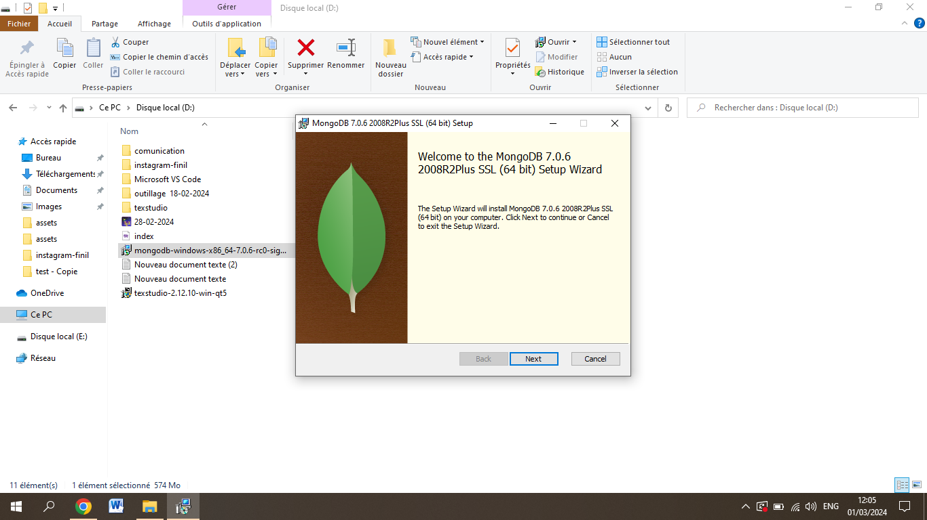

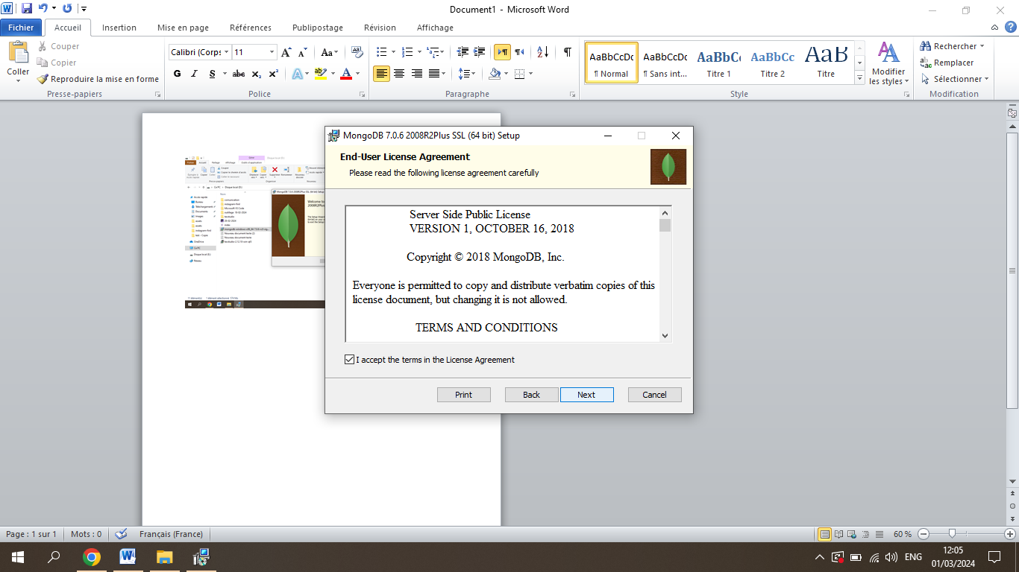

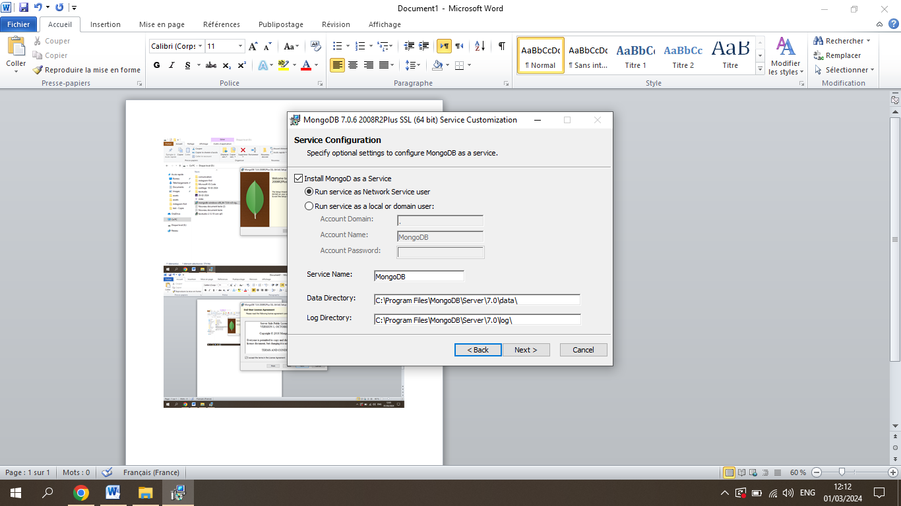

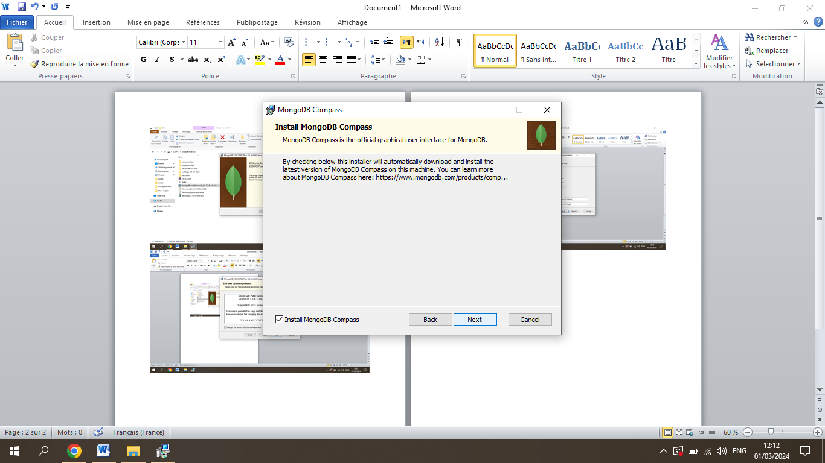

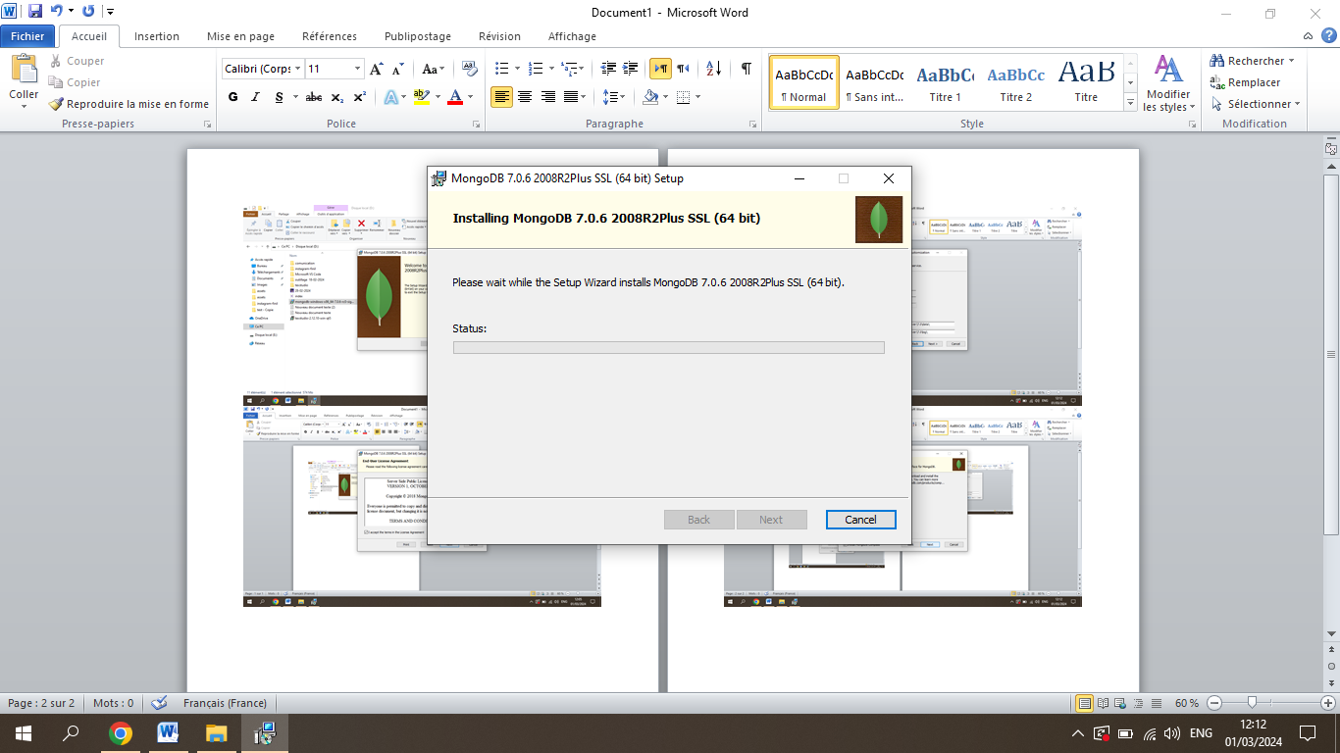

Second : add MongoDB PHP driver on XAMPP server by the following the link below

<https://pecl.php.net/package/mongodb>

BE SURE that Installing php depend on your php in xampp

paste to C:\xampp\php\ext