Estudios de Ingeniería en Informática

SUBJECT: | SIMULACIÓN (M1.205)
PEC Num.: | 2
Date of proposal: | 31/03/2018 | Date of delivery: |  30/04/2018
Observations: | - The answers will be on this document, keep the original text and take care on the final presentation.  - It is needed to justify all the answers.  - The name of the file must be  Surname1_Surname2_Name.RTF (o .DOCX o .PDF)
Evaluation: | All the exercises indicates its weigh.

EXERCISES

In this second PAC we are working with the chapters 7-13 of Robinson Book. Follow the “Simulation” guide.

Q1 - 15%) (Chapter 7) Use the Distributions.xls spreadsheet (see the website www.wileyeurope.com/go/robinson) to investigate the effect of changing distribution parameters on the shape, mean and standard deviation of the following distributions: Normal, binomial, gamma and poisson. Drawn the distributions graphically and describe the main effects of changing the parameters.

Normal distribution

In this distribution there is Mean and SD parameters.

If Mean changes from 0 to 4 the distribution is displace to its right and the peak, the maximum moves from X = 0.2 to 4.2. If, instead of Mean, we increased standard deviation from 2 to 6 the distribution moved to the right but not as much as Mean increase, the maximum changes from X = 0.2 to 0.6. Likewise the signal is made wider, going from values of -6 to 6 that are -18 to 18.

If we reduce standard deviation then the signal becomes narrower, although it is not seen in the graph can be verified that the X values are between -1.5 and 1.5.

Binomial distribution
If we start from an experiment of 10 repetitions with a 10% probability of success we have the equivalent to a normal distribution (Mean 1 and SD 0.95). If we increase the number of repetitions by a factor of 5, the resulting distribution is a normal distribution with a Mean multiplied by the same factor of the increase and standard deviation multiplied by approximately 2.2. On the other hand, if we increase the probability by 5, the mean is multiplied by the same factor but the standard deviation by approximately 1.5 (Mean 25 and SD 3.54).

Gamma distribution

Increasing the shape increases the standard deviation and the graph is more disperse, obtaining values of X between 6 to 42. When increasing the Scale value, the graph is more distributed than increasing with shape, where the maximum value changes from 2,1 to 10,6 and the distribution change to values from 14 to 80.

Poisson distribution

By increasing the mean to 50 we obtain a distribution similar to a normal or binomial distribution with a similar average. Also, if we reduce the mean we have a similar distribution to the initial binomial distribution where the lower values are more likely.

Q2 - 15%) (Chapter 9). The time-series graphs below show typical simulation output. For each graph identify the type of model (terminating or non-terminating) and the nature of the simulation output (transient, steady-state, steady-state cycle).
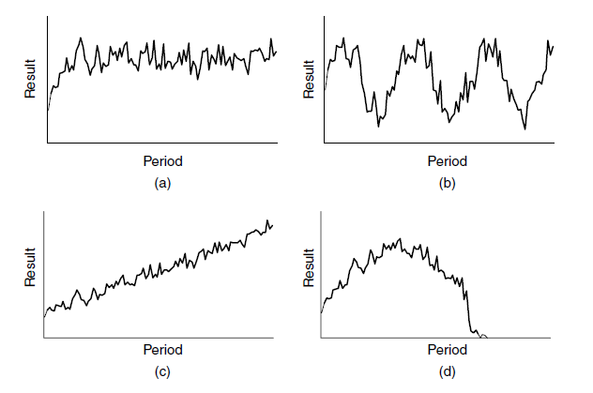

- It is non-terminating because at the end of the graph the data keeps appearing and is not at zero. It is Steady-state because the distribution of the values is maintained over time.
- It is non-terminating because at the end of the graph the data keeps appearing and is not at zero. It is steady-state cycle so that the steady-state periods are repeated over time.
- It is non-terminating because at the end of the graph the data keeps appearing and is not at zero. It is Transient because the values change constantly.
- It is terminating because at the end of the graph the values are zero. It is Transient because the values change constantly.

Time-series graph | Type of model | Nature of the simulation output
a | Non-terminating | Steady-state
b | Non-terminating | Steady-state cycle
c | Non-terminating | Transient
d | Terminating | Transient

Q3 - 25%) (Chapter 10). Section 10.5 describes various formal approaches to search experimentation (experimental design, metamodelling and optimization). Carry out some further research into one of these areas, identifying the key methods for aiding simulation experimentation.

I did a research into optimization area where the components to optimize are: decision variables, objective function, and constraints. There wont be a mathematical algorithm that guarantee the best solution and the most common approach is heuristic search.

The optimization techniques can be classified by the nature of the feasible region, in continuous and discrete decision variables, it depend if there is a countable region or a countable finite respectively. In Continuous decision variables there are methods like stochastic approximation, the sample path, response surface methodology (RSM) and low cost response surface. For discrete decision variables there are methods as Statistical Selection, Random Search, Metaheuristics.

To find key methods for aiding simulation experimentation i will focus in Statistical Selection, Metaheuristics and a combination of different methods.

- In Statistical Selection procedures there are different approaches like subset selection, indifference-zone ranking and selection (R&S), multiple comparisons procedures (MCP), decision theoretic methods or Bayesian analysis. To optimize simulation is recommended to combine subset selection for screening (reduce the subset of solutions) with R&S for selection of a specific solution or MCP to calculate simultaneous confidence intervals. It’s important to estimate carefully the mean and the variance needed to minimize how many simulations are enough to run, because each simulation consumes time.
- In Metaheuristics there are methods like Simulated annealing where the constant temperature search, used in the algorithm to select a new candidate solution, may work as well or better than a variable one. Tabu search allows to go back and search from a previous starting point. In general these methods can be used to determine the amount of sampling needed from each regions to be simulated.
- To get better solutions we can combine Statistical selection with Metaheuristics methods, for example:
  - A genetic algorithm is used to get a solution that will be screened using a statistical selection (subset selection) and then the best solution is selected using a Metaheuristic method (two-stage indifference-zone).
  - Use a two-stage indifference-zone to guarantee that the nested partitions random search method converges with a fixed probability to within an indifference zone of the optimal solution to get a good solution but not necessarily the optimal one.
  - Use the nested partitions framework, Metaheuriscitcs (GA or Tabu search) to speed up the search without lossing performance guarantees.

Bibliographic
“SIMULATION OPTIMIZATION” by Sigurdur Olafsson (2002).
Q4 - 15%) (Chapter 12). Carry out some verification and validation tests with the model of the bank model developed from the case described Exercise E6.1 (Chapter 6):
A bank is planning its requirements for ATMs (automated teller machines) in a new branch. There are spaces for up to six ATMs, not all of which have to be used. Three types of ATM can be purchased: general ATMs (giving cash, balances, mini statements and PIN change facilities), ATMs for paying money into accounts and ATMs that provide full account statements. The bank has a policy that customers should not wait more than 5 minutes in the majority of cases (generally interpreted as 99%)

Modelling objectives:
Determine the ATMs resources, number and type, required in a new bank branch so the customer won’t wait more than 5 minutes in the 99% of cases. Due to space constraints, a maxim of six ATM will be available.

General Project Objectives:
- Time-scale: 24 hours.
- Flexibility: Flexible, except arrival rate and wait time.
- Run-speed: Very simple model so run-speed should mot be an issue.
- Visual display: Simple 2D.
- Ease-of-use: Use by modeler only.

Model Outputs/Responses:

Outputs (to determine achievement of objectives)
- Percentage of customers queuing for less than 5 minutes.
- Maximum waiting time for ATMs (grouped for type of ATM).
- Percentage of service point utilization less than 80%.

Outputs (to determine reasons for failure to meet objectives)
- Queuing ATM time: maximum and percentage for less than 5 minutes.
- Percentage service point utilization for each one: maximum.

Experimental Factors:
- Quantity of ATMs independently of its type (1-6).
- Probability of type of ATM that a costumer needs.

Model Scope

Component | Include/Exclude | Justification
Entities:
Customers | Include | Flow through the service process
Activities:
Service Point | Include | Required for waiting time of service point and for experimental factor as number of ATMs and probability of what kind of ATMs is needed.
Queues:
Service point queue | Include | Required for waiting time
Resources:
Service personnel | Exclude | Simplification: Represented by service points
Maintenance | Exclude | Simplification: No breakdowns or maintenance.

Model Level of Detail

Component | Detail | Include/  Exclude | Justification
Entities:
Customers | Quantity: number | Include | Flow through the service process.
 | Arrival pattern: mean | Include | Required for flow of customers into the system.
 | Attribute: nature of service | Include | Determines which kind of ATM is required.
 | Routing: to service point queue | Include | Connects customers arrivals to other processes.
Activities:
Service Point | Quantity: number | Include | Experimental factor: Required for number of ATMs.
 | Nature: X in Y out | Exclude | Simple 1 in 1 out
 | Cycle time: service time distribution | Include | Required for workload and utilization service points (ATMs).
 | Breakdowns/Repair | Exclude | Simplification: assume no breakdowns.
 | Set-up/changeover | Exclude | Simplification: assume no set-up/changeover needed.
 | Resources | Exclude | Simplification: assume no resources needed.
 | Shifts | Exclude | Simplification: assume no resources needed.
 | Routing: from queue to exit | Include | Last activity before leave the bank.
Queues:
Service point queue | Quantity: number | Include | Required for waiting time.
 | Capacity: unlimited | Exclude | Assumption: No limit to number of customers who can wait.
 | Dwell time | Include | Required for waiting time.
 | Queue discipline: first-in-first-out | Include | Customers behaviors not being modelled.
 | Routing to: service point
Resources:
n/a

Assumptions
- Mean arrival rate is about 80% of the mean service rate (for the purposes of calculating this percentage both rates should be aggregated across all customer types and service points)
- Each type of ATM only can do their operations.
- The queue service is unlimited, there can be unlimited customers waiting.
- In the bank there is inly ATMs and no resources (director or any employee).
- The probability of which ATM needs is:

Service Point | Probability
General_ATM | 50%
Payments_ATM | 15%
Statements_ATM | 35%

Simplifications
- There is no breakdowns or repairs and neither maintenance resources.
- There is no set-up/changeover modelled.
- There is no modelled any resources the service is provide by service points (ATM)
- Without resources there is no need for shifts.

Q5 - 30%) Develop a computer model for the bank case described in Exercise E6.1 (Chapter 6). First devise the model structure and then develop the model code in the software of your choice. Set up the data so that the mean arrival rate is about 80% of the mean service rate (for the purposes of calculating this percentage both rates should be aggregated across all customer types and service points).

Based on the conceptual model from Question4, the model structure is compose by the following components:

Component | Include/Exclude | Justification
Entities:
Customers | Include | Flow through the service process
Activities:
Service Point | Include | Required for waiting time of service point and for experimental factor as number of ATMs and probability of what kind of ATMs is needed.
Queues:
Service point queue | Include | Required for waiting time

Model Coding

I use SIMIO software to configure the model. I describe each component in detail:

Customers:
There is an entrance and an exit for customers. The arrival rate of customers (interarrival Time) I left what SIMIO have for default Random.Exponential(5) because in my opinion is good enough without more data. The exit depends the time they spend inside the bank.

Service Point (ATM):
To configure the processing time for each ATM SIMIO show by default Random.Triangular(min, median, max). To determine the parameters I consider that each ATM only can do the explicit operations enumerated in this exercise, and also that a regular operation could take from 4 to 7 minutes and an average of 5 minutes, but a payment operation that involves cash takes more time and have higher deviations. I also assume that a statement operation is equivalent to a regular operation. For the initial configuration each service point is assigned a quantity of 1. The configuration is showed in the next table:

Service Point | Minimum [minutes] | Median [minutes] | Maximum [minutes] | Capacity [number]
General_ATM | 4 | 5 | 6 | 1
Payments_ATM | 5 | 6 | 8 | 1
Statements_ATM | 4 | 5 | 6 | 1

Service Point Queue:
I use a TransferNode to distribute customers from entrance to ATMs and also to converge the customers in their way out, TransferNodeIN and TransferNodeOUT respectively. I consider that general operations are more common than statements, and payments operations are less common to assign weights to the paths that connects TransferNode to ATMs. In the following table I show the configuration that I use at the different paths.

Service Point | Path Name | Selection Weight
General_ATM | Path2 | 50%
Payments_ATM | Path5 | 15%
Statements_ATM | Path7 | 35%

Simulation
The first simulation shows that the queue waiting time for General ATM is 18 minutes for Statement ATM more than 9. In the second iteration i add 1 General ATM. In the third iteration is added 1 Statement ATM.

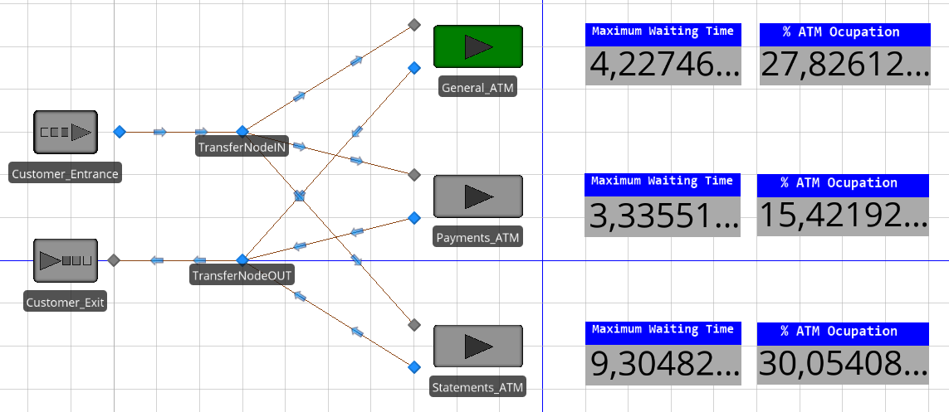
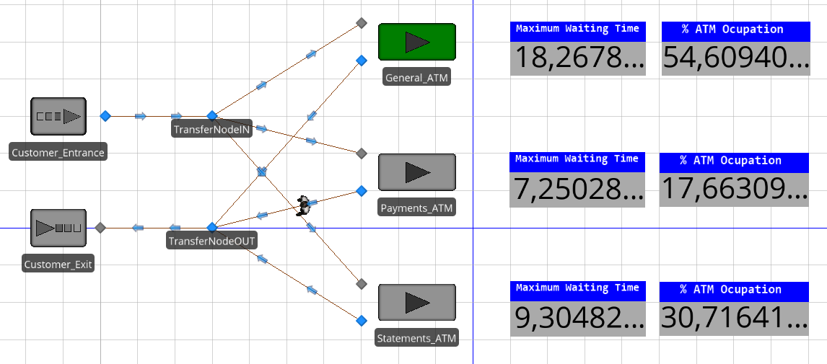
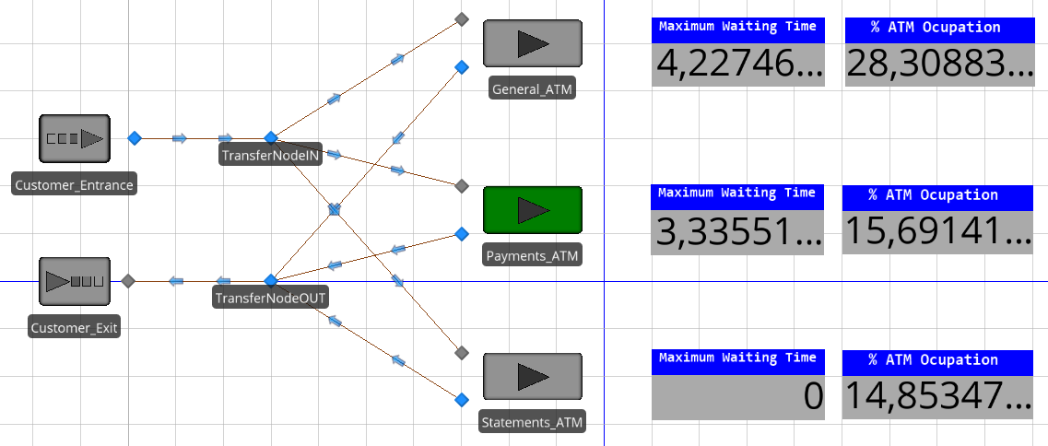

In the last iteration, the scenario achieve the objectives and the requirements of ATMs for the new branch bank are:
- 2 General ATM
- 1 Payment ATM
- 2 Statement ATM

I also add in another file the SIMIO simulation.

