Estudios de Ingeniería en Informática

SUBJECT: | SIMULACIÓN (M1.205)
PEC Num.: | Pràctica
Date of proposal: | 22/04/2018 | Date of delivery: | 27/05/2018
Observations: | - The answers will be on this document, keep the original text and take care on the final presentation.  - It is needed to justify all the answers.  - The name of the file must be  Surname1_Surname2_Name.RTF (o .DOCX o .PDF)

EXERCISES

In this practical you can use all the different techniques learned during the course. Define the goals of the model, the hypotheses to be used and the conceptual model. Finally implement the model with SIMIO and discuss the results.

System to model.
A conveyor system is implemented in an airport for managing the transfer of the passengers baggage and air packages from their origins to the boarding area, where packages will be collected and boarded. The model is concerned with the capacity of the security checks that are needed to be carried out between package collection and the deployment at the boarding buffer. The speed of conveyors is already set by the manufacturer. Both x-ray and manual inspection servers have limited space, and only allow up to four parallel processes (for each one). Nonetheless, improving those facilities is expensive ant the airport's authorities want to achieve good throughput values at minimum cost (minimum number of those parallel facilities). Sources for passport baggage and air parcels are different, and packages are driven by conveyors until a common conveyor is used to feed the security facilities. The times of the system elements are represented on the next table.

FACILITY | DISTRIBUTION (TIME IN MINUTES)
PASSENGERS BAGGAGE CHECK | Exponential(2.5)
AIR PARCEL SOURCE | Exponential(4)
X-RAY INSPECTION | Triangular(1.5, 3 , 5)
MANUAL INSPECTION FACILITIES | Erlang(5, 3)

On the next figure is shown the systematic representations of the part of the system that is needed to be modeled.

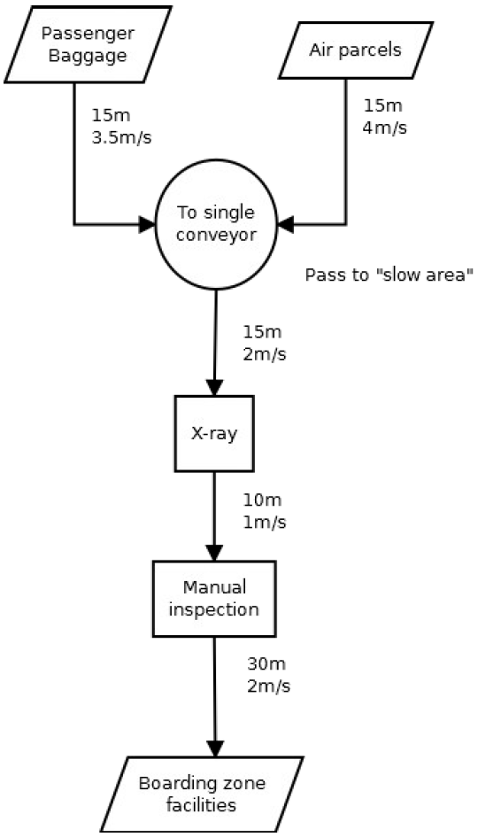
What is the final number of facilities that must be used on the airport? What validation techniques can be applied to assure that the conclusions are correct?

Modelling objectives:
Determine the number minimum number of facilities that must be used on the airport (due tom limited space, x-ray and manual inspection servers is limited to four parallel processes for each one).

General Project Objectives:
- Time-scale: 24 hours.
- Flexibility: Flexible, except number of x-ray and manual inspection servers.
- Run-speed: There are a few experiments to do, so a run-speed should not be a problem.
- Visual display: Simple 2D.
- Ease-of-use: Use by modeler only.

Model Outputs/Responses:

Outputs (to determine achievement of objectives)
- The input from air parcels and passenger baggage is close to the input packages on boarding zone.

Outputs (to determine reasons for failure to meet objectives)
- Difference of input packages at x-ray and ouput packages.
- Difference of input packages at manual inspection and ouput packages.

Experimental Factors:
- Quantity of x-ray and manual inspection servers.

Model Scope

Component | Include/Exclude | Justification
Entities:
Passenger Baggage | Include | Flow through the service process.
Air package | Include | Flow through the service process.
Activities:
X-ray service | Include | Required for experimental factor as quantity of x-ray service is needed.
Manual inspection service | Include | Required for experimental factor as quantity of manual inspection is needed.
Queues:
Passenger baggage to conveyor queue | Include | Required for input rate to conveyor.
Air parcels to conveyor queue | Include | Required for input rate to conveyor.
Conveyor to X-ray queue | Include | Required for waiting time and queue size response.
X-ray to Manual inspection queue | Include | Required for waiting time and queue size response.
Manual inspection to Boarding zone Queue | Include | Required for waiting time and queue size response.
Resources:
Service personnel | Exclude | Simplification: Represented by Activities (X-ray, Manual inspection).
Maintenance | Exclude | Simplification: No breakdowns or maintenance.

Model Level of Detail

Component | Detail | Include/  Exclude | Justification
Entities:
Passenger Baggage | Quantity: number | Include | Flow through the service process.
 | Arrival pattern: mean | Include | Required for flow of packages into the system.
 | Attribute: nature of service | Exclude | Excluded: packages are differentiated entities.
 | Routing: to single conveyor service point | Include | Connects package arrivals to other processes.
Air package | Quantity: number | Include | Flow through the service process.
 | Arrival pattern: mean | Include | Required for flow of packages into the system.
 | Attribute: nature of service | Exclude | Excluded: packages are differentiated entities.
 | Routing: to single conveyor service point | Include | Connects package arrivals to other processes.
Activities:
X-ray service | Quantity: number | Include | Experimental factor: Required for number of x-ray services.
 | Nature: X in Y out | Exclude | Simple 1 in 1 out
 | Cycle time: service time distribution | Include | Required for workload and utilization service point.
 | Breakdowns/Repair | Exclude | Simplification: assume no breakdowns.
 | Set-up/changeover | Exclude | Simplification: assume no set-up/changeover needed.
 | Resources | Exclude | Simplification: assume no resources needed.
 | Shifts | Exclude | Simplification: assume no resources needed.
 | Routing: from queue to manual inspection service | Include | Flow package trough system.
Manual inspection service | Quantity: number | Include | Experimental factor: Required for number of manual inspection services.
 | Nature: X in Y out | Exclude | Simple 1 in 1 out
 | Cycle time: service time distribution | Include | Required for workload and utilization service point.
 | Breakdowns/Repair | Exclude | Simplification: assume no breakdowns.
 | Set-up/changeover | Exclude | Simplification: assume no set-up/changeover needed.
 | Resources | Exclude | Simplification: assume no resources needed.
 | Shifts | Exclude | Simplification: assume no resources needed.
 | Routing: from queue to boarding zone facilities | Include | Last activity before sending packages to boarding zone.
Queues:
Passenger baggage to conveyor queue | Quantity: 1 | Include | Required for queue responses.
 | Capacity: unlimited | Exclude | Assumption: No limit to number of packages at the queue.
 | Dwell time | Exclude | Simplification: conveyor speed is set from fabric.
 | Queue discipline: first-in-first-out | Include | Simplification: same priority for baggage and air packages.
 | Routing to: Conveyor service | Include | Packages are send to a conveyor service
Air parcels to conveyor queue | Quantity: 1 | Include | Required for waiting time.
 | Capacity: unlimited | Exclude | Assumption: No limit to number of packages at the queue.
 | Dwell time | Exclude | Simplification: conveyor speed is set from fabric.
 | Queue discipline: first-in-first-out | Include | Simplification: same priority for baggage and air packages.
 | Routing to: Conveyor service | Include | Packages are send to a conveyor service
Conveyor to X-ray queue | Quantity: 1 | Include | Required for waiting time.
 | Capacity: unlimited | Exclude | Assumption: No limit to number of packages at the queue.
 | Dwell time | Include | Required for waiting time.
 | Queue discipline: first-in-first-out | Include | Customers behaviors not being modelled.
 | Routing to: service point | Include
X-ray to Manual inspection queue | Quantity: 1 | Include | Required for waiting time.
 | Capacity: unlimited | Exclude | Assumption: No limit to number of packages at the queue.
 | Dwell time | Include | Required for waiting time.
 | Queue discipline: first-in-first-out | Include | Simplification: same priority for baggage and air packages.
 | Routing to: service point | Include
Manual inspection to Boarding zone Queue | Quantity: 1 | Include | Required for waiting time.
 | Capacity: unlimited | Exclude | Assumption: No limit to number of packages at the queue.
 | Dwell time | Include | Required for waiting time.
 | Queue discipline: first-in-first-out | Include | Customers behaviors not being modelled.
 | Routing to: service point | Include
Resources:
n/a

Assumptions
- There is no breakdowns or repairs and neither maintenance resources.
- Machine repair and set-up are rare and there is no need to be modelled.

Simplifications
- Same priority for baggage and air packages when enter the simple conveyor service.
- Conveyor speed is set from fabric.
- There is no set-up/changeover modelled.
- There is no modelled any resources, the service is provided by service points (single conveyor, x-ray, manual inspection).
- Without resources there is no need for shifts.
- No limit to the number of packages who can wait in the queue for service.

Model Coding

I use SIMIO software to configure the model. I describe each component in detail:

Entities, Sources and Sinks:
There are two sources and one sink. The entity Air parcel is assign to Arrival_Air_Parcels Source and the Passenger Baggage is assign to Arrival_Passenger_Baggage Source. The arrival rate for each source is defined in the exercise and configured as shown below. A sink is used to model the exit model and where the packages are send.

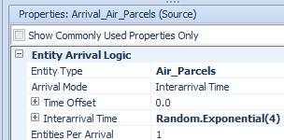
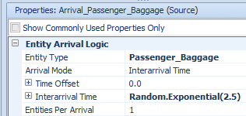
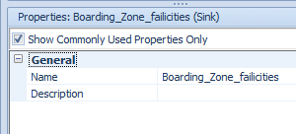

Activities (X-ray service, Manual inspection service):
To configure the processing time for each service I use what is defined by this activity. For the initial configuration each service point is assigned a quantity of 1.

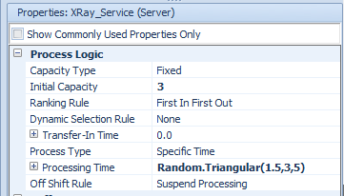
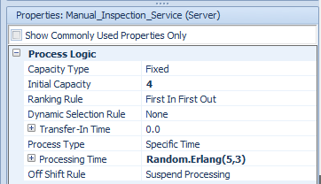

Queues:
I use a Basic Node to connect the conveyors from air parcels and passenger packages to send them to the x-ray service. I also use a conveyor to connect the x-ray service to manual inspection and manual inspection with boarding zone facilities.
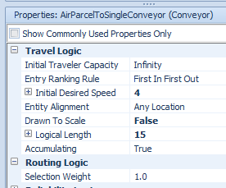
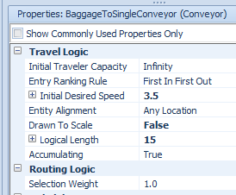
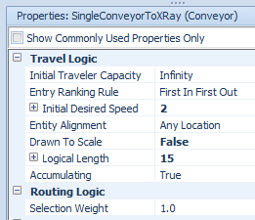
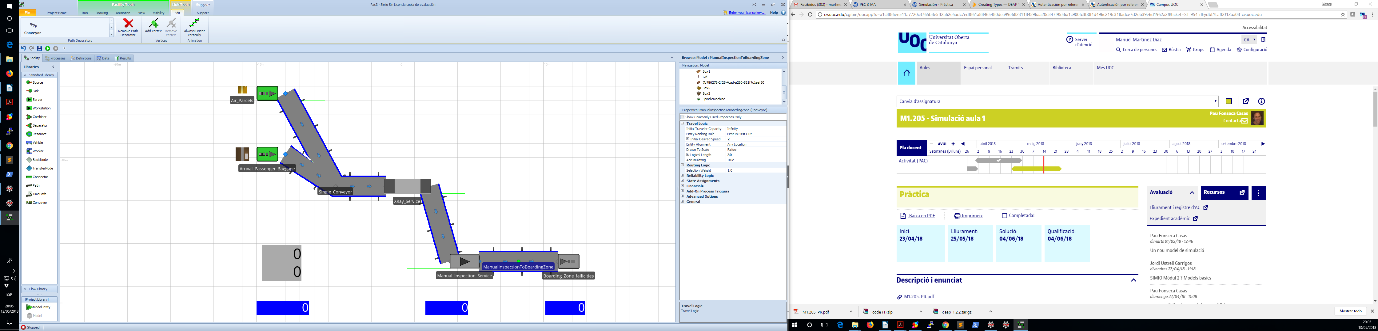

Simulation
The first simulation with 1 unit of each service, shows that only 287 packages of 902 are processed.

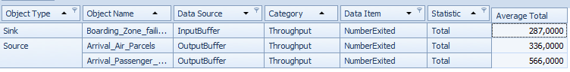

In the second simulation with 2 units of each service, the ouput improves but only half of packages are processed.
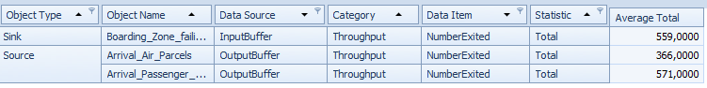
In the third simulation with 3 units of each service, the model process 873 of 941 arrived.

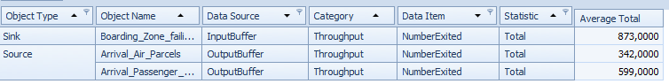
Depends on requirements to meet the objectives to determine that three units of each service could be enough and 75 packages inside the system at the end of simulation.

Beside I consider that 75 packages inside the system could be enough, I set the goal of this model to minimize the packages inside the system. With 3 units of Xray and 4 manual inspection we have a model so that only 6 packages are inside the system at the end of simulation, as shown in the diagram below.

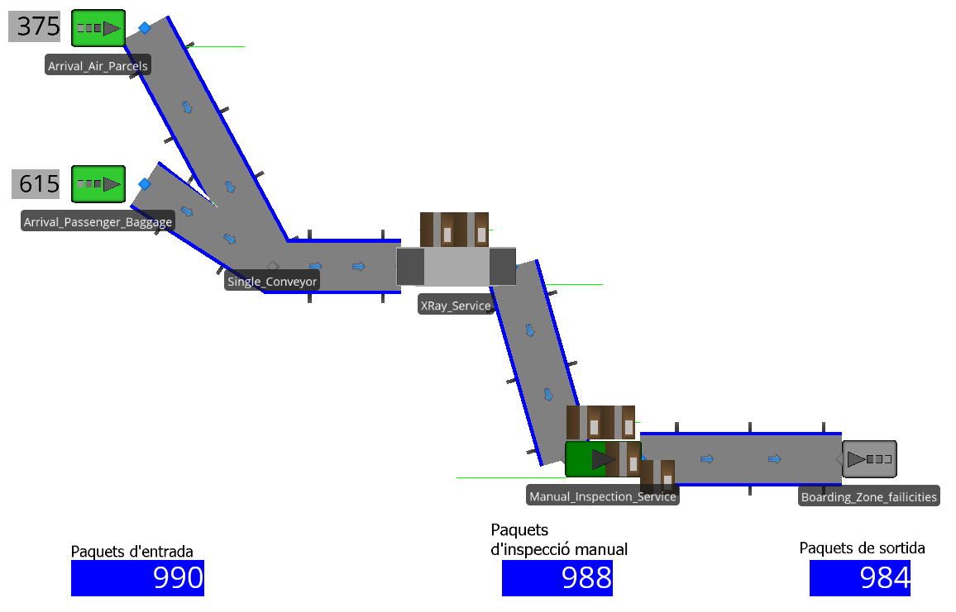

At that last iteration, almost every packaged inside the model is being dispatched to the boarding zone. The number os Xray and Manual Inspection service are:
- 3 Xray service.
- 4 manual inspection service.

I also add in another file the SIMIO simulation.

Validation techniques

For the exercise I use different validation techniques:

Conceptual Model Validation:
Considering the assumptions that there is no breakdowns, repairs are rare and should affects very few times and the simplifications I consider the model is quite reliable. The simplifications and assumptions I made have low impact except there I no breakdown for any element on the model and repair time.

To improve the model reliability we should consider to mode the characteristics with more impact, like breakdowns for path and x-ray machines.

White-Box validation
I consider given data at these exercise, the distribution time of the system elements ant the systematic representation with lengths paths ant speeds, is enough to model.
I use inspecting Output Reports to determine the utilization model and increase the service numbers until the output packages reduce to a few packages.

Experimentation Validation
Increasing the number of Xray service ant manual inspection service is been used to improve the result model.

