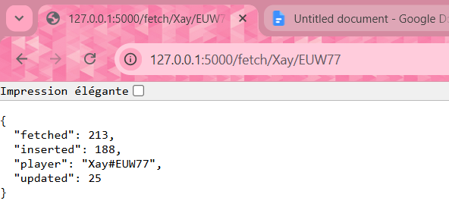
## Technical Notes

### Unicode & Special Character Support
The API fully supports Riot IDs containing special characters (e.g., `Röyhkeä#121`, `16 γραμμες#11111`).

This is handled in two places:

**`quote(player_name)`**
When fetching a player, the name is percent-encoded before being sent to the tracker URL.
This converts special characters into URL-safe format:
- `ö` → `%C3%B6`
- `space` → `%20`

Without this, names with accents or unicode characters would break the request entirely.

**`app.config["JSON_AS_ASCII"] = False`**
By default, Flask escapes non-ASCII characters in JSON responses (e.g., `ö` → `\u00f6`).
Setting this to `False` tells Flask to display them as-is, so the API returns `Röyhkeä#121` instead of `R\u00f6yhke\u00e4#121`.

---

## Notes
- Fetching the same player twice is safe — the API uses upsert logic, so existing matches are updated rather than duplicated.
- Riot IDs are case-sensitive. Make sure to use the correct casing (e.g., `Faker/KR1`).
- Only ranked matches are tracked.

