**DOCUMENTO DE DESIGN DE UM JOGO DIGITAL**

**Grupo:**

|  |  |
| --- | --- |
| **Alunos** | Manuel Gonçalves; [manuelaugusto.6@gmail.com](mailto:manuelaugusto.6@gmail.com) |
| Margarida Coelho; [margaridafcc@hotmail.com](mailto:margaridafcc@hotmail.com) |
| Simón Marcos; [simonaprea777@gmail.com](mailto:simonaprea777@gmail.com) |
| Fernando Prata; [argent.fernando.prata@gmail.com](mailto:argent.fernando.prata@gmail.com) |
| Alexandre Sousa; [sousabalexandre@gmail.com](mailto:sousabalexandre@gmail.com) |
| Mário Leite; [mariotomasleitetomas@gmail.com](mailto:mariotomasleitetomas@gmail.com) |
| Catarina Anastácio; [ccatarinanastacio23@gmail.com](mailto:ccatarinanastacio23@gmail.com) |

**Versão:** 1.0

**Data:** 11 de Maio de 2024

**Título: Bloodsvânia**

**Storyline:** Bloodsvânia, an action-adventure game mashing both the action of the Arkham games and the vibes of Resident Evil 4! In Bloodsvânia, you'll live through a Victorian-like era where vampires and humans, enemies for most of their lives, learned to coexist! Taking control of the first human-vampire hybrid that was locked up for most of their life you'll try to escape your prison and find out who and what you are, discovering secrets about this world and the unseen wonders lurking beneath it!

**Informação de copyright**

##### Outline

1. Tabela de Conteúdos – Se for prático, podem fazer-se hiperligações dentro do próprio documento. De qualquer modo, a paginação deve estar sempre actualizada.
2. Historial do Design – Listagem sintética das alterações efectuadas nas diferentes versões.
3. Secção I – Visão Geral //
   1. Conceito de jogo //
   2. Features //
   3. Género //
   4. Público-alvo //
   5. Referências no mercado – Remete para o anexo com as fichas de referência. //
   6. Sumário do fluxo de jogo – Como é que o jogador percorre o jogo. //
   7. Estética (Visualização e atmosfera) – Qual o tipo de ambiente do jogo? Que tipo de estilo visual tem?
   8. Abrangência do Projecto – Um sumário da abrangência do projecto.
      1. Número de locais
      2. Número de níveis
      3. Número de NPC’s
      4. Número de armas
      5. Etc.
4. Secção II – Gameplay e Mecânica
   1. Gameplay
      1. Progressão de jogo
      2. Estrutura de desafios (missões)
      3. Estrutura de Puzzles
      4. Objectivos – Quais são?
      5. Fluência de jogo – Como é que o jogo flui para o jogador?
   2. Mecânica base – Quais são as regras do jogo, quer explícitas quer implícitas. Qual é o modelo de universo criado; como é que todas as suas peças interagem?
      1. Física – Como funciona a física deste universo?
      2. Movimento
         1. Geral
         2. Outro
      3. Objectos
         1. Agarrar Objectos
         2. Mover Objectos
      4. Acções
         1. Switches e Botões
         2. Agarrar, carregar e largar
         3. Falar
         4. Ler
      5. Combate / Luta – Se existe luta ou conflito, como é que é modelado?
      6. Economia – Qual é a economia do jogo? Como funciona?
   3. Fluxo de Interfaces
      1. Fluxograma de interfaces– Descrição gráfica (em mapa) dos principais interfaces e do seu relacionamento.
      2. Layout / Descrição de interfaces – Qual a utilidade de cada interface?
         1. Menú principal
         2. Opções
         3. Etc.
   4. Opções de Jogo – Quais são as opções de jogo e como é que afectam o gameplay e a mecânica?
   5. Replaying e Saving
   6. Cheats e/ou Easter Eggs
5. Secção III – História, Mundo e Personagens
   1. História e Narrativa – Elementos específicos, como argumentos para cut-scenes, são referidos e anexados; não interrompem o fluxo do DDJD.
      1. Back story
      2. Plot-points
      3. Progressão de jogo
      4. Considerações de licença
      5. Cut Scenes
         1. Cut scene #1
            1. Personagens
            2. Descrição
            3. Storyboard
            4. Argumento (referência ao anexo)
         2. Cut scene #2
         3. etc.
   2. Mundo
      1. Ambiente geral e atmosfera
      2. Area #1
         1. Descrição geral
         2. Características físicas
         3. Níveis que usam a área
         4. Ligações a outras áreas
      3. Area #2
         1. etc.
   3. Personagens
      1. Personagem #1
         1. Back story
         2. Personalidade
         3. Aparência
            1. Características físicas
            2. Imagens e animações
         4. Competências especiais
         5. Relevância para a história
         6. Relação com as outras personagens
         7. Estatísticas
      2. Character #2
      3. etc.
6. Secção IV – Níveis
   1. Nível#1
      1. Sinopse
      2. Material de introdução (Cut scene? Briefing de missão?)
      3. Objectivos
      4. Descrição física
      5. Mapa
      6. Critical Path
      7. Encontros
      8. Level Walkthrough
      9. Material de resolução (Cut scene?)
   2. Nível #2
   3. etc.
   4. Nível Tutorial
7. Secção V - Interface
   1. Sistema visual
      1. HUD
      2. Menús
      3. Modelo de Câmara
      4. Modelo de iluminação
   2. Sistema de controle – como é que o jogador controla o jogo? Quais são os comandos específicos?
   3. Áudio
   4. Música
   5. Efeitos sonoros
   6. Sistema de ajuda
8. Secção VI – Inteligência Artificial
   1. IA de adversários – O adversário activo que “joga” contra o jogador e, portanto, requer decisões estratégicas (exemplo, Civilization ou Xadrez)
   2. IA de adversários: vilões e/ou monstros
   3. Personagens não conflituosos
   4. Personagens amigáveis
   5. IA de suporte
      1. Detecção de colisões
      2. Pathfinding
9. Secção VII – Aspectos Técnicos
   1. Target Hardware
   2. Hardware e software de desenvolvimento
   3. Procedimentos e standarts de desenvolvimento
   4. Motor de jogo
   5. Network
   6. Linguagem Scripting
   7. etc.
10. Secção VIII – Arte
    1. Concept Art
    2. Guia de Estilo
    3. Personagens
    4. Ambientes
    5. Arquitectura e Equipamentos
    6. Cut scenes
    7. Miscelânea
11. Secção IX – Software Secundário
    1. Editor
    2. Installer
    3. Software de Update
12. Secção X – Gestão
    1. Calendário
    2. Orçamento
    3. Análise de riscos
    4. Plano de testes
13. Anexos
    1. Fichas de referência
    2. etc.
14. Apêndices
    1. Lista de Assets
       1. Arte
          1. Lista de Modelações e Texturas
          2. Lista de Animações
          3. Lista de Efeitos
          4. Lista de Arte para Interfaces
          5. Lista de Cut scenes
       2. Som
          1. Sons Ambiente
          2. Sons de Armas
          3. Sons de Interface
       3. Música
          1. Ambiente
          2. “Acção”
          3. Vitória
          4. Derrota
       4. Voz
          1. Falas Actor #1
          2. Falas Actor #2
          3. Etc.

**Section 1 - Overview**

**Game Concept**

Bloodsvânia was the first idea the GWC had, used in the 9th Edition of the Interdisciplinary Week. It was a visual novel set in a Victorian-like world, where vampires and blood selling vending machines automatons lived together. You controlled Bloodslot, an automaton that got purchased by a Vampire Dentist and got caught herself in a love quarrel.

Enthusiastic and passionate about this project, we decided to put our feet in the cold waters of Bloodsvânia and both expand and create something we’re all proud of. With that in mind, we expanded the world, made humans more prevalent in the story and developed an idea for an Action-Adventure set in the mythic and dark world of Bloodsvânia.

Inspired by Resident Evil 4, we took the narrative into a dark and cryptic vibe, yet with some out of the box comedy that hits you out of nowhere. We found this type of narrative fitting for our game as well as our group, as we tend to always put a comedic side to every work we do.

For the gameplay we were very impressed by the Wolverine PS5 leaks, the wild and violent take on the Arkham’s combat (Freeflow combat) inspired us to try and build a real time reaction-based combat, with different combos and finishers to end our enemies in a fashionable way. As we all liked the iconic suplex Leon does to old senile people in Resident Evil 4, we decided to take that aspect and implement it in the finishers, making the main character use moves inspired in the WWE to finish his opponents. We also took the idea of Maiden from the Dark Souls games, more akin to Dark Souls 2 and 3, where you’re obliged to talk to your Maiden to level up. Bloodslot will be the chosen Maiden for this game. The camera will be third person, where the player has full control of it, able to completely rotate around the player and see the front too, when in combat, the camera will zoom out a bit to see the area better, and when in a moment we want the player to focus on something we make the camera focus on that specific thing and stop the player from rotating too much.

The target audience for this game would be PEGI-16, as we intend to put a lot of dark humor, but we also intend to have romance and *explicit* scenes.

**Game Flow**

When talking about the whole game, we can easily divide the game in three acts, the escape part where the player is stuck on the factory he was imprisoned in, the middle part where we discover and uncover the world and what is really happening here, and the end war where the player will see which side he will choose. For the prototype we intend to adapt the whole escape from the factory, having itself be divided in three acts, when we escape the actual prison and learn how to play; when we get the metaphorical key for the exit, knowing this act ends when we meet the mother; the final act that has the reveal of the boss fight, the boss fight and the appearance of Bloodslot, which connects us to the outside world.

**Section 2 – Gameplay and Mechanics**

Bloodsvânia is planned to be an action-adventure game, with real-time reaction-based combat where the player controls a vampire human hybrid.

The player has 4 stats that can be upgraded, he has Health, Blood, Composition and Reflex. The Health stat affects the amount of health the player has, consequently affecting the health bar, the Blood stat affects the size of the rage bar, consequently making it so that the player can stay on rage mode longer, the Composition stat makes the player more resistant, making him receive less damage and makes it so that, when in rage mode, the player won’t lose so much HP, making the rage mode longer, the Reflex stat enables the player to counter and attack faster. To level up these stats the player will have Fulgurite, which is an equivalent to souls in Dark Souls, where the player uses them to level up and, if in a future version we add that mechanic, to buy and sell items.

The rage bar is a mechanic where the player, when it’s full, can activate it to enter his rage mode, where he sacrifices health points for movement speed, faster attacks and the ability to finish enemies when they are low on health. We intend to make it so that the rage bar consumes more health points than consuming itself, this way the player feels punishment and makes it so that he uses it more wisely in combat. Upgrading the Blood stat makes it so that the rage bar is longer, yet it still only needs a value of 50 to start itself, we will represent this in the UI by separating the extra rage with a little space, like God Of War. The player can also trade his rage bar for health points in combat.

Starting up the player will have (All these values are temporary and will be most liked changed with further testing) 100 health points and his rage bar will be half the size of his health bar, 50 points. Using Fulgurite, the player can improve these values.

For this prototype we will only use mouse and keyboard so I will directly say the buttons each thing does. The player can move around using the WASD keys, move the camera around the character using the mouse, by clicking the right click he can attack, by clicking the left click he can counter-attack, if he attacks within a certain time frame, he will combo. The player can click the F key to interact, like talking to NPCs, if he presses the escape key he enters the pause menu. The player can press the spacebar to jump, use the Q key to enter rage mode or the E key to heal himself. He can sprint using the Shift key. When in rage mode he can click both the right and left click of the mouse to finish low health enemies with a cool animation.

For the game we have in mind, the player will be able to interact with more than just NPC’s or the Maiden, but also with objects that could explain and give the player more information about the world and everything around him, but also trigger certain sequences, for example, we divide the first level in two parts, before the lab and in the lab, to get to the lab the player interacts with a key and then falls onto the lab.

The objective in this prototype is to escape the place where he’s been imprisoned his whole life. For this we have a sense of urgency, quickly moving the player between scenes, closing doors behind him and making it so that he can’t backtrack, this also helps in optimizing the game as we can deactivate or activate certain objects in the game.

**UI Fluxogram**

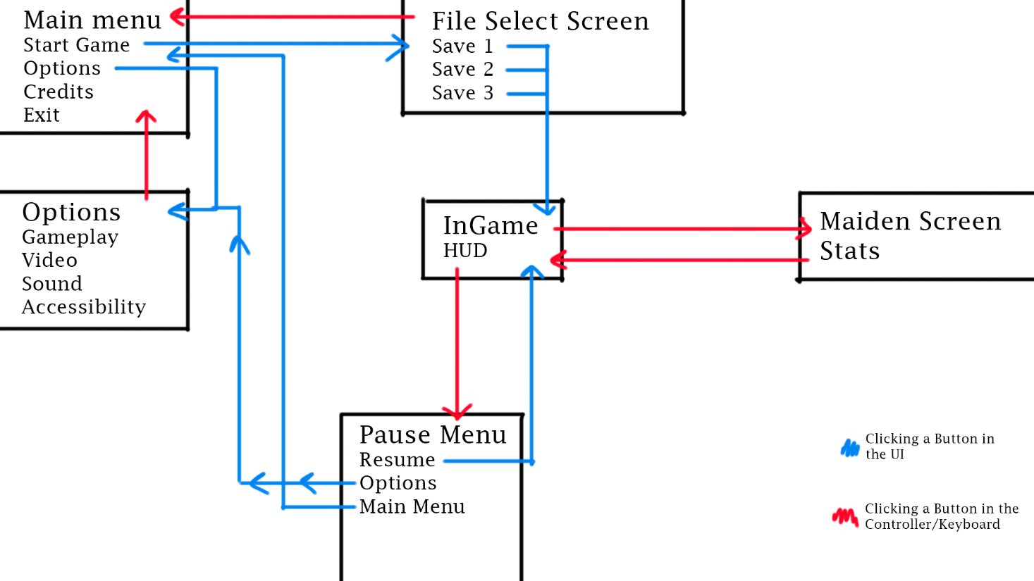

**Section 3 – Story, World and Characters**

**Section 4 – Levels**

**Section 5 – Interface**

**Section 6 – Artificial Intelligence**

Due to Bloodsvânia being based on Free-Flow combat, smart and interactive enemies are an essential. For this we decided to elaborate and try to work a bit more on the enemy’s behavior. For starters, due to every enemy having its own group, every group has an Enemy Manager, that will act as a brain telling and appointing functions to each enemy during or off combat. When not in combat enemies might be walking around a pre-determined path or standing idly looking at an entrance or at a point of interest. When in combat the enemies randomize whether they’ll strafe to the right or left, perpendicular to the player, in a circle movement. The Enemy Manager then decides that one of them will attack the player, running towards them and when close enough triggering an attack, it’s also in this moment the player can counter-attack. When the attack ends the enemy retreats and sends a signal to the Enemy Manager that then waits a couple of seconds before deciding who attacks now, being that the same enemy can’t attack twice in a row unless he’s the last one.

This is the basis of our AI in the combat, as we are not that knowledgeable in this area, this is as far as we could make them, we’re using Boolean variables that act as states, that the Enemy Manager both receives and reads, but also changes them. As this is the first part where we actually talk about code, the whole combat system moved forward in a clearer and faster way due to this video:

<https://www.youtube.com/watch?v=GFOpKcpKGKQ>, which, because the creator also supplies the viewers with the whole code on GitHub, helped us and fast-forwarded a lot in the making of the AI.

**Section 7 – Technical Aspects**

XX

**Section 8 – Art**

**Section 9 - Management**

XX