**MANENO MICHAEL**

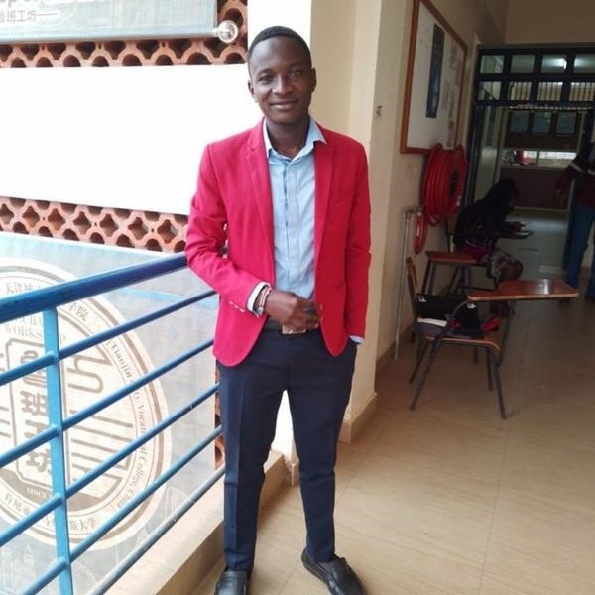

Software Engineer & Developer

**Experience:** 2 years | **Available:** Immediately | **Location:** Nairobi

manenomichael99@gmail.com |

+254 718 776 401

+254 794 112 862

|  |  |  |  |  |  |
| --- | --- | --- | --- | --- | --- |
| |  |  | | --- | --- | |  |  | | **ABOUT ME** |  | |  |

Am a hardworking, passionate and dedicated team builder and member intrigued with providing solutions through technology. Am a self-driven individual with a 2-year experience in the software development field especially in the frontend web-development. Am a tech enthusiast with fascination in the field of Artificial Intelligence and Data Science using python.

Am full stack developer and UX/UI designer with expertise in both the front-end and back-end development. In my frontend development area, am experienced in the WordPress, Bootstrap, Angular, React and Vue.js frameworks. For the backend area, am vast in Node.js and Php Laravel Framework while in design work, am adept with the Adobe XD tool for design. I’m not only capable of building real time projects but also responsive applications that suit the changes in the market.

I have worked with Oaknet Business Company where we worked on various real time projects including the Amal Investment platform and the FYX application platform. Became the team leader of the front-end developers’ team where was able to exercise my team building and leadership skills.

**WORK EXPERIENCE**

**IEBC**

Entry level | Election Clerk

Nairobi, Kenya

2022-08-01 | 2022-09-01

Was privileged to take part in the 2022 general elections in Kenya as a polling clerk. Under this docket was able to work with the KIEMS kit used for voter identifycation purposes. Was able to carry out the task and help in trouble shooting the KIEMS kit in the case where they failed with my IT background.

**Oaknet Business technologies**

Volunteer, internship | Front-end developer

Nairobi, Kenya

2022-01-01 | 2022-04-01

Secured a chance for an industrial attachment with Oaknet Business and was placed in a team of front-end developers. As a team, we managed to work on the AMAL investment platform during that period. Was later made the team leader and we were able to work on the FYX platform program. Gained skill in React, Bootstrap, Vue.js and Angular.js front-end frameworks. Also made it in my interest to learn the working of back-end and learned Node.js and Php Laravel backed framework.

**Machakos University**

Volunteer, internship | Career Ambassador

Machakos, Kenya

2021-05-01 | Currently working here

Applied and was shortlisted among the few to work in partnership with the career office of Machakos University as a Career ambassador. The job description entails giving career guidance to students on their career path and the available market offers for them. It bridges the gap between the students and the real time market place and aims to sharpen the perspective of the students in preparation for the same. We also take part in guiding and counselling of the students with various and different academic issues.

**Upwork**

Entry level | Freelancer

Remote, Kenya

2021-02-01 | Currently working here

I'm currently working as a software developer specialised in front-end development on different freelance platforms including Upwork, Freelancer, Fiverr, Toptal and Guru. The experience has been awesome as it pushes me to learn and explore more. Got my first Upwork deal in 2021 where was contracted to take part in an AI Image recognition project by Pactera edge.

**Madam Medina**

Entry level | Shop attendant

Bungoma, Kenya

2020-05-01 | 2020-08-01

This was during my school long holiday where was contracted to work as a shop attendant. In the line of work, the duties delegated to me were more than just the "attending to customers" thing. Under my belt was the whole management of the business including the M-pesa management. Did stock purchases and updates for the store and deliveries too. Was always in-charge of the daily financial record keeping for audits on weekly basis.

**Chemwa Secondary**

Entry level | Teacher

Bungoma, Kenya

2018-01-01 | 2018-08-01

Was contracted to be a board teacher of Mathematics, Physics and Chemistry combination. Taught the form one class physics and Mathematics subject combination. For the form two class, I was privileged to take them through Chemistry and Physics combination and for the form three class, I took them through Mathematics and chemistry combination. From the experience, was able motivate students and help those who had lost hope to believe in themselves.

|  |  |  |  |  |  |
| --- | --- | --- | --- | --- | --- |
| |  |  | | --- | --- | |  |  | | **EDUCATION** |  | |  |

**Machakos University**

Bachelor | Bachelor in Computer Science

Am a final year student with a month to finish my course work in a bachelor’s degree as a computer scientist. Am passionate about software development especially front-end development. I'm a fast learner and can adapt to an environment. Have worked on two real time projects during my attachment period at Oaknet Business where I gained the necessary skills in development including team work. I personally also have worked on other personal projects of my own to sharpen my skills and gain more experience.

Currently am undertaking a certification with Huawei in Cloud computing just to widen my scope of view in the field. Also received a software Engineering scholarship under Adanian Labs in partnership with the Family Group Foundation under the program TUFUZU. The program is still ongoing till February 2023 where I will be certified as a software Engineer.

|  |  |  |  |  |  |
| --- | --- | --- | --- | --- | --- |
| |  |  | | --- | --- | |  |  | | **JOB SKILLS** |  | |  |

**JavaScript**

**HTML5**

**CSS**

**React**

**Angular**

**PHP**

**Vue.js**

**Laravel**

**Python**

**Node.js**

|  |  |  |  |  |  |
| --- | --- | --- | --- | --- | --- |
| |  |  | | --- | --- | |  |  | | **LANGUAGE SKILLS** |  | |  |

**English Swahili**

|  |  |  |  |  |  |
| --- | --- | --- | --- | --- | --- |
| |  |  | | --- | --- | |  |  | | **ASSOCIATIONS** |  | |  |

**Adanian Labs and Family Group Foundation:** Cohort II Software Engineering scholarship beneficiary.

**Family Group Foundation:** High school Scholarship beneficiary.

**Huawei:** Huawei ICT competition participant.

|  |  |  |  |  |  |
| --- | --- | --- | --- | --- | --- |
| |  |  | | --- | --- | |  |  | | **CERTIFICATES & AWARDS** |  | |  |

**Praise and Worship Coordinator:** Certificate | 2021

|  |  |  |  |  |  |
| --- | --- | --- | --- | --- | --- |
| |  |  | | --- | --- | |  |  | | **PROJECTS & PORTFOLIO** |  | |  |

**Gitlab projects account:**

<https://gitlab.com/Bahatimyk>

**LinkedIn Account:**

<https://www.linkedin.com/in/michael-maneno-ab7325201/>

|  |  |  |  |  |  |
| --- | --- | --- | --- | --- | --- |
| |  |  | | --- | --- | |  |  | | **Hobbies** |  | |  |

Reading Tech books

Doing research

Playing football

Singing

Playing the guitar

|  |  |  |  |  |  |
| --- | --- | --- | --- | --- | --- |
| |  |  | | --- | --- | |  |  | | **Referees** |  | |  |

1. **Charles Wepukhulu.**

Ward Administrator, Nalondo Ward.

Mobile number +2547 1555 4994.

1. **Peter Asutsi.**

Academics Teacher.

Shagungu Secondary School.

Mobile Number +254 72833 2402.

1. **Medina Malabe.**

Shop owner/ Youth pastor.

Mobile Number: +254 71201 0346

1. **Wesley Ochieng.**

Senior Developer.

Oaknet Business Technology.

Mobile Number: 0726 580246

1. **Madam Ruth Munene.**

Career Office Coordinator,

Machakos University.

Mobile Number: +254 722 332510