**Analysis of Population Growth and Energy Consumption**

**Abstract:**

In the below study I will be analyzing world bank data and try to explore the trends and relation between the variables and try to explore the differences between one versus other countries which involves features like population growth and power consumption. This analysis will help us understand about various countries and its population percentage and their power consumption. I have used various visualization techniques to show the difference between each country and their power consumption details graphically using plots like scatterplot, box plot etc.

**Analysis:**

I have used various plots to analyze the World Bank data visually as below.

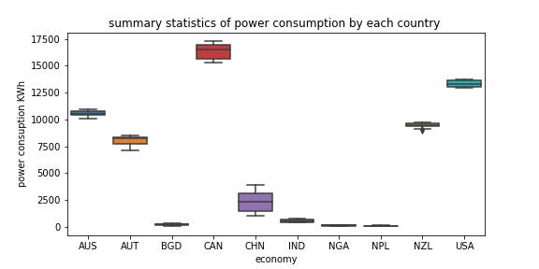

Fig.1 power consumption

Box plot: Box plot helps us find the distribution of data along with outliers if any present. we get values like min,max,25%,75%, outliers if any present. So from the below box plot, we can observe the summary statistics of all the 10 countries electric consumption. It clearly shows USA is the country with highest electric consumption and with Nepal being the lowest among the countries in terms of power consumption. Average values are 13322 for USA and 92.47 for Nepal.

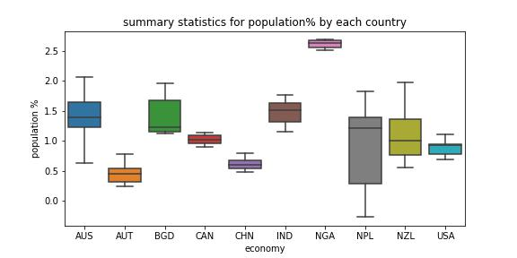

Fig.2 population %

Box plot for population : Just like we plotted earlier for electric consumption, now we applied box plot for population and summary statistics are evident for 10 countries. Observation is country 'AUT' has been the lowest with 0.78 and country 'NGA' being the highest with 2.68. Also one observation from the summary statistics is min value for country 'NPL' is -0.26 which could be a data collection error as its not possible in terms of population. Also no outliers are evident for population.

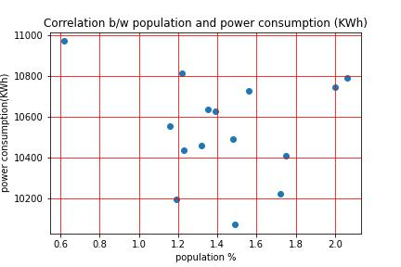

Fig.3 correlation b/w population &power consumption

Scatterplot for population vs electricity consumption for Australia helps us understand the relation between two variables. It shows whether variables have strong correlation or weak correlation or no correlation at all. We also can know the direction of the relationship between the Variables. We have plotted scatter plot for variables population and electric consumption with X-axis being Population and Y-axis being electric consumption between years ranging between 2000 -2014 for country Australia. We have seen negative correlation between these features and with increase of population percentage there is decrease in electric power consumption. Corresponding correlation coefficient values for country Australia is -0.13 which indicates strong negative correlation.

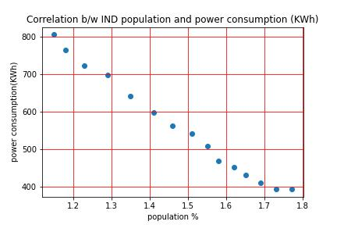

Fig.4 correlation b/w population &power consumption

Scatterplot for population versus electricity consumption for country India helps us understand the relation between two variables. It shows whether variables have strong correlation or weak correlation or no correlation at all.

We also can know the direction of the relationship between the variables. We have plotted scatter plot for variables population and electric consumption with X-axis being Population and Y-axis being electric consumption between years ranging between 2000 and 2014 for country India. We have seen negative correlation between these features and with increase of population percentage there is decrease in electric power consumption. Corresponding correlation coefficient values for country India is -0.95 which indicates strong negative

**Conclusion:**

In the analysis we have done on the data extracted from World Bank. We have features like population and electric consumption for many countries in the data as our main focus of analysis relied on population percentage of each country along with their power consumption. Also we focused on comparing each country’s population versus power consumption and explored the summary statistics which helped us in understanding the distribution of data and we have found some domain specific data collection errors for country 'Nepal' with population value in negative numbers which is technically not possible. We analyzed with increase or decrease in population percentage there is increase or decrease in power consumption over a period of time. This analysis helped in differentiating power consumption in relation with population percentage for a period of years.

**References:**

<https://data.worldbank.org>

<https://worldpopulationreview.com/countries/india-population>