MotoMedic AI concept and architecture
  - Manual question answering with private drafting semantic verification and buffered delivery
Version 04 reconciled 11 October 2026 with TRD v0.6
TRD v0.6 records the owner decision of 11 October 2026: open manual question answering through DRAFT, a separate online semantic VERIFY call, and delivery of the saved buffered response through STREAM. This supersedes A/B selection, exact-answer-only restrictions, universal StepDefinition or diagnostic-path gates, and the later no-online-verifier amendment. Source integrity, selected-manual applicability, privacy, limits and source display restrictions remain binding. This design decision does not authorize new spending, billing changes or deployment.

Current answer architecture
The rider may ask any question about the selected motorcycle and manual, including a documented procedure. No predefined question, canonical response, intent catalogue, fact group, answer scope or registered action is required for an otherwise source-supported answer. The applicable manual evidence is the knowledge authority. Give concise useful information, state partial support clearly, and provide the verified OEM support route where appropriate. Do not invent diagnosis, repairs, conditions or OEM ordering. Rider usefulness feedback does not establish technical correctness or a verified repair.
Reuse versioned hosted Docling ingestion, BGE M3 plus BM25 and Qdrant. Retrieve and assemble relevant immutable passages through hybrid search, bounded recovery and conditional reranking. Do not parse or embed the manual per request. A high relevance score does not establish support; failure to retrieve an answer is not proof of absence throughout the manual.
DRAFT privately using the actual question, relevant conversation history and outcomes, assembled applicable evidence and citation IDs, and the source-only policy. Produce the complete proposed answer with claim mappings, conditions, warnings and any limits. There is no separate assess-evidence-first LLM call. Allow new wording and combinations of supported facts; never expose private drafting tokens.
VERIFY in a separate LLM call against the exact question, relevant history, complete proposed response, claim mappings and source passages. Check meaningful question coverage and every technical claim, including applicability, conditions, warnings, prerequisites, units and specifications. Record strict structured question coverage, per-claim support, omissions, conflicts and an ordinary decision of RELEASE_COMPLETE, RELEASE_PARTIAL or SHOW_FALLBACK, bound to exact response and evidence hashes. Preserve RELEASE_CLARIFICATION for AMBIGUOUS and RELEASE_SAFETY_STOP for SAFETY_STOP special routing. Confidence is not acceptance. The verifier evaluates and does not rewrite a released answer.
Finalize all server-added technical text, warnings, citations and any partial-answer limitation before verification. Withhold rejected drafts. Permit at most one evidence-supported correction and a new verification call; any changed technical response must be verified again. If support cannot be established or the bounded correction fails, use SHOW_FALLBACK without another correction. Verification remains probabilistic; evaluate false acceptance and false refusal independently against original pages.
Show the operational labels Retrieving manual information, Drafting your answer, Checking the answer against the manual, and Displaying the verified answer when the backend actually enters each stage. Open the progress channel promptly, without chain-of-thought, fake percentages or simulated timing. Release technical answer content only after whole-response verification, final integrity checks and durable save. Stream the exact buffered verified response without another model call. Bind delivery to response hash, evidence and runtime versions, and operation ID; preserve complete saved answers and idempotent recovery after disconnects. Fixed neutral fallback and system-error messages do not need successful LLM verification; never label their display as a verified technical answer.
Relevant typed facts and immutable outcomes remain separate from conversational wording. ACTION_COMPLETED_UNRESOLVED never becomes OBSERVED_NORMAL. Optional legacy troubleshooting flows may retain reviewed StepDefinition and ApplicabilityRule records, but they cannot restrict ordinary manual Q&A or source-supported questions about documented procedures. Source-derived prerequisites and warnings must be satisfied, clarified when rider-resolvable, or explicitly handled in the verified answer.
The ordinary verifier decisions are exactly RELEASE_COMPLETE, RELEASE_PARTIAL and SHOW_FALLBACK. These decision labels are distinct from the application states SUPPORTED, AMBIGUOUS, UNSUPPORTED, SAFETY_STOP and SYSTEM_ERROR; do not introduce ACCEPTED or PARTIAL as verdict labels. RELEASE_COMPLETE and RELEASE_PARTIAL release only the exact verified technical response; a partial response must include its limitation before verification. SHOW_FALLBACK handles irrelevant evidence, missing support or failed bounded correction, while preserving RELEASE_CLARIFICATION for AMBIGUOUS and RELEASE_SAFETY_STOP for SAFETY_STOP as distinct special decisions. Ask one focused question only for a rider-resolvable ambiguity needed for the actual question. Source gaps or review decisions are maintainer issues. Malformed output, timeout, outage, exhausted quota or integrity failure is SYSTEM_ERROR, never acceptance or proof of absence throughout the manual. Preserve safety-stop precedence; technical safety wording is also covered by verification before delivery.
For SHOW_FALLBACK, display this exact fixed application message: I couldn’t find relevant information in the selected manual to answer your question. Please contact Royal Enfield or an authorised service centre. Attach the verified OEM contact URI from source_manifest.json, preserving its manifest binding. Record the exact internal reason code IRRELEVANT_ANSWER, MISSING_SUPPORT or CORRECTION_UNSUCCESSFUL. Preserve specific provider, schema and source-integrity failure reason codes in telemetry while displaying the fixed neutral SYSTEM_ERROR message. This fallback is neutral application wording, not a verified technical answer. For SYSTEM_ERROR, display this exact fixed application message: I couldn’t check the answer right now. Please try again shortly. These fixed neutral messages require no successful LLM generation or verification call and remain available during provider failure. Do not expose rejected technical drafts or claim these messages received semantic technical approval. Preserve application routing, safety precedence, session ownership and saved delivery integrity.
Disable old Arm A and exact-response shortcuts in the initial integration; they cannot bypass the new verification call. Index reuse and provider prompt caching are separate optimizations. Future verified-response reuse needs exact source, query, state, response and runtime bindings plus separate evaluation. Similarity alone never authorizes reuse. Count complete requests and all draft, verify, correction and re-verification attempts against existing token, byte, output, concurrency, quota, retention and spending limits; never silently truncate mandatory evidence.
Preserve exact immutable source IDs, original-page provenance and approved source-object bindings. Source-integrity review is distinct from authored-answer approval; the frozen 161-case v3 package and its exact bytes remain unchanged. Parent labels do not authorize whole parent bodies. Restore applicable warnings, prerequisites, table headers, units and referenced context only through reviewed source relationships. Page 103 fallback and unresolved source-specific limitations remain explicit. Rider PDF, excerpt and figure-crop delivery remains prohibited under source_manifest.json; use verified paraphrases and server-derived citation metadata.
This is the current design contract, not a deployment or semantic-correctness claim. The new draft, verifier, buffered delivery and progress boundary need fresh runtime tests and independent real-output evaluation. Preserve failed prior runs. Use the currently authorized gemma-4-26b-a4b-it model unless the owner approves a change. Consult current deployment, evaluation and budget receipts; the design decision grants no new provider-spending authority.

Executive concept
MotoMedic AI is a shareable assistant for an identified motorcycle model and a versioned Royal Enfield New Himalayan 450 owner's manual. Users may describe a symptom in text, upload a motorcycle photo, or optionally dictate a voice message. The assistant retrieves and composes only manual-supported advice, cites the relevant pages, and explicitly escalates to OEM support when evidence is unavailable.
Product thesis Retrieval locates applicable source evidence. A drafting LLM answers the actual question privately; a separate verifier evaluates question coverage and source support before the exact saved answer is streamed.

User promise and boundaries
In scope | Out of scope
Open manual questions, useful partial answers and relevant multi-turn history | General mechanical knowledge, unsupported diagnosis, or repair improvisation
Citations to exact OEM pages, including warnings and tables | Claiming a visual observation proves a hidden root cause
Text and photo input; optional speech-to-text | Unrestricted speech-to-speech repair advice
Honest refusal + verified OEM support route | Saying “not in the manual” when the index or parser failed

End-to-end logical architecture
Historical flow illustration retained for provenance. This drawing predates the current draft verify stream decision; the current architecture text governs.
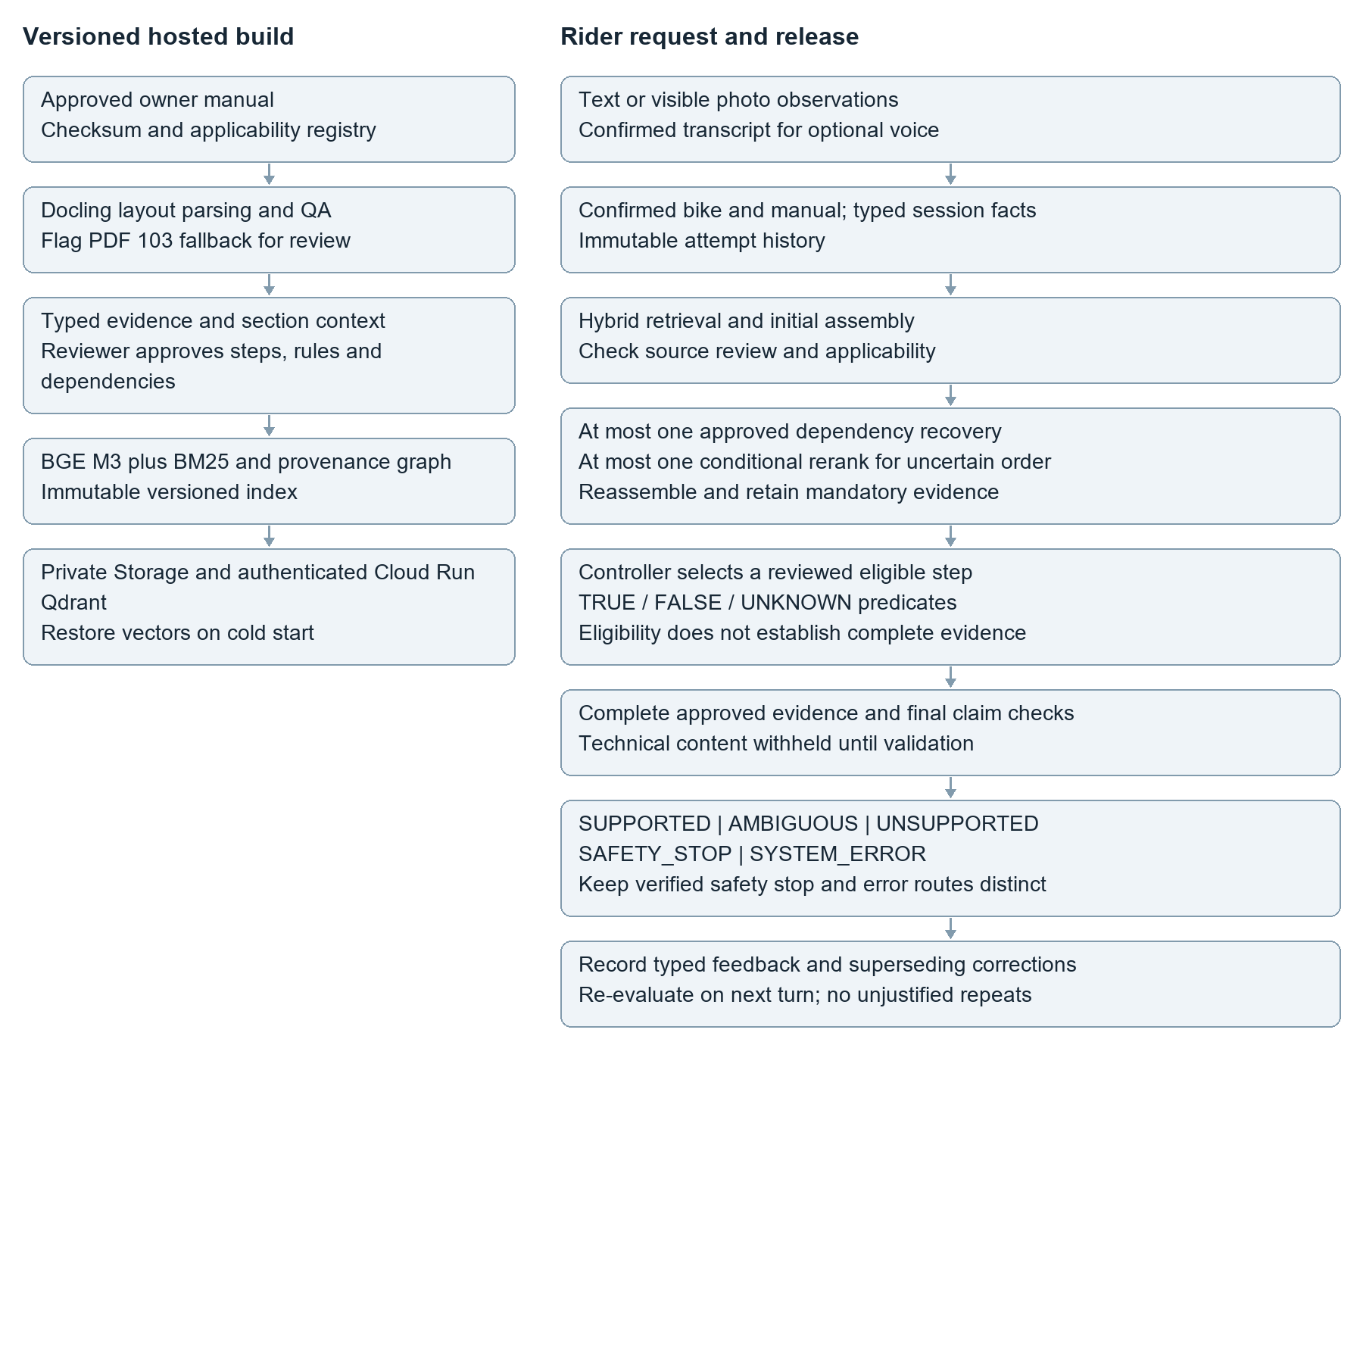
Both build and runtime are hosted. Versioned ingestion parses, chunks and embeds the approved manual ahead of requests. Serving reuses the immutable dense/BM25 index, reviewed source context, bounded recovery and conditional reranking, then privately drafts, separately verifies, validates, saves and streams the accepted response. Optional diagnostic paths are separate product features, not admission gates for ordinary Q&A.

Relevant feedback and optional legacy troubleshooting
The assistant treats customer feedback as an observation, not as authorization to assume a diagnosis. “That component looked fine,” “I completed the action but the symptom remains,” and “that condition does not apply” are different structured outcomes.
Historical flow illustration retained for provenance. This drawing predates the current draft verify stream decision; the current architecture text governs.
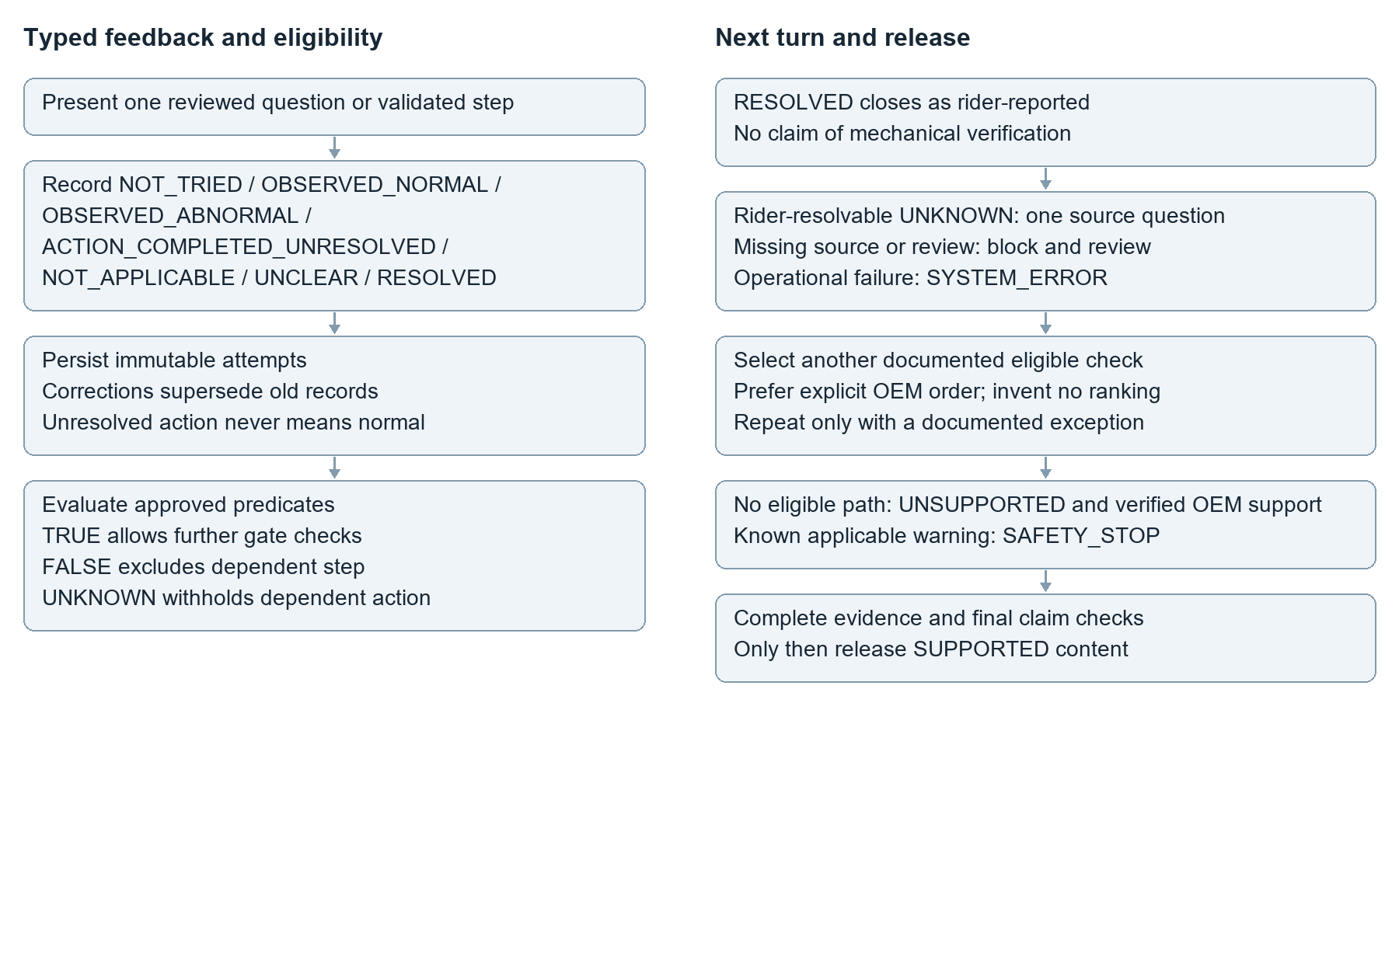
Customer statement | Session interpretation | Next move
“I checked it; it was normal.” | OBSERVED_NORMAL | Exclude only a branch whose reviewed condition is contradicted; do not infer a hidden fault or system health
“I tried that; it still happens.” | ACTION_COMPLETED_UNRESOLVED | Preserve unresolved outcome; answer the follow-up only from applicable evidence without inferring normality or OEM order
“My bike does not have that part.” | NOT_APPLICABLE (after variant confirmation) | Re-check bike/manual variant and avoid the inapplicable procedure
“I cannot tell what I am seeing.” | UNCLEAR | Ask one discriminating question or request another photo
“It works now.” | RESOLVED | Close session with recap; no unsupported claim of root cause

Conceptual evidence policy
- A technical instruction must cite the exact applicable evidence object (manual ID, section, printed/page index, optional image bounding box)
- Attach prerequisites, cautions, warnings, variant-specific specifications and referenced sections before composing a procedural answer
- When a reviewed rider observation is missing, ask one source-derived question. Missing source objects or review are maintainer issues and block advice; never complete a procedure from general motorcycle knowledge.
- Use document-linked OEM service-routing metadata to provide an escalation path after all applicable documented options are exhausted
- If retrieval infrastructure is unavailable, return “temporarily unable to verify,” never the false claim that the information is absent

Guardrails and release checks
- Source and applicability gate: confirm the selected owner manual checksum, model and variant before any procedure; block advice when applicability is unresolved.
- Evidence gate: assemble the relevant procedure, conditions, warnings, specifications, tables and linked pages; require every technical claim to map to an immutable source object and page.
- Safety gate: surface source warnings and unmet prerequisites, stop unsafe or undocumented bypass requests, and refer to authorised service when the manual gives no safe next step.
- Dialogue guardrail: ask one discriminating, source-derived question at a time; store typed outcomes; never infer that an attempted action was normal or repeat it without a documented reason.
- Untrusted input guardrail: treat PDF text, images and user messages as data; ignore embedded instructions that try to change source, safety or citation policy.
- Failure distinction: insufficient evidence triggers clarification or honest abstention; a parser, retrieval or model outage triggers a system-error message, never a false claim that the manual lacks information.
- Disable old Arm A and exact-response shortcuts in the initial integration; they cannot bypass the new verification call. Index reuse and provider prompt caching are separate optimizations. Future verified-response reuse needs exact source, query, state, response and runtime bindings plus separate evaluation. Similarity alone never authorizes reuse. Count complete requests and all draft, verify, correction and re-verification attempts against existing token, byte, output, concurrency, quota, retention and spending limits; never silently truncate mandatory evidence.
- Privacy and cost guardrail: keep photos and audio ephemeral by default, redact traces, protect secrets, and apply rate and spending limits to a public demo.

User-facing experience
Screen state | What the customer sees
Model selection | Bike/make/year/variant and selected manual edition; no advice until applicability is resolved
Ask | Text prompt, upload-photo control, optional record-voice control
Verified answer | Concise answer to the actual question, applicable conditions and warnings, citations, and explicit partial-support limits
Feedback | “Normal”, “Abnormal”, “Tried - not fixed”, “Not applicable”, “Not sure”, “Fixed”
Evidence | Immutable evidence ID and server-derived original page metadata; no rider PDF, excerpt or crop
Escalation | Transparent unsupported/undocumented status and a verified OEM support link or copyable request

Progressive capability release
Release | Capability | Gate
MVP / P0 | Hosted source retrieval, private draft, separate verifier, typed history, progress, saved buffered streaming and controls | Confirmed source/variant/rights; independently reviewed cases and all safety gates pass
Enhanced / P1 | Optional vision/voice and verified-response reuse only after separate evaluation | Measured benefit on reviewed cases; identical release gates
Experiment / P2 | Sarvam voice, late-interaction retrieval, visual-page retrieval, model/reranker ablations | Measured lift in evidence completeness, cost or latency

Assumptions still to verify
- The supplied Himalayan BS6 owner manual is the approved prototype source. Edition RAM00818/A dated 4 November 2025 and the owner-selected applicability policy are recorded in source_manifest.json. Exact source approvals remain scope-bound; market fit and redistribution rights are separate limitations. End-user PDF, excerpt and crop delivery is prohibited.
- Critical cross-references, diagrams, safety blocks and table headers survive layout extraction; review difficult pages manually
- A hosted Streamlit rider UI remains the planned demo; authenticated Cloud Run Qdrant and private Cloud Storage are the recorded retrieval deployment. UI latency and independent text/photo smoke tests remain pending.
- The interviewer will judge a text-output demo sufficient; audio output is optional
Supporting vendor and research references are consolidated in the companion To Build document.

Source applicability conversation history and release policy
Relevant typed facts and immutable outcomes remain separate from conversational wording. ACTION_COMPLETED_UNRESOLVED never becomes OBSERVED_NORMAL. Optional legacy troubleshooting flows may retain reviewed StepDefinition and ApplicabilityRule records, but they cannot restrict ordinary manual Q&A or source-supported questions about documented procedures. Source-derived prerequisites and warnings must be satisfied, clarified when rider-resolvable, or explicitly handled in the verified answer.
The ordinary verifier decisions are exactly RELEASE_COMPLETE, RELEASE_PARTIAL and SHOW_FALLBACK. These decision labels are distinct from the application states SUPPORTED, AMBIGUOUS, UNSUPPORTED, SAFETY_STOP and SYSTEM_ERROR; do not introduce ACCEPTED or PARTIAL as verdict labels. RELEASE_COMPLETE and RELEASE_PARTIAL release only the exact verified technical response; a partial response must include its limitation before verification. SHOW_FALLBACK handles irrelevant evidence, missing support or failed bounded correction, while preserving RELEASE_CLARIFICATION for AMBIGUOUS and RELEASE_SAFETY_STOP for SAFETY_STOP as distinct special decisions. Ask one focused question only for a rider-resolvable ambiguity needed for the actual question. Source gaps or review decisions are maintainer issues. Malformed output, timeout, outage, exhausted quota or integrity failure is SYSTEM_ERROR, never acceptance or proof of absence throughout the manual. Preserve safety-stop precedence; technical safety wording is also covered by verification before delivery.
Disable old Arm A and exact-response shortcuts in the initial integration; they cannot bypass the new verification call. Index reuse and provider prompt caching are separate optimizations. Future verified-response reuse needs exact source, query, state, response and runtime bindings plus separate evaluation. Similarity alone never authorizes reuse. Count complete requests and all draft, verify, correction and re-verification attempts against existing token, byte, output, concurrency, quota, retention and spending limits; never silently truncate mandatory evidence.

Current hosted build and pending release
Hosted ingestion and embedding comparisons are complete. Candidate index index_a3282c4d98cf54595e4ba168 has 532 search chunks and 277 section parents at a 1,024-token budget. Private Cloud Run Qdrant restores stored immutable vectors on cold start, without reparsing or re-embedding. Historical backend smoke passed 11/11. These results do not validate the new draft verify stream pipeline or public release.
Preserve exact immutable source IDs, original-page provenance and approved source-object bindings. Source-integrity review is distinct from authored-answer approval; the frozen 161-case v3 package and its exact bytes remain unchanged. Parent labels do not authorize whole parent bodies. Restore applicable warnings, prerequisites, table headers, units and referenced context only through reviewed source relationships. Page 103 fallback and unresolved source-specific limitations remain explicit. Rider PDF, excerpt and figure-crop delivery remains prohibited under source_manifest.json; use verified paraphrases and server-derived citation metadata.
Use dense cosine retrieval plus BM25 and RRF, initial parent/dependency assembly, source and applicability checks, at most one exact-ID recovery for approved missing dependencies, and at most one conditional cross-encoder attempt for uncertain ordering. Reassemble while retaining mandatory evidence. Missing review must not trigger reranking. Conditional is the normal policy; off and always_diagnostic are ablations. Current unreviewed bundles skip reranking and block technical generation.

