Example modeling of a 2-dimensional Gaussian bell function using fzymodel

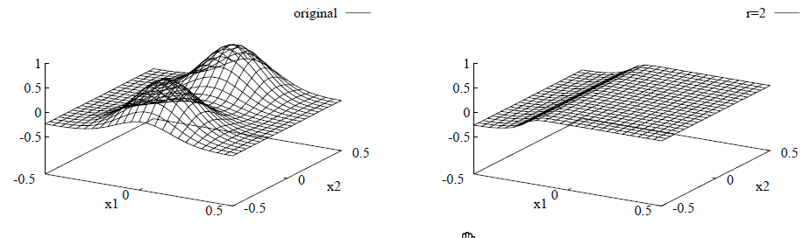
Original function to approximate (left) and modeling result of a two-rule model (right).

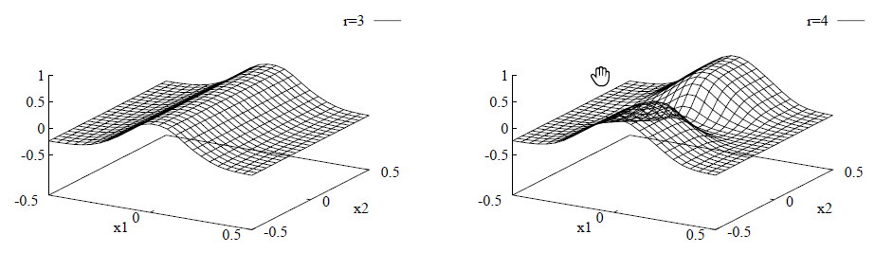
Modeling result of a three-rule model (left) and four-rule model (right).

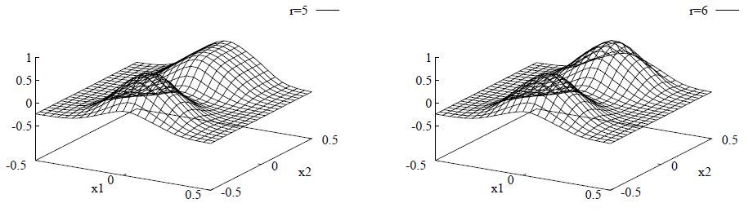
Modeling result of a five-rule model (left) and a six-rule model (right).

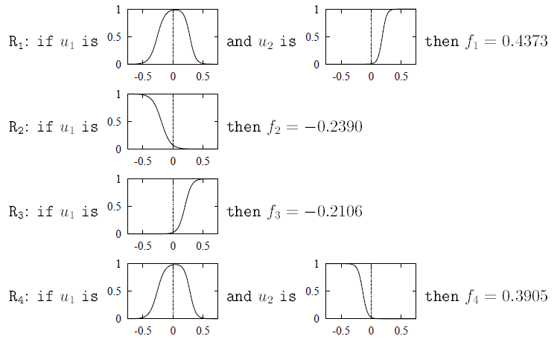

The four-rule model
in a human readable representation:

