**1. Reference Scenario**

We consider a Mobile CrowdSensing architecture designed to gather sensing information from the crowd from and from specific locations of interest. The architecture we refer to is composed by a back-end server, a set of end-devices and a flock of UAVs. The back-end assigns *sensing tasks* to the end-devices and it collects the data gathered. A task is a specific action required to a set of end-devices, such action might or might not require the user intervention. Examples of sensing tasks are: collecting environmental data, taking a picture of a place or recording a short movie. End-devices are generally user’s pocket devices such as smartphones; such devices offer sensing capabilities through virtual and environmental sensors commonly available on commercial products. We also consider the adoption of UAVs in order to increase the efficiency of the Mobile CrowdSensing architecture. UAVs are more and more adopted in different scenarios, such as urgent shipping, fast delivery and also as future public transportation system. In particular, the UAV’s flocks are employed to gather data from specific locations, those from which no data are already gathered from the end-devices.

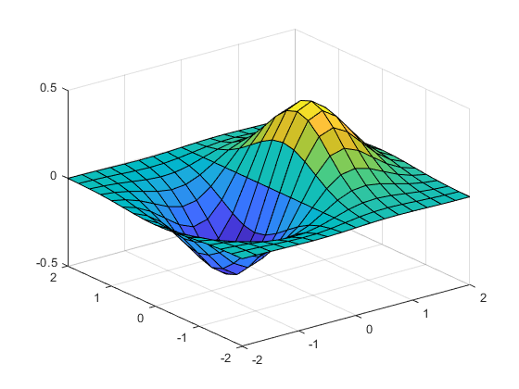

Fig. 1 – The sensing region.

We refer to common drones available on the market, such as a quad-copter. A commercial quadcopter can be provisioned with a short and long-range transmission radio, as well as tiny sensors able to sense the environment. The drone has the advantage of flying *on-demand* over a bounded area.

We consider the adoption of UAVs as complementary sensing units with respect to the end-devices, in fact drones are supposed to fly and to gather data from locations that are not *covered* by any end-device. A location is covered is there exists at least one user passing through the location and collecting data from it. We also consider the option that a location is covered by users that accept to de-tour towards such location and to collect fata. The coverage of location lh is defined as the probability of being able to collect data from such location, *p = 1* if at least one user already visits the location, while *0≤p<1* otherwise.

UAVs are adopted in our architecture when it is required to gather data from uncovered locations, namely those from which no user pass or might pass accepting a detour. Therefore, it is required to identify where to deploy a charging station for UAVs. The location has to be strategic, so that to quickly reach uncovered locations and to limit the maximums travelled distance of UAVs from the charging station. To this purpose, we analyze the trajectories followed by the users during an observation period. Such period allows us to measure the coverage of the locations of interest. The coverage is given by analyzing the user’s trajectories so that to build a map of coverage, such information is, in turn, used in order to plan the mission of UAVs toward the most uncovered locations. Figure 1 shows an example of a coverage map of a sensing region. Locations on the map’s corners are required to be sensed by UAVs, they are also highly uncovered since no users will pass through them. Therefore, the charging station is deployed in *x*, close enough to locations l1 to lh so that UAVs can fly over them and return safely to the *x.* Section 2 describes a probabilistic model for measure the coverage of any location and Section 3 describes the UAV mission plan strategy for a set of uncovered locations.

**2. The Data Coverage Probabilistic Model**

We now define the coverage of a location in a given sensing region. The covered locations are those from which we can expect to collect data from users passing through such locations. Differently, uncovered locations are those from which no users pass through. The model we propose assigns to each of the locations a coverage probability. The score measures the probability that such location is already covered by at least one user, or that such location can be covered by one or more users accepting to *de-tour* to such location.

2.1 A Generic Coverage Model

Locations are denoted with |L| = H and each location lh = (x, y) is identified with the centroid of a circle tile of center (x, y) and of radius *r*. We assume the existence of K distinct users U = {u1… uk}, |U| = K roaming in the region of interests. Every user ui follows a set of trajectories, namely an ordered sequence of geo-referenced points. The trajectories of user ui are denoted with the set Ti, where $t_{ij}∈T_{i}=\{{\left(x,y\right)}_{t}…{\left(x,y\right)}_{t+∆}\}$ is the set of temporally ordered way-points (w.p.) . Given the location lh and the w.p. (x, y)t in $t_{ij}$, $δ\left(l_{h},t_{ij}\right)$ is a distance measure.

We now model the coverage of a location as the probability a user accepts a de-tour to such location. We argue that the de-tour probability increases as the distance between the user and the target location decreases. Indeed, the closer a user to a location, the higher the probability he/she will move toward such location.

We define the r.v. $X_{ij}^{h}:Ω−→R^{+}$, where $Ω$ is defined as the set of events in the form: location lh is covered by the user ui at distance x = $δ$ (lh,tij), for a given w.p. in $t_{ij}∈T_{i}$. The r.v. $X_{ij}^{h}$ associates to every event in $Ω$ a numeric value which is the distance *x* between lh and a way-point. Values assumed by the random variables $X_{ij}^{h}$ are continuous in $R^{+}$, therefore the probability $P$ x]) for any given increment $Δ$*x*, is given by $\int_{x}^{Δx}{f_{X_{ij}^{h}}\left(x\right)dx}$ (1).

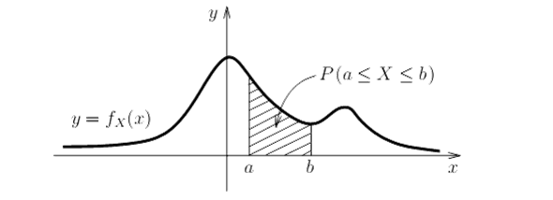

Propongo di ridefinire l’intervallo di integrazione: invece che [$x,Δ$ x], [$x−Δ$, $x+Δ$] ovvero calcolo la prob che la location sia coperta da un utente che si trova a x+- $Δ$ metri dalla locazione e non x, $x+Δ$ metri. Ad esempio nella figura sopra, X è la distanza a cui l’utente si trova (100 metri), *a* *b*  sono la tolleranza della distanza. Possiamo calcolare $Δ$ come l’errore di posizionamento tipico di un GPS (ex. 5 metri).

We now define the probability the location lh is covered by the user ui at any distance from lh. More specifically, we measure the probability that ui de-tours to lh starting from any of its trajectories. We define the r.v. $X_{i}^{h}:Γ−→R^{+}$, where $Γ$ is defined as the set of events in the form: location lh is covered by the user ui at any distance x from lh. We assume that the random variables $X_{ij}^{h}$ are all independent, since the probability of user ui to de-tour to lh is independent from the trajectory he/she is following.

The probability of an event in $Γ$ happens is given by:

$P\left(X_{i}^{h}∈\left[x,x+Δx\right]\right)=1−\prod_{∀x∈D_{i}^{h}}{1−P\left(X_{ij}^{h}∈\left[x,x+Δx\right]\right)},∀Δx\left(2\right)$

Where $D_{i}^{h}=\{δ\left(l_{h},t_{ij}\right),∀w.p.∈t_{ij}∈T_{i}\}$, the set of distances between ui ‘s trajectories and lh. More specifically, the set $D_{i}^{h}$ contains all the distances between all the w.p. of the trajectoties followed by user ui and the location $l_{h}$.

From equation (2) we can derive the probability that the location lh is covered by any of the users in U. We define the r.v. $X^{h}:θ−→R^{+}$, where $θ$ is defined as the set of events in the form: location lh is covered by any user at any distance *x* from lh. The probability of events in $θ$ is given by:

$P\left(X^{h}∈\left[x,x+Δx\right]\right)=1−\prod_{∀i∈U}{P\left(X_{i}^{h}∈\left[x,x+Δx\right]\right)}=1−\prod_{∀i∈U}{}$

**3. Optimal Deployment of UAV Stations**

Given the coverage map for a given area, we now define an optimization strategy to deploy a UAV base station. Given a set of target locations, namely those locations with a coverage value lower a given threshold, the deployment strategy aims at maximizing the covered locations. A location is covered if its coverage value is greater a given threshold OR it the locations is covered by a UAV flying over the location.

More formally, we a box B delimiting the area of interest. We consider the coverage map reported below:

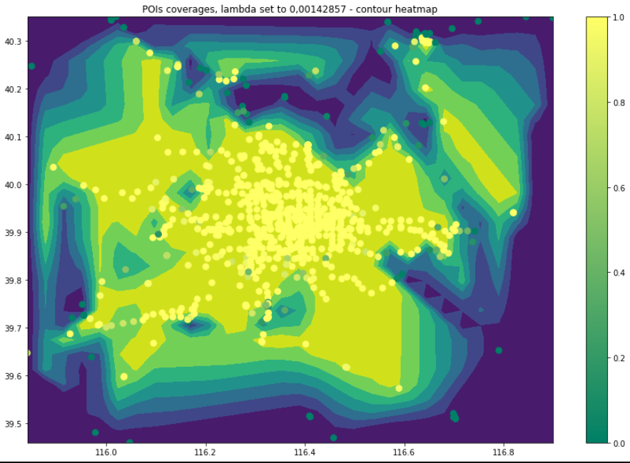

The map can be represented as the matrix C, where the element $c_{ij}∈C$ represents the coverage value bound in the interval [0,1] (note: *i*, *j* correspond to longitude, latitude). $C_{r}$ is the coverage threshold.

We also consider the matrix A of the same dimension of C, the matrix A defines the un-admissible locations where the UAV stations can be deployed. Examples of such locations are: rivers, buildings and any kind of obstacle preventing the possibility of a deployment. In particular, $a_{ij}=1$ if the location (i, j) can be used to deploy the UAV station, 0 otherwise.

Given the locations (i, j) and (h, w) inside the box B, we define the distance measure $δ\left(\left(i,j\right),\left(h,w\right)\right)$ as the geodesic distance.

*optimal deployment*

The problem we address is to deploy the UAV station to a target location (x, y) such that the following conditions are verified:

1. (x, y) in B

$a_{xy}=1$

$max\left|T_{x,y}\right|,T_{x,y}=\left\{\left(i,j\right):c_{ij}≥C_{r}∨δ\left(\left(i,j\right),\left(x,y\right)≤D_{r}\right)\right\}$

Where $D_{r}$ is the maximum admissible distance between the UAV and the base station. The optimal deployment problem can be easily extended with multiple UAV stations, each of the them deployed according to the conditions defined with the *optimal deployment* problem.

**4. Experimental Settings**

**4.1 Data Coverage**

The PDF defined in (1) determines the coverage probability expressed in (3) for a generic location.The density of $P$ x]) follows an exponential distribution of mean 1/ $λ$:

$f_{X_{ij}^{h}}\left(x\right)=λ\frac{1}{e^{λx}},x≥0$

The exponential distribution models the intuitively idea that the coverage probability increases with the decrease of the distance between the trajectory and a location of interest.

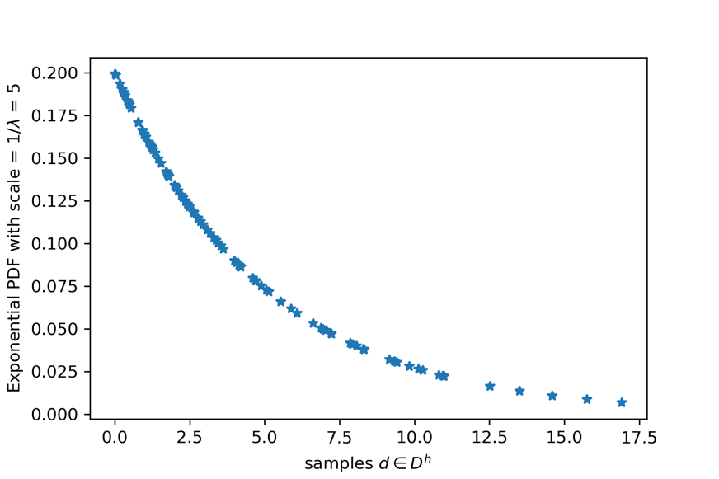

Figure 1 reports an example of exponential probability density function of mean = 1/ $λ$, in this case we set 1/ $λ$ = 5 meters. The mean is the inverse of the distribution rate $λ$. The samples in the *x* axis of Figure 1, are also generated according to an exponential distribution. Given our general model in (3) we obtain:

$P\left(X^{h}∈\left[x,x+Δx\right]\right)=1−\prod_{∀i∈U}{}$

where $D_{i}^{h}=\{δ\left(l_{h},t_{ij}\right),∀w.p.∈t_{ij}∈T_{i}\}$.

Fase 1:

1. Generiamo |L| locazione disposte a (cerchio di raggio r e centro x,y) :
   1. griglia distanziata di x metri. Ogni locazione ha lato ex. 50 metri
   2. Casuale
   3. Usare POI da un motore di ricerca (openstreet, google maps)
   4. *Rappresentare graficamente le locazioni*
2. Definiamo :
   1. una soglia di de-tour π per il calcolo delle distance tra le locazioni e le traiettorie. Tale soglia è il limite oltre il quale la prob. Di detour è 0. Ad esempio π = 1000 m
3. Per ogni locazione lh in L e per ogni utente ui, calcoliamo $D_{i}^{h}$
$D_{1}^{1},D_{2}^{1}…D_{k}^{1}$

$D_{1}^{2},D_{2}^{2}…D_{k}^{2}$

$….$

$D_{1}^{h},D_{2}^{h}…D_{k}^{h}$

4. Calcoliamo per ogni locazione lh in L la coverage usando la (3)
 $P\left(X^{1}\right),P\left(X^{2}\right)…P\left(X^{h}\right)$

  1. *Rappresentare graficamente le coverage locazioni*

**Altre cose da anlizzare:**

* **Impatto campionamento delle tracce sintetiche. Ex 1 punto ogni 5 metri vs 1 punto ogni 1000 metri sulla coverage**
* **Impatto del detour_radius sulla coverage**

**4.2 UAV Station Deployment**

Fase 2:

Problema di posizionamento della stazione di droni conoscendo la coverage delle H locazioni di interesse, consideriamo:

* + La stazione di droni può essere collocata solo in certe zone
    - Posizionamento guidato dalle Base station presenti (medoide)
    - Posizionamento arbitrario
  + Il drone può volare ad una distanza massima dalla stazione con una certa velocità di crociera
* A questo punto dobbiamo scegliere le locazioni da sorvolare con il drone:
  + Clusterizziamo le locazioni in modo da avere delle macro-area, ovver gruppi di locazioni contigue e ne prendiamo il centroide
  + Ottimizziamo questo problema:
    - Massimimzzare il numero di macro-area sorvolate
    - Minimizzare il tempo di volo
      * Tempo di volo ex . < 20 minuti
      * Distanza massima dal punti di partenza : ex. 1 km

***References***

1. [1-1] D. Belli, S. Chessa, A. Corradi, G. Di Paolo, L. Foschini, M. Girolami, “Selection of mobile edges for a hybrid crowdsensing architecture,” *IEEE* *Symposium on Computers and Communications (ISCC),* 2019.
2. [1-2] P. Bellavista, D. Belli, S. Chessa, L. Foschini, “A social-driven edge computing architecture for mobile crowd sensing management,” *IEEE Communications Magazine*, vol. 57, pp. 68-73, 2019.
3. [1-3] D. Belli, S. Chessa, L. Foschini, M. Girolami, “A social-based approach to mobile edge computing,” *IEEE Symposium on Computers and Communications (ISCC)*, pp. 292-297, 2018.