Supervision Meeting — Introduction, Literature Review, Methodology
  - Preparation and feedback-capture document · 30 June 2026
Enrico Manfron

Purpose of this document
This meeting covers three chapters: Chapter 1 — Introduction, Chapter 2 — Literature Review, Chapter 3 — Methodology. This document explains, as concise points, what we did and how we set it up, with a few figures, and leaves room to record your feedback (the To discuss / Feedback boxes).

The thesis in one sentence
Extend a production agentic system that today is purely descriptive (it reports what happened) with a lightweight forecasting substrate, so that it can provide forecast-informed decisions that are reliable and cost-justified, within a ~8 GB RAM budget. The artefact has three layers: (1) a substrate of lightweight models → (2) a typed forecast-tool interface → (3) a bounded LLM agent. It is compared against a code-as-action baseline (an LLM that writes and executes its own forecasting code).

Chapter 1 — Introduction

What it argues
- The shift of BI systems from descriptive (dashboards, KPIs, historical trends) to forecast-informed (what will happen and what to do).
- Why FMCG beverages are a hard, representative test bed: volatility, promotions, seasonality, SKU proliferation; erratic and intermittent demand.
- The constraint the literature ignores: an SME cannot afford expensive GPUs; ~8 GB RAM is the realistic budget, and it rules out transformers and locally hosted LLMs up front.
- The real case: Manifold AI / Prometheus, an agentic system in production but descriptive only → it is both the motivation and the empirical case.

How it is structured (§1.1–§1.5)
- §1.1 Background & Motivation — the descriptive → forecast-informed transition, the FMCG case, the computational constraint, the gap in the agentic literature, the Danish context.
- §1.2 Research Problem — the four problems of the predictive extension: accuracy within budget; a typed interface (reliability, uncertainty, traceability); the production system’s capability to integrate it; beating the code-as-action baseline.
- §1.3 Research Questions — Main RQ + SRQ1–4 (figure below).
- §1.4 Delimitation — scope boundaries (domain, 8 GB constraint, monthly batch, research prototype, generalisability).
- §1.5 Thesis Structure — the chapters mapped onto the DSR process.

Key choices set here
- Main RQ is “cost-justified” and SRQ4 baseline = code-as-action LLM (the v4 reframe, aligned with Manifold).
- The 8 GB constraint is treated as a formal design criterion, not a convenience.
- Four beverage categories (CSD, danskvand, energidrikke, RTD); beer (totalbeer) excluded because its facts are absent at source. CSD is the worked category.

The Research Questions
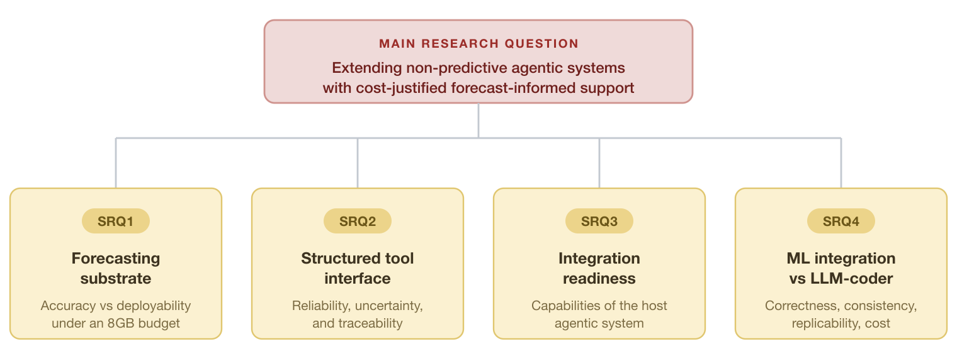
Structure of the research questions: the Main RQ and its four sub-questions (SRQ1–SRQ4).
- Main RQ — How can non-predictive agentic systems be extended with lightweight forecasting to support reliable, forecast-informed and cost-justified decisions under computational constraints?
- SRQ1 — Which lightweight models give the best accuracy / memory / category-specialisation trade-off?
- SRQ2 — How to expose forecasts to the agent through a structured interface that preserves reliability, uncertainty and traceability?
- SRQ3 — What capabilities does a production system need to integrate forecast support?
- SRQ4 — Does a dedicated model improve correctness/consistency/replicability (at justified cost/latency) over a code-as-action LLM?
🗨 To discuss / Supervisor feedback (Ch. 1):

Chapter 2 — Literature Review

How we set it up
- It is a narrative, integrative review, not a systematic one: the contribution lies at the intersection of several literatures, so we make bodies of work that normally do not speak to each other speak, rather than answering a single effectiveness question with a rigid protocol.
- A traceable but flexible method: Google Scholar + NotebookLM + Zotero; ~100 records screened by title → ~40 read in full → 39 cited sources (15 preprints, flagged as such).
- Throughout, a distinction is kept between what the literature establishes and what the thesis designs / plans to evaluate / leaves to future work.

The eight thematic sections
- §2.1 Forecasting as substrate (FMCG) — M4/M5, LightGBM, exogenous features; no single model dominates (Ma 2025); stability as a production criterion alongside accuracy (Klee & Xia 2025).
- §2.2 Lightweight ML under constraints — efficiency as a binding constraint; Ng (2017) as a precedent on memory; clarified that the binding constraint here is deployment cost, not data size (after aggregation the data is small).
- §2.3 From descriptive BI to forecast-informed — “predict-then-optimize” (a forecast is valuable through its link to the decision; low error ≠ good decision); the distinction between tight coupling and our loose, agent-mediated coupling.
- §2.4 LLM agents and tool use — tool delegation can substitute for model scale (Toolformer); JSON function-calling (our choice) vs code-as-action (the baseline); Sapkota’s taxonomy → the thesis is a bounded tool-using agent.
- §2.5 Reliability, traceability, uncertainty, evaluation — risks (hallucination, input noise, coordination failure); traceability as a requirement; uncertainty calibration; LLM-as-judge for SRQ4.
- §2.6 Production-oriented agentic systems & integration readiness — González-Potes (2026) as the closest exemplar; synthesis of the required capabilities (SRQ3).
- §2.7 Research gap — the missing intersection (figure below).
- §2.8 Design Science Research — why DSR is the right paradigm.

The gap and the novelty
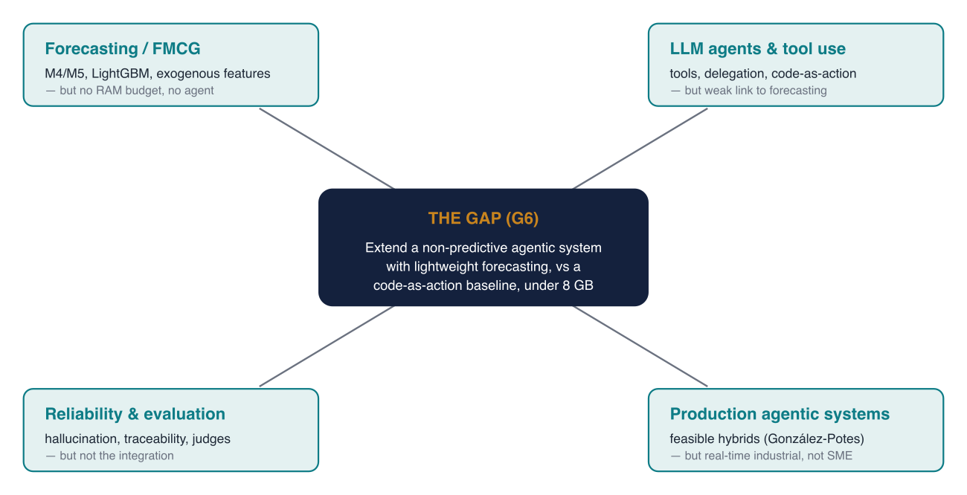
Each of the four literatures supplies one piece; none covers their intersection — gap G6.
- Gap G6: no study extends a non-predictive, production-oriented agentic system with lightweight forecasting, through a loose, reliable, traceable interface, and compares it against a code-as-action baseline, under SME constraints.
- Novelty: the intersection of (dedicated ML vs code-as-action) × (cost-aware FMCG) × (extension of a production agentic system) appears in no paper in the corpus.
🗨 To discuss / Supervisor feedback (Ch. 2):

Chapter 3 — Methodology

Philosophy of science (§3.1)
- Pragmatism: knowledge is judged by its practical consequences (“knowledge is what works”) → well-suited to artefact-oriented research.
- Modest realism about the data: demand and sales exist, but are known only through the Nielsen instrument with its assumptions → this motivates the data quality assessment and a context-bounded interpretation.

Research design: DSR (§3.2)
- Design Science Research (Hevner 2004): build a working artefact + generate transferable design knowledge.
- Three cycles: relevance (Manifold’s need) · design (Ch. 5–8) · rigor (Ch. 2 literature).
- Six activities of Peffers (2007) mapped onto chapters; CBS design type = explanatory; declared status of a research prototype, not a production-ready system.

Research strategy (§3.3)
- Quantitative quasi-experiment + single-case embedded study: the experiment provides the controlled evaluations (SRQ1, SRQ4); the case (Manifold/Prometheus) anchors the findings in real data.
- Unit of analysis: the artefact, evaluated across the categories at brand × retailer → month granularity; the DVH EXCL. HD scope is locked (aligned with Manifold).

Approach per sub-question (§3.5)
- SRQ1 — 5 models (ARIMA, Prophet, LightGBM, XGBoost, Ridge), Optuna-tuned; metrics MAPE/WMAPE + RAM/runtime + stability; specialised vs pooled; RAM profiled in RSS.
- SRQ2 — JSON function-calling interface with strict schemas; forecast + interval (calibration); reliability via validation, traceability via mapping; lightweight Python coordinator (LangGraph = production target).
- SRQ3 — a capability-readiness assessment of the four capabilities against the real Prometheus (not a live integration).
- SRQ4 — ~50 shared prompts, dedicated model vs code-as-action (E2B sandbox); correctness/consistency/replicability (primary) + cost/latency (secondary); LLM-as-judge + human subset; pilot scale.

Validity and limitations (§3.6–§3.7)
- Internal validity: the same split across all models, fixed seeds, a single manipulation in SRQ4.
- External validity is explicitly limited (Danish market, 8 GB, monthly batch).
- Limitations: data confidentiality (reproducibility limited to features/code/protocol); sample size near the limits; SRQ4 at pilot scale; sequential model execution (due to the 8 GB constraint).
🗨 To discuss / Supervisor feedback (Ch. 3):

Open questions for the supervisor
- DSR acceptance (OI-03): is DSR accepted as the methodology for a Business Administration + Data Science thesis at CBS?
- Page limit: 80 (solo) vs 120 (group) standard pages — to confirm.
- Preprints: is it acceptable to cite preprints where they are the closest available precedent (they are flagged as such)?
- Four vs five categories: beer excluded because its facts are missing at source — is this acceptable?
- Calibration: present it as a result (conformal already implemented, CSD coverage 90.5%) rather than as future work.
- Novelty / gap (G6): is it convincing as the primary contribution?
🗨 General notes / agreed next steps:

Brief status (context, not for discussion today): Ch. 1–5 are in review-ready draft; SRQ1 results are in; the SRQ4 code-as-action run is the main remaining work and unblocks Ch. 7–10.

