Health Risk Analysis
output: html_document: toc: true

title: “Completed Health Risk Analysis” author: “Fungai Mupezeni” date: “2026-05-15”

Global chunk options
knitr::opts_chunk$set( echo = TRUE )

Set project root directory
knitr::opts_knit$set( root.dir = “..” )

=============================================================================================

HEALTHCARE RISK PREDICTION AND STATISTICAL MODELLING INSPIRED BY MY PREVIOUS PROJECTS IN NHS

=============================================================================================

Author : Fungai Mupezeni

Purpose : Healthcare data analysis, statistical modelling,

machine learning, PCA, and Data visualisation

Language: R
required_packages <- c( “tidyverse”, “caret”, “randomForest”, “FactoMineR”, “factoextra”, “ggplot2”, “reshape2”, “GGally”, “rmarkdown”,
)
installed_packages <- rownames(installed.packages())
for (package in required_packages) { if (!(package %in% installed_packages)) { install.packages( package, repos = “https://cloud.r-project.org” ) } }

=====================================================

INSTALL REQUIRED PACKAGES (THAT YOU CAN RUN ONCE ONLY)

=====================================================
#================================================================= # I START BY LOADING LIBRARIES, THAT POWERS DIFFERENT FUNCTIONS #==================================================================
library(tidyverse) library(caret) library(randomForest) library(FactoMineR) library(factoextra) library(ggplot2) library(reshape2) library(GGally) library(rmarkdown) library(TinyTeX) # ================================================================== # LOAD DATASET (Is the file that contain data in different formats) # ==================================================================
healthcare_data <- read.csv( “data/processed/healthcare_data.csv” )

This help display current working directory
getwd()

Preview dataset see few roles and the data contained
head(healthcare_data)

Checking the Dataset structure
str(healthcare_data)

=====================================================

DATA CLEANING/WRANGLING AS PART OF AND PREPROCESSING

=====================================================

Remove duplicate observations from the entire dataset
healthcare_data <- distinct( healthcare_data )

Checking and Removing missing values from the dataset
healthcare_data <- na.omit( healthcare_data )

Summary statistics to check the data distribution using descriptive statistics
summary(healthcare_data)

==================================================================================

TRAIN / TEST SPLIT (I used this to divide a dataset into two subsets) 80:20% ratio

==================================================================================
#I have used set seed ensures that the same random numbers are generated every time the code runs set.seed(123)
#This code creates indices for splitting the dataset into training data (80%) and testing data (20%) train_index <- createDataPartition( healthcare_data$risk_score, p = 0.80, list = FALSE )
training_data <- healthcare_data[ train_index,]
testing_data <- healthcare_data[ -train_index,]

HERE I HAVE INTRODUCED RANDOM FOREST MACHINE LEARNING MODEL
#The code below trains a Random Forest classification model using the training dataset . #My goal here is to predict healthcare risk outcomes (risk_score) based on other variables
random_forest_model <- randomForest( as.factor(risk_score) ~ ., data = training_data )

Generate predictions
predictions <- predict( random_forest_model, testing_data )

In order to evaluate this model, I employed the use of Confusion Matrix
#The reason being to check the performance of the machine learning classification model(RF)
confusion_matrix <- confusionMatrix( predictions, as.factor(testing_data$risk_score) ) #Here I printed the results print(confusion_matrix)

Then I Saved model
saveRDS( random_forest_model, file = “outputs/models/random_forest_model.rds” )

============================================================================================

PRINCIPAL COMPONENT ANALYSIS (PCA)

I often use PCA for dimensionality reduction technique , feature selection data visualisation

Learned during my Data Science Internship at the National Center for Social research (NATCEN)

=============================================================================================

Select numerical variables and left out the target variable risk_core as a factor(Categorical)
pca_data <- healthcare_data[, c( “age”, “bmi”, “blood_pressure”, “cholesterol”, “glucose”, “heart_rate”, “smoking_score”, “physical_activity” )]

Here I ran Principal Component Analysis (PCA)
pca_results <- PCA( pca_data, scale.unit = TRUE, graph = FALSE )

Getting the PCA summary
summary(pca_results)

========================================================================

HERE I CHOOSE TO DEMONSTRATE THE LINEAR REGRESSION MODEL BUILDING

I used this to examine the relationship between healthcare risk outcomes

========================================================================
linear_model <- lm( risk_score ~ age + bmi + blood_pressure, data = healthcare_data )

To obtain detailed statistical summary of the linear regression model, I used summary function
summary(linear_model) #=======================================================================

======================================================================

LOGISTIC REGRESSION MODEL (GLM)

=====================================================================
logistic_model <- glm( risk_score ~ age + bmi + blood_pressure, family = binomial, data = healthcare_data )
summary(logistic_model)

==============================================================================

DATA VISUALIZATION, I HAVE DECIDED TO USE DIFFERENCE TYPES OF REPRESENTATION

==============================================================================

—————————————————–

TO SHOW BMI DISTRIBUTION USING A HISTOGRAM

—————————————————–
bmi_plot <- ggplot( healthcare_data, aes(x = bmi) ) + geom_histogram( bins = 30, fill = “brown”, color = “black”, alpha = 0.8 ) + labs( title = “BMI Distribution”, x = “BMI”, y = “Frequency” ) + theme_minimal() + theme( plot.title = element_text( hjust = 0.5, face = “bold”, size = 14 ), axis.title = element_text( face = “bold” ) ) #print(bmi_plot) 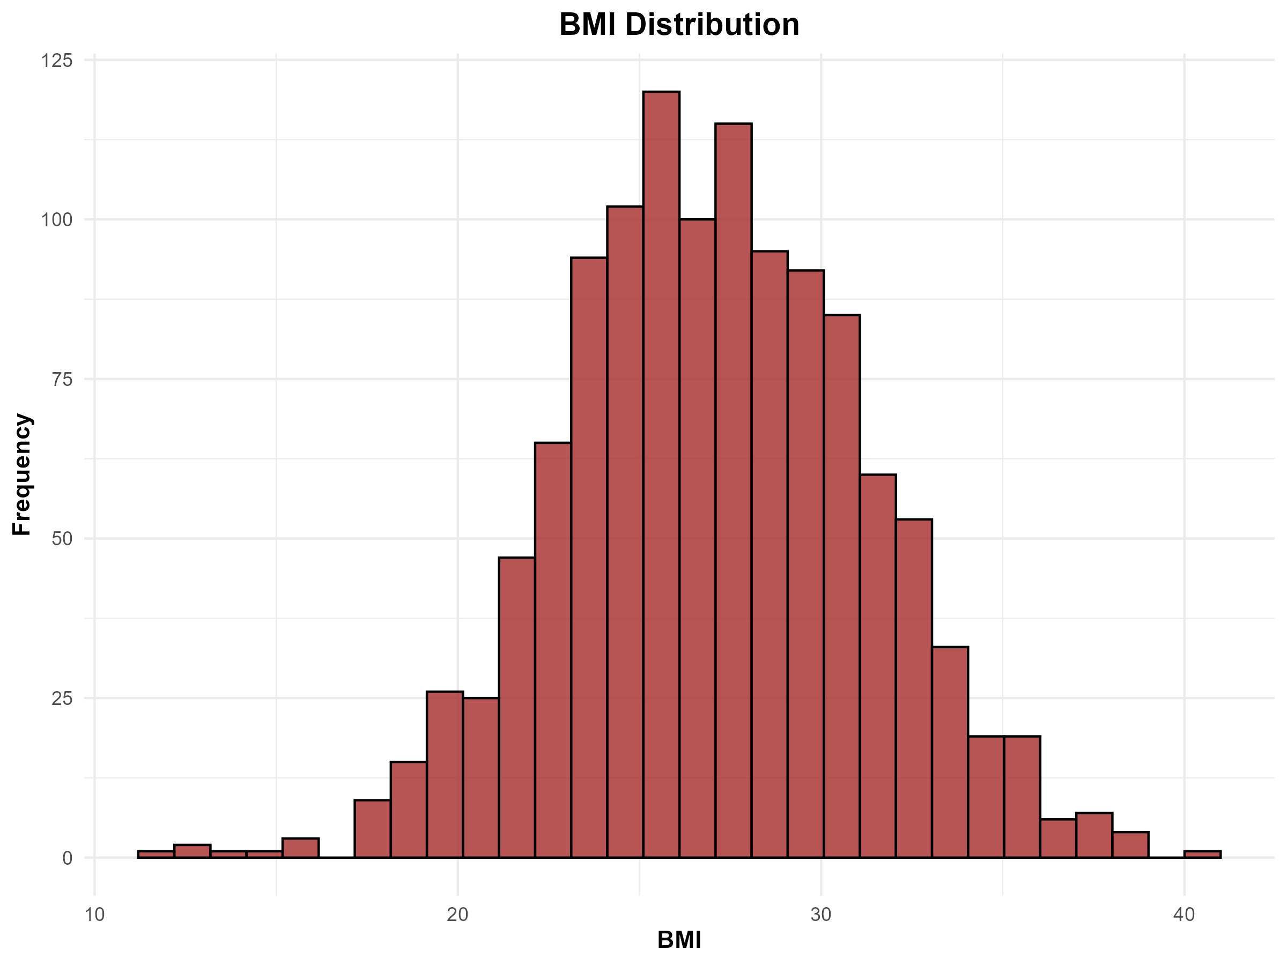
#=================================================== # After plotting I Saved the figure in file name given below ggsave( filename = “outputs/figures/bmi_distribution.png”, plot = bmi_plot, width = 8, height = 6, dpi = 300 )
#====================================================

——————————————————————————

I EMPLOYED THE USE OF A SCATTERPLOT TO SHOW AGE VS CHOLESTEROL

——————————————————————————
scatter_plot <- ggplot( healthcare_data, aes( x = age, y = cholesterol, color = age ) ) + geom_point( size = 3, alpha = 0.7 ) + scale_color_gradient( low = “blue”, high = “red” ) + labs( title = “Age vs Cholesterol”, x = “Age”, y = “Cholesterol Level” ) + theme_minimal()
#print(scatter_plot) 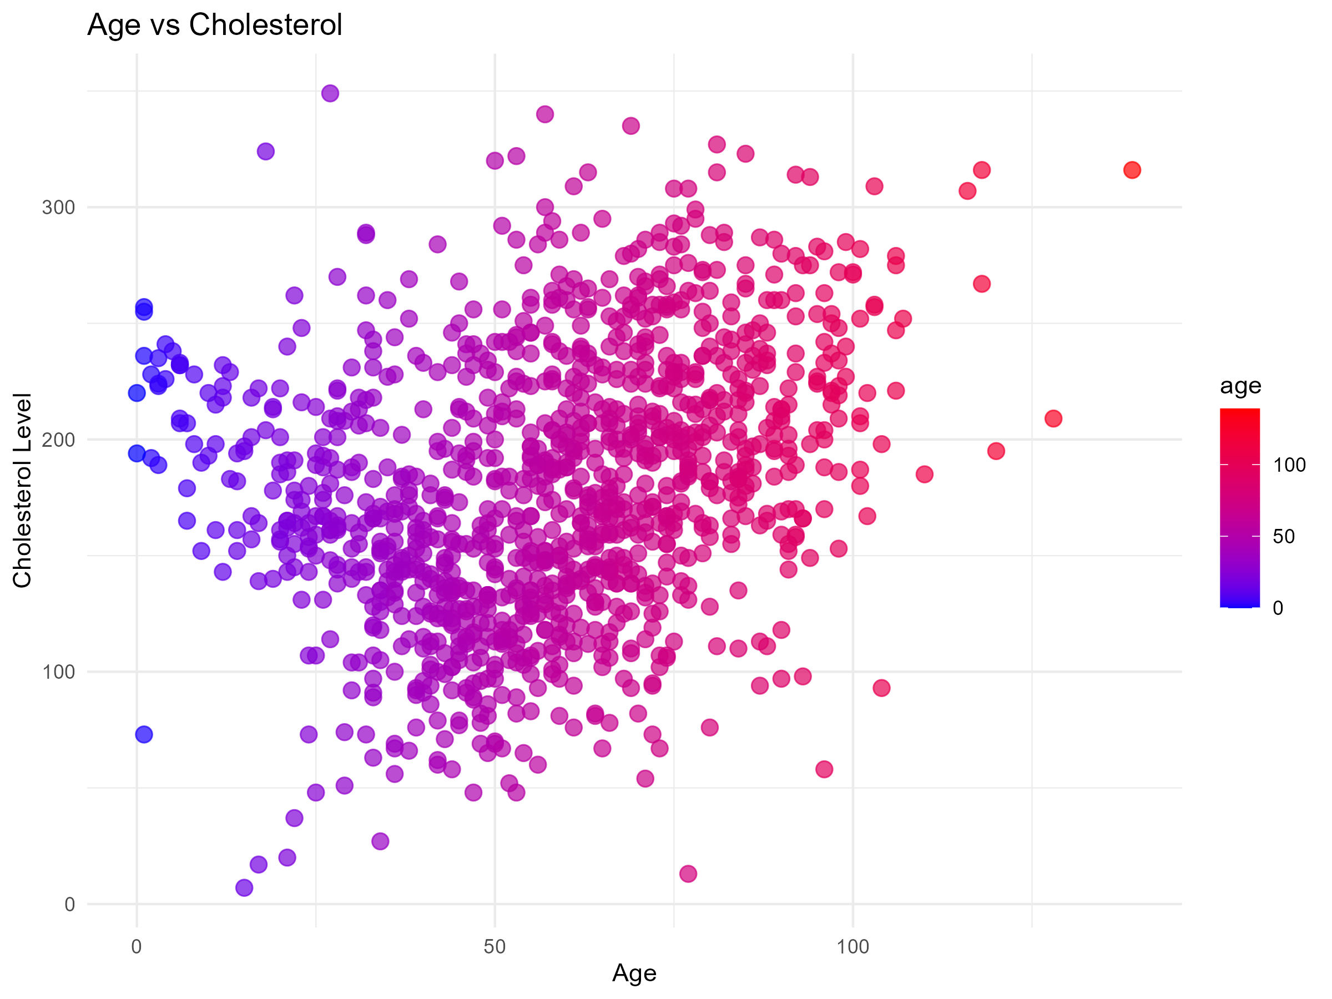
#====================================================== # I Saved the figure in file name given below ggsave( filename = “outputs/figures/age_vs_cholesterol.png”, plot = scatter_plot, width = 8, height = 6, dpi = 300 ) #=====================================================

—————————————————–

I DECIDED TO SHOW VARIABLE CORRELATION ON HEATMAP

—————————————————–

Here I generated a correlation matrix
correlation_matrix <- cor( healthcare_data )

Then I had to Convert matrix to long format by melting the Matrix
melted_correlation <- melt( correlation_matrix )

I then Created a heatmap
correlation_heatmap <- ggplot( melted_correlation, aes( x = Var1, y = Var2, fill = value ) ) + geom_tile() + scale_fill_gradient2( low = “blue”, mid = “white”, high = “red”, midpoint = 0 ) + labs( title = “Correlation Heatmap” ) + theme_minimal() + theme( axis.text.x = element_text( angle = 45, hjust = 1 ) ) #This printout the heatmap #print(correlation_heatmap) 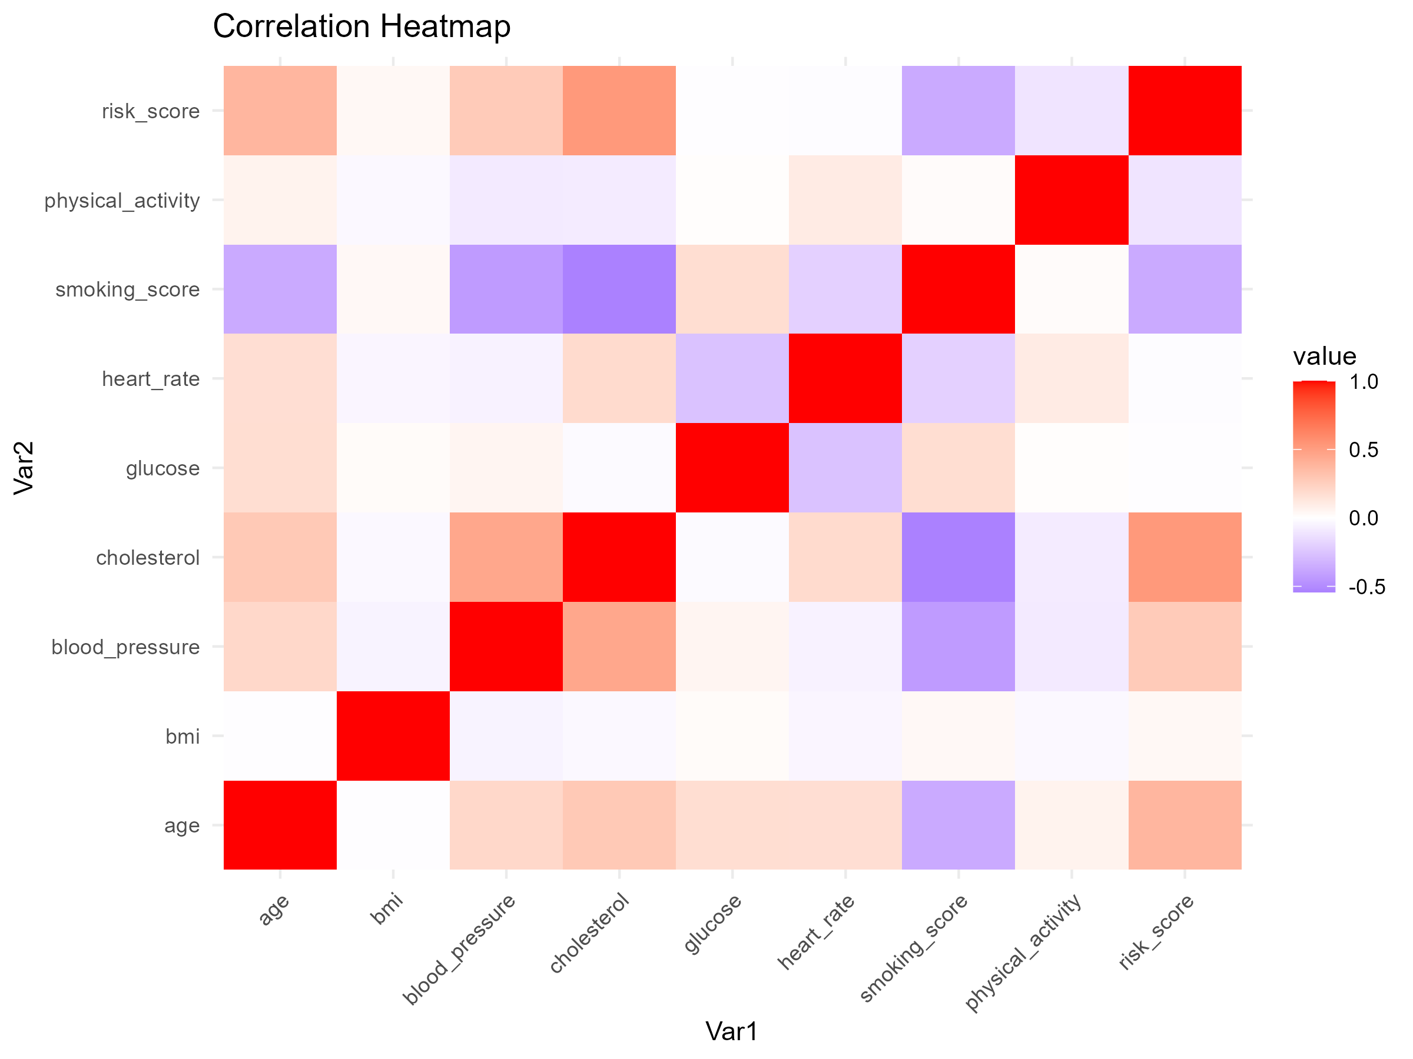 #==================================================== # I Saved the heat map in the outputs ,figures folder ggsave( filename = “outputs/figures/correlation_heatmap.png”, plot = correlation_heatmap, width = 8, height = 6, dpi = 300 ) #====================================================

—————————————————–

I SHOWED BMI IN A BOXPLOT BY RISK SCORE

—————————————————–
bmi_boxplot <- ggplot( healthcare_data, aes( x = as.factor(risk_score), y = bmi, fill = as.factor(risk_score) ) ) + geom_boxplot() + scale_fill_manual( values = c(“skyblue”, “tomato”) ) + labs( title = “BMI Distribution by Risk Score”, x = “Risk Score”, y = “BMI” ) + theme_minimal()
#print(bmi_boxplot) 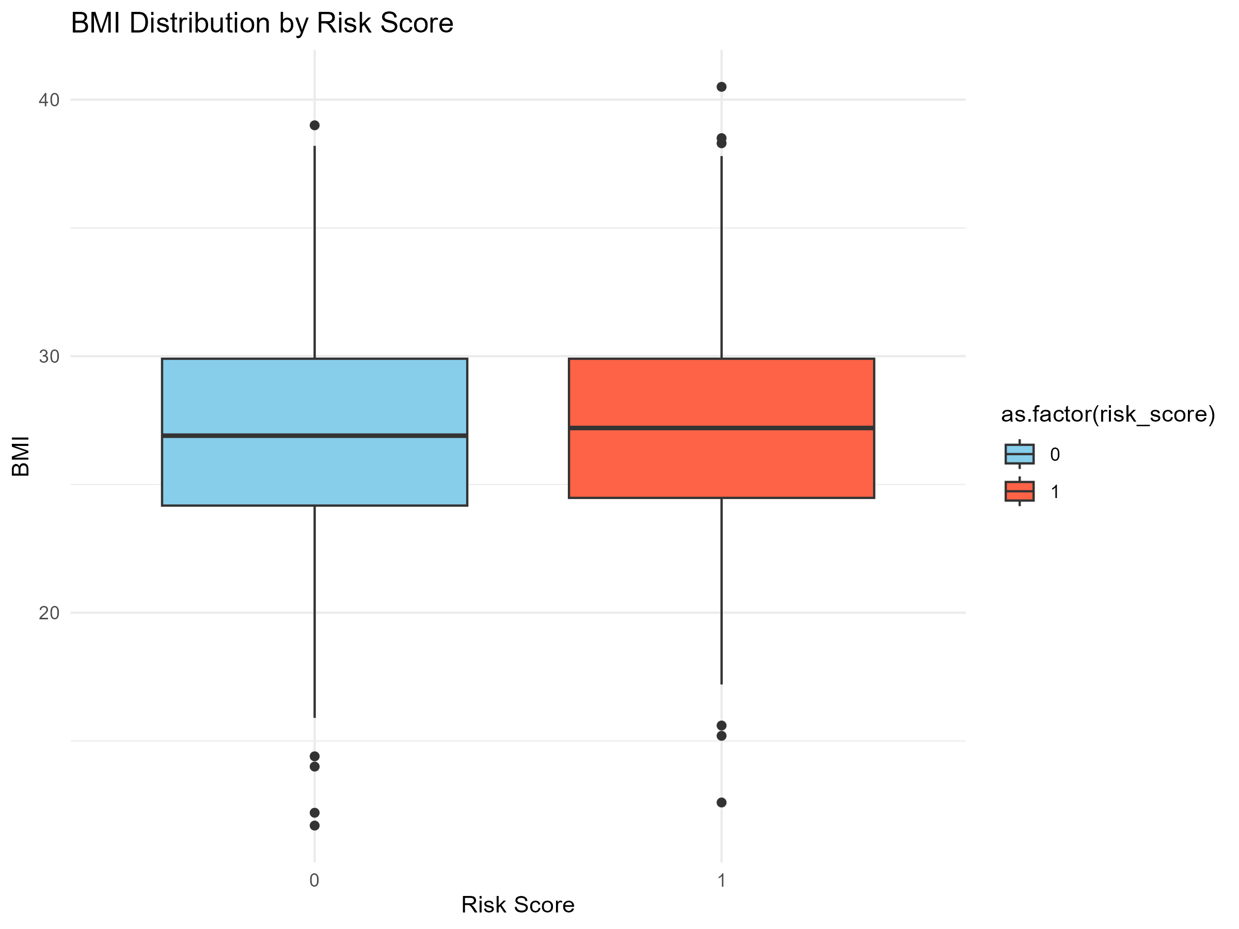

I save this in the same folder as other outputs
ggsave( filename = “outputs/figures/bmi_boxplot.png”, plot = bmi_boxplot, width = 8, height = 6, dpi = 300 )

—————————————————–

HERE I CHECKED THE BMI BY RISK GROUP ON A HISTOGRAM

—————————————————–
risk_histogram <- ggplot( healthcare_data, aes( x = bmi, fill = as.factor(risk_score) ) ) + geom_histogram( bins = 30, alpha = 0.7, position = “identity” ) + scale_fill_manual( values = c(“cyan”, “magenta”) ) + labs( title = “BMI Histogram by Risk Group”, x = “BMI”, y = “Frequency” ) + theme_minimal()
#print(risk_histogram) 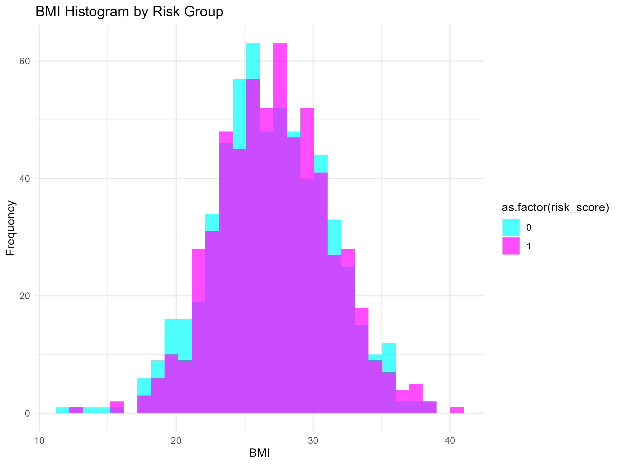 #———————————————————— # I saved this in the same folder as other outputs ggsave( filename = “outputs/figures/risk_histogram.png”, plot = risk_histogram, width = 8, height = 6, dpi = 300 )

=====================================================

I USED PCA FOR DATA VISUALIZATIONS

=====================================================

I first Converted the target variable to factor which is the risk_score
healthcare_data$risk_{s}core<−as.factor(healthcare_{d}ata$risk_score )

I presented this in a Scree Plot visualisation to capture the variance
scree_plot <- fviz_eig( pca_results, addlabels = TRUE, barfill = “steelblue”, barcolor = “black” ) + ggtitle( “Scree Plot - Explained Variance” )
#print(scree_plot) 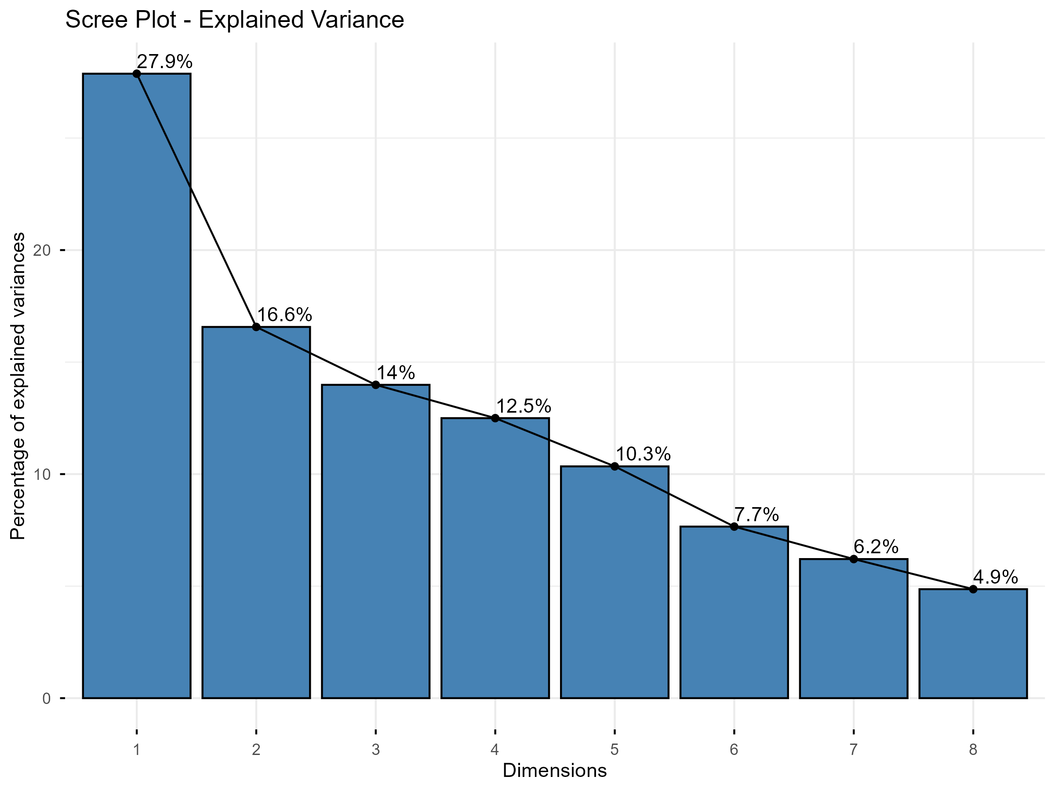
#I Saved the scree plot in the link below with other figures ggsave( filename = “outputs/figures/scree_plot.png”, plot = scree_plot, width = 8, height = 6, dpi = 300 )

—————————————————–

PCA INDIVIDUALS PLOT

—————————————————–
pca_individual_plot <- fviz_pca_ind( pca_results, geom.ind = “point”, habillage = healthcare_data$risk_score, palette = c(“blue”, “red”), addEllipses = TRUE )
#print(pca_individual_plot) 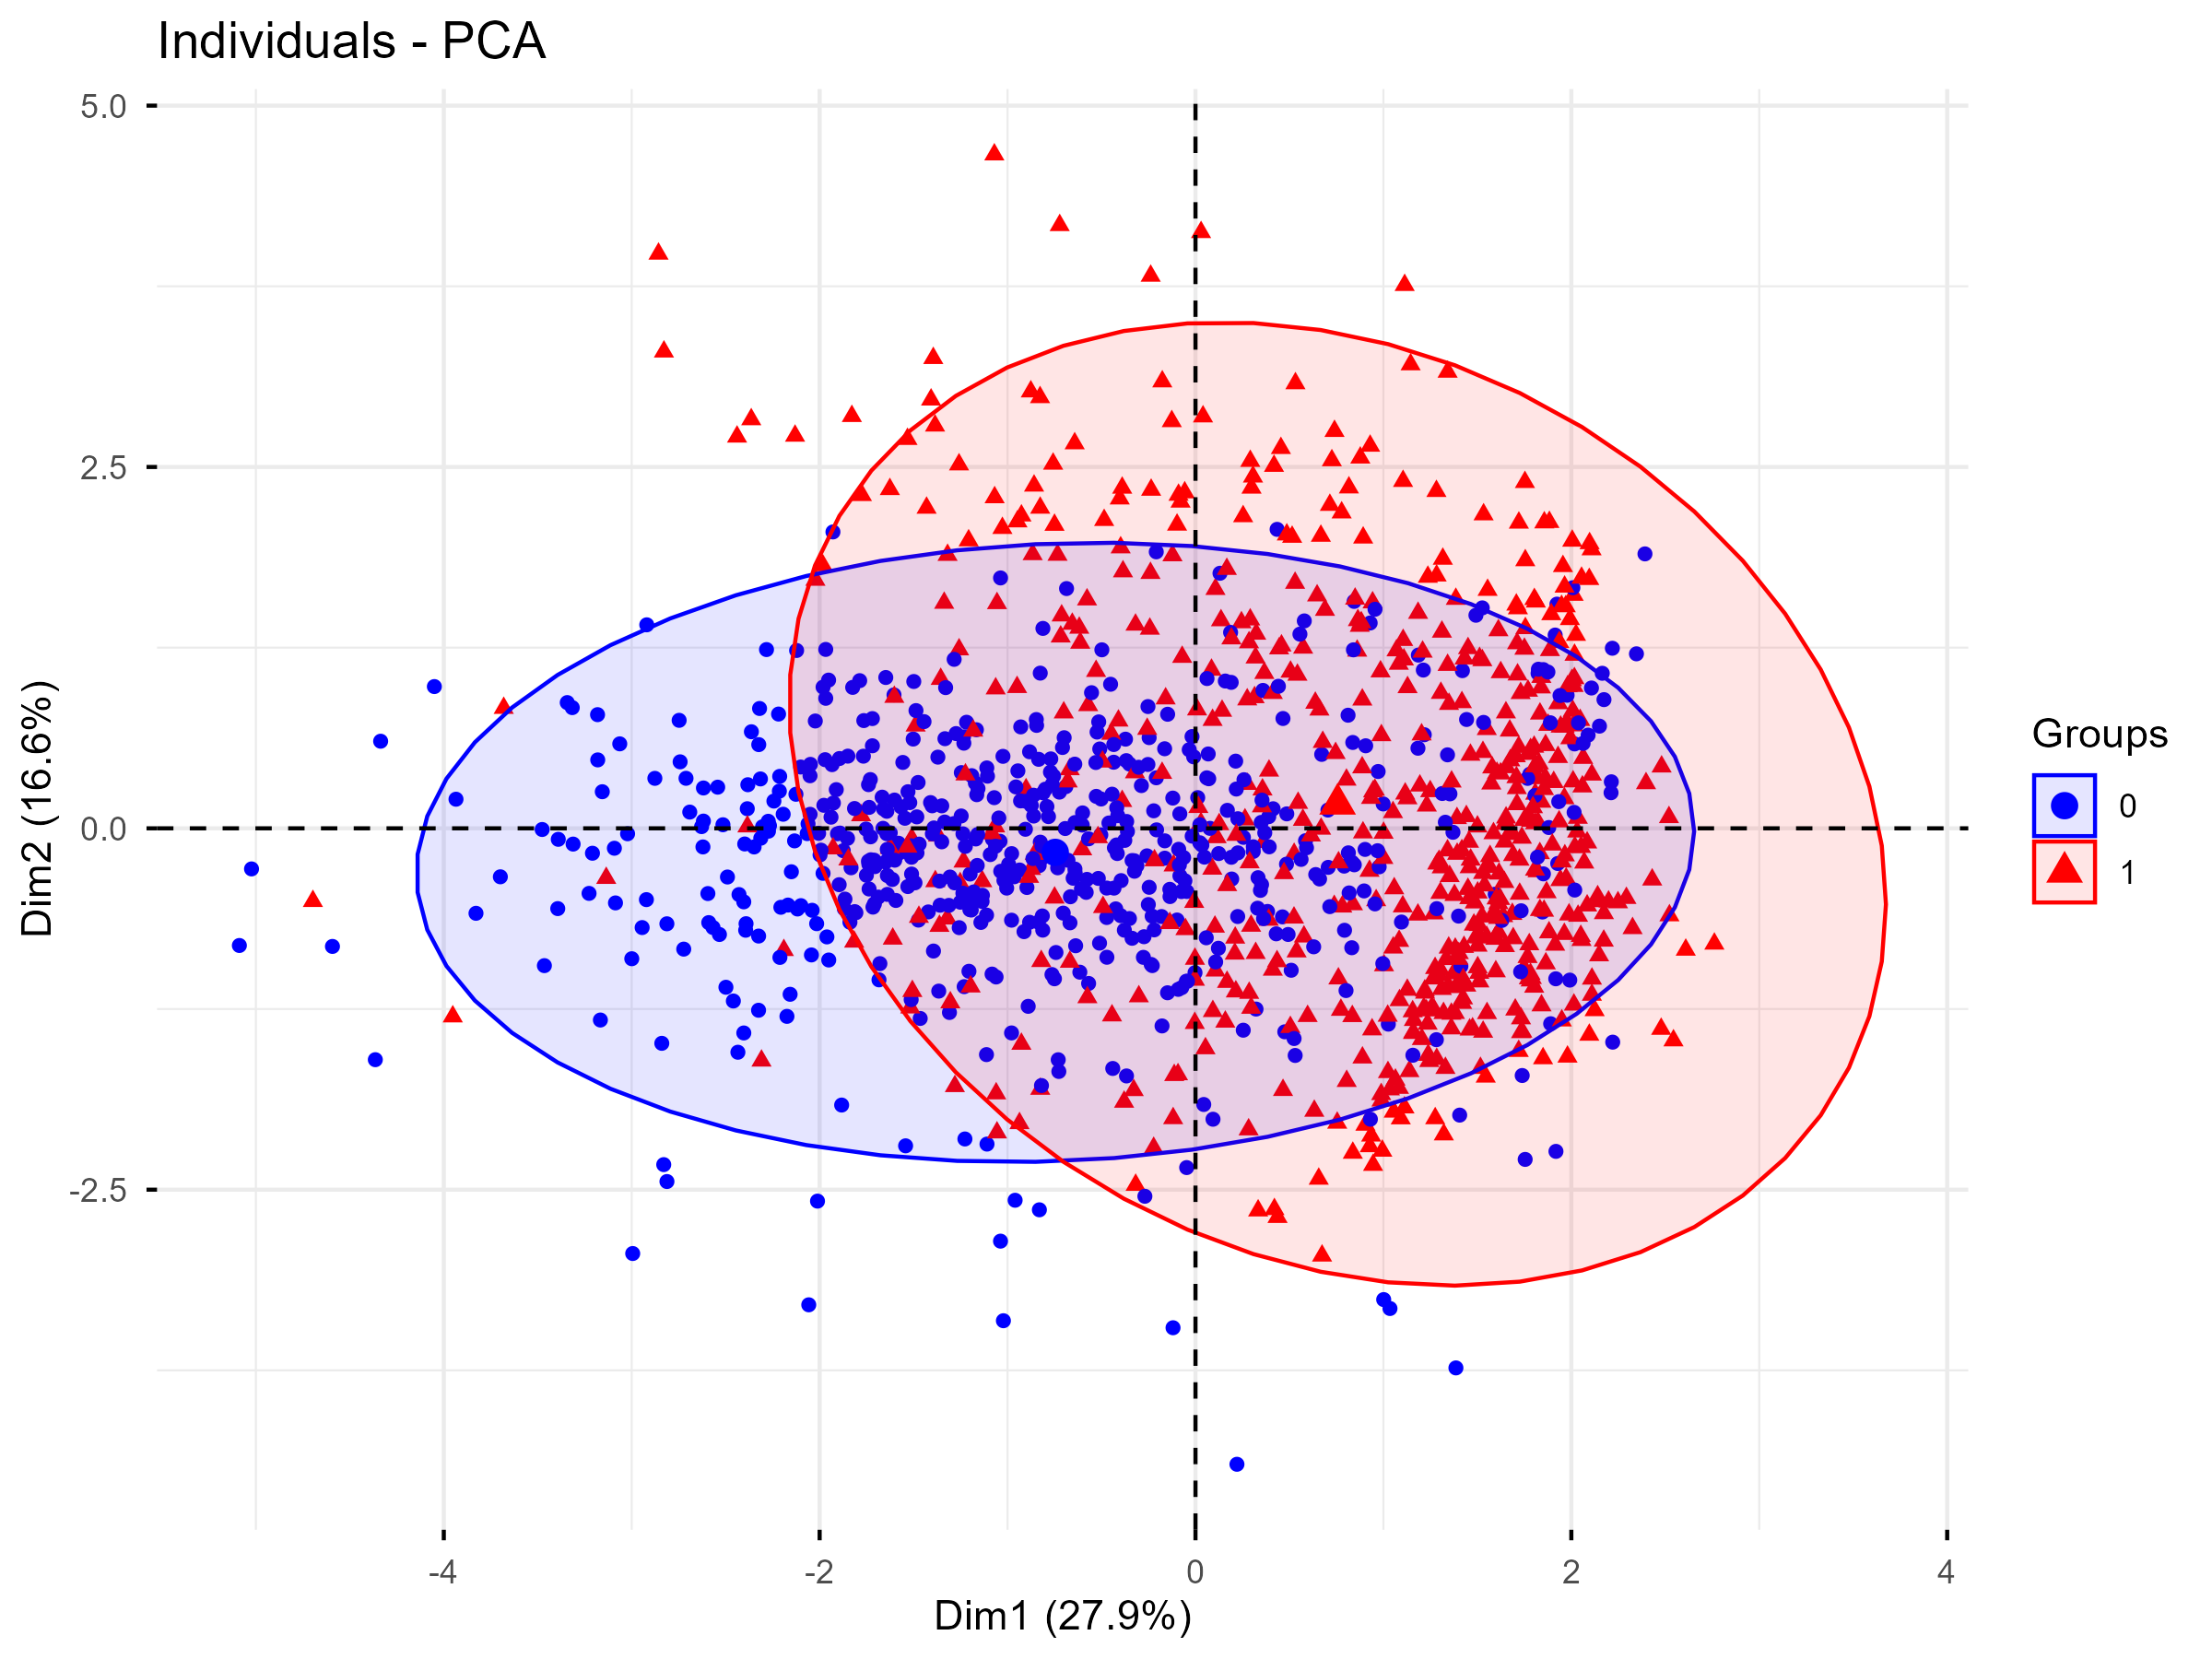

Saved PCA individuals plot in the outputs/figures folder
ggsave( filename = “outputs/figures/pca_individual_plot.png”, plot = pca_individual_plot, width = 8, height = 6, dpi = 300 )

=====================================================

LASTLY I SAVED ALL OTHER REPORTS OUTPUTS IN THE REPORTS FOLDER PATH
#Regression summary,Confusion matrix,PCA eigenvalues # =====================================================

I Saved regression summary
sink( “outputs/reports/linear_regression_summary.txt” )
summary(linear_model)
sink()

I Saved confusion matrix
capture.output( confusion_matrix, file = “outputs/reports/confusion_matrix.txt” )

Save PCA eigenvalues
write.csv( pca_results$eig, “outputs/reports/pca_eigenvalues.csv” )

=====================================================

SESSION INFORMATION

=====================================================
R.version.string sessionInfo()

