NAME and Profession: Reijin-maru G. Migriño, Futsal

How do you acquire the said profession?
-By being invited of a friend and wanting to be more active on playing sports

How long have you been in Sports, Health, Fitness and Physical Education Industries?
-About 1 year

Are you satisfied with your chosen career? *

YES or NO
-Yes

What challenges do you encountered? How do you manage to overcome it?
-The challenges that I've encountered is the pressure and lack of mental focus.
-I trained myself not to be nervous and just play for fun

Do you have any advice for the students who wish to have a career related in Sports, Health, Fitness and Physical Education
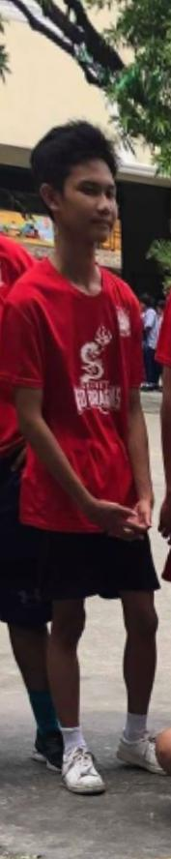
-My advice is always take care of your physical and mental health. Have passion when you are playing it

