Course information: Cs 008: Intro to Web Dev

Shivani Sharma and Hannah Nguyen

Assignment: Final Project

Final Project

Version <1.0>

Table Of Contents

Time Log 3

Introduction 4

Purpose 4

Definitions, acronyms, and abbreviations 4

Overall Description 4

Story Board 5

Specific requirements 6

|  |  |  |  |
| --- | --- | --- | --- |
| Time Log | | | |
| Estimated time to complete assignment => | | | 80Hours |
| Date | Time Spent  (in hours) | Description | Author |
| 10/25 | 20 m | Formed group, assigned group roles | Shivani Sharma |
| 10/27 | 5 m | Decided to meet during Wednesday labs. | Shivani Sharma |
| 10/30 | 15 m | Talked about what kind of website we wanted to make. | Shivani Sharma |
| 11/8 | 50m | Talked about what the form would look like. | Shivani Sharma |
| 11/20 | 4hr | Fleshed out content of website. | Shivani Sharma |
| 11/25 | 2hr | Created first iteration of story board. | Shivani Sharma |
| 11/26 | 1hr | Condensed story board. Outlined form. | Shivani Sharma |
| 11/27 | 2hr | Put together empty html pages based on story board, and condensed the story board. More work on content. | Shivani Sharma |
| 11/29 | 2hr | Filled in some skeleton code. Linked pages together. | Shivani Sharma |
| 11/30 | 1hr | Added more code to pages, started filling some content. | Shivani Sharma |
| 12/3 | 4hr | Added color to hand drawn pictures digitally. Added more to story. | Shivani Sharma |
| 12/4 | 5hr | More work on content/story. Begin Form code. | Shivani Sharma |
| 12/5 | 4hr | Bug fixes, implementing form validation, email, and csv saving. Playing around with browser cookies. | Shivani Sharma |
| 12/6 | 5hr | Finalizing technical aspects of how website will remember user’s form choices. Story finalized, pages linked. Some CSS | Shivani Sharma |
| 12/2-12/5 | 4 hr | Worked on the content | Hannah Nguyen |
| 12/7 | 5hr | Finalize Css, Spec, and project requirements. Hand in Project. | Shivani Sharma |
|  | 40 hr 30 min | <=Total Time Spent |  |

# Introduction

### Purpose

The purpose of this document is to describe the requirement specification for the web site “Choose your own adventure”.

The intended audience for this document is anyone looking to spend some free time on fun.

### Definitions, acronyms, and abbreviations

ER Diagram – a diagram to represent the data you want to save with your system

W3 Validation – refers to both Html and CSS validation tool provided by the W3c.org. the html validator is located at:

<http://validator.w3.org/>

with the CSS validator located at:

<http://jigsaw.w3.org/css-validator/>

# Overall Description

The site is a choose your own adventure game. The user will be able to select certain character options on a form, and depending on their choices their story gets effected, and the appearance of their character changes.

# C:\Users\shiva\AppData\Local\Microsoft\Windows\INetCache\Content.Word\StoryBoard (1).pngStory Board

# FORM:

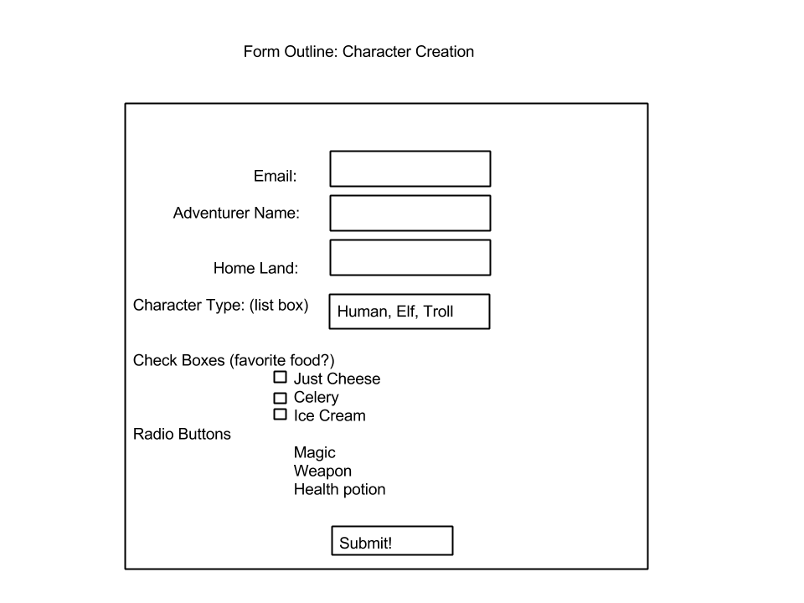

# Specific requirements

1. Title for main page: *Tales of Nazhir*
2. Meta Description: *Choose your own adventure to save the world.*
3. Meta Character set: UTF - 8
4. Usage of background image for every page.
5. Index.php is where the site starts. Here, give the user an idea of what the site is. Nav.php should be included here. A link to this page should be on the sitemap.
6. Navigation for the site will be simple, and only death scenes, end game, form pages will have it. It will take you back to index, the form (“character creator”), or will let you go back to the very first player choice page (“restart game”. You can also restart the adventure.
7. The form will send an email to the user containing the character choices the user made. These will also be saved in a CSV. In order for other pages to display the same character picture that is determined based on character class and equipment, make use of browser cookies.
8. Form.php
   1. The Form will have one text box for user’s email address, character name, and character homeland.
   2. The form will also have 3 radio buttons choosing equipment. Weapon, magic, and potion will be the three options.
   3. Three checkboxes will allow the user to choose “favorite food”. The three choices will be celery, just cheese, and ice cream.
   4. There will also be a list box allowing the user to choose a class. The three classes are Human, Elf, and Troll.
   5. No real specific order for form.
   6. The form will email the user indicating what the user had chosen.
   7. Every control on the form will be validated. Nothing should be allowed to be empty/ not chosen.
   8. Form data is also sent to a CSV. There should be a link on the Nav.
9. There should be a top.php,header.php, and footer.php.
10. Top.php will include library functions for form validation, security, and sending emails. It will also set up the path.
11. No solid CSS requirements