SET08101 – Web Technologies

Coursework 1 - Report

Edinburgh Napier University

Paul Chalmers

40315122

## Introduction

This assignment aims to demonstrate an understanding of common web technologies used in a constructive and practical manor. Using languages such as Hyper-Text Markup Language (HTML), Cascading Style Sheet (CSS) and JavaScript to create a working website which enables the user to access two different ciphers to encrypt and decrypt data or generate an output through custom input. The following learning outcomes are to be met through the submission of a working website and a demonstration:

* **LO1:** Describe Internet and World Wide Web technology standards
* **LO2:** Identify and apply an appropriate web page development methodology
* **LO3:** Demonstrate competence in the use of authoring tools & markup languages.
* **LO4:** Demonstrate competence in Client-Side and Server-Side programming

For this assignment, a simple yet appealing colour scheme was chosen coupled with an easy to use design. The website contains two ciphers, these being a Caesar cipher and a Diffie-Hellman key generator. The pages which contain these ciphers also contain a brief description of the cipher and how to use it with a few examples. These are both accessed through a hyperlink connecting separate web pages each formatted through a global CSS file. Both cipher pages also link to an information page respective to each cipher detailing its origin and usages.

## Design

The design stage of the project was broken down into stages, these being the initial thoughts, visual aspects of the website, functional aspects of the website and how the website interacts with itself.

### Initial thoughts

The first thoughts of the design involved looking at other websites which are frequently used and well known. These included Google, Facebook and Youtube:

**Google** – Google has a very simplistic design with the black text on a white background, logo in the centre of the page with the main interaction area directly underneath it. When searches are made, it retains this colour scheme with the search bar and logo moving to the top-left area of the page and all subsequent searches pushed to the left margin of the page. This is very simplistic but also very easy to use and easy on the eye.

**Facebook** – Facebook has a more complex design to it, there is a lot more going on within the page however still follows the black text on a white background however does this slightly differently by introducing a box for each body of text with the overall background being a grey colour while adding its iconic deep blue within the header section. Again, this is very easy to use with both a left hand and header-based navigation bar.

**Youtube** – Youtube again has a more complex design to it, once again going with black text on a white background having the logo in the top left, search bar top centre and a navigation bar on the left with videos presented in the centre-right of the page. This again uses grey and white to differentiate between background areas with the navigation bar having a grey background. While a complex design, it is still easy to use and to look at.

From looking at these three successful webpages it can be determined that users will respond positively to relatively simplistic designs which have a soft colour scheme, in some cases using this to differentiate between different sections within the page. Most websites to date use a white background with a non-offensive colour scheme using 3-5 colours throughout the website with a sans-serif based font. For this reason, it was concluded that a webpage consisting of few soft colours with a majority white background and a sans-serif based font would be used.

### Visual Aspect

From the conclusion of website research, it is clear that simple designs incur a positive response from users. The website will align with the following points:

* White majority background
* Black text
* Sans-Serif font
* Grey box background to differentiate bodies of text
* Coloured navigation bar

### Functional Aspect

Functionally, the website will need to flow well, the user should be able to access all pages from anywhere within the website. This should be easy to navigate, make sense and any hyperlinks should be relevant to the page they are on. The ciphers should work they way they are intended to and have enough information with clearly explains how to use them. The following is a site map which shows that all pages (rectangles) are interlinked and can be accessed via each page, all pages use the global CSS file and the two ciphers use separate JavaScript files. (See figure 1)

*Figure 1:*



## Implementation

The website home page details what the site does and what the user can access through the site (see figure 2.1) with a navigation bar which remains consistent throughout the website.

*Figure 2.1:*

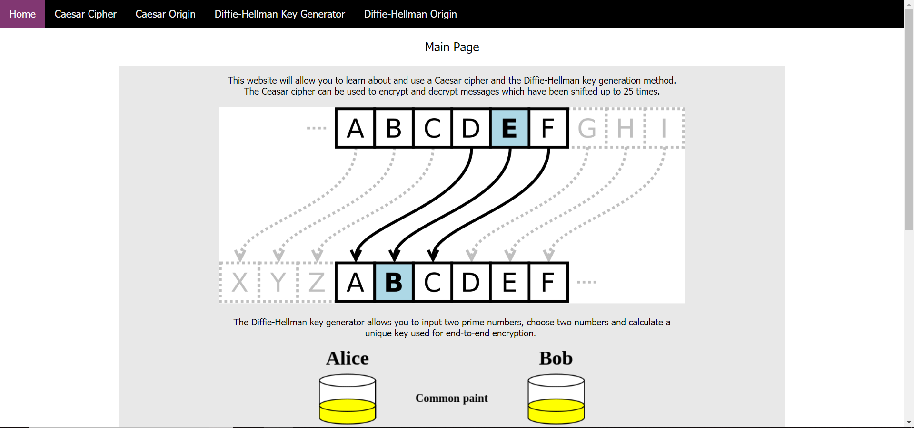

The user can then look at the Caesar Cipher by clicking on the option in the navigation bar. (see figure 2.2) On the Caesar Cipher page, the user can click a link at the top which will direct the user to the Caesar Origin page which explains what it is and how it works. This is the same for the Diffie-Hellman Key Generator. (see appendix 2.3 and 2.4)

*Figure 2.2:*

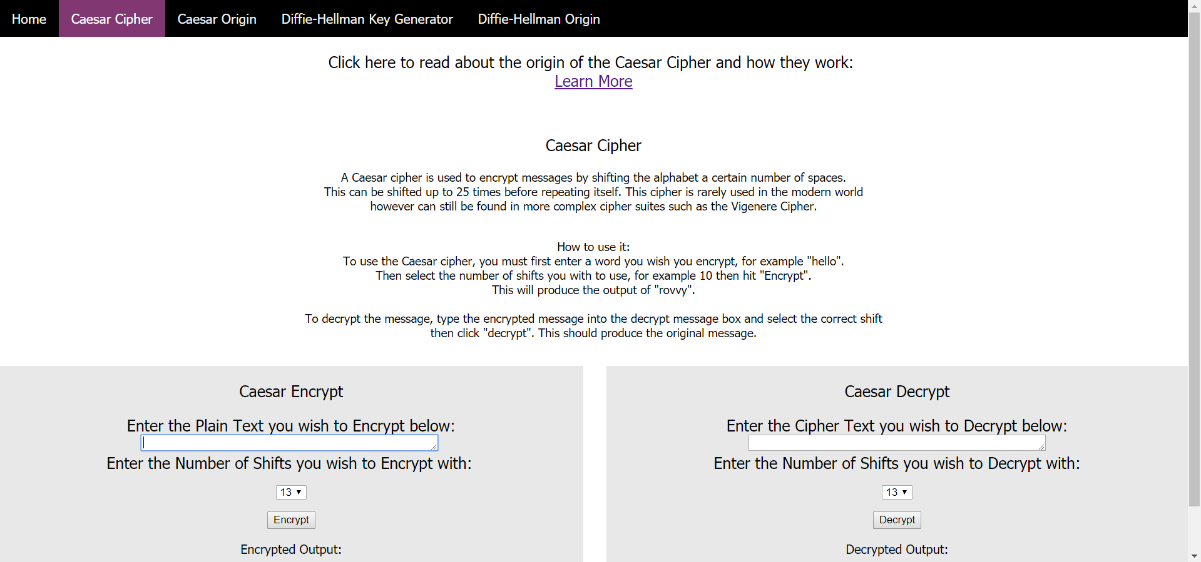

## Critical Evaluation

The finished product of the website looked and felt the way it was set out to. This said, there is plenty of room for improvement such as the navigation bar, this could be more condensed by using drop down lists for the cipher information. This would help keep each cipher more segregated and give their associated information pages a more distinct link. More ciphers could be added in the future to expand the user availability, perhaps having the option to switch between a Caesar and Vigenere cipher within the main Caesar cipher page. The output areas for the ciphers could be more defined as at current when an output is processed it expands the area to which the cipher sits – this would make the site look cleaner and more seamless. The ciphers themselves could work a lot better, perhaps laid out in a different way to make them easier to read and make sense of. All this considered, the website could be much more interactive and provide a more satisfying service to the user.

## Personal Evaluation

Throughout this assignment I felt I could achieve a lot more than I did, while having moderate experience with using HTML and CSS both through studies and in the workplace the biggest challenge was grasping the basics of JavaScript. Getting the ciphers working was a challenge in itself, while I knew how they both operate through exposure in scripting them with Python, it became clear that my ability to work with JavaScript was miniscule. To combat this, many hours were spent reading how-to guides, books on the basics of JS and video tutorials explaining the fundamentals. These three resources helped me to form a conceptualisation of JS formatting and function usages. With this, and using the rot13 cipher from the lab, I was able to get a semi-working Caesar cipher which was later improved through further reading (which involved looking at existing Caesar JS examples). Overall, I feel my performance throughout this assignment has varied, at the beginning I feel I was more enthusiastic about the task and was able to create a working prototype in little time. However, as time went on I feel my performance deteriorated from the daunting task of learning how to use JS. This however, I feel, picked up towards the end as I began to get more comfortable with using the language.

## Appendix

*Figure 2.3*

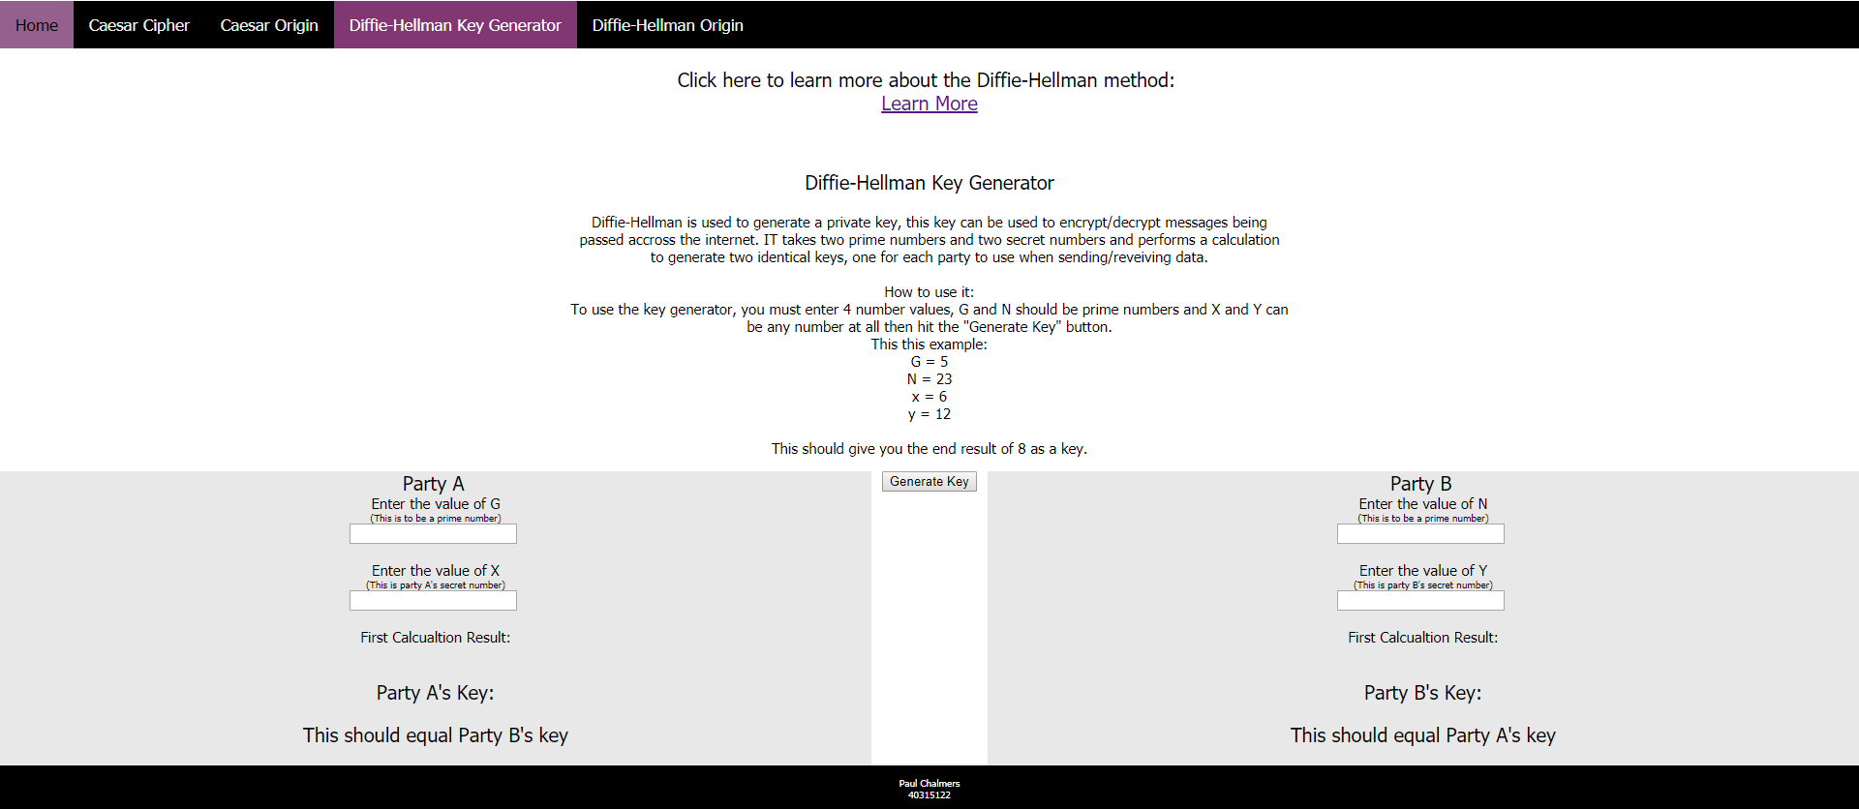

*Figure 2.4*

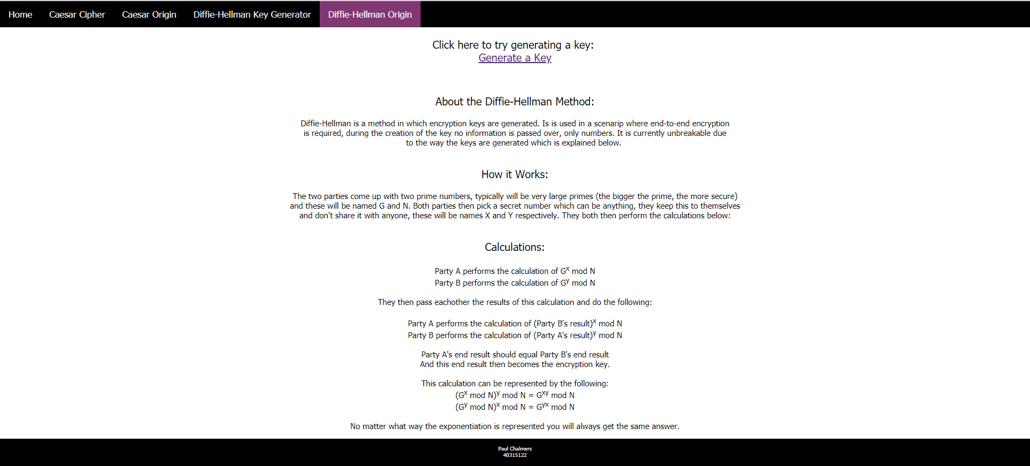

# References

Any references made within the website are commended in-line it was used.