Anne Lorraine Ruslin

**PAINTING**

**Giotto (1267 - 1337) Italian, Florentine, Early Renaissance**

Giotto's famous painting of Hell and Sinners being dragged into the Fiery Furnace

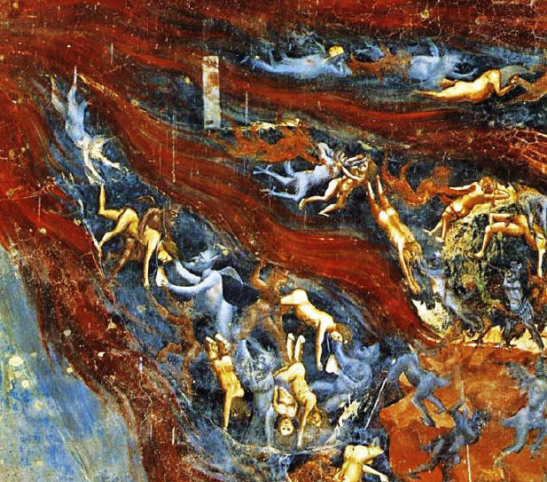

**SCULPTURE**

**Spillover II** by **Jaume Plensa**

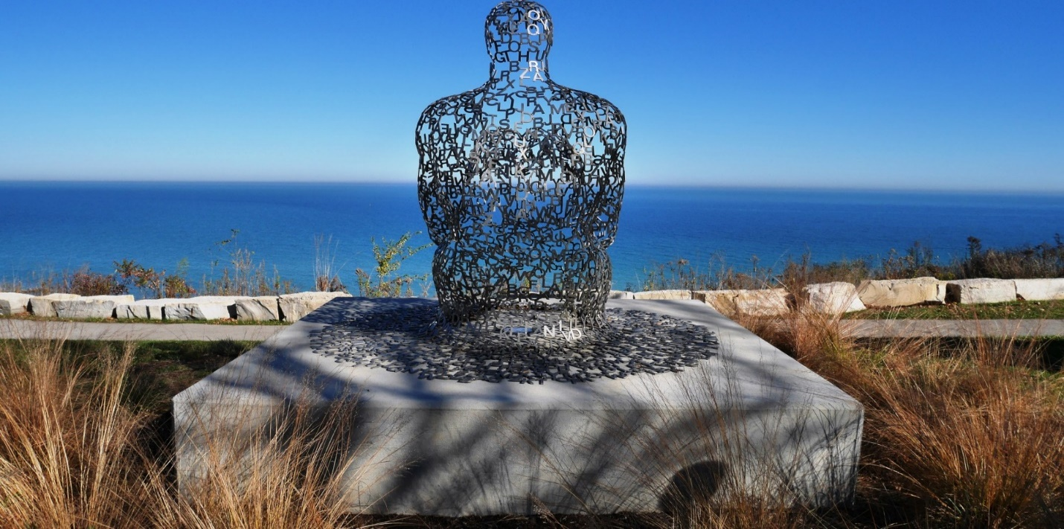

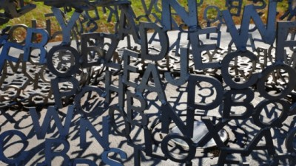

**ARCHITECTURES**

**Compostable Towers** by **New York architecture firm**

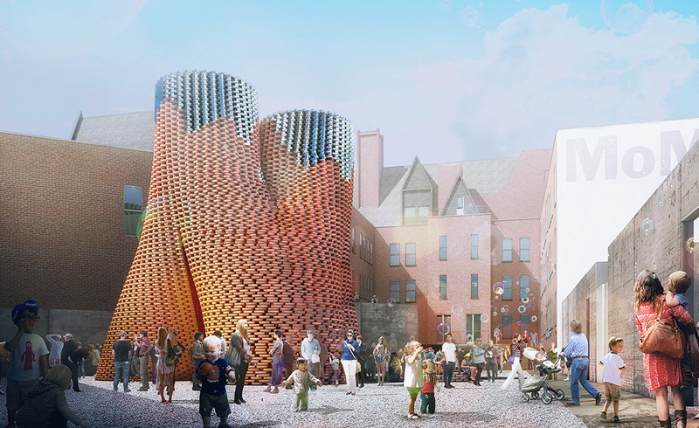

**GRAPHICS**

**Xeonetik** by **z-design**



**PHOTOGRAPHY**

**THE SLOW DISAPPEARANCE OF MEANING AND TRUTH** by **CRISTINA CORAL**

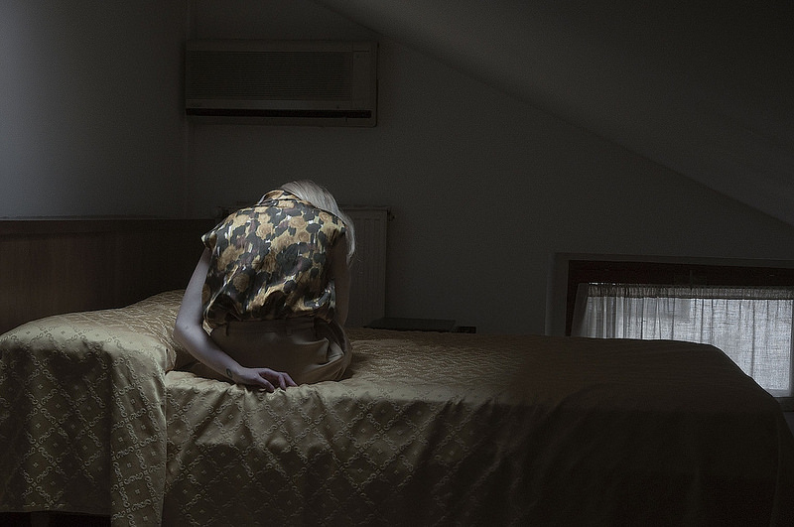

**INTERIOR DESIGN**

**The interior of New College Chapel looking east, Oxford, England**

by **Diliff**

