A PROJECT REPORT

ON

“**E-COMMERCE**”

FOR THE PARTIAL FULFILLMENT OF VIII SEMESTER MAJOR PROJECT (BIT479CO) FOR THE REQUIREMENTS OF BACHELOR IN

INFORMATION TECHNOLOGY (BIT) AWARDED BY PURBANCHAL UNIVERSITY

**SUBMITTED TO:**

DEPARTMENT OF SCIENCE AND TECHNOLOGY

COLLEGE OF INFORMATION TECHNOLOGY AND ENGINEERING (CITE) SUBIDHANAGAR, TINKUNE, KATHMANDU

**SUBMITTED BY:**

ANJAN SAPKOTA (382216)

MANGAL TAMANG (382223)

SHIRSHAK SUBEDI (382775)

September,2023

September, 2023

# CERTIFICATE

This is to certify that this project work entitled “E-COMMERCE” submitted by by Mr. Anjan Sapkota Mr. Mangal tamang and Mr. Shirshak subedi is a work carried out under our supervision and guidance fulfilling the nature and standard required for the partial fulfillment of the degree of Bachelor in Information Technology.

Supervisor:

…………………………

…………………………

External Examiner

………………………………

# ACKNOWLEDGEMENT

We are pleased to acknowledge to our respected instructor **Dr. R.N. Thakur**, for his invaluable guidance during the course of this project work without his guidance, this project would have been an uphill task.

We are very much thankful to **Er. Sudhir Guragain**, Principal, CITE for providing facilities which helped in completion of this project.

We extend our sincere thanks to **Mr. Saroj Dahal**, Academic Director (Science & Technology), CITE who continuously helped us throughout the project.

Last but not least, a great deal of appreciation and best wishes to all my friends for their contribution & encouragement during the work.

ANJAN SAPKOTA MANGAL TAMANG SHIRSHAK SUBEDI

# ABSTRACT

In this report/project we tried to make recommendation system which is integrated to ecommerce site made up of Django. Recommendation system is one of the major sources for generating revenue in different online companies. Recommendation not only increases the sales of product but it helps to make the system personalized and helps to find out the preferences and interest of particular user to the product. It is currently being used in big tech companies for recommending products, songs, videos, movies, jobs services etc. It is also implemented in search engine, ranking, friend suggestion, gaming, Point of interest, online advertisements etc. It is one of the most studied and researched topics in the field of artificial intelligence. Researcher and scientist now studying and developing recommendation using deep neural network.

# Table of Contents

CERTIFICATE i

ACKNOWLEDGEMENT ii

ABSTRACT iii

Table of Contents vi

CHAPTER 1: INTRODUCTION 1

* 1. Introduction 1
  2. Academic question 4
  3. Aims 4
  4. Objective: 4
  5. Scope of project 5

CHAPTER 2: LITERATURE REVIEW 6

* 1. Introduction 6
  2. Recommendation system 7
     1. Content-based filtering technique 8
     2. The clustering based Collaborative filtering 8
     3. Hybrid filtering technique 10
  3. Latent factor models 11
     1. Matrix Factorization: 11
     2. Dimensionality Reduction: 11
     3. Recommendation Systems: 11

Chapter 3: RESEARCH METHODOLOGY 12

* 1. System Analysis 12
  2. Requirement analysis 12
     1. Functional Requirements 12
     2. Non-functional requirement 13
  3. System Design 14
     1. Primary design phase 14
     2. Secondary design phase 15
  4. System development life cycle 16
  5. Feasibility Study 17
     1. Economic feasibility 17
     2. Technical Feasibility 17
     3. Operational Feasibility 17
  6. Gantt chart 18
  7. Functional Decomposition diagram 19

CHAPTER 4: DESIGN AND ARCHITECTURE 20

* 1. Introduction 20
  2. Usecase diagram 21
  3. State Transition diagram: 22
  4. Activity diagram 23
     1. Activity diagram for user 23
     2. Activity diagram for Admin 24
  5. Entity relation diagram 25
  6. System architecture 26
     1. The MVT pattern 26

CHAPTER 5: IMPLEMENTATION AND EVALUATION 28

* 1. Implementation 28
  2. Technical specification: 28
  3. Development 29
  4. Testing for Recommendation system 32

CHAPTER 6 : CONCLUSION AND FUTURE WORK 37

* 1. Conclusion 37
  2. Critical evaluation 37

SCREENSHOTs 38

References 45

Figure 1 ecommerce sales world wide 1

Figure 2 ecommerce revenue growth 2

Figure 3 worldwide statistics of e commerce revenue 2

Figure 4 figure of recommender system 7

Figure 5 gantt chart 18

Figure 6 functional decomposition diagram 19

Figure 7 usecase diagram 21

Figure 8 state transition diagram 22

Figure 9 activity diagram for user 23

Figure 10 activity diagram for admin 24

Figure 11 E-R diagram 25

Figure 12 MVT architecture 26

Figure 13 recommendation system diagram 27

# CHAPTER 1: INTRODUCTION

## Introduction

Nowadays, Companies and individual are increasingly trying to buy and sell variety of products online. The most of the transaction are conducted with the help of internet. Not only products, but buying and selling of services are quite popular nowadays. According to Statistic, Revenue in the e-Commerce market is projected to reach US$1,034.00m in 2023. Revenue is expected to show an annual growth rate (CAGR 2023-2027) of 12.39%, resulting in a projected market volume of US$1,650.00m by 2027. With a projected market volume of US$1,319.00bn in 2023, most revenue is generated in China.

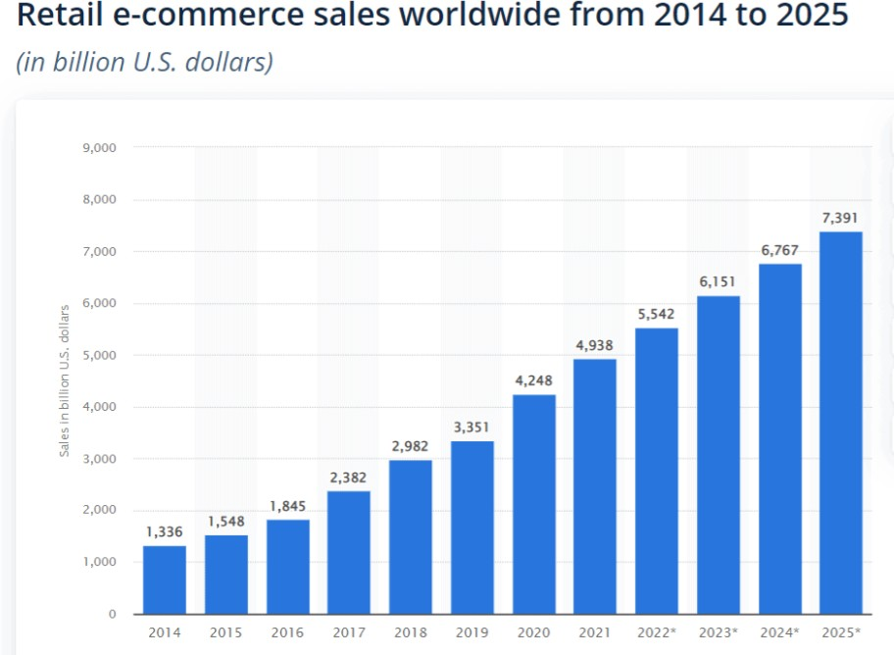

*Figure 1 ecommerce sales world wide*

Although the digital market like ecommerce companies are not more here in Nepal. Ecommerce development in Nepal is also in growing order which can be seen in figure below.

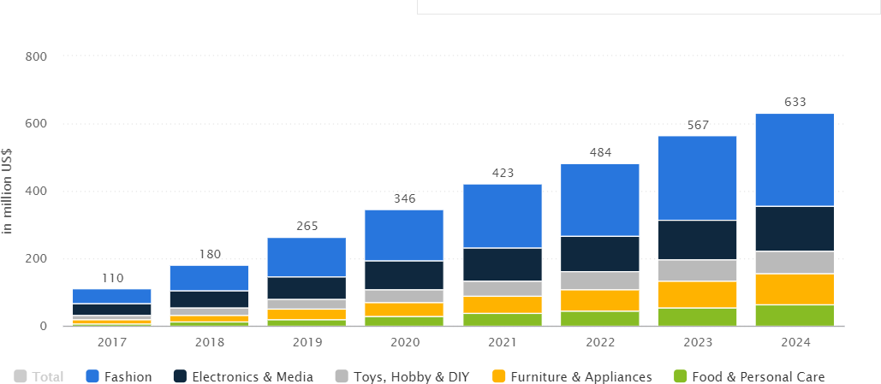

*Figure 2 ecommerce revenue growth*

These figures are projected to increase due to increase in number of mobile internet users which can also be seen in figure above.

The ecommerce market is blooming in advanced and developed country of world. The development of online commerce can also be seen in figure below:

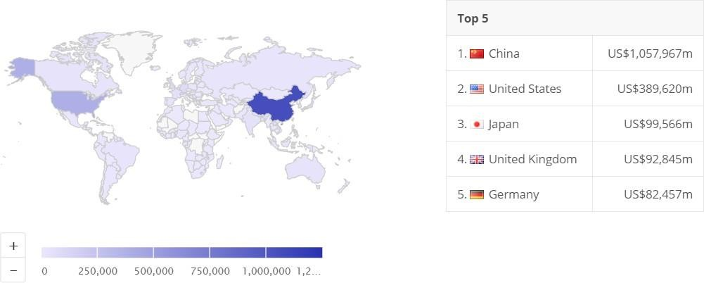

*Figure 3 worldwide statistics of e commerce revenue*

The idea of building this system is to ease both buyer and seller by recommending products to individual user. Our country Nepal stills lack certain types of ecommerce. There are very limited ecommerce sites in Nepal where user get their desired product. Nearly all of Nepal’s ecommerce platform fails to produce satisfactory revenue from the product till this date. Because of this reason We have built an ecommerce framework for purchasing and selling of numerous products in different categories like books, electronics, fashion, cosmetics, baby products and many more.

The one reason behind the stagnation of growth in the present ecommerce site is due to lack of knowledge about the individual interest of the user and the customer's on-site behavior. Sales are not boosting as expected here in Nepal because it is one of the tough tasks to find and target the right audience in ecommerce. To address this type of problem, we researched the topic of recommendation system to generate the personalized recommendation system for each user who uses our system. This build system uses automated recommendation system which solves the mentioned problem. The developed recommendation system helps the new and existing user to discover relevant and related product recommended from our system based on browsing history, user’s behaviors, ratings, demographics and purchase history. The developed system is Business to customer type of ecommerce where customer may order, buy, rate and review different products online posted by the admin of this site. The web application is very easy to use because of simple and comfortable user-centric interface.

## Academic question:

How will a recommendation system that uses machine learning technique be used to predict the interest/desires of users, boost their experience to increase the sale of products, earn revenue in ecommerce sector and what are the possible challenges and issues in real word?

## Aims:

The main aim of this developed project are to:

* + - design, develop and test the full featured ecommerce web app for viewing, buying, rating and reviewing different product
    - build recommendation system to recommend different product to individual user.
    - examine, identify and evaluate the past publication or existing system of the related topic.

## Objective:

The main objectives of the study are as follows:

* + - To study about the B2C type of ecommerce in Nepal and recommendation types that can actually be used in ecommerce site.
    - To build the powerful recommendation system that can recommend each and every individual user of the system.
    - To provide the online platform to view, buy rate and review different product.

## Scope of project

The scope of e-commerce in the context of Nepal is promising and has been steadily growing in recent years. Nepal, like many other countries, is experiencing a digital transformation, and e- commerce plays a vital role in this evolution. Here are some key aspects that define the scope of e- commerce in Nepal:

* + - Rapidly Expanding Internet Access
    - Digital Payment Solutions
    - Local Product Promotion
    - E-commerce Education and Training
    - Government Initiatives
    - Geographical Diversity

While the scope of e-commerce in Nepal is promising, it is essential to address the challenges and continue to invest in infrastructure, digital literacy, and regulatory frameworks to support sustainable growth. Additionally, businesses and entrepreneurs in Nepal should seize the opportunities presented by e-commerce to reach new markets and customers.

* 1. **Introduction**

# CHAPTER 2: LITERATURE REVIEW

Our topic of research is not the new topic but active area of research. Recommendation system (RS) is popular field of study among the researcher and scientist since last few decades. RS to recommend products, books and news is fairly common in large tech companies including amazon and Google. Social media site like Facebook, Tinder and twitter also suggest new friends and advertisements. Not only that but last FM, Pandora etc. also offers songs that the user may like. Films and online videos are likewise generating meaningful recommendation by companies such as Netflix, Movie Lens, IMDb, YouTube etc (Aggrawal, et al., 2017)

RS comes into practice in order to address, deeper analyze and resolve the issue and problem of both buyers and sellers by automating the activities based on the quality of user-item communication. (Melville & Sindwani, 2018)

Recommendation engines is totally transforming or reshaping ecommerce industry by helping the customer to choose the relevant product. Recommendation system allows to increase the figures of sells, to offer more varied products, to improve user satisfaction and to fully consider customer needs. In simplest term recommendation engines are the ranked list of products to the user based upon different factors like user’s preference and constraints. To first determine the constraints and preference, RS collects user’s view with the help of ratings to the particular product in most of the cases. (Ricci, et al., 2011) RS can also be called as information retrieval as it is used to filter the system and display only item’s that match the user’s interest. For this, user must give some of interest to the system and system tries to display products user may like. If user does not give any information to the system, the system cannot provide any recommendation. Various tools are available to recommend the product. Most used recommender system in existing online environment are collaborative filtering, content-based filtering, Popularity based, Hybrid approach. (Anantha & Bhattula, 2017).

## Recommendation system

Before making recommendation system, one must know the pros and cons of each type of recommender system which are described in this section. Broadly speaking there are two approaches of recommendation system. They are content based filtering, collaborative filtering and hybrid filtering. Each of this type has their own limitation and benefits which is shown in later part of this section. Collaborative filtering is further divided into two type: Model-based filtering techniques and memory-based filtering techniques. Model-based filtering techniques is further divided into clustering, association, Bayesian and neural networks. Memory based filtering technique is further divided into user-user based collaborative filtering and item-item based collaborative filtering

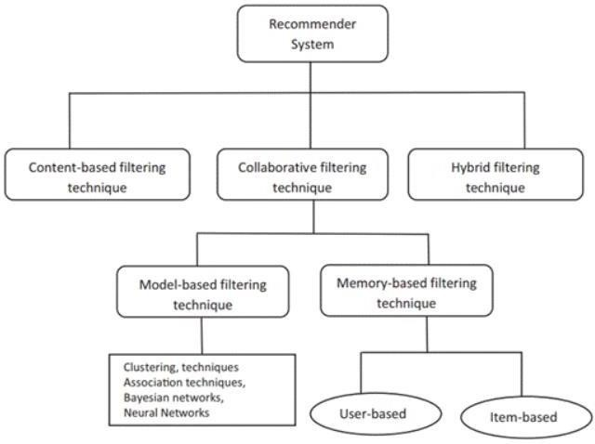

*Figure 4 figure of recommender system*

### Content-based filtering technique:

Content-based (CB) filtering, also known as cognitive filtering recommends similar products that the user had already bought from the system. Content-based filtering can also recommend product to user with other factors like age, gender, geography, review, usage pattern etc. The preferences of particular users can be determined by retrieval method such as cosine similarity matrix, term frequency-inverse document frequency, Long Distance Affair etc. or by using machine learning techniques like support vector machines, Naïve Bayes, decision trees etc. (Pazzani & Billsus, 2015)

* + - 1. **Neighborhood-based approach:**

Neighborhood-based algorithm can be used to predict the user’s desire and opinion. It also analyzes the existing users from the system. In this method, the group of similar users is segregate and their average rating is computed from all users that are close to the actual logged in user. In simple form collaborative filtering is based upon the assumption that similar customers like similar products. So, the main task is to find the similar customer from the set of all the customer available in the database. The one way to find similar customer is from the ratings and reviews given by the customer to different products

* + - 1. **Constrained Pearson correlation:**

(Shardanand & Maes, 1995) proposed constrained Pearson correlation to develop the song’s recommendation systems named RINGO. They developed this algorithm from Pearson correlation approach replacing the average rating with average positive and negative level from 1(dislike) to 7(like) and neutral (neither preferred nor hated) +1(same direction) and -1(opposite direction) represents high correlation and 0(irrelevant) represents no correlation. This approach gives both negative ranking and blank rated product as zero rating. (Liu, et al., 2014).

* + - 1. **Pearson Correlation:**

The Pearson correlation coefficient, often denoted as "r" or Pearson's r, is a statistical measure that quantifies the linear relationship between two continuous variables. It is widely used to assess how strongly two variables are related and to what extent they move together in a positive or negative direction.

### The clustering based Collaborative filtering:

Clustering-based collaborative filtering is a technique used in recommendation systems to provide

personalized recommendations to users based on the preferences and behavior of similar users. It involves clustering users or items into groups or clusters, and then making recommendations within those clusters. This approach can be especially useful when you have a large number of users or items and want to reduce the computational complexity of generating recommendations.

Clustering-based collaborative filtering can help improve recommendation accuracy, especially when you have sparse data and can group users or items with similar preferences together. However, choosing the right clustering algorithm, similarity metric, and cluster size is crucial for the success of the recommendation system. Additionally, it may not capture complex user-item relationships, which can be addressed by combining it with other recommendation techniques like matrix factorization or content-based filtering

* + - 1. **Collaborative filtering (CF):**

The developers at Xerox first coined and developed the term collaborative filtering. Since then, has been enhanced and developed by using different technology and algorithms. The main goal of recommendation system is to suggest the content based on individuals’ desires. Collaborative filtering (CF) suggests the item which are preferred by other related users. There are various types of algorithms that can recommend the item and every algorithm has different set of features. Different algorithm may be great or bad for various datasets depending upon the features

### Hybrid filtering technique:

Hybrid filtering is a recommendation technique that combines multiple recommendation methods or algorithms to improve the quality and accuracy of recommendations. It leverages the strengths of different approaches while mitigating their weaknesses. Hybrid filtering is a common approach in recommendation systems because it can provide more diverse and personalized recommendations, addressing the limitations of individual techniques. There are several ways to implement hybrid filtering:

* + - 1. **Weighted Hybrid Filtering:**

In weighted hybrid filtering, each recommendation method is assigned a weight, and the final recommendation is a weighted combination of the recommendations from different methods. The weights can be static or dynamic, adjusted based on their historical performance.

* + - 1. **Switching Hybrid Filtering:**

In switching hybrid filtering, different recommendation methods are applied based on specific conditions or user contexts. For example, one method may be used for new users with limited data, while another method is used for experienced users with extensive interaction history.

* + - 1. **Feature Combination Hybrid Filtering:**

Feature combination hybrid filtering combines the features or characteristics of items from different recommendation methods to create a unified feature representation for items. This combined feature representation is then used to make recommendations.

## Latent factor models

Latent factor models are a class of machine learning models used in various fields, including recommendation systems, collaborative filtering, and dimensionality reduction. These models are designed to capture hidden or latent patterns in data by representing it in a lower-dimensional space. Latent factors are unobservable variables that help explain the observed data.

Here are some key aspects of latent factor models:

### Matrix Factorization:

Latent factor models often involve matrix factorization, where a high-dimensional matrix (e.g., user-item interactions in a recommendation system) is decomposed into lower-dimensional matrices representing latent factors. For example, in a recommendation system, you can factorize the user-item interaction matrix into two matrices: one representing users and the other representing items.

### Dimensionality Reduction:

By reducing the dimensionality of the data, latent factor models help uncover underlying patterns or structures in the data. This can be especially useful in scenarios where the original data is sparse or noisy.

### Recommendation Systems:

Latent factor models are extensively used in recommendation systems, where they aim to predict user preferences for items (e.g., movies, products) by identifying latent factors that describe both users and items. Collaborative Filtering and Matrix Factorization are common techniques employed in recommendation system

# Chapter 3: RESEARCH METHODOLOGY

## System Analysis

Analysis of requirement can be defined as to identify system requirements for investigation, documentation all the requirements and analysis of those collected requirement. The major problem behind this project is to build the ecommerce web app and integrate recommendation system.

In this section we discuss about the fact-finding techniques, function requirement, non- functional requirement and usability requirements.

## Requirement analysis

Requirements for a system are the description where the primary focus is on gathering, documenting, and comprehending the needs and expectations of stakeholders for a software system. These requirements encompass functional specifications (what the system must do) and non-functional specifications (how the system should perform), and they serve as the basis for designing, developing, and testing the software. Requirement analysis involves techniques such as interviews, surveys, use case modeling, and prototyping to ensure a clear and complete understanding of user needs, allowing for the creation of a system that meets those needs effectively

### Functional Requirements:

Functional requirements are the system’s technical features or what the system is meant to do. Some of the functional requirement are described below:

* + - 1. **UI/ UX requirement**

Attractive design, easy to navigate and speedy page loading are three features ecommerce site must have. Apart from that, use of color, fonts and images also plays a vital role to engage the user. These issues must be resolved. Mobile devices are the great source of user nowadays. So, this system must be mobile friendly and scalable to different screen sizes. This system must have features of search and filter product based upon categories and sub categories. To ease the use for the native user, this system must have language option to change the language to English to Nepali. Customer always

want to hear from other customer how the shopping suits their needs and expectation. To solve this problem review and ratings must be used. This system must have featured of shopping cart and checkout to both logged in user and anonymous user.

* + - 1. **personalized recommendation system:**

Most popular system are dynamic and personalized to user. It is one of the key factors to engage the user with the system. The products are recommended to users based upon their preferences, user history and ratings. The already rated product must not be recommended to the user.

* + - 1. **Management requirements:**

Management requirements contains only registered admin can access the admin panel and login to admin panel of the system. Only admin can upload and manage products and customer can buy needed product from the system.

### Non-functional requirement:

Nonfunctional requirements specify whether a particular task will be performed or not. Some of the no non – functional requirements are listed below:

* **Speed:**

Speed is actually much more complicated than it seems. Speed is one of the nonfunctional requirements that must be considered. The speed may lag because of 21 many reasons. Some of the common reason for slow load is due to high resolution unoptimized images, complex order entry process, use of many API calls to render, unclean code etc. All of these issues must be solved.

* **Security and privacy**:

Since this web app use most sensitive data of the user. The system must be protected from vulnerabilities. The authentication must be secured from data breach. To protect the system from code manipulation, the software must be coded with much complexity.

* **Extensibility**:

One of the strong points of this system is this system can be extended to large number of users and large number of products with different categories and sub categories because admin panel is responsible for the flash sale, slider, product, categories, subcategories and many more.

## System Design

In this phase, the conceptualized system from earlier stages is transformed into a detailed technical blueprint. System design aims to ensure that the software meets all specified requirements and is scalable, maintainable, and efficient. It involves creating high-level and low-level designs, specifying how different components of the system will interact, and addressing technical constraints. The logical system is built which fulfills the given requirements. Normally, design is performed in the following two steps:

### Primary design phase:

The initial design phase or conceptual design phase, is an early stage in the software development process where high-level concepts and ideas are formulated and analyzed. During this phase, the focus is on defining the system's overarching architecture, major components, and essential functionalities based on the initial project requirements and goals. It's a critical stage for making key decisions that will shape the direction of the project, such as choosing the appropriate technology stack, identifying major subsystems, and defining the system's overall structure. The primary design phase sets the foundation for more detailed design and development activities that follow in subsequent phases of the software development lifecycle.

### Secondary design phase:

In this secondary phase, the focus shifts to a more detailed and granular level of design, where specific technical decisions are made, and the system's components are further refined. Key activities during the secondary design phase may include creating detailed specifications, defining the data structures, designing algorithms, specifying interfaces between modules or components, and addressing issues related to performance, security, and maintainability. In the secondary phase the detailed design of every block is performed. The general task involved in the design process are the following:

* Design various blocks for overall system processes.
* Design smaller, compact and workable modules in each block.
* Design various database structures.
* Design the form inputs and outputs of the system.
* Perform documentation of the design.
* System reviews.

## System development life cycle

Agile methodology in the context of e-commerce refers to an approach to software development and project management that prioritizes flexibility, collaboration, and customer-centricity to deliver e-commerce solutions more efficiently and effectively. Here's how Agile principles can be applied in the e-commerce industry:

Agile breaks down e-commerce projects into small, manageable pieces called "sprints." These sprints typically last 2-4 weeks, during which cross-functional teams work on specific tasks or features. This iterative approach allows for rapid development and frequent updates to the e- commerce platform. Agile places a strong emphasis on understanding and meeting customer needs. In the e-commerce context, this means continuously gathering customer feedback, monitoring user behavior, and adapting the platform to improve the shopping experience. E-commerce is a dynamic and competitive field. Agile methodologies enable e-commerce businesses to respond quickly to changing market conditions, customer preferences, and emerging technologies. New features and updates can be rolled out more frequently. Agile promotes collaboration among cross-functional teams, including developers, designers, marketers, and product managers. In e-commerce, this collaboration is essential for creating a seamless shopping experience, optimizing product listings, and enhancing the overall user interface. Agile allows e-commerce businesses to prioritize features and tasks based on customer value and business impact. This ensures that resources are allocated to the most important and revenue-driving aspects of the platform. Continuous testing and user feedback are integral to Agile. E-commerce websites can benefit from A/B testing, usability testing, and user surveys to fine-tune the shopping experience and improve conversion rates. Agile promotes transparency through regular meetings (e.g., daily stand-ups, sprint reviews, retrospectives) where team members discuss progress, challenges, and potential improvements. In the e-commerce context, transparency helps identify issues and opportunities for enhancement. Agile allows e-commerce businesses to adapt to market trends, seasonality, and unexpected challenges. For example, during holiday seasons or sales events. Agile teams can adjust priorities and focus on tasks that maximize sales and customer satisfaction. Agile includes automated testing and continuous integration to maintain software quality.

## Feasibility Study

A feasibility study is a critical phase in the development of any project, including the E-commerce project. It assesses the practicality, viability, and potential challenges associated with the project.

Feasibility study includes consideration of all the possible ways to provide solution to the given problem. The proposed solution should satisfy all the user requirements and should be flexible enough so that the future changes can be easily done based on the future upcoming requirements.

### Economic feasibility

This is very important aspect to be considered while developing a project. All the hardware and software cost have to be borne by the organization. Overall, we have estimated that the benefits of the organization are going to receive from the proposed system will surely overcome the initial costs and later on the running cost for the system.

### Technical Feasibility

This included the study of function, performance and constraints that may affect the ability to achieve an acceptable system. For this feasibility study, we studied complete functionality provided in the system, as described in the System Requirement Specification (SRS), and checked if everything was possible using different type of frontend and backend platforms. Evaluate the technical requirements and resources needed for the project. Assess the feasibility of using the Django framework for development. Consider scalability, server infrastructure, and database management. Identify potential technical challenges and how they can be addressed.

### Operational Feasibility

No doubt the proposed system is fully GUI based that is very user friendly and all inputs to be taken are self-explanatory even to a layman. Besides a proper training can be conducted to let know the essence of the system so that they feel comfortable with new system.

Assess the operational aspects of running the E-commerce platform. Identify the team and skills required for development, maintenance, and support. Determine how the project will be managed and what processes will be in place. Consider partnerships with educational institutions or organizations to enhance operational feasibility.

## Gantt chart

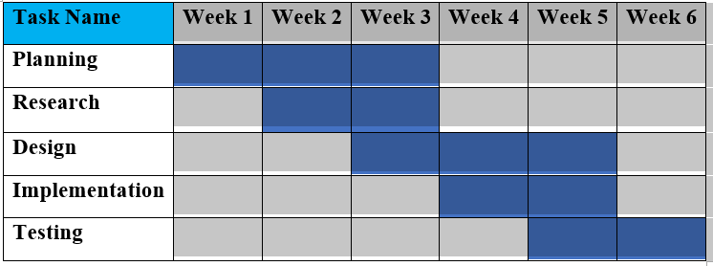

*Figure 5 gantt chart*

## Functional Decomposition diagram:

A functional decomposition diagram is a visual representation that breaks down a complex system or process into smaller, manageable functions or components. It is a hierarchical diagram that illustrates the relationships and dependencies between various functions or sub-functions within a system.

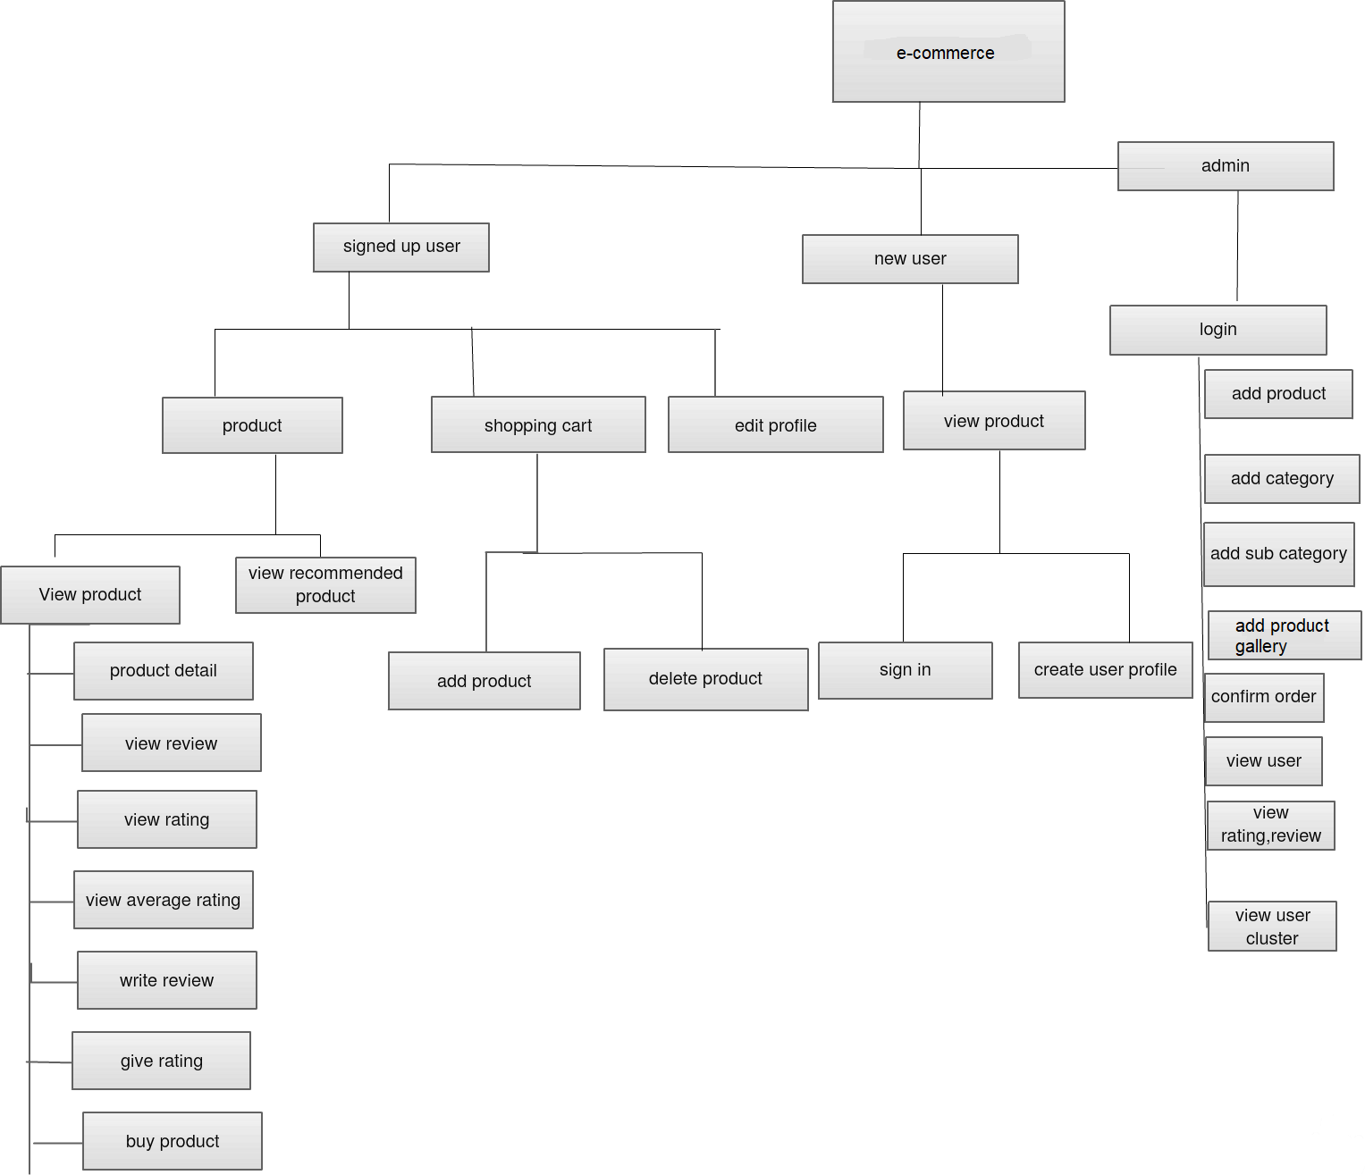

*Figure 6 functional decomposition diagram*

# CHAPTER 4: DESIGN AND ARCHITECTURE

## Introduction

Designing and architecting an e-commerce website is a complex endeavor that demands careful planning and attention to various crucial components. The user interface design is paramount, requiring responsiveness across devices, intuitive navigation, and effective search functionality to enhance product discovery. High-quality imagery and a user-friendly checkout process are essential for a seamless shopping experience. On the backend, scalability and performance optimization are critical, ensuring the website can handle increased traffic and data growth. Robust security measures, including SSL encryption and secure payment processing, are non-negotiable to protect user data. The product catalog should be efficiently managed, and support for product variations is necessary. Features like persistent shopping carts, multiple payment options, and user accounts contribute to customer convenience. Integrating reviews, ratings, and personalized recommendations fosters user trust and engagement. Incorporating SEO, marketing tools, and analytics enables better visibility and data-driven decision-making. A mobile app can complement the website, enhancing the mobile shopping experience. Providing customer support through live chat and a comprehensive help center is vital, while legal compliance and regular maintenance ensure a well-rounded e-commerce platform that can adapt to changing market needs.

## Usecase diagram

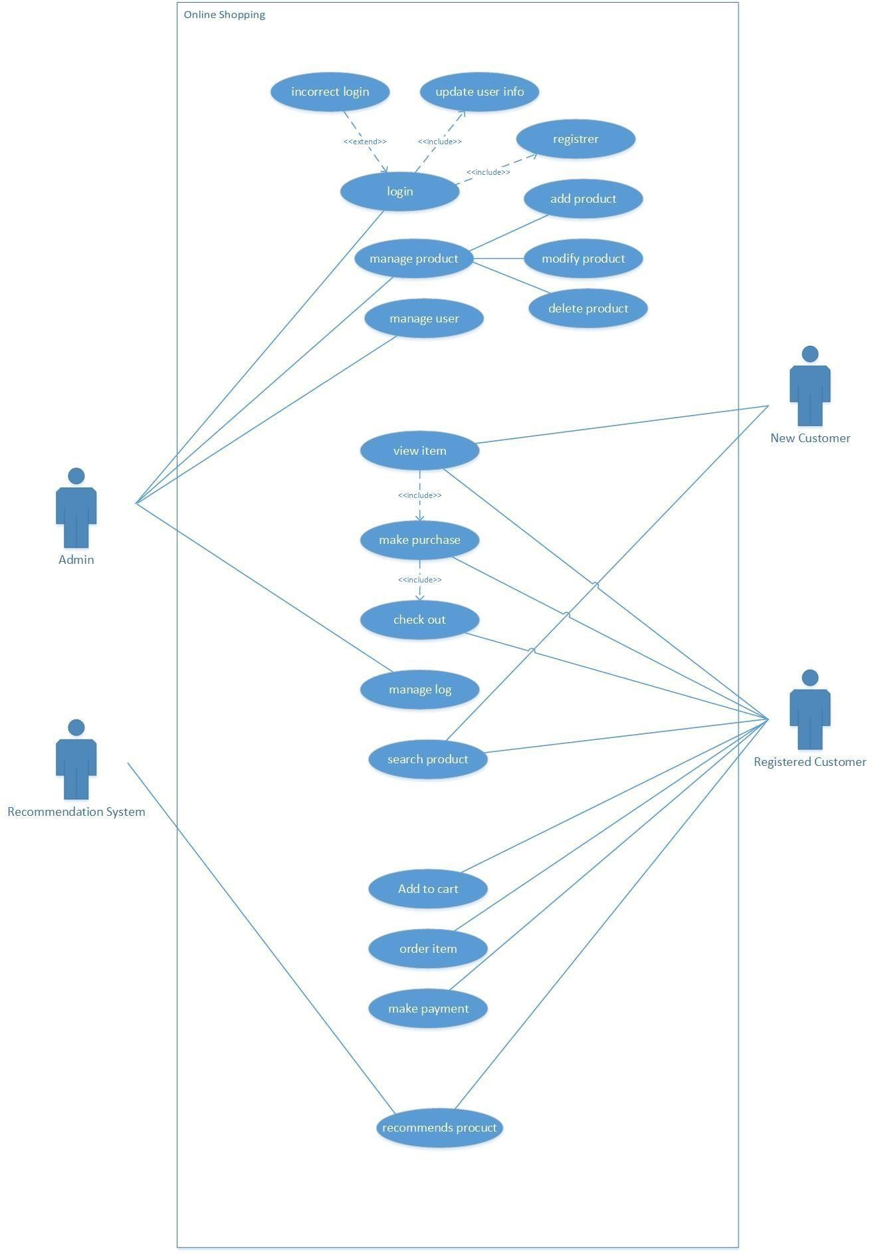

*Figure 7 usecase diagram*

## State Transition diagram:

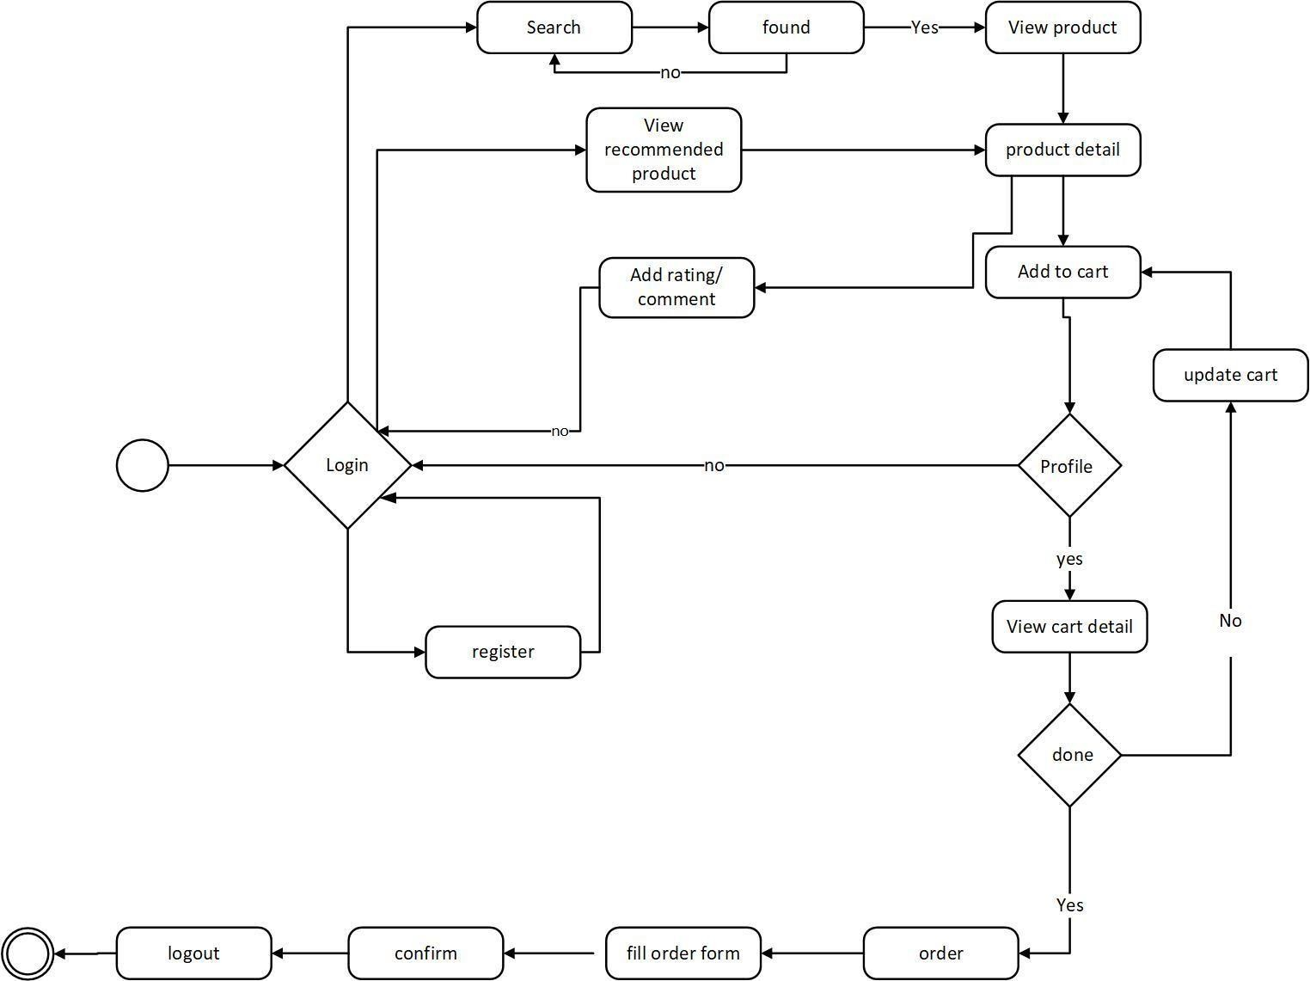

*Figure 8 state transition diagram*

## Activity diagram:

### Activity diagram for user:

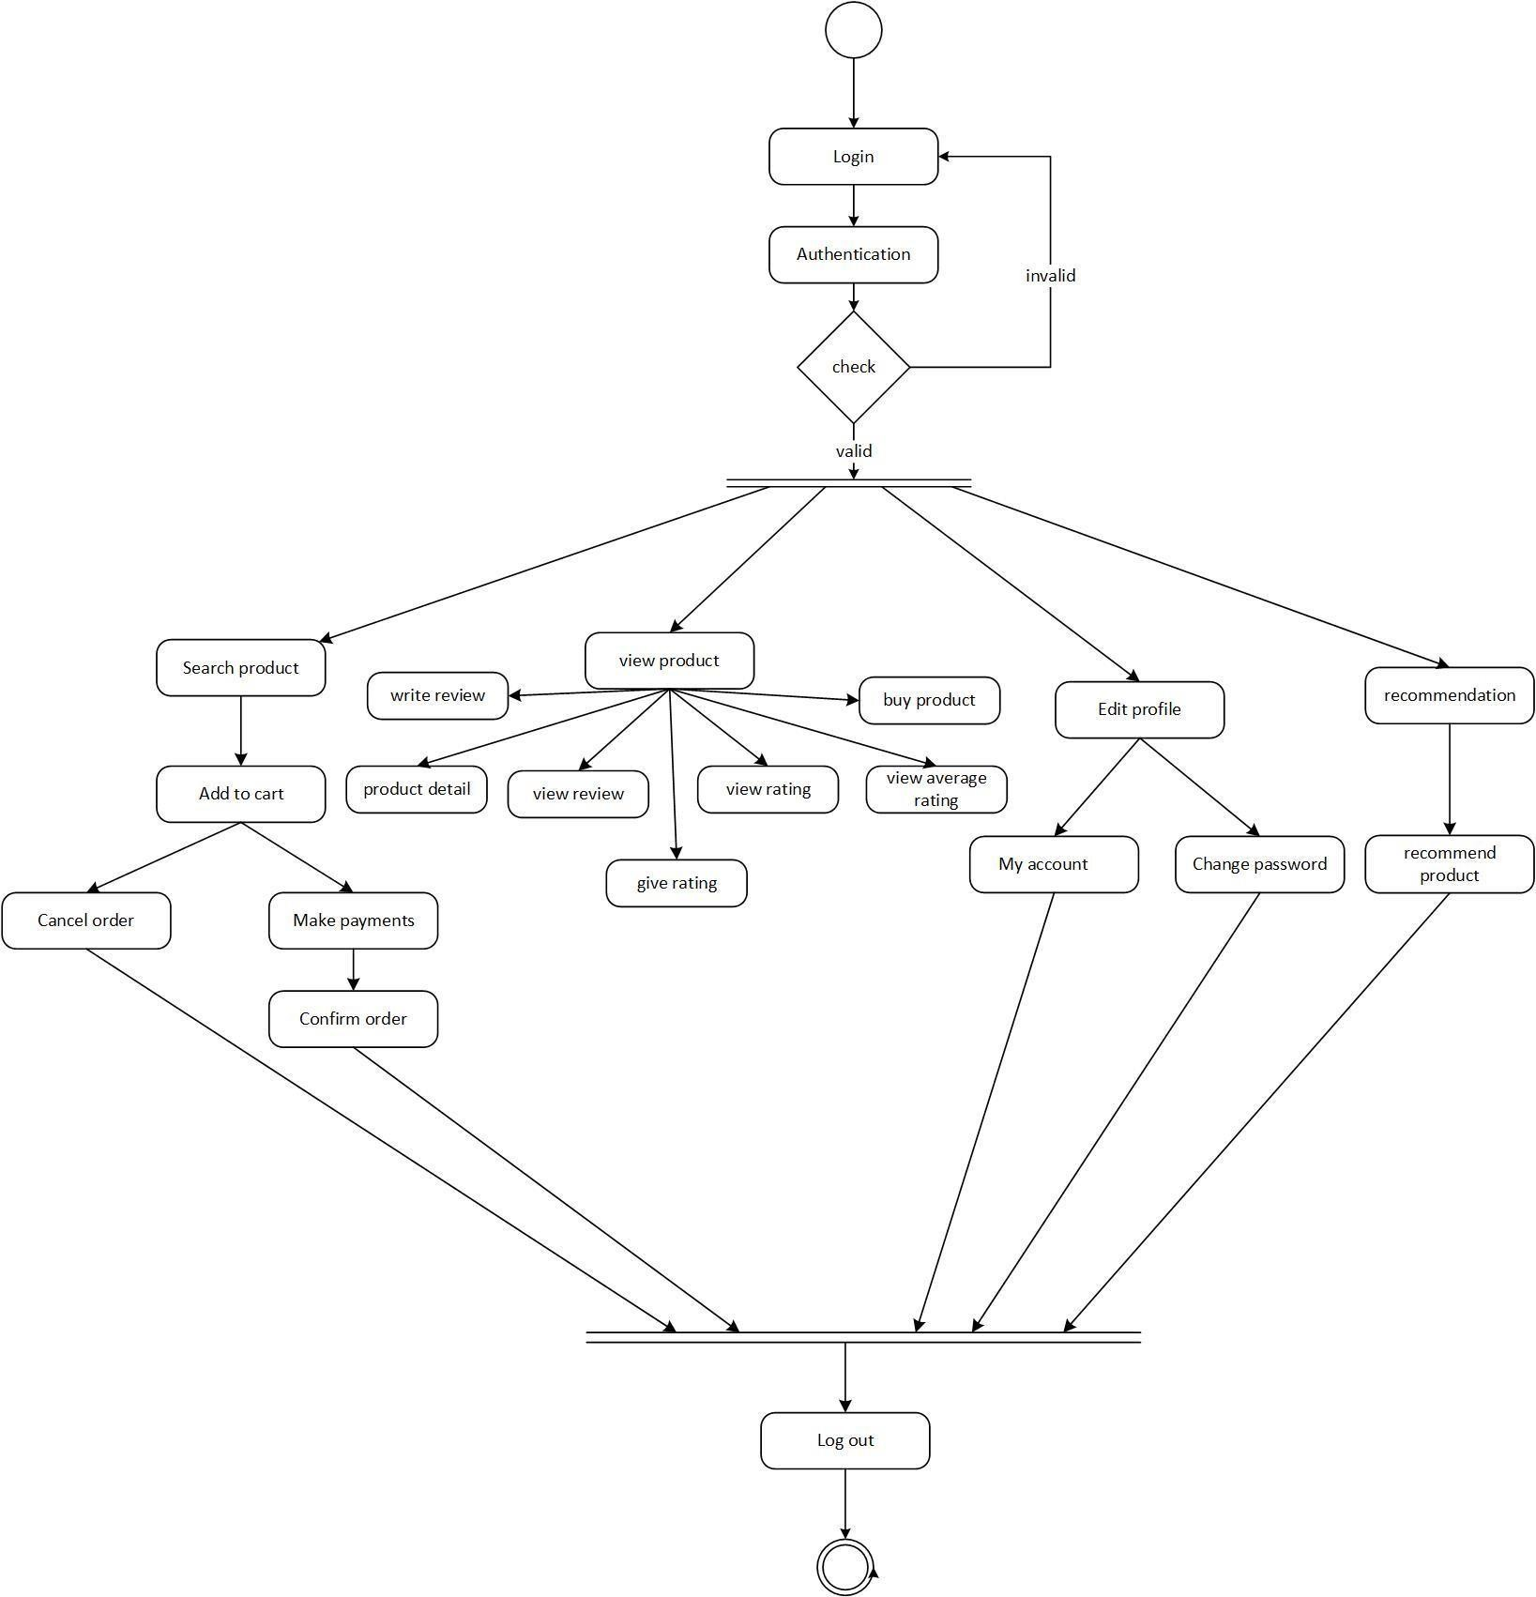

*Figure 9 activity diagram for user*

### Activity diagram for Admin

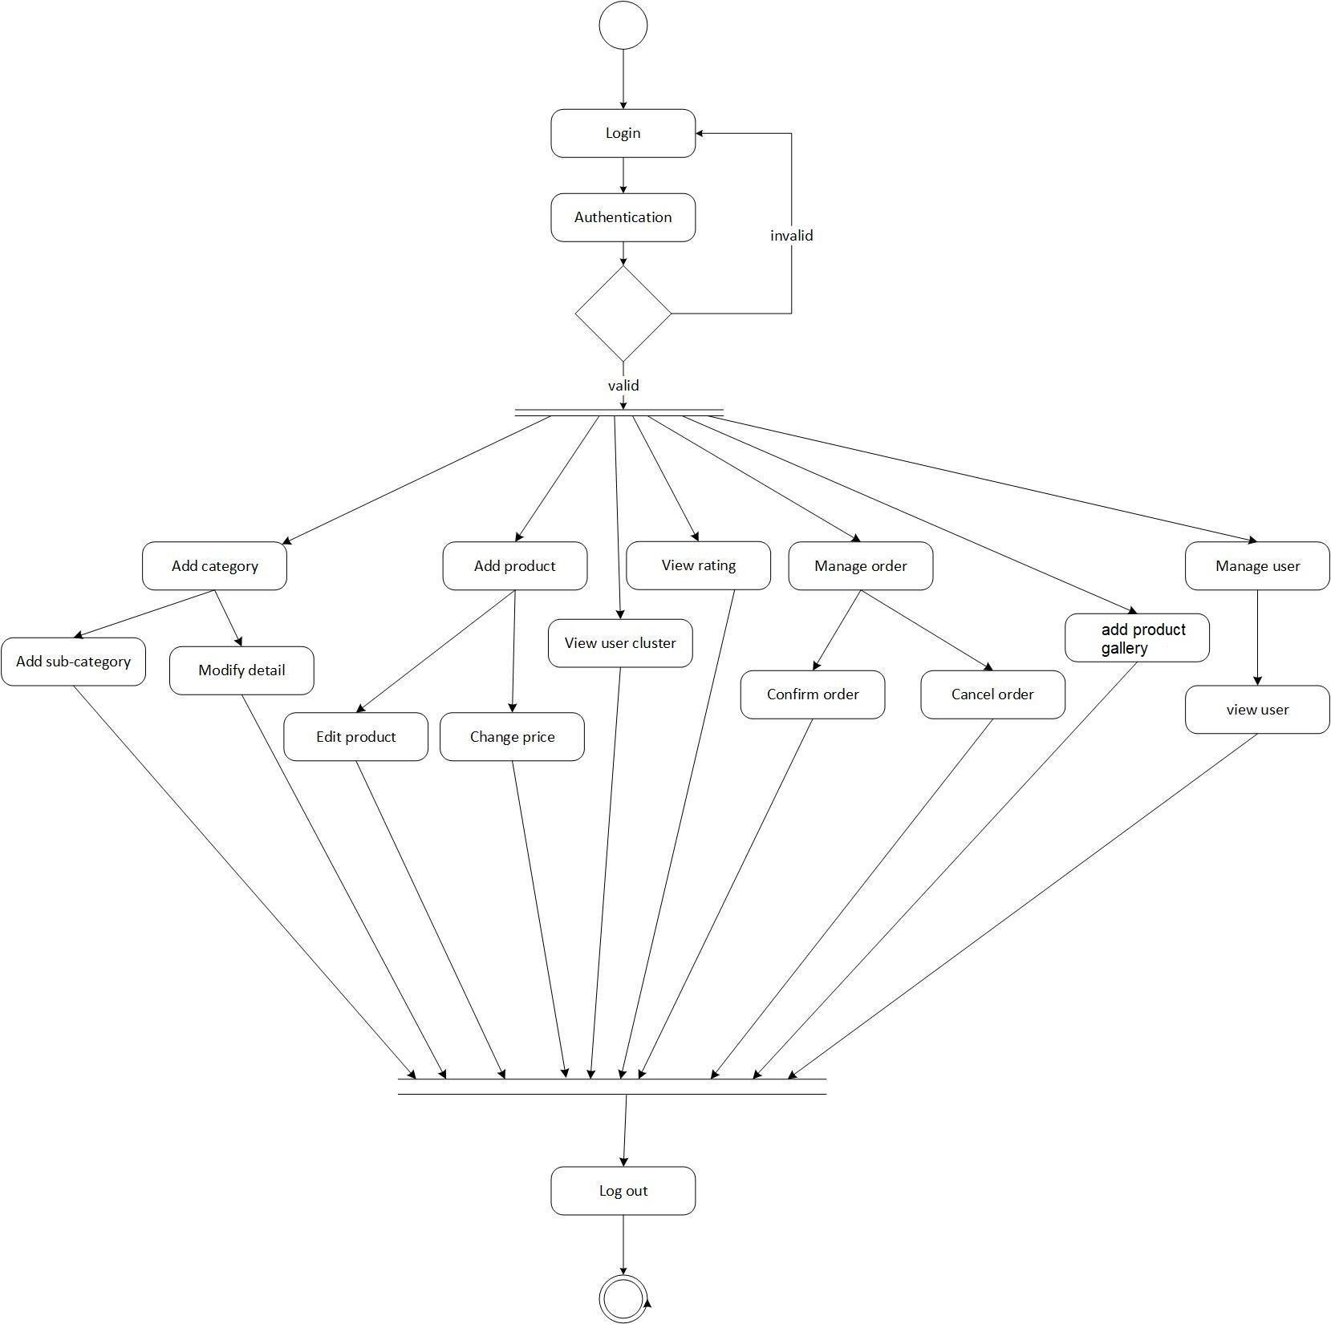

*Figure 10 activity diagram for admin*

## Entity relation diagram

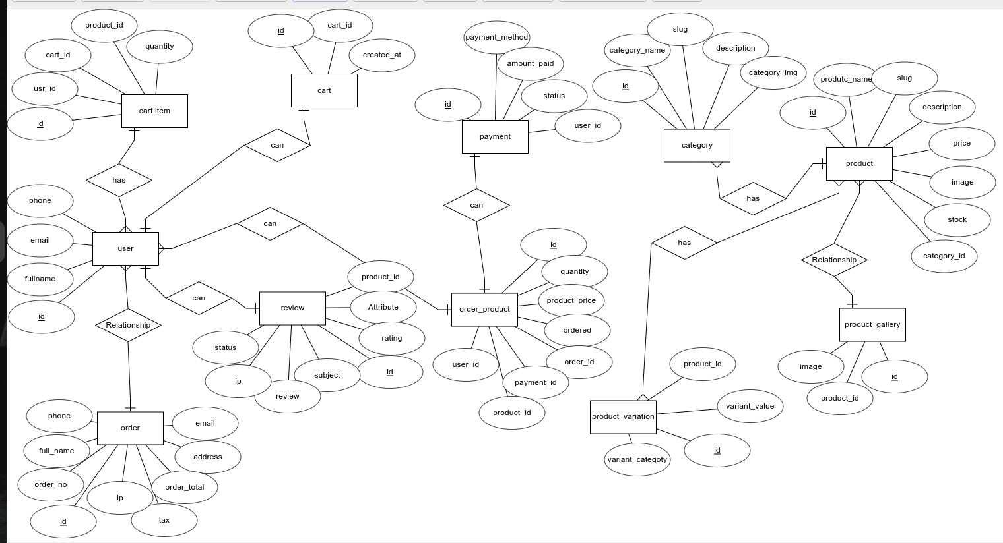

*Figure 11 E-R diagram*

## System architecture

### The MVT pattern

This site uses MVT (model, view, controller) pattern instead of traditional server-side code. As I am using Django as a framework, Django differentiate business logic from representation. This architecture splits an application into three strata/layer. They are: Model, View and Template. Model mostly deals with the database. To be more specific, models defines the table of database. Views are what we see in browser or what the user views when visited. View mostly deals with the client or end user of the system. Controller helps to control information flow. The controller is the center of the MVC architecture, as it helps to connect models with views. Thus, MVC architecture helps us to create and maintain complex application. Django uses MTV (model, template, view) architecture. Only the terminology used in Django are different.

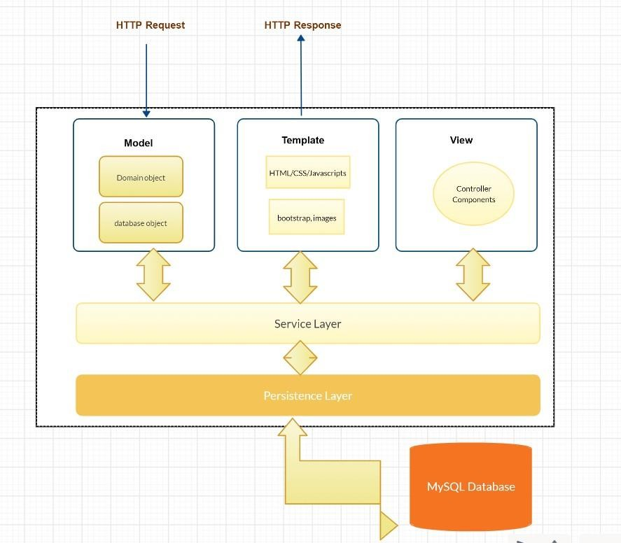

*Figure 12 MVT architecture*

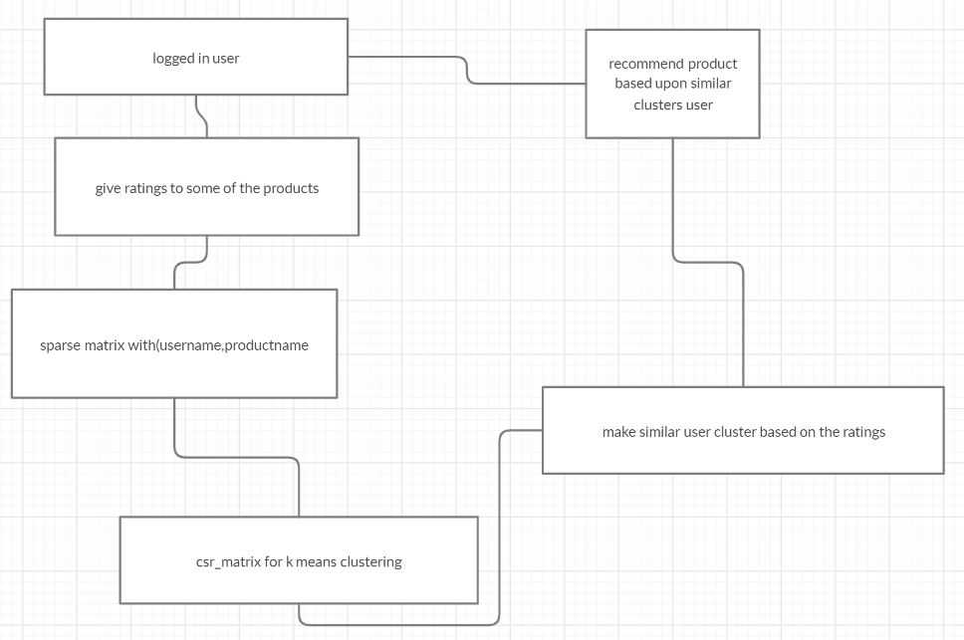

*Figure 13 recommendation system diagram*

# CHAPTER 5: IMPLEMENTATION AND EVALUATION

## Implementation

One of the key features of this system is to develop the recommendation for a given active user. The development component is then split into three major phases: firstly, the implementation of ecommerce system; secondly, the development of a recommendation system that can give reliable products independent of the size of the dataset and thirdly integrating the recommendation model to web app. First step is the downloading and installing all the necessary packages needed to develop the tool

## Technical specification:

Framework: Django 3.9

Library: bootstrap5, numpy, pandas Text editor: VS Code

Language: python 3.8.3

Database: MySQL 8.0 Browser: Google Chrome

Front end: Html, CSS, JavaScript

Documentation, diagram and presentation: Microsoft Office, PowerPoint

## Development:

After installing all above packages and library, it’s time to develop the ecommerce system. First front- end part is made just like the wireframe mentioned above with the help of html, css, javascript and bootstrap using VS Code as a text editor. After that front end is connected to backend database MySQL with the help of python and Django. The database is designed like the above-mentioned entity relation database. All of these are discussed in next chapter in detail. The only problem faced during the development of this system is generating recommendation as I have very less number of data and my database does not match with the dataset given by any dataset provider. After successfully developing ecommerce site.

The product has different features like product id, product description, rating, comments, category, etc. First the query set is done to the logged in active user for all the rating that the logged in user has provided. The data is fetched by using the Review class. Review class has review id, rating, user_id, comment. In similar fashion all the information of user. Only fetching the data from database and recommending the random products from the database is not the wise way and I never wanted to do that. First things needed to recommend the product is to find out preferences of the user. So, for this purpose the newly logged in fresh user is asked to rate some of the products of the system. The data gets updated once the user rate any new product. The similar user is calculated by the rating given the user u to product p assumed that the user in particular cluster have same preferences with each other as they have rated the products in similar manner. In similar fashion, other logged in user are also categorized in cluster. All the inactive users of the system are placed in one of the clusters. The users with no ratings in any of the products are also considered as inactive users, those users are encouraged to rate the product to get the recommendation. This system works perfectly in only three condition: product is not deleted in database, the product has been rated positive by the similar user which are stored in same clusters as in logged in user and lastly , the products that were never reviewed by the logged in user are shown to the user. The already rated product by user is never shown in recommended part of the system. After successfully making and updating the cluster based upon the user preferences. Similar user’s cluster data are fetched to the system to recommend the product.

To automate the task, instead of making cluster by only the admin, the cluster must be updated by the user’s activity in the system. Every time it would not be feasible to view and update the similar clusters from the admin side. Recommendation works with data and knowledge provided by the user to the system. I used clustering based recommendation because it is not always feasible to compare the logged in user with any other user in the system whenever recommendation is required. So, to increase the speed of the prediction, I use cluster of the similar user based upon the preferences, system tries to predict the rating for the system. The cluster must not be calculated immediately after a user rate new product, otherwise it would lead to scalability problem which was one of the reasons behind choosing clustering technique.

The system works as shown in figure above in system architecture. First of all, the sparse matrix is created using the rating provided by the user and their user information. I have made the matrix with row of username and column with product name. in simpler term, it can be said that the matrix R1, R2…. Rn is the username1, username2…username n and c1,c2.. cn is the productname1, productname2 to till n. For each element(r,c) contains username with their corresponding rating to the user. For each user, there will be rating for each product. In order to make the sparse matrix, I used to prebuild function dok_matrix of scipy library. I don’t want to make this system complex. I want to make the project simple, so made 1/10th of the user as cluster. This code must be changed if the system is used for the large number of user and rating. dok_matrix is converted to csr_matrix to calculate the k means clustering. Both dok_matrix and csr_matrix are class of scipy library which can be found on the documentation page of the scipy library.

The review, rating and user information can also be passed from csv dataset and read from csv files using panda’s library. Since I don’t want to make this system more complex. I have used in the real database instead prebuild dataset. The cluster is then updated in database.

There are some limitations of using this system which I have discussed in chapter 8. K- means is not most common model for recommending product. The only reason behind choosing this algorithm is simplicity and fast recommendation as it uses parallel and

scalable approach. It is best for the developer like me to understand and is very easy to maintain.

Another recommendation that I have made during this process is popularity based recommendation system which can be shown to the user if no recommendation are shown to the user. The popularity is calculated by using the sum of rating times the total number of rating. however, this popularity- based system can be improved.

I have also used tf-idf technique for recommending products that has similar word in the description box. The similar products are displayed so, it is a content-based filtering.

Before making all of this recommendation, I have calculated and used different approach and techniques of recommendation which can be seen in jupiter notebook. First, I tried to calculate the score similarity between users in the system. For simplicity, I used two users from the dataset and try to find out the similarity between those two users who have rated already.

After finding, similarity score, products are displayed to the similar user based upon the rating provided by the similar

I later made the algorithm based upon collaborative algorithm on amazon dataset on both user-user based and item- item based algorithm. To increase the accuracy, I removed all the ratings with 3 values from the dataset as three ratings does not directly determine either the user rated positive or negative.

## Testing for Recommendation system:

For this purpose, I have created three new users as admin, test and test1. I have rated at least four items and try to get the recommendation from the system. Since this recommendation system tries to find the similar user. The similar user must be clustered in database and admin must be able to view the clusters from admin panel. Each time when some user rate different items, the cluster must be updated. The cluster with zero rating and no rating at all must be placed in separate cluster.

To show the recommendation actually working I have rated some of the product from three different user’s admin, test and test1. First admin (user) has rated three books including one mouse and other chain. The test1 also rated three books but two of them are different from admin. Later test user rated exactly the three books including gaming pc. By viewing this pattern, we can also say that the preferences of both admin and test look similar. On other hand test 1 user has rated completely different products than admin and test. So, the similar user for the test is admin.

* + - Invalid credentials

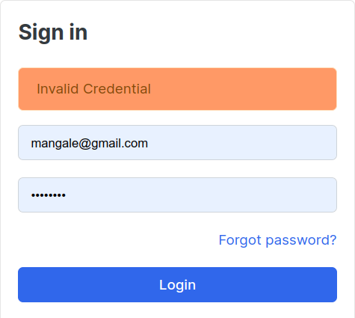

* + - If username matches with another user in database.

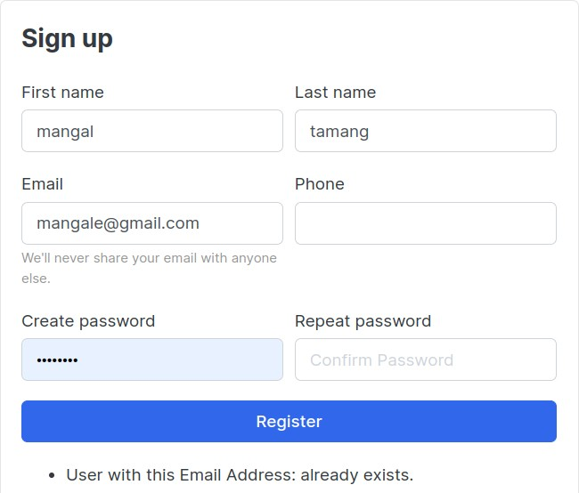

* + - New password and confirmation password do not match.

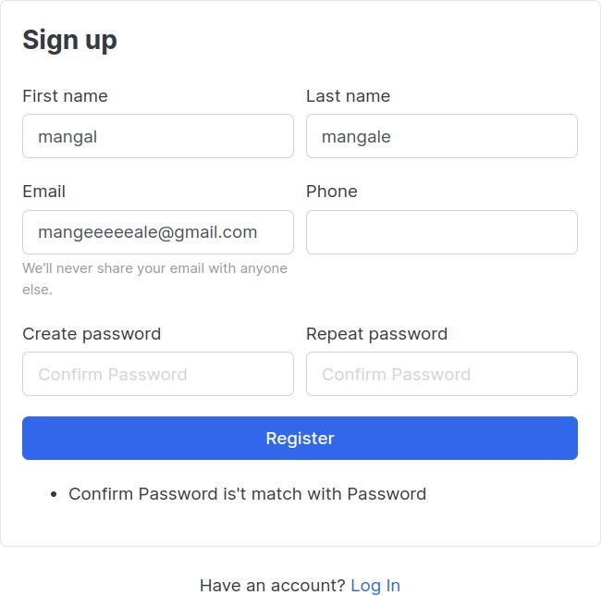

* + - Mobile friendly testing registration page

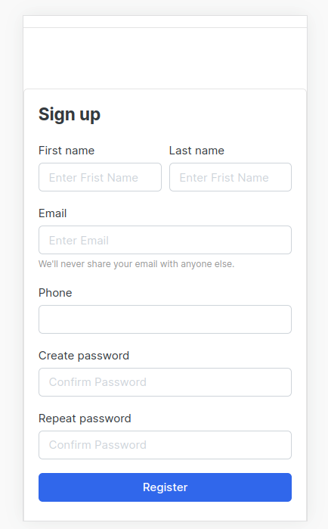

# CHAPTER 6 : CONCLUSION AND FUTURE WORK

## Conclusion

In this final semester, a full-fledged ecommerce system with different products from different categories and powerful recommendation system is integrated. We used user clustering technique which boost the performance of the system. The system can highly be improved.

Some of the work for future work is to extend the search features and use different filters to the system. Trending list can be generated based upon the popularity of the product in certain period of time in certain area. To increase the sell, flash sell and promo code for certain discount must be integrated. Password strength checker can also be integrated for better security. The option for language can be increased in future to sell more product to the native people of different community. There are many possibilities for the development of the system.

Just like other software, this software also has a lot of unseen bug. I will regularly fix and upgrade the software during maintenance and deployment of the system in real life.

## Critical evaluation:

Recommendation systems are the hot topic in online big tech. Constantly, recommendation systems are changing to user’s behavior in the system. The recommendation systems are of different types as described in literature review part. The distance between similar user can be calculated by using different approach as shown in Chapter 2. I tried some of the approach for calculating distance. I used latent factor model for recommendation purpose. The matrix is used with user’s and their particular rating in product in this system. Most of the ecommerce site uses rating as one of the main components to get the user’s preferences on particular topic. So, I did the same thing. I used the rating as the main component for determining or predicting the rating of the particular user. Apart of rating, other implicit features such as like, comment, purchase record, purchase feedback etc. can also be used to recommend products more accurately.

# SCREENSHOTs

A walkthrough of the application is illustrated in this chapter. Examples of features are presented for each user type: new user, returned user and administrators. Additional functionality and features that are common to all users can be found in Appendix.

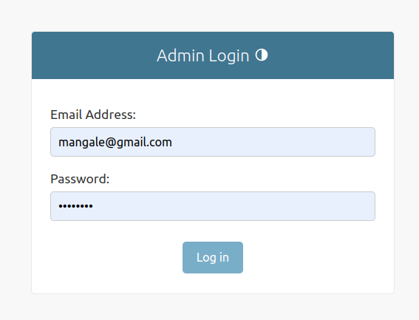

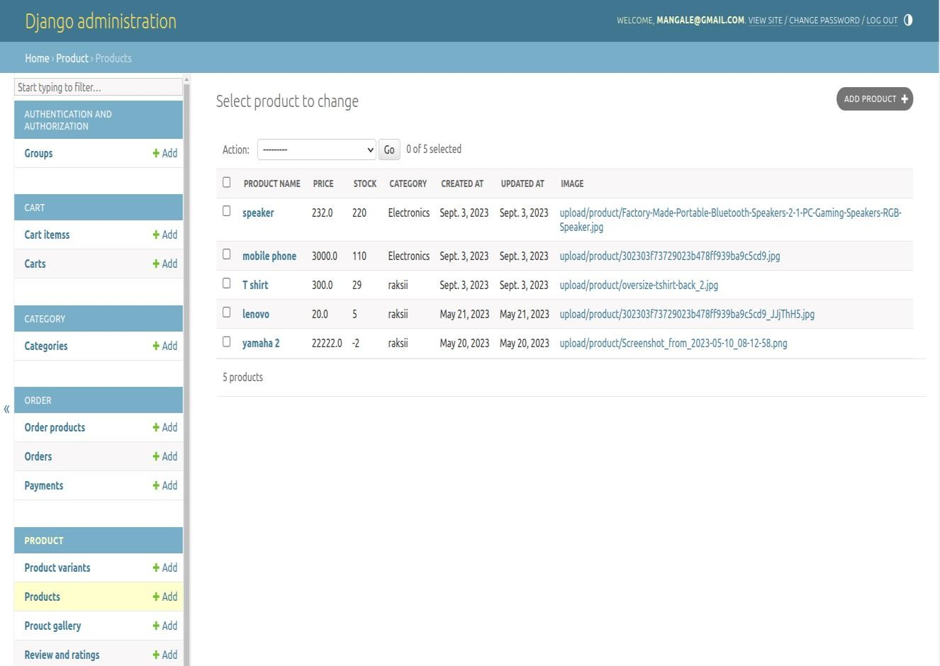

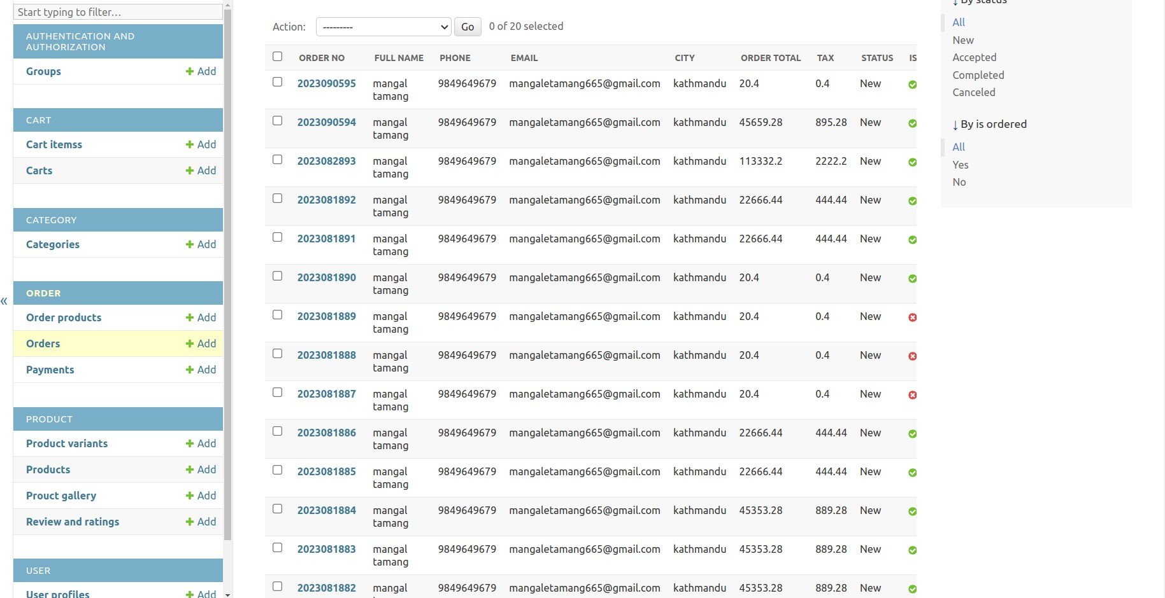

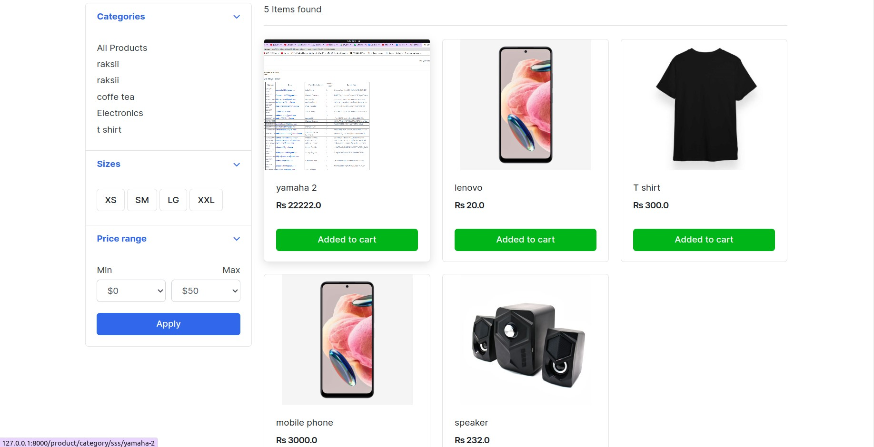

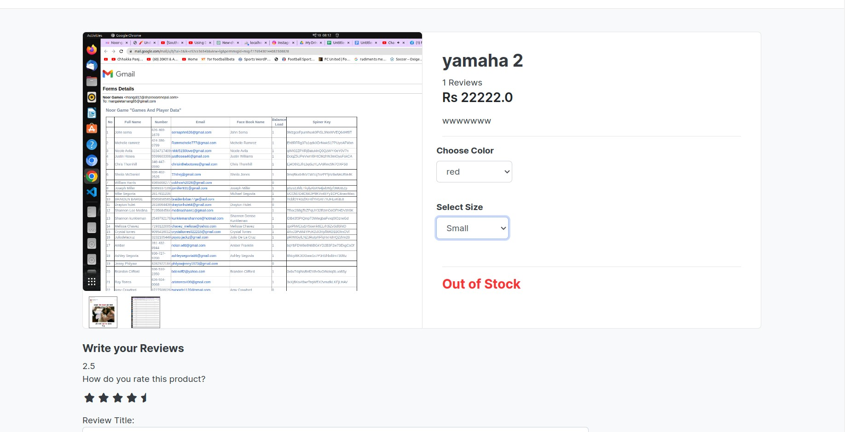

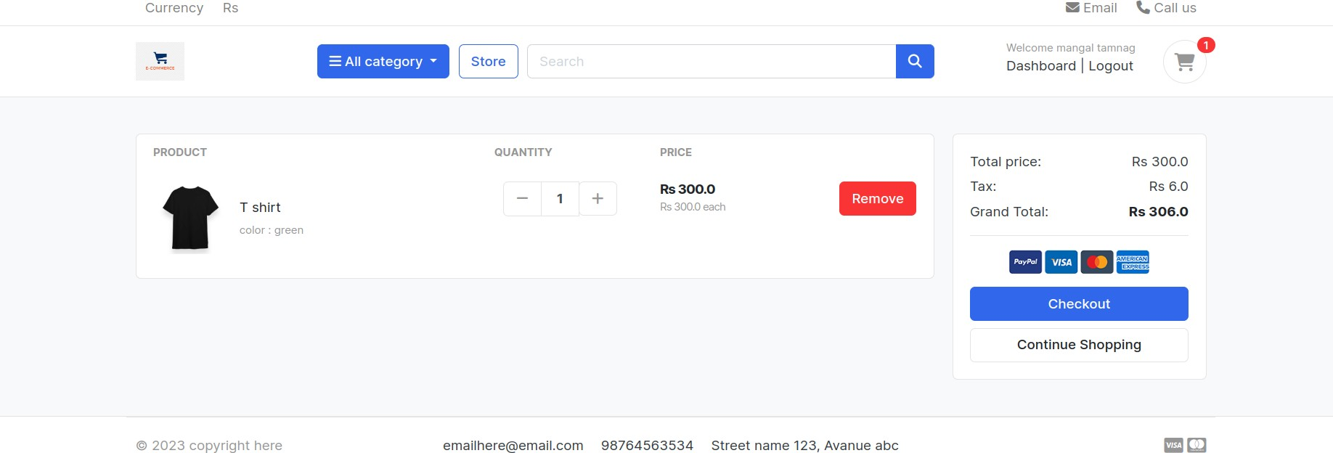

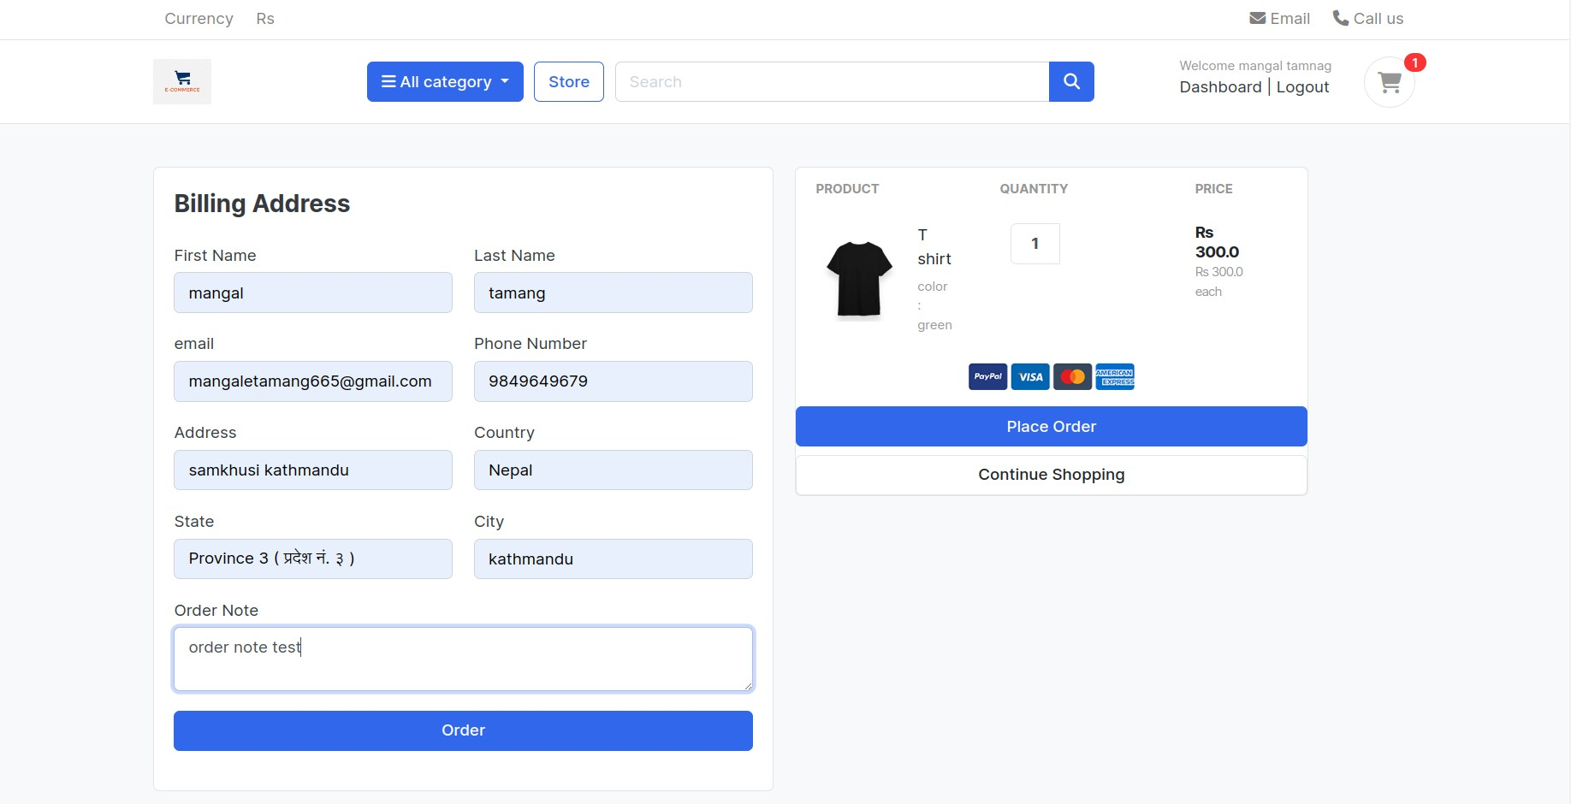

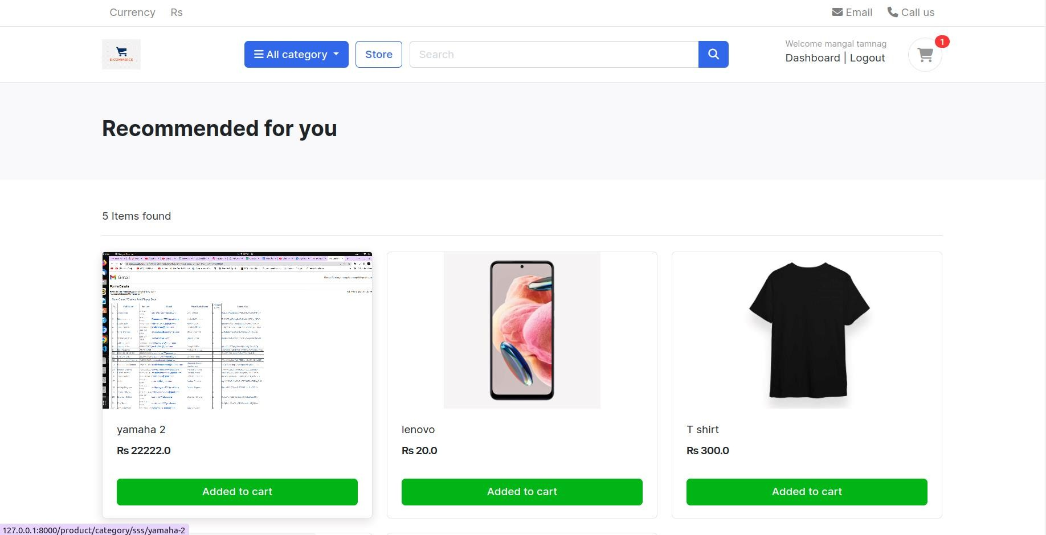

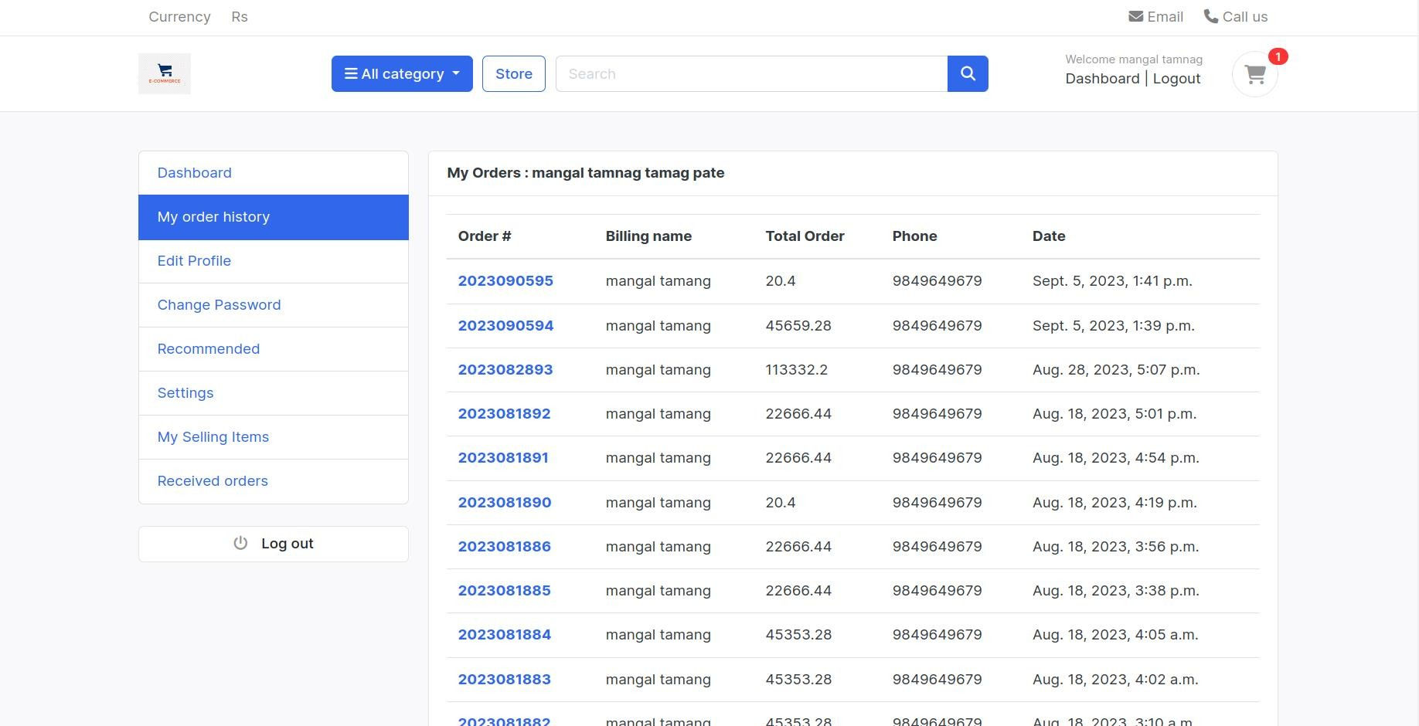

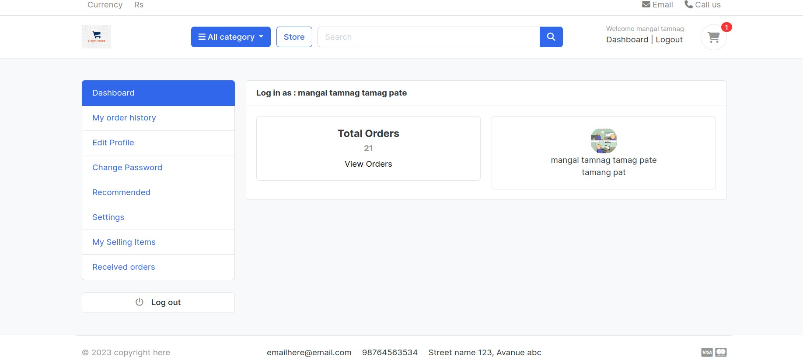

# References

Shao, H. et al., 2020. paper2repo: GitHub Repository Recommendation for Academic papers, Taipei,Taiwan: Amazon Web Services Deep Learning.

aggrawal, P., Tomar, V. & Kathuria, A., 2017. Comparing Content Based and Collaborative. International Journal of New Technology and Research (IJNTR), 3(4), pp. 65-67.

Anantha, L. & Bhattula, B. P., 2017. A REVIEW ON RECOMMENDATION SYSTEM USING RATING DATASET.

International Journal of Pure and Applied Mathematics, 116(5), pp. 133-135.

Beel, J., Breitinger, C. & Langer, S., 2017. Evaluating the CC-IDF citation-weighting scheme: How

effectively can ‘Inverse Document Frequency’ (IDF) be applied to references?, s.l.: iConference.

Chnag, S., Harper, F. M. & Terveen, L., n.d. Crowd-Based Personalized Natural Language Explanation for recommendation, Minnesota: The GroupLens Center for Social and Human- Centered Computing.

Desrosiers, C. & Karypis, G., 2017. A comprehensive survey of neighborhood-based, s.l.: s.n. Guru99, 2020. What is BIG DATA? Introduction, Types, Characteristics & Example. [Online] Available at: https://[www.guru99.com/what-is-big-data.html#2](http://www.guru99.com/what-is-big-data.html#2) [Accessed 07 May 2020].

HERLOCKER, J., KONSTAN, J., TERVEEN, L. & RIEDL, J., 2004. Evaluating Collaborative Filtering Recommender systems. ACM Transactions on Information System, 22(1), pp. 5-10.