**Introduction**

Extreme ultraviolet lithography (EUVL) is a leading technology utilizing incoherent EUV light for fabricating integrated circuits and devices with spatial resolution at a level of a few tens of nanometers. A detailed history of the development of EUVL technology starting from large-scale synchrotron radiation and leading up to lab-scale commercial EUVL systems utilizing EUV sources based on strong-field laser-matter interactions can be seen in the references  [1] [2]. The present state-of-the-art EUVL technology utilizes a 13.5 nm EUV light source. Such short wavelength radiation is rapidly absorbed by air and the glasses used to fabricate typical refraction-based optical components. Therefore, any system utilizing EUV light needs to be placed in a vacuum environment, and only reflective optics can be used to guide the EUV light from the source to the substrate for device fabrication. Laser-produced plasma (LPP)-based EUV sources are currently employed in commercial EUVL systems.

**LPP-based EUV sources**

The EUV light is generated in LPP-based sources when intense laser pulses (typically of nanosecond or picosecond time duration) are focussed on a suitable material to create a hot plasma emitting broadband light covering the EUV range. The EUV light generation by the plasma takes place by spontaneous emission due to the excitation and relaxation of various atomic and ionic species in the plasma.

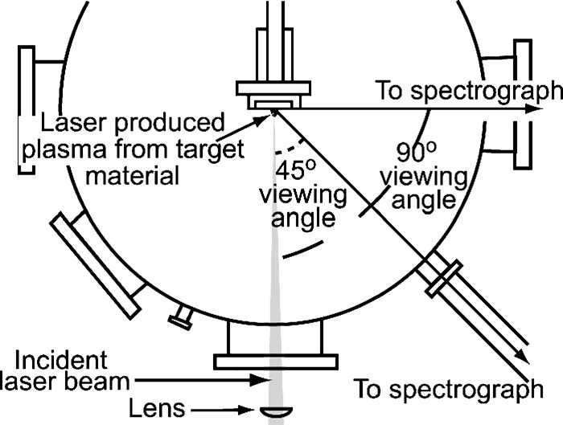

Fig. 1 Schematic of the chamber for generating EUV light using LPP from a solid target [3]

Over the past two decades, the EUVL technology has been developed using the EUV wavelength of 13.5 nm obtained from the LPP of tin  [3]. The majority of the reflection optics at 13.5 nm are based on Mo/Si-based multilayer mirrors [4]. The high demand in the industry has resulted in many advancements in the fabrication methods of Mo/Si mirrors for their mass production. However, the continuous irradiation of the solid tin target surface results in surface degradation that limits the operating time of the LPP-based EUV source due to the fast reduction in the EUV flux.

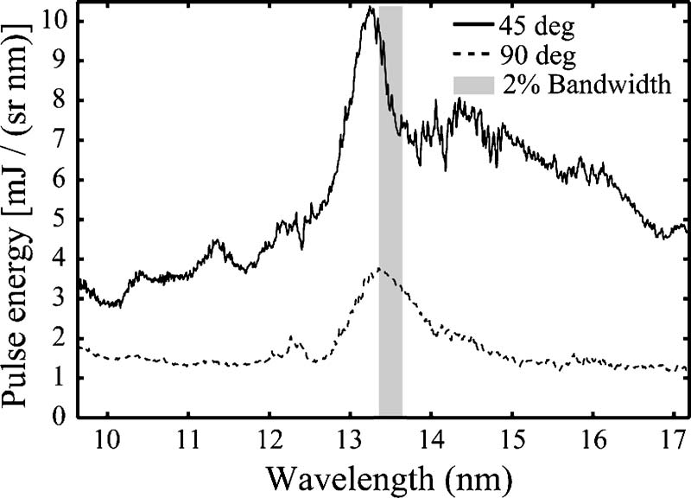

Fig. 2 Emission spectra of the LPP formed from a solid tin target [3]

Another issue with the LPP-based EUV sources is the production of large amounts of debris due to the laser irradiation of the material in the vacuum chamber. The debris deposited on the various optical and mechanical components of the EUVL system limits the operation time in a single run.

To solve the issue of EUV flux reduction due to surface degradation, liquid-jet tin targets are used for EUV production [5]. The continuous flow of the liquid provides a regenerative target with a fresh target surface for laser shots, hence solving the issue of surface degradation [5].

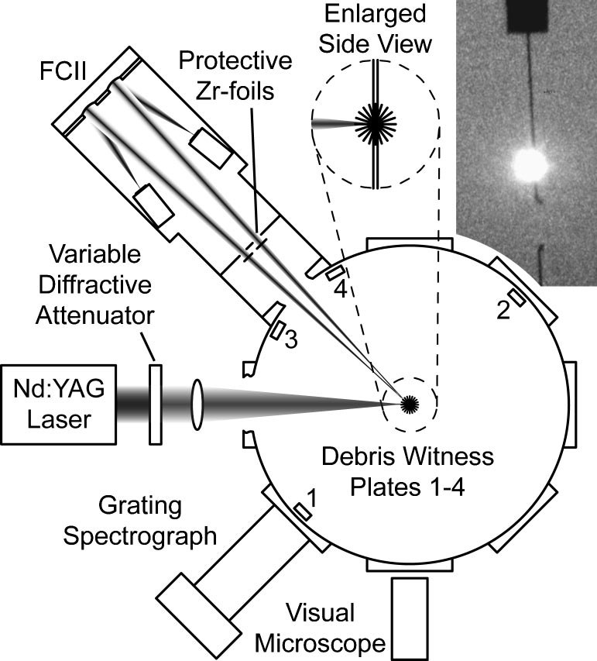

Fig. 3 Experimental arrangement of the liquid-jet LPP-based EUV source [5].

The liquid-jet EUV sources do not solve the problem of limited system run time due to the creation of debris. Some proposals have been made to shift the EUVL systems to a new debris-less Xe-based LPP source for the EUV light generation at 11.2 nm [6]. The proposal was made due to the developments in the Be-containing multilayer mirrors effectively reflecting in the 11-nm range [7]. The ~ 11 nm EUVL systems were expected to deliver the same EUV dose at the substrate by using Mo/Be multilayer mirrors. However, due to the well-established industry standards around tin-based LPP sources together with the protocols of high-volume Mo/Si-based multilayer mirror fabrication procedures, the present state-of-the-art EUVL systems are still operating at 13.5 nm wavelength.

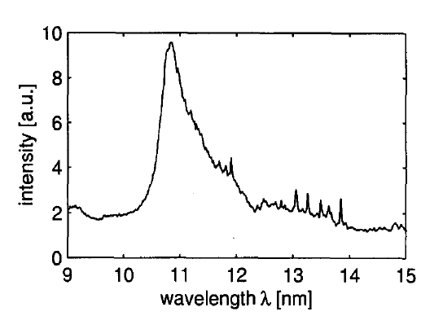

Fig. 4 Xe emission spectra with peak emission at 11.2 nm [6]

In an attempt to reduce debris production in EUVL systems, the idea of a *mass-limited target* was introduced. The bulk target produces large amounts of debris due to the propagation of a shock wave created by the intense laser pulse. Attempts are made to maximize the use of material that effectively participates in EUV production, for example, by using a thin tape target for the LPP [8].

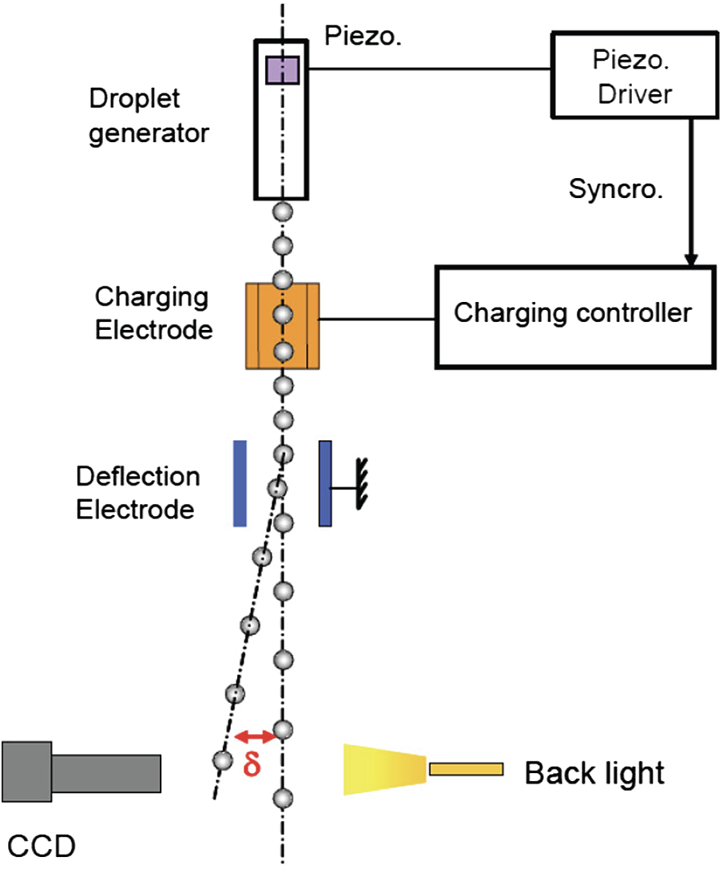

Fig. 5 Schematic diagram demonstrating the charge-and-deflect concept for reducing the frequency of droplets [9].

The best solution to realize a mass-limited target is to use a stream of droplets injected into the laser focus [9]. A stream of liquid decays into droplets due to capillary forces. The pressure modulations on the liquid container can be used to stabilize the frequency of droplet formation matching the laser pulse frequency. In addition, electrostatic deflection can be employed to reduce the liquid droplet frequency [9].

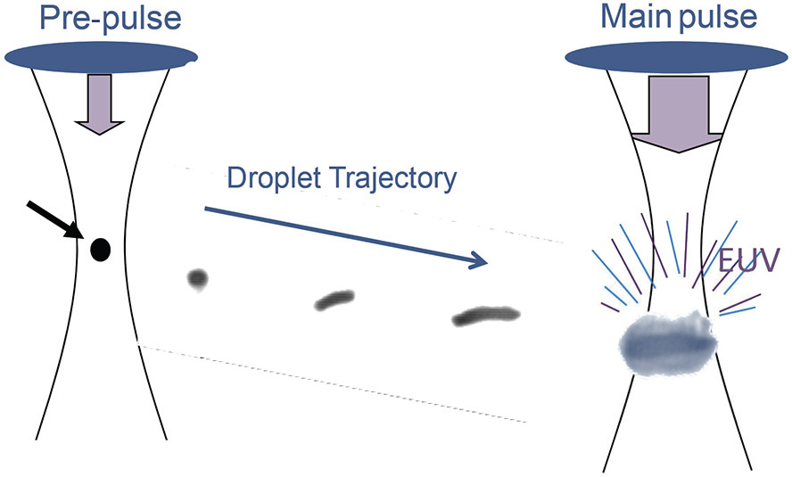

Fig. 6 Pre-pulse concept illustration showing the expansion of a droplet to match the main-pulse beam waist diameter with a lower density of the target material [10].

To further increase the effective surface of the droplet interacting with the laser pulse, pre-pulse technology was introduced. This technology is used in commercial EUVL systems [10]. In this system, an initial pre-pulse interacts with the droplet resulting in their expansion. This expansion creates a target that has a lower density than the liquid and hence produces a plasma without a steep density gradient upon interaction with the main pulse. The use of pre-pulse results in reduced debris and a higher EUV conversion efficiency.

**References**

1. B. Wu and A. Kumar, "Extreme ultraviolet lithography: A review," Journal of Vacuum Science & Technology B **25**, 1743 (2007).

2. Vivek Bakshi, *EUV Lithography* SPIE Press, Vol. 178 (2009)

3. P. Hayden, A. Cummings, N. Murphy, G. O’Sullivan, P. Sheridan, J. White, and P. Dunne, "13.5nm extreme ultraviolet emission from tin based laser produced plasma sources," J Appl Phys **99**, 093302 (2006).

4. R. H. Stulen and D. W. Sweeney, "Extreme ultraviolet lithography," IEEE J Quantum Electron **35**, 694–699 (1999).

5. P. A. C. Jansson, B. A. M. Hansson, O. Hemberg, M. Otendal, A. Holmberg, J. de Groot, and H. M. Hertz, "Liquid-tin-jet laser-plasma extreme ultraviolet generation," Appl Phys Lett **84**, 2256 (2004).

6. B. A. M. Hansson, L. Rymell, M. Berglund, and H. M. Hertz, "A liquid-xenon-jet laser-plasma x-ray and EUV source," Microelectron Eng **53**, 667–670 (2000).

7. D. E. Pariev, V. N. Polkovnikov, M. G. Sertsu, A. N. Nechay, M. v. Svechnikov, D. A. Tatarsky, F. Schäfers, A. Sokolov, S. A. Gusev, N. I. Chkhalo, and N. N. Salashchenko, "High-reflection Mo/Be/Si multilayers for EUV lithography," Optics Letters, **42**, 5070-5073 (2017).

8. I. E. et al. Turcu, "High-power x-ray point source for next-generation lithography," EUV, X-Ray, and Neutron Optics and Sources, SPIE **3767**, 21–32 (1999).

9. T. Y. H. S. T. A. G. S. A. E. A. S. Masaki Nakano, "Sn droplet target development for laser produced plasma EUV light source," Emerging Lithographic Technologies XII, SPIE **6921**, (2008).

10. I. Fomenkov, D. Brandt, A. Ershov, A. Schafgans, Y. Tao, G. Vaschenko, S. Rokitski, M. Kats, M. Vargas, M. Purvis, R. Rafac, B. la Fontaine, S. de Dea, A. LaForge, J. Stewart, S. Chang, M. Graham, D. Riggs, T. Taylor, M. Abraham, and D. Brown, "Light sources for high-volume manufacturing EUV lithography: Technology, performance, and power scaling," Advanced Optical Technologies **6**, 173–186 (2017).