COURSE CODE/TITLE: | CPE-007 |  | SECTION: | CPE11S4
DATE PERFORMED: | 9/4/2026 |  | DATE SUBMITTED: | 9/4/2026
NAME: | Mangana, Prince Adrian M. |  | INSTRUCTOR: | Robin Valenzuela

Seatwork No. 4.2 | Working with Characters and Strings!
. Write a C++ program named message_analyzer.cpp that does the following:
- Declare a character array that can hold a message of up to 50 characters.
- Prompt the user: Enter a message (max 50 characters):
- Read the entire line, including spaces.
- Compute the length of the message without using strlen().
- Walk the array one index at a time and stop when you reach the null terminator.
- Traverse the message once and count how many characters fall into each of these categories:
  - Uppercase letters
  - Lowercase letters
  - Digits
  - Spaces
  - Special Characters
- Count how many words the message contains.
- Build a second character array holding the message in all uppercase.
- Build a third character array holding the message in all lowercase.
- Use toupper() and tolower().
- The original message must remain unchanged.
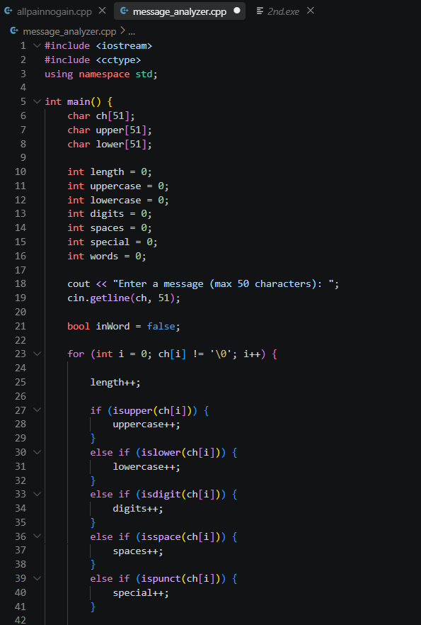
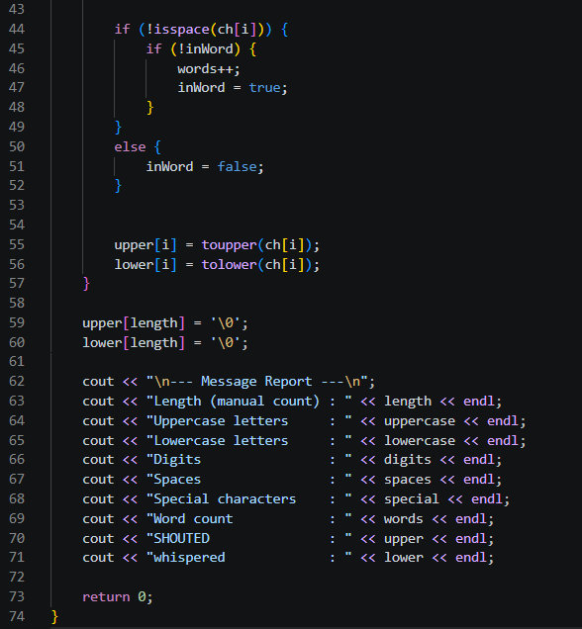
OUTPUT
