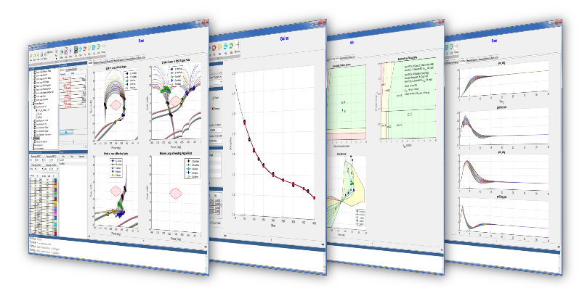

DRAFT

**CONFIDENTIAL**

**USER’S GUIDE** | **VERSION 2.0**

**FLIGHT *Control***

THIS DOCUMENT CONTAINS PROPRIETARY AND CONFIDENTIAL INFORMATION OF AEROSPACE CONTROL DYNAMICS, LLC. AND SHALL NOT BE USED, DISCLOSED OR REPRODUCED, IN WHOLE OR IN PART, FOR ANY PURPOSE WITHOUT THE PRIOR WRITTEN CONSENT OF AEROSPACE CONTROL DYNAMICS LLC.

**Table of Contents**

1 Installation 2

1.1 Sub Section Title 2

2 Project Setup 3

2.1 Stability Analysis Editor 4

2.2 Frequency Response Analysis Editor 7

2.3 Simulation Analysis Editor 8

2.4 Handling Qualities Editor 10

2.5 Aeroservoelastic Analysis Editor 10

2.6 Root Locus Analysis Editor 10

# 1 Installation

## 1.1 Sub Section Title

# 2 Project Setup

This chapter describes how to setup a project to build your own design problems. The project window will pop up after launching the FLIGHT Control program.

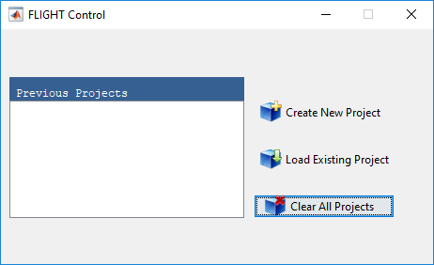

Figure 1: Project Window

The list box on the left-hand-side shows all the previous projects which were loaded into the FLIGHT Control software. The user has three options:

1. **Create New Project**: By selecting this option the file browser will pop up and the user can navigate to and specify the new project file name.
2. **Load Existing Project**: By selecting this option the file browser will pop up and the user can navigate to and select the project file.
3. **Clear All Projects**: By selecting this option the previous projects list, if any, will be cleared from the list box on the left-hand-side. Note, the actual project files will not be deleted.

## 2.1 Stability Analysis Editor

The Stability Analysis Editor allows the user to build objects related to stability analysis which can be imported into the project. Typical stability analysis objects are, but not limited to, eigenvalues plots, Nichols plots, Nyquist plots, etc. The user has the capability to build any type of stability analysis plot and this will be grouped under Stability Analysis node in the project tree, see Figure 2.

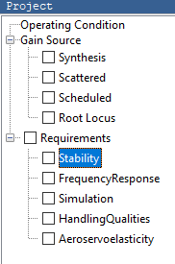

Figure 2: Stability Analysis Project Tree Node

The user can launch the Stability Analysis Editor by clicking on the STAB icon in the ribbon, see Figure 3 below.

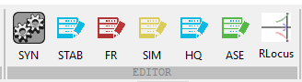

Figure 3: Stability Analysis Editor Launch Button

After launching the Stability Analysis Editor, the following fields are required to build a Stability Analysis Object:

* **Method:** This is the method which is a function m-script which contains the algorithm the user wants to execute.
* **Model Name:** This is the Simulink model which the method has access to and will be given as an input argument to the function.
* **Title:** The title which will be displayed on top of the plot.
* **Output Data Index**: If a method computes data for multiple plots than the user can specify the index for *X* and *Y* to be used for the plots. More information on this can be found in the **Method** Section.
* **Requirement Plot**:This is a background plot which is plotted once. This could be empty or if the user wants to plot specific boundaries than this field can be used to display the requirements boundaries. For example, the user could display the stability margins boundaries for the Nichols plot. Once the user has specified the requirements plot than the background plot will be displayed on the Stability Analysis Editor.

Once all the fields have been specified the user can **Export** the Stability Analysis object and save it. The user can then import the Stability Analysis object into the project. An example of the Stability Analysis Editor settings is shown in Figure 6.

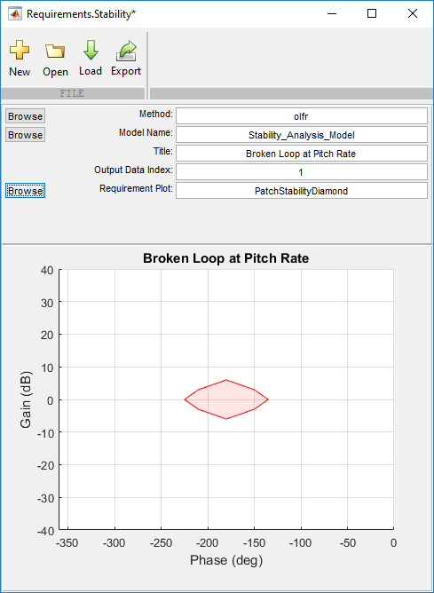

Figure 4: Example of Stability Analysis Editor Settings

## 2.2 Frequency Response Analysis Editor

The Frequency Response Analysis Editor allows the user to build objects related to frequency response analysis which can be imported into the project. Typical frequency response analysis objects are, but not limited to, command response frequency response, disturbance rejection frequency response, etc. The user has the capability to build any type of frequency response analysis plot and this will be grouped under Frequency Response node in the project tree, see Figure 5.

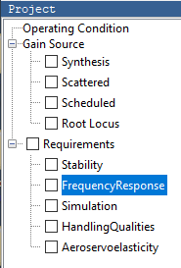

Figure 5: Frequency Response Analysis Project Tree Node

The user can launch the Frequency Response Analysis Editor by clicking on the FR icon in the ribbon, see Figure 6 below.



Figure 6: Frequency Response Analysis Editor Launch Button

After launching the Frequency Response Analysis Editor, the following fields are required to build a Frequency Response Analysis Object.

* **Method:** This is the method which is a function m-script which contains the algorithm the user wants to execute. More details on the **Method** setup can be found in the **Method** Section.
* **Model Name:** This is the Simulink model which the method has access to and will be given as an input argument to the function.
* **Title:** The title which will be displayed on top of the plot.
* **Output Data Index**: If a method computes data for multiple plots than the user can specify the index for *X* and *Y* to be used for the plots. More information on this can be found in the **Method** Section.
* **Requirement Plot**:This is a background plot which is plotted once. This could be empty or if the user wants to plot specific boundaries than this field can be used to display the requirements boundaries.

Once all the fields have been specified the user can Export the **Frequency Response** Analysis object and save it. The user can then import the **Frequency Response** **A**nalysis object into the project.

## 2.3 Simulation Analysis Editor

The Simulation Analysis Editor allows the user to build Simulation objects related to time history analysis which can be imported into the project. This will be grouped under the Simulation node in the project tree, see Figure 7.

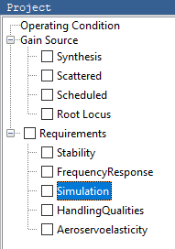

Figure 7: Simulation Analysis Project Tree Node

The user can launch the Stability Analysis Editor by clicking on the SIM icon in the ribbon, see Figure 8.



Figure 8: Simulation Analysis Editor Launch Button

After launching the Simulation Analysis Editor, the following fields are required to build a Simulation Analysis Object.

* **Method:** This is the method which is a function m-script which contains the input port specification and simulation specific parameters. More details can be found in the Simulation Method Section.
* **Model Name:** This is the Simulink model which the method has access to and will be given as an input argument to the function.
* **Title:** The simulation title which will be displayed on the left-hand-side of the grouped plots.
* **Post-Simulation Method:** This is a method which is a function m-script in which the time history data can be processed by a user defined algorithm. For example, the user could run a turbulence time history and compute the RMS using the Post-Simulation Method function.

Once the **Model Name** is specified all the input ports, output ports, and Signal Logs will be displayed in the tree, see Figure 9.

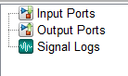

Figure 9: All Signals Identified In The User Specified Model

The user can select the signals of interest to be plotted by using the arrow/remove buttons. All selected signals will show up in the in the list box on the right-hand-side of the Simulation Analysis Editor. The order of the signals in the list box will be the order of the plots for each signal.

Once all the fields have been specified and all signals of interest have been chose, the user can Export the **Simulation Analysis** object and save it. The user can then import the **Simulation Analysis** object into the project.

## 2.4 Handling Qualities Editor

## 2.5 Aeroservoelastic Analysis Editor

## 2.6 Root Locus Analysis Editor