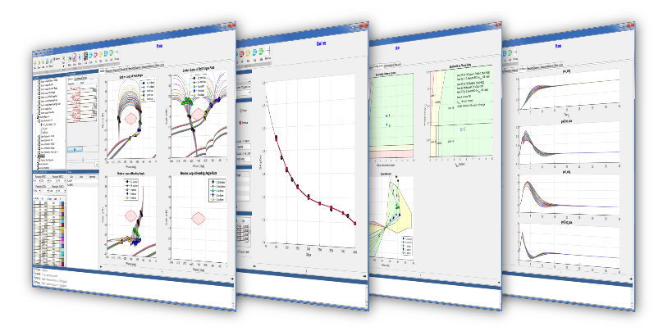

DRAFT

**CONFIDENTIAL**

**USER’S GUIDE** | **VERSION 2.0**

**FLIGHT *Dynamics***

THIS DOCUMENT CONTAINS PROPRIETARY AND CONFIDENTIAL INFORMATION OF AEROSPACE CONTROL DYNAMICS, LLC. AND SHALL NOT BE USED, DISCLOSED OR REPRODUCED, IN WHOLE OR IN PART, FOR ANY PURPOSE WITHOUT THE PRIOR WRITTEN CONSENT OF AEROSPACE CONTROL DYNAMICS LLC.

**Table of Contents**

1 Installation 3

1.1 Sub Section Title 3

2 Project Setup 4

2.1 Analysis Task Editor 5

2.2 Trim Definition Editor 6

2.3 Linear Model Editor 7

2.4 Requirement Editor 8

2.5 Simulation Editor 9

Running the Flight Dynamics Tool 9

Project Tree 10

Basic Trim Settings (Recommended for ease of use) 10

Advance Trim Settings 12

The Run Button 14

Results 14

Table 15

Plots 16

Simulation 17

Post-Simulation 18

# 1 Installation

## 1.1 Sub Section Title

# 2 Project Setup

This chapter describes how to setup a project to build your own design problems. The project window will pop up after launching the FLIGHT Control program.

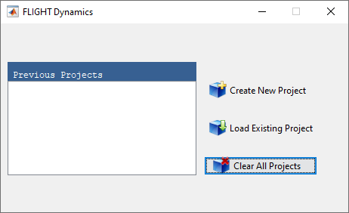

Figure : Project Window

The list box on the left-hand-side shows all the previous projects which were loaded into the FLIGHT Dynamics software. The user has three options:

1. **Create New Project**: By selecting this option the file browser will pop up and the user can navigate to and specify the new project file name.
2. **Load Existing Project**: By selecting this option the file browser will pop up and the user can navigate to and select the project file.
3. **Clear All Projects**: By selecting this option the previous projects list, if any, will be cleared from the list box on the left-hand-side. Note, the actual project files will not be deleted.

## 2.1 Analysis Task Editor

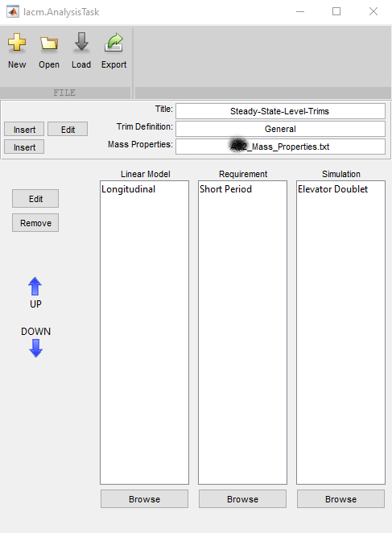

Adding an Analysis Task

Right click analysis task

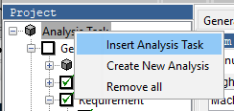

And select “Insert Analysis Task”

select the new analysis task by highlighting it

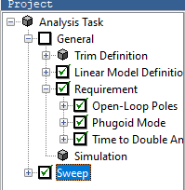

then select the new sweep tab if its not already selected



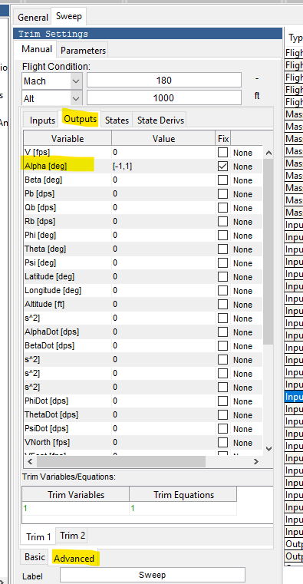

## 2.2 Trim Definition Editor

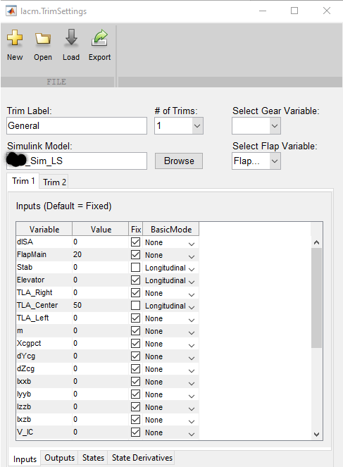

## 2.3 Linear Model Editor

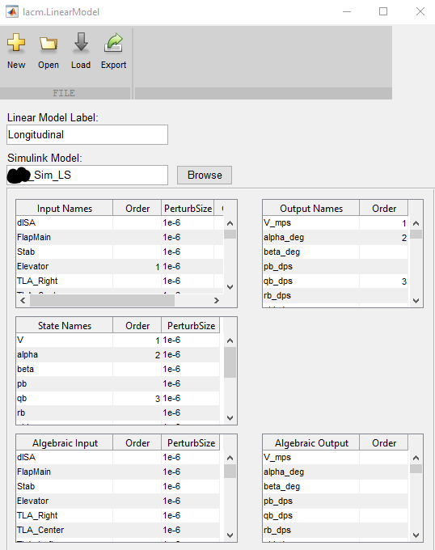

## 2.4 Requirement Editor

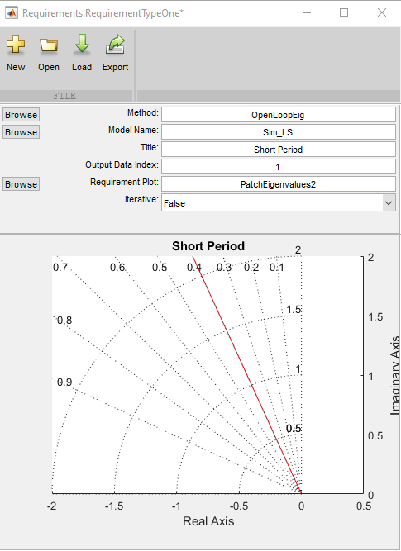

## 2.5 Simulation Editor

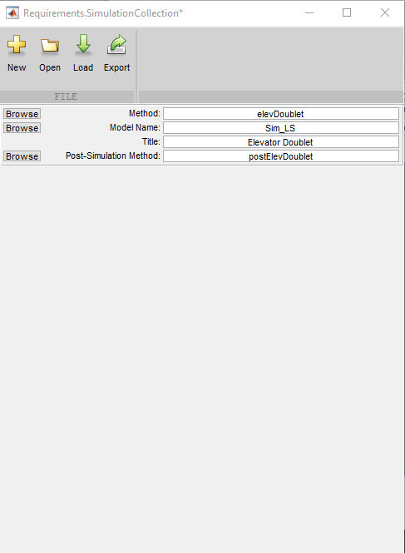

## 2.6 Editor Menus

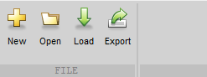

The editor menu has 4 buttons.

1. New – Creates a new instance of the current object in the editor (Trim, LinearModel, Requierment, etc.).
2. Open – Opens a saved instance of an object.
3. Load – Loads any changes into the tools workspace or current analysis task. A green arrow means there are unsaved changes.
4. Export – Exports the current object into a .mat file.

# Running the Flight Dynamics Tool

## Project Tree

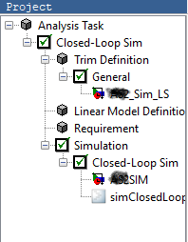

Select the analysis task that you want to run. In this example “Closed-Loop Sim” analysis task is selected. If you included a Simulation select/deselect it.

## Basic Trim Settings (Recommended for ease of use)

1. Flight condition.
   1. Select the flight condition units.
   2. Input the flight condition using a scalar or standard Matlab vector format. Must be a 1 x N numeric where N is greater than 1. N will be the number of trim conditions run.

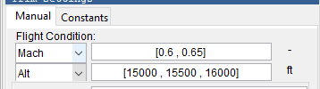

1. Input flap and gear settings.

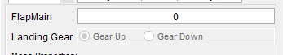

1. Select the mass properties that will be used for the trim.

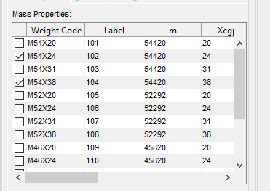

1. Set any conditions for the simuilation inputs/outputs for both trim 1 and trim 2. The values may be scalar or standard Matlab vector format. Must be a 1 x N numeric where N is greater than 1. N will be the number of trim conditions run

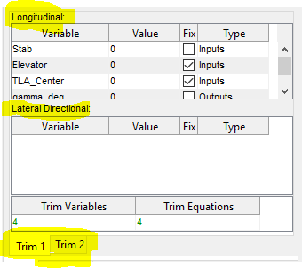

1. Add a label to the group of trims.

* Note: This will also serve as a way to label groups of trims in the FLIGHTcontrol tool.



1. Run Trim or Continue to build your trim case
   1. If you are ready to run hit the “Run”  button in the tool bar
   2. To continue to build your trim you can hit “Add Run Cases”  in the toolbar.

## 

## Advance Trim Settings

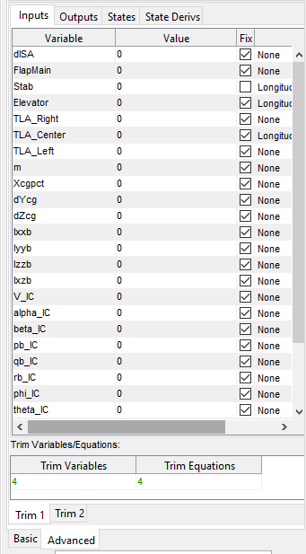

In the advanced section the user may use any configuration.

It is diveded up into two main trim tabs and each trim tab is then diveded into four sections ( Inputs, Outputs, States, StateDerivs), the parameters in each section corespnd to their respective location withing the simulink model.

Again, The values may be scalar or standard Matlab vector format. Must be a 1 x N numeric where N is greater than 1. N will be the number of trim conditions run.

To assist the user in selecting the correct number of trim equations, the selected number of Trim Variables and Trim equations are displayed. They must be equal.

## The Run Button



When your task is set up click on the “Run” button.

## Results

In the results section there are 4 tabs.

### Table

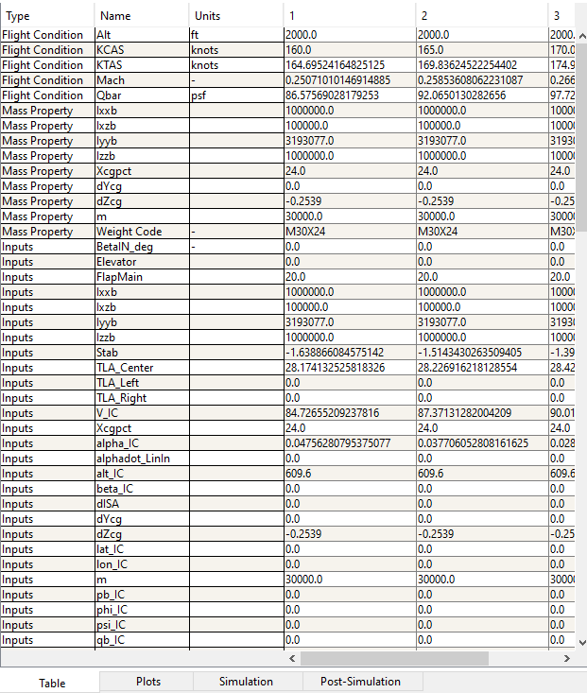

The results are displayed in a table format with the trims being numbered 1-N.

Plotting results

The results can be plotted in several ways:

1. Select 1 row and right click the selected row and choose “Plot”.
2. Select 2 rows by holding down shift and selecting, then choose “Plot”. The first will be the dependent variable in the plot and the second selected will be the independent variable.
3. Select 3 or more rows by holding down shift and selecting, then choose “Plot”. The first will be the dependent variable in the plot and the remaining selected variables will be the independent variables.
4. Select 3 rows by holding down shift and selecting, then choose “ Carpet Plot”. The first will be the dependent variable in the plot and the second selected will be the independent variable and the 3rd with be the z axis.

It’s also possible to filter the results. The Variable Selection panel (shown below) selects the visible rows in the table.

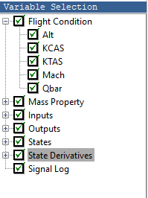

The Column Filters 1-4 select the column.(Shown below)

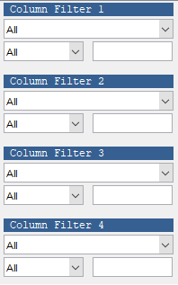

### Plots

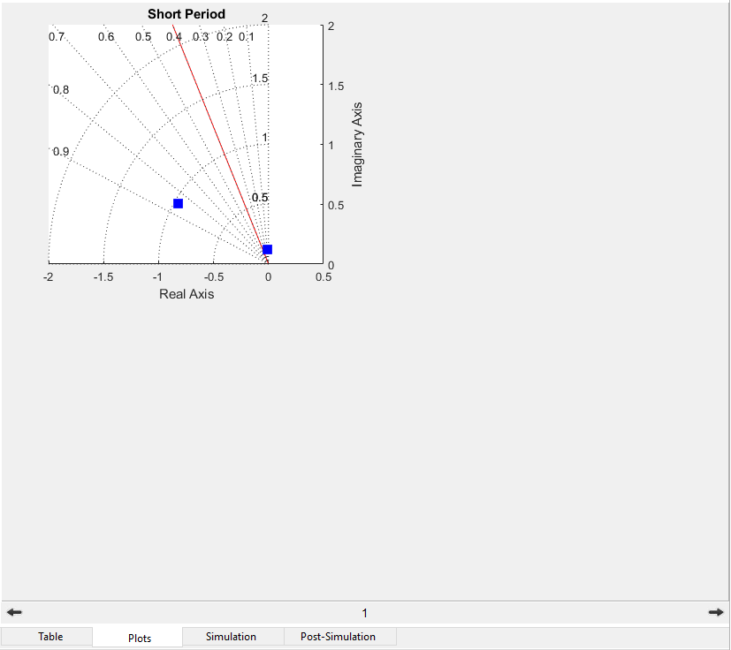

### Simulation

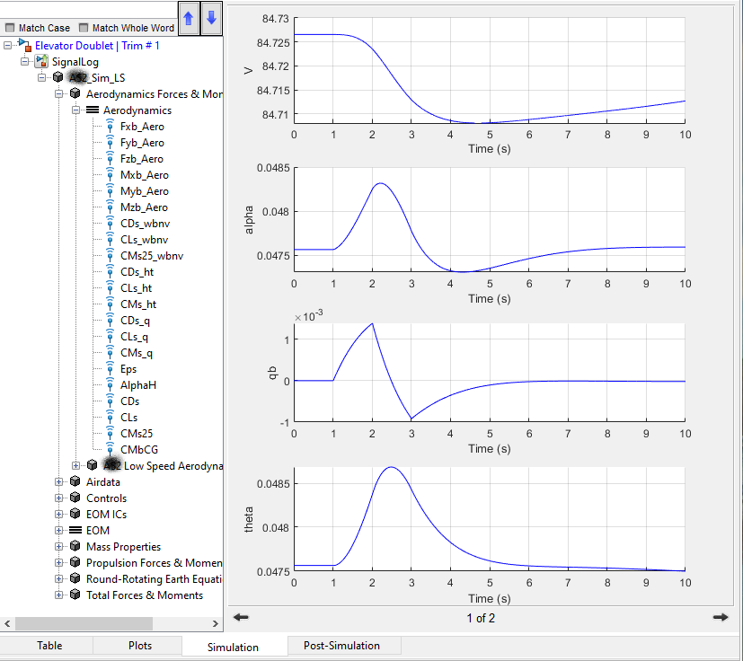

### Post-Simulation

