Practice Questions

- Write a program to print “Hello There” in command line.
- Write a program to print following pattern.(Use single , double and tripple quotes)
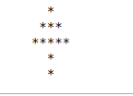

- Write a program to pring following pattern using single print statement.
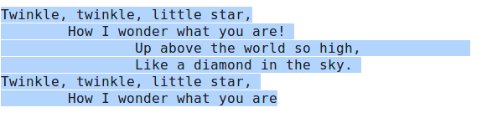
- Use escape charater to generate above pattern.
- Use carriage return (excape charater \r) to print “Hello this is carriage return example” as “return examplecarraige”.
- Print following pattern using vertical tab.
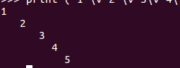

- Take values from input and print on command line.
- Ask name of the user and print as follows
  - Hello <user given name>, This is <Ur Name>
- Take input from user and find following values.
  - Find area of square. (user input length)
  - Find area of rectangle.(user input length and width)

