Pattern Using for loop:

- Ask user input for length of pattern and print on screen.
  - Print following pattern
    - Enter a length of pattern 5
    - Output be like
      - * * * * *
      - * * * * *
      - * * * * *
      - * * * * *
      - * * * * *
  - Print Triangle as follows:
    - Enter a length of pattern 5
    - Ouput be like,
      - 1
      - 1 2
      - 1 2 3
      - 1 2 3 4
      - 1 2 3 4 5
  - Print Triangle as follows:
    - Enter a length of pattern 5
    - Output be like
      - 1 2 3 4 5
      - 1 2 3 4
      - 1 2 3
      - 1 2
      - 1
  - Print Triangle as follows
    - Enter a length of pattern 5
    - Output be like
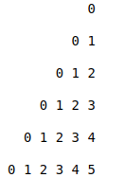

  - Print followin pattern
    - Enter input 7
    - output be like
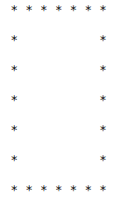

- Print following pattern
  - Enter length of pattern 5
  - Output be like
