**AAROHI SEWING ENTERPRISES**

**One Stop Store for All Sewing Needs**

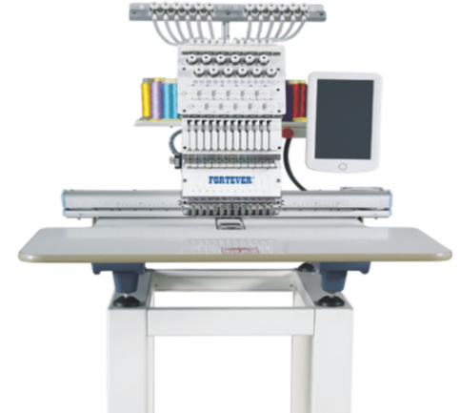**FORTEVER: FT-1201/1501 Single Head Commercial Embroidery Machine**

***Chinese brand. Classic single head series different embroidery area suitable for different embroider demands. Supports blouses, sarees, cap, finished garments, flat embroidery, Optional device has : Sequins, Cording, rhinestone, beads, laser cutting, Robot frame device etc.***

***Perfect for small and established businesses alike***

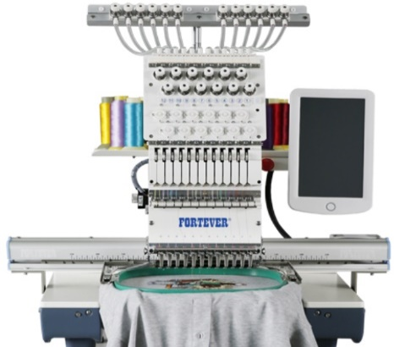

**Our Services**

* 1 Year Free Service
* Welcome Kit
* 500+ Blouse Designs, 3000+ Butties, Extra Dress and Kid designs
* Home Delivery (Customer to pay transport charges)
* Home Installation
* Home Demo
* Home Service
* Training is available at our store (Charges applicable)

**Major Features**

* Max Speed: 1000 SPM
* Memory Capacity: 20 Million Stitches / 200 designs
* LCD display showing real-time stitching
* Around 10 Hoops
* Design format: DST
* Automatic Thread Trimmer & Auto Color Change
* Wide Voltage Ac80v-260v Input ,Adapt to Any Unstable Electricity
* 1 Auto winding machine
* 1 Toolbox

**Price and Delivery Time**

|  |  |  |
| --- | --- | --- |
| No. Of Needles | Frame/Hoop size | Price (In lacks) |
| 12 | 400x800 mm | 3.75 |
| 12 | 500X1200 mm | 4.75 |
| 12 | 700X1200 mm | 6.75 |

Extra charges applicable for optional devices like cap, shoe, cording, Sequins, and Beads devices, etc.,

**Delivery time:** 1 to 2 days incase stock is available, else 1 to 2 months’ time for delivery since advance payment.